Supplement to Van der Sluijs et al., Characterizing tree species in northern boreal forests using multiple-endmember spectral mixture analysis and multi-temporal satellite imagery.
S1: Distributions of forest inventory metrics for calibration and validation plots.
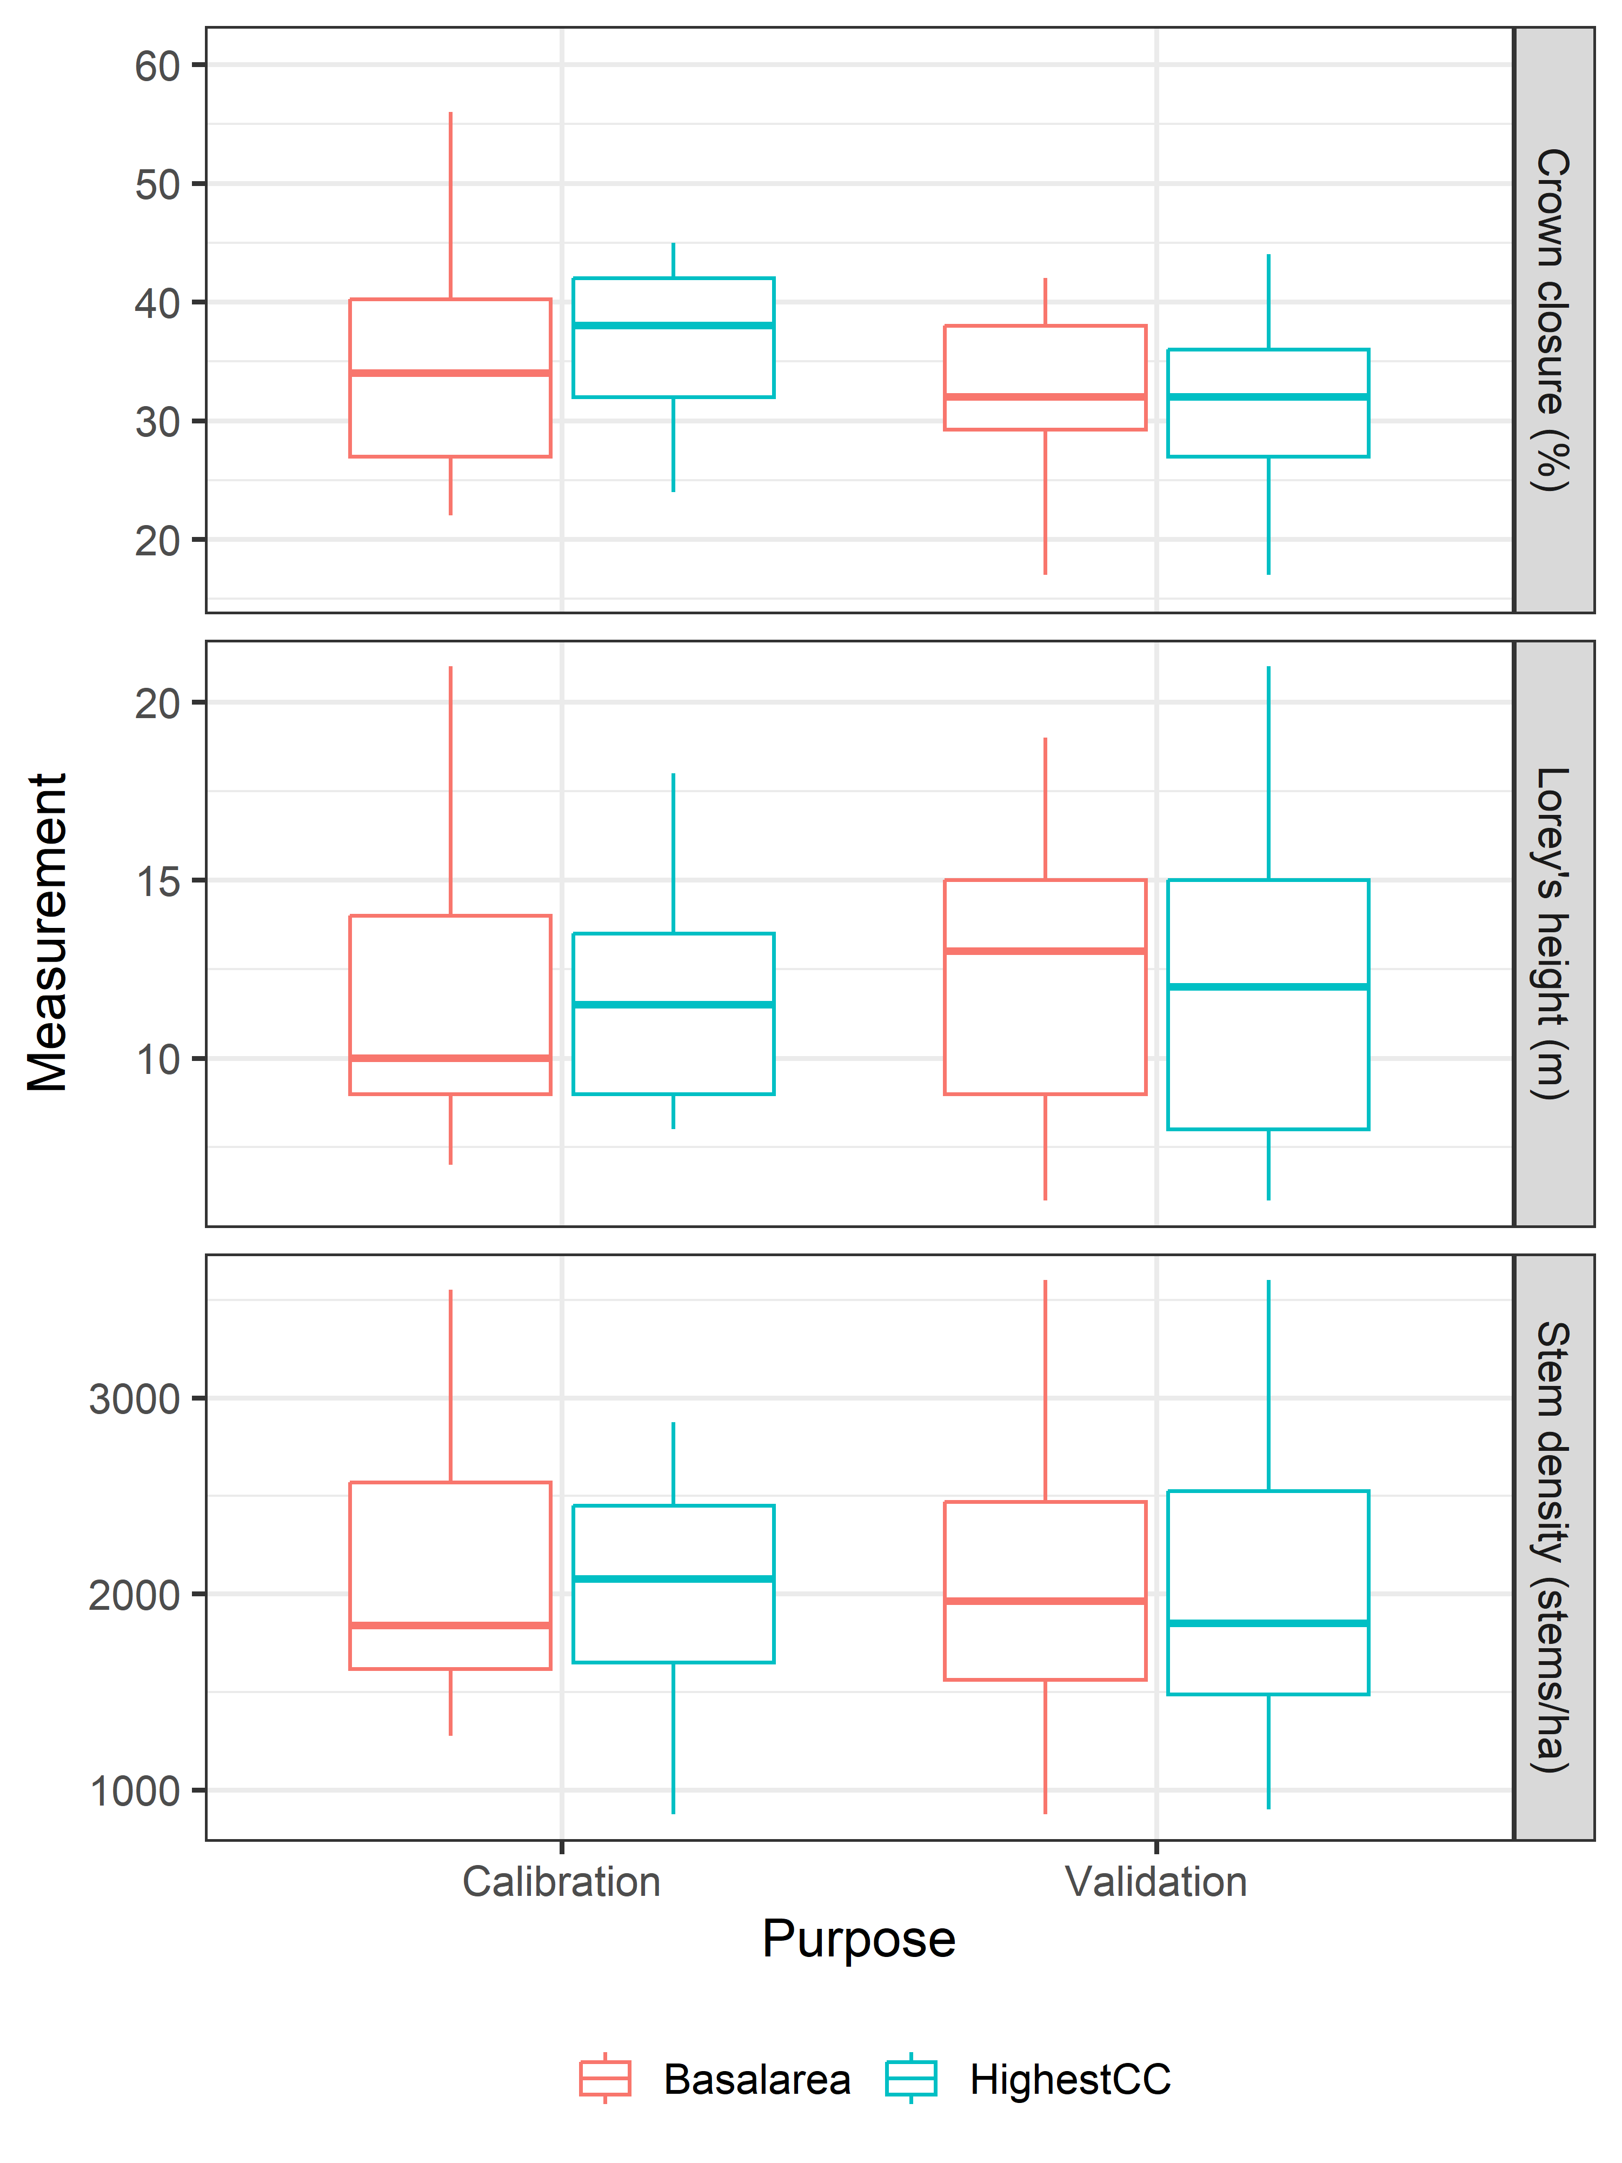
Figure S1: Boxplot of forest inventory metrics by sunlit canopy endmember selection method and by purpose. The selection methods have similar distributions for Lorey height and stem density, while the HighestCC calibration plots have higher crown closures compared to Basalarea calibration plots, as expected.

S2: Spectral reflectance of sunlit canopy and background endmembers.
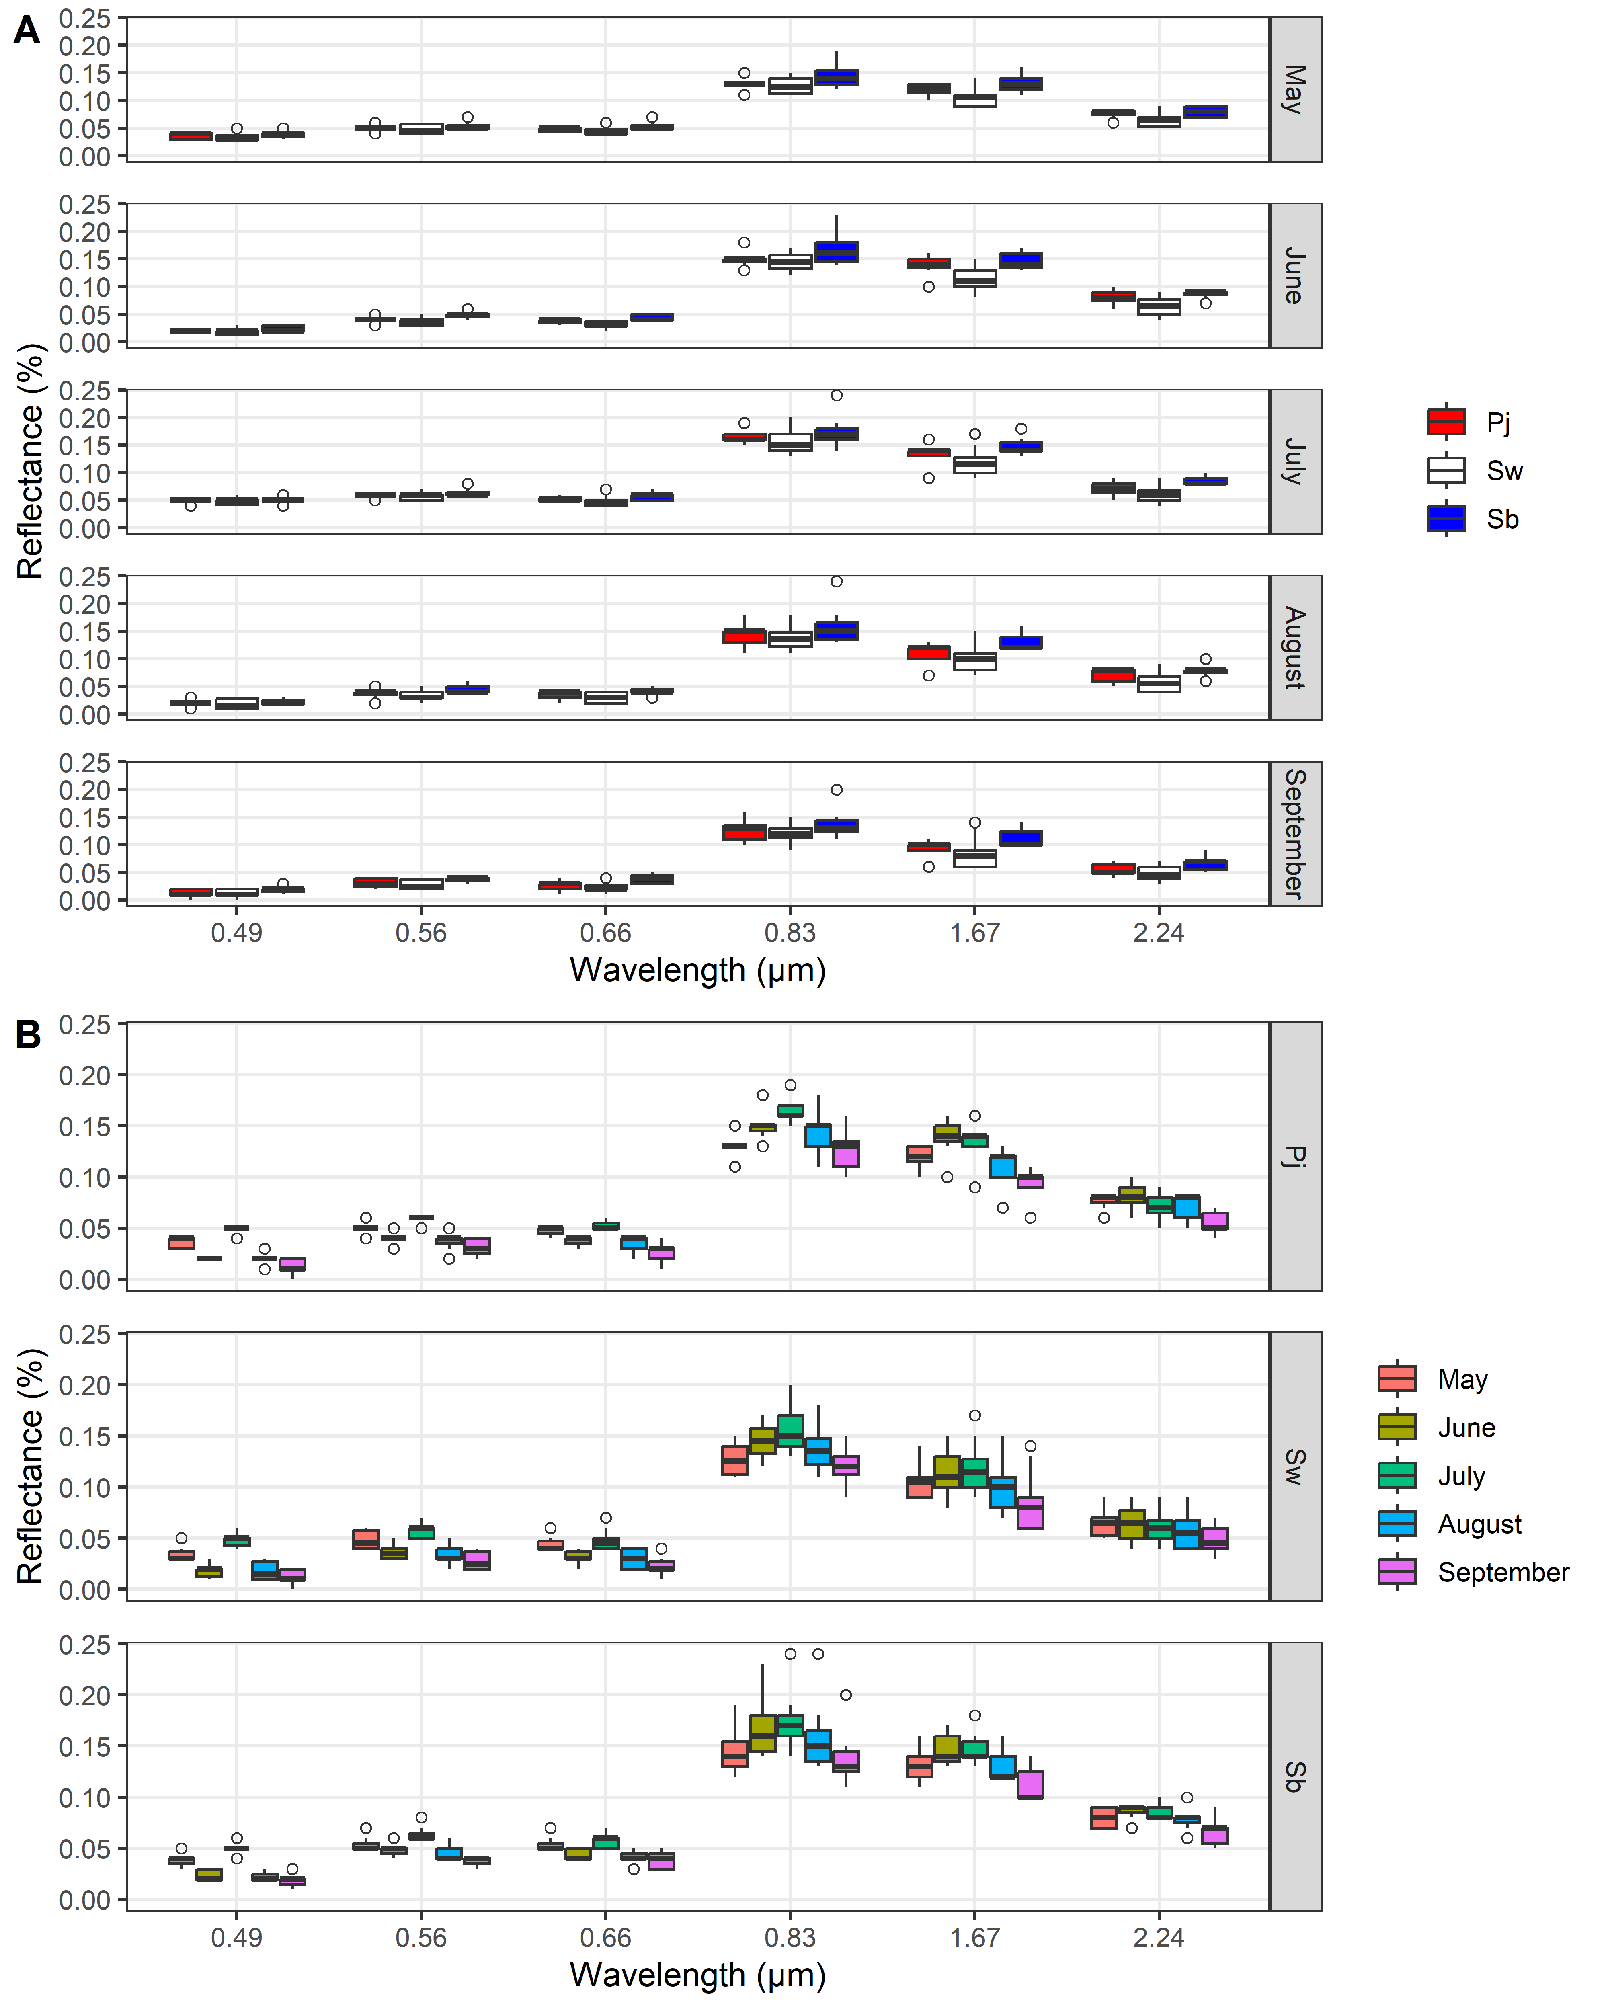
Figure S2: Boxplot of band reflectance values by conifer species and phenological period for the Basalarea image endmember sets (sunlit canopy). Plot highlights small differences in spectral reflectance between conifer species (A) and throughout the phenological period (B). Tree species: white spruce (Sw), black spruce (Sb), and jack pine (Pj).
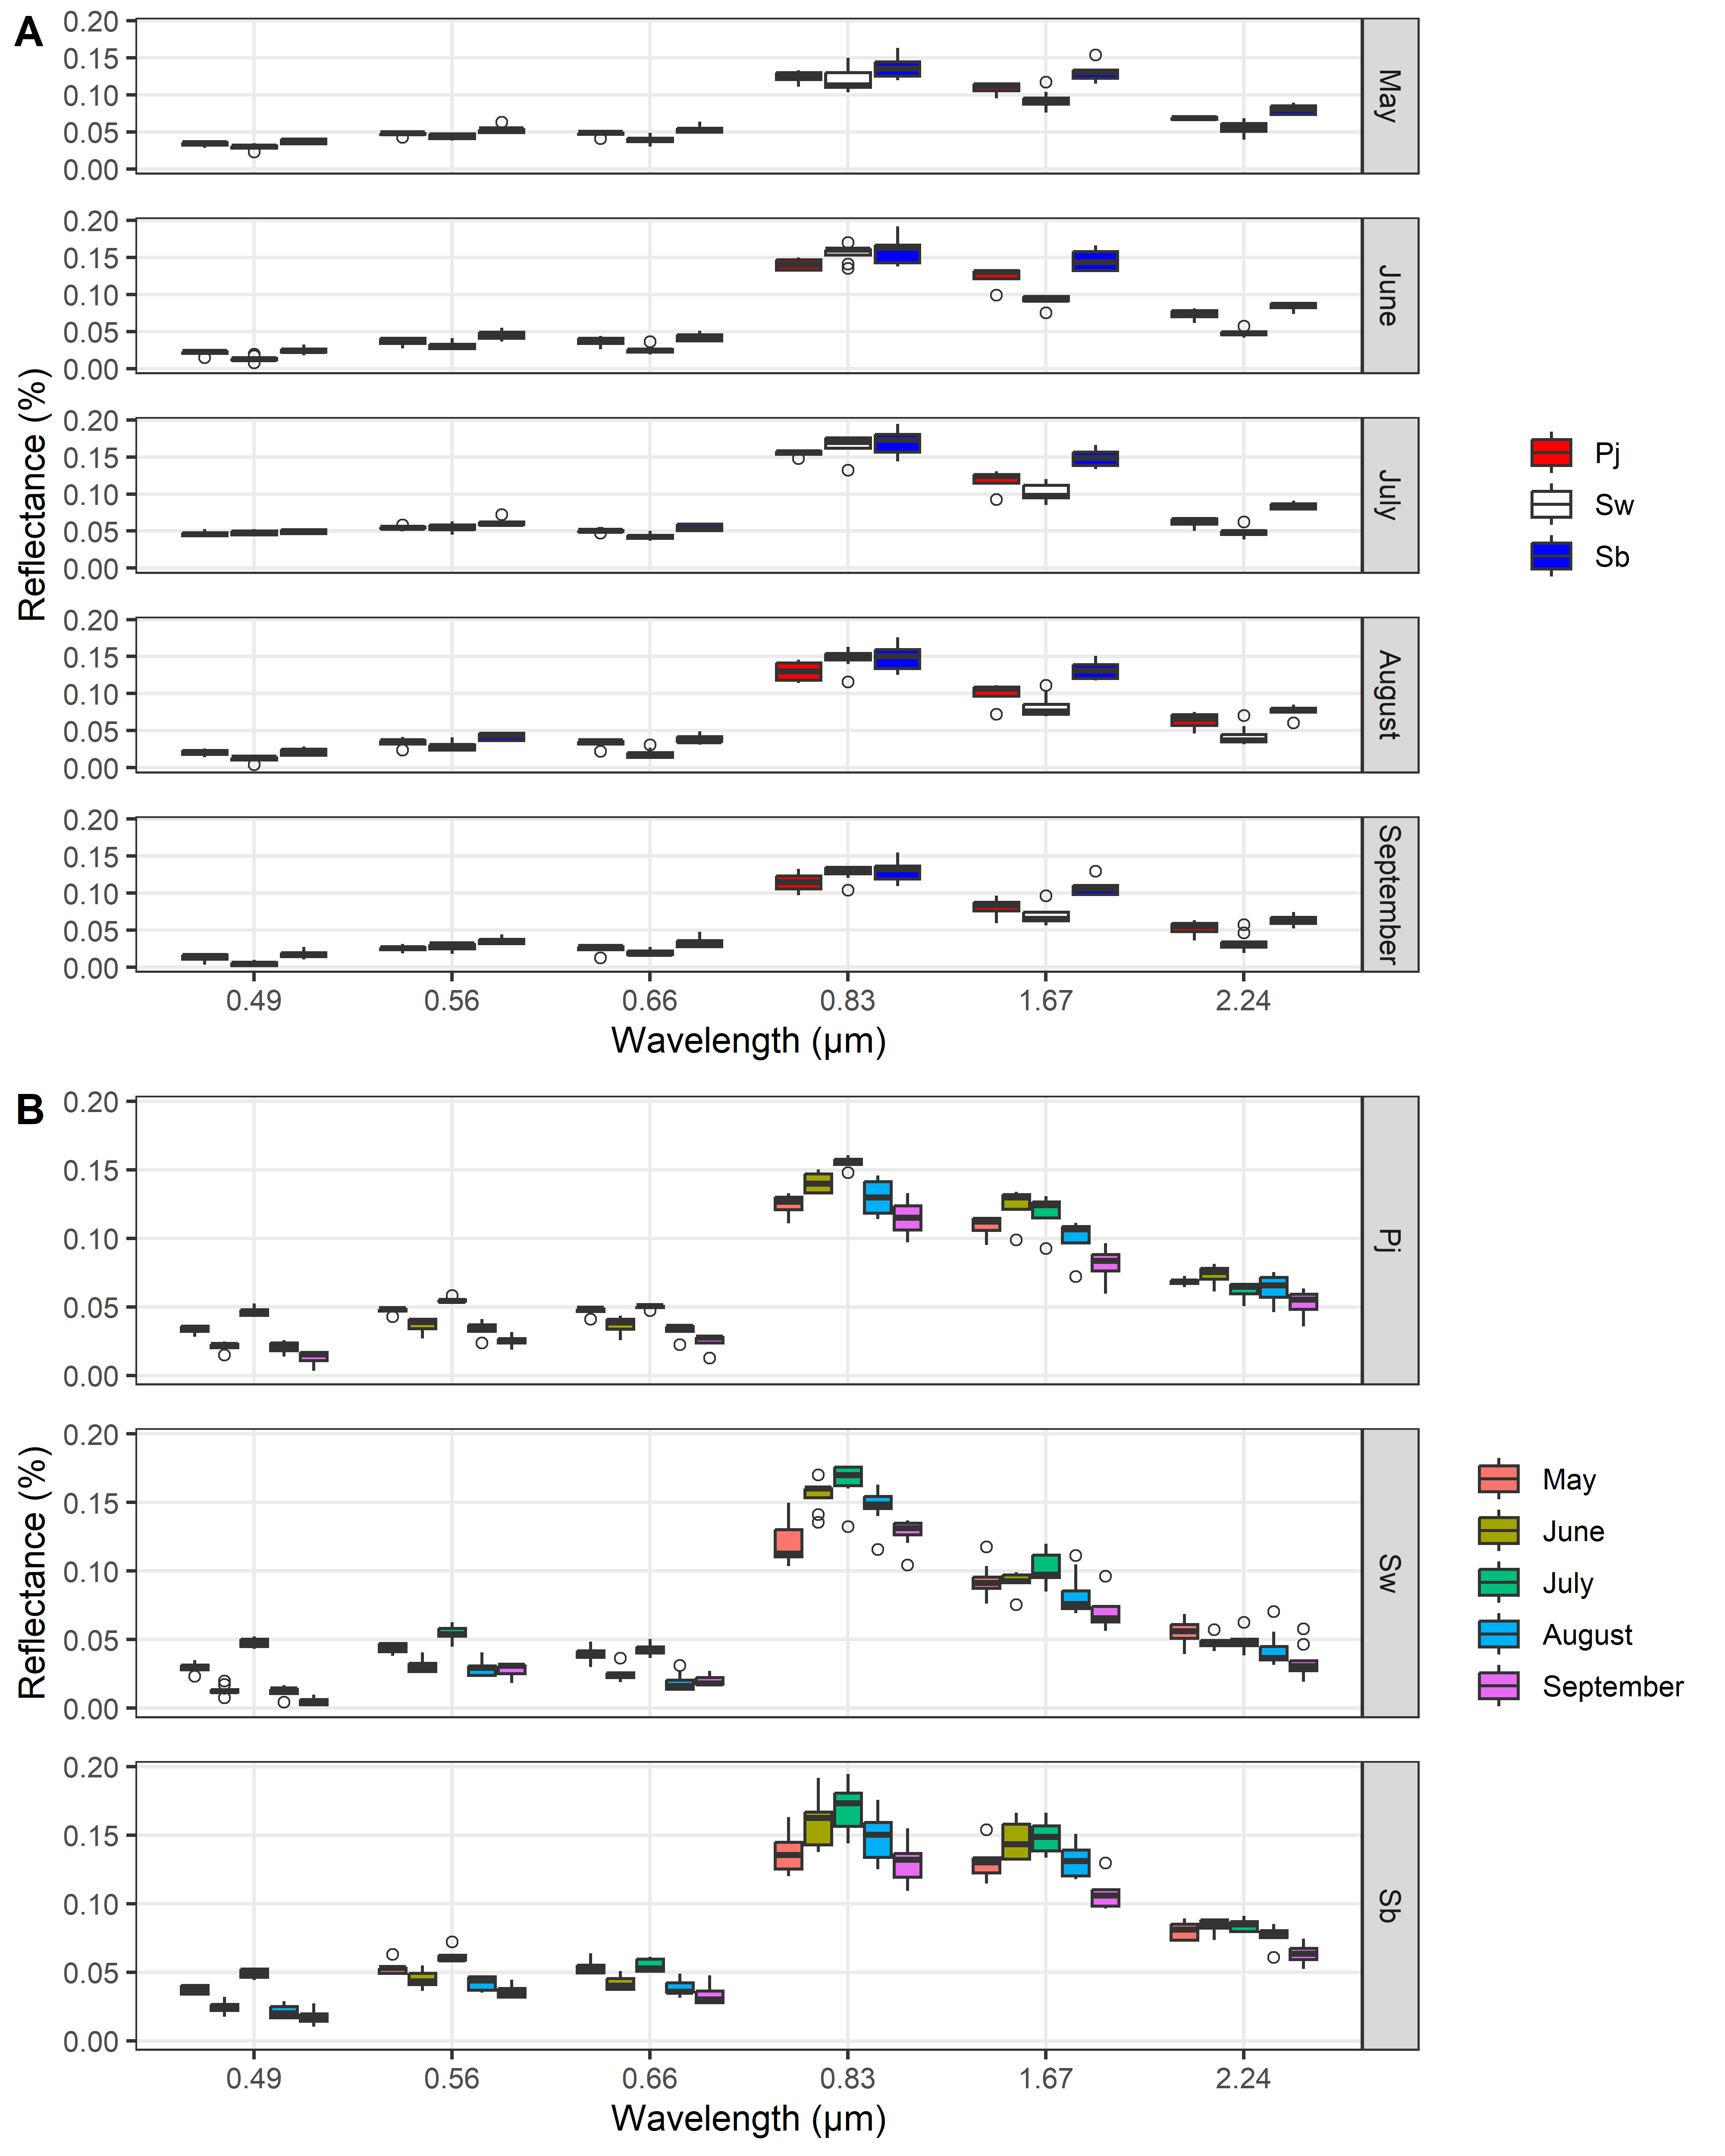
Figure S3: Boxplot of band reflectance values by conifer species and phenological period for the HighestCC image endmember sets (sunlit canopy). Plot highlights small differences in spectral reflectance between conifer species (A) and throughout the phenological period (B). Tree species: white spruce (Sw), black spruce (Sb), and jack pine (Pj).

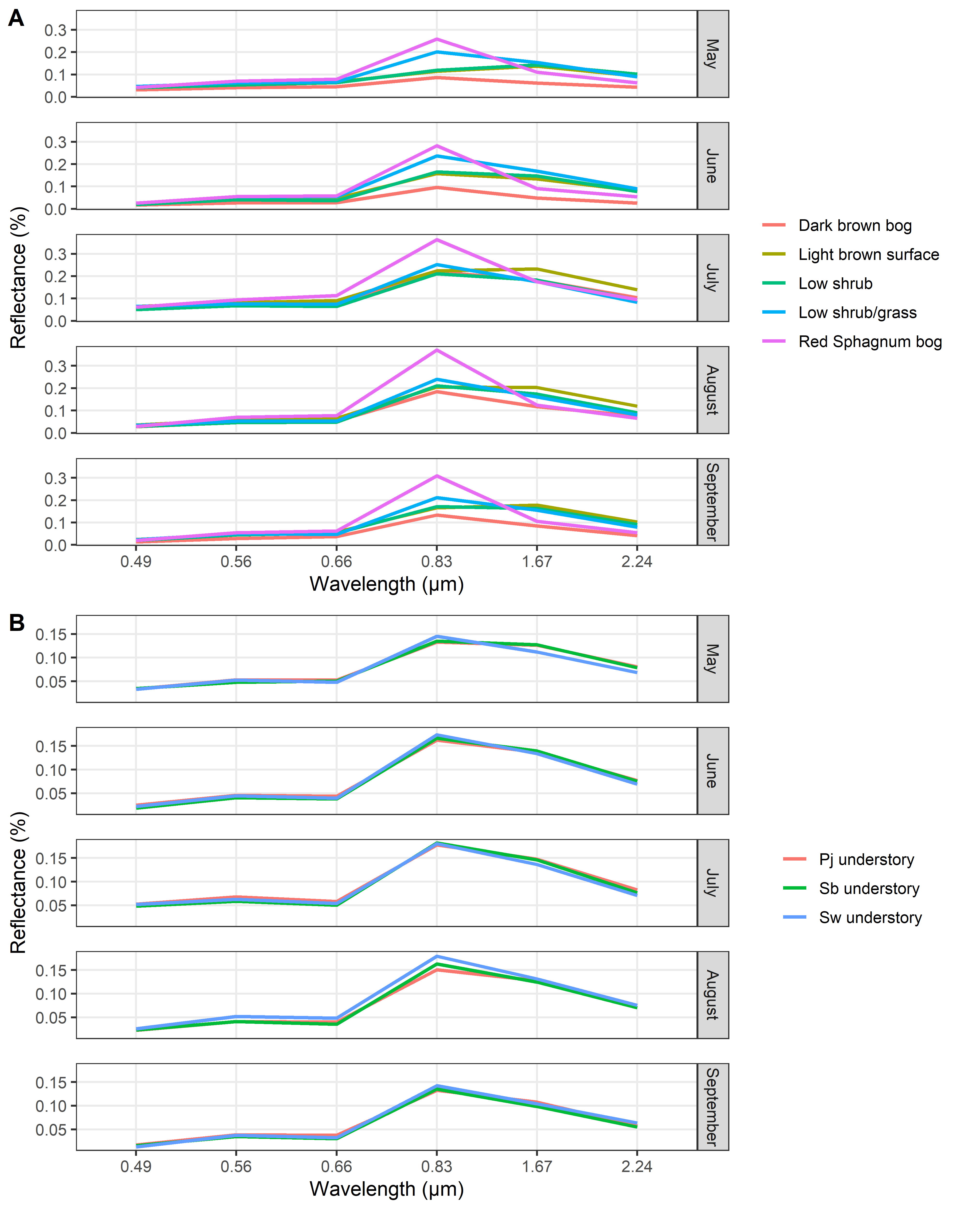
Figure S4: Band reflectance values for the PurestBg (A) and HighestCC (B) image endmember sets (background). Medians are shown for legibility. Tree species: white spruce (Sw), black spruce (Sb), and jack pine (Pj).

