Supplementary file for Table S1 and Figure S1 for:

Tracking the origins of the introduced terrestrial amphipod, Puhuruhuru patersoni, on sub-Antarctic Macquarie Island

Elahe Parvizi ª, Angela McGaughran ª, Mark I. Stevens ^{b,c*}

ª Te Aka Mātuatua/School of Science, Waikato University, Hamilton, New Zealand.
^{b} Securing Antarctica’s Environmental Future, Earth and Biological Sciences, South Australian Museum, SA 5000, Australia.
^{c} School of Biological Sciences, University of Adelaide, SA 5005, Australia.

CONTACT Mark I. Stevens mark.stevens@samuseum.sa.gov.au

Table S1. Specimen identification (ID), sampling information, and associated mtDNA clade following phylogenetic analysis of Puhuruhuru patersoni.
Specimen ID | GenBank accession number | Location | Latitude (south) | Longitude | Main Island | mtDNA clade
Nugget_1 | OQ734985 | Nugget Point | 46.46606 | 169.75764 | South Island | Clade 1
Nugget_2 | OQ735041 | Nugget Point | 46.46606 | 169.75764 | South Island | Clade 1
Nugget_3 | OQ735043 | Nugget Point | 46.46606 | 169.75764 | South Island | Clade 1
Nugget_4 | OQ735042 | Nugget Point | 46.46606 | 169.75764 | South Island | Clade 1
Nugget_5 | OQ735056 | Nugget Point | 46.46606 | 169.75764 | South Island | Clade 1
Nugget_6 | OQ735060 | Nugget Point | 46.46606 | 169.75764 | South Island | Clade 1
Nugget_7 | OQ735044 | Nugget Point | 46.46606 | 169.75764 | South Island | Clade 1
Nugget_8 | OQ735061 | Nugget Point | 46.46606 | 169.75764 | South Island | Clade 1
Nugget_9 | OQ735063 | Nugget Point | 46.46606 | 169.75764 | South Island | Clade 1
Nugget_10 | OQ735059 | Nugget Point | 46.46606 | 169.75764 | South Island | Clade 1
Nugget_11 | OQ735064 | Nugget Point | 46.46606 | 169.75764 | South Island | Clade 1
Nugget_12 | OQ735057 | Nugget Point | 46.46606 | 169.75764 | South Island | Clade 1
Nugget_13 | OQ735058 | Nugget Point | 46.46606 | 169.75764 | South Island | Clade 1
Stewart_Paterson | OQ735067 | Paterson Inlet | 46.902732 | 168.118259 | Stewart Island | Clade 1
Stewart_Bench_1 | OQ735075 | Bench Island | 46.90778 | 168.23239 | Stewart Island | Clade 1
Macquarie_1 | OQ734997 | Macquarie Island | 54.499281 | 158.936131 | Macquarie Island | Clade 2
Macquarie_2 | OQ735048 | Macquarie Island | 54.499281 | 158.936131 | Macquarie Island | Clade 2
Macquarie_3 | OQ735032 | Macquarie Island | 54.499281 | 158.936131 | Macquarie Island | Clade 2
Macquarie_4 | OQ735033 | Macquarie Island | 54.499281 | 158.936131 | Macquarie Island | Clade 2
Macquarie_5 | OQ735049 | Macquarie Island | 54.499281 | 158.936131 | Macquarie Island | Clade 2
Macquarie_6 | OQ735009 | Macquarie Island | 54.499281 | 158.936131 | Macquarie Island | Clade 2
Macquarie_7 | OQ735030 | Macquarie Island | 54.499281 | 158.936131 | Macquarie Island | Clade 2
Macquarie_8 | OQ735031 | Macquarie Island | 54.499281 | 158.936131 | Macquarie Island | Clade 2
Macquarie_9 | OQ734991 | Macquarie Island | 54.499281 | 158.936131 | Macquarie Island | Clade 2
Macquarie_10 | OQ734992 | Macquarie Island | 54.499281 | 158.936131 | Macquarie Island | Clade 2
Macquarie_11 | OQ734994 | Macquarie Island | 54.499281 | 158.936131 | Macquarie Island | Clade 2
Macquarie_12 | OQ734995 | Macquarie Island | 54.499281 | 158.936131 | Macquarie Island | Clade 2
Macquarie_13 | OQ734996 | Macquarie Island | 54.499281 | 158.936131 | Macquarie Island | Clade 2
Macquarie_14 | OQ734998 | Macquarie Island | 54.499281 | 158.936131 | Macquarie Island | Clade 2
Macquarie_15 | OQ734993 | Macquarie Island | 54.499281 | 158.936131 | Macquarie Island | Clade 2
Macquarie_16 | OQ734999 | Macquarie Island | 54.499281 | 158.936131 | Macquarie Island | Clade 2
Macquarie_17 | OQ735000 | Macquarie Island | 54.499281 | 158.936131 | Macquarie Island | Clade 2
Macquarie_18 | OQ735001 | Macquarie Island | 54.499281 | 158.936131 | Macquarie Island | Clade 2
Macquarie_19 | OQ735002 | Macquarie Island | 54.499281 | 158.936131 | Macquarie Island | Clade 2
Macquarie_20 | OQ735003 | Macquarie Island | 54.499281 | 158.936131 | Macquarie Island | Clade 2
Macquarie_21 | OQ735004 | Macquarie Island | 54.499281 | 158.936131 | Macquarie Island | Clade 2
Macquarie_22 | OQ735005 | Macquarie Island | 54.499281 | 158.936131 | Macquarie Island | Clade 2
Macquarie_23 | OQ735007 | Macquarie Island | 54.499281 | 158.936131 | Macquarie Island | Clade 2
Macquarie_24 | OQ735047 | Macquarie Island | 54.499281 | 158.936131 | Macquarie Island | Clade 2
Macquarie_25 | OQ735008 | Macquarie Island | 54.499281 | 158.936131 | Macquarie Island | Clade 2
Macquarie_26 | OQ735006 | Macquarie Island | 54.499281 | 158.936131 | Macquarie Island | Clade 2
Macquarie_27 | OQ735010 | Macquarie Island | 54.499281 | 158.936131 | Macquarie Island | Clade 2
Macquarie_28 | OQ735011 | Macquarie Island | 54.499281 | 158.936131 | Macquarie Island | Clade 2
Macquarie_29 | OQ735040 | Macquarie Island | 54.499281 | 158.936131 | Macquarie Island | Clade 2
Macquarie_30 | OQ735012 | Macquarie Island | 54.499281 | 158.936131 | Macquarie Island | Clade 2
Macquarie_31 | OQ735014 | Macquarie Island | 54.499281 | 158.936131 | Macquarie Island | Clade 2
Macquarie_32 | OQ735013 | Macquarie Island | 54.499281 | 158.936131 | Macquarie Island | Clade 2
Macquarie_33 | OQ735015 | Macquarie Island | 54.499281 | 158.936131 | Macquarie Island | Clade 2
Macquarie_34 | OQ735016 | Macquarie Island | 54.499281 | 158.936131 | Macquarie Island | Clade 2
Macquarie_35 | OQ735017 | Macquarie Island | 54.499281 | 158.936131 | Macquarie Island | Clade 2
Macquarie_36 | OQ735018 | Macquarie Island | 54.499281 | 158.936131 | Macquarie Island | Clade 2
Macquarie_37 | OQ735019 | Macquarie Island | 54.499281 | 158.936131 | Macquarie Island | Clade 2
Macquarie_38 | OQ735020 | Macquarie Island | 54.499281 | 158.936131 | Macquarie Island | Clade 2
Macquarie_39 | OQ735021 | Macquarie Island | 54.499281 | 158.936131 | Macquarie Island | Clade 2
Macquarie_40 | OQ735022 | Macquarie Island | 54.499281 | 158.936131 | Macquarie Island | Clade 2
Macquarie_41 | OQ735023 | Macquarie Island | 54.499281 | 158.936131 | Macquarie Island | Clade 2
Macquarie_42 | OQ735024 | Macquarie Island | 54.499281 | 158.936131 | Macquarie Island | Clade 2
Macquarie_43 | OQ735025 | Macquarie Island | 54.499281 | 158.936131 | Macquarie Island | Clade 2
Macquarie_44 | OQ735026 | Macquarie Island | 54.499281 | 158.936131 | Macquarie Island | Clade 2
Macquarie_45 | OQ735027 | Macquarie Island | 54.499281 | 158.936131 | Macquarie Island | Clade 2
Macquarie_46 | OQ735028 | Macquarie Island | 54.499281 | 158.936131 | Macquarie Island | Clade 2
Macquarie_47 | OQ735029 | Macquarie Island | 54.499281 | 158.936131 | Macquarie Island | Clade 2
Ratanui_1 | OQ735045 | Ratanui | 46.51611 | 169.5584 | South Island | Clade 2
Auckland_Is | OQ734987 | Auckland Island | 50.540896 | 166.272684 | Auckland Islands | Clade 3
Adams_1 | OQ734990 | Adams Island | 50.866433 | 166.026804 | Auckland Islands | Clade 3
Adams_2 | OQ734988 | Adams Island | 50.866433 | 166.026804 | Auckland Islands | Clade 3
Adams_3 | OQ734989 | Adams Island | 50.866433 | 166.026804 | Auckland Islands | Clade 3
Stewart_Bench_2 | OQ735034 | Bench Island | 46.90778 | 168.23239 | Stewart Island | Clade 4
Stewart_Bench_3 | OQ735071 | Bench Island | 46.90778 | 168.23239 | Stewart Island | Clade 4
Stewart_Bench_4 | OQ735035 | Bench Island | 46.90778 | 168.23239 | Stewart Island | Clade 4
Stewart_Bench_5 | OQ735072 | Bench Island | 46.90778 | 168.23239 | Stewart Island | Clade 4
Stewart_Bench_6 | OQ735052 | Bench Island | 46.90778 | 168.23239 | Stewart Island | Clade 4
Stewart_Bench_7 | OQ735068 | Bench Island | 46.90778 | 168.23239 | Stewart Island | Clade 4
Stewart_Bench_8 | OQ735070 | Bench Island | 46.90778 | 168.23239 | Stewart Island | Clade 4
Stewart_Bench_9 | OQ735037 | Bench Island | 46.90778 | 168.23239 | Stewart Island | Clade 4
Stewart_Bench_10 | OQ735074 | Bench Island | 46.90778 | 168.23239 | Stewart Island | Clade 4
Stewart_Bench_11 | OQ735069 | Bench Island | 46.90778 | 168.23239 | Stewart Island | Clade 4
Stewart_Bench_12 | OQ735051 | Bench Island | 46.90778 | 168.23239 | Stewart Island | Clade 4
Stewart_Bench_13 | OQ735076 | Bench Island | 46.90778 | 168.23239 | Stewart Island | Clade 4
Stewart_Bench_14 | OQ735050 | Bench Island | 46.90778 | 168.23239 | Stewart Island | Clade 4
Snares_Oleasia | OQ735053 | Oleasia Forest | 48.021944 | 166.609353 | Snares Islands / Tini Heke | Clade 4
Snares_Rinni | OQ735054 | Rinni Bay | na | na | Snares Islands | Clade 4
Snares_Penguin | OQ735055 | near Penguin Colony | na | na | Snares Islands | Clade 4
Invercargill | OQ734986 | Otatara Scenic Reserve, Invercargill | 46.431335 | 168.296045 | South Island | Clade 5
Stewart_Bench_15 | OQ735036 | Bench Island | 46.90778 | 168.23239 | Stewart Island | Clade 5
Stewart_Bench_16 | OQ735073 | Bench Island | 46.90778 | 168.23239 | Stewart Island | Clade 5
Dunedin_1 | OQ735038 | Dunedin | 45.83862 | 170.49957 | South Island | Clade 5
Dunedin_2 | OQ735039 | Dunedin | 45.83862 | 170.49957 | South Island | Clade 5
Ratanui_2 | OQ735046 | Ratanui | 46.51611 | 169.5584 | South Island | Clade 5
Ratanui_3 | OQ735065 | Ratanui | 46.51611 | 169.5584 | South Island | Clade 5
Ratanui_4 | OQ735066 | Ratanui | 46.51611 | 169.5584 | South Island | Clade 5
NZsouth_TheRocks | OQ734984 | The Rocks | 46.3826 | 168.03682 | South Island | Clade 5
Nugget_14 | OQ735062 | Nugget Point | 46.46606 | 169.75764 | South Island | Clade 5

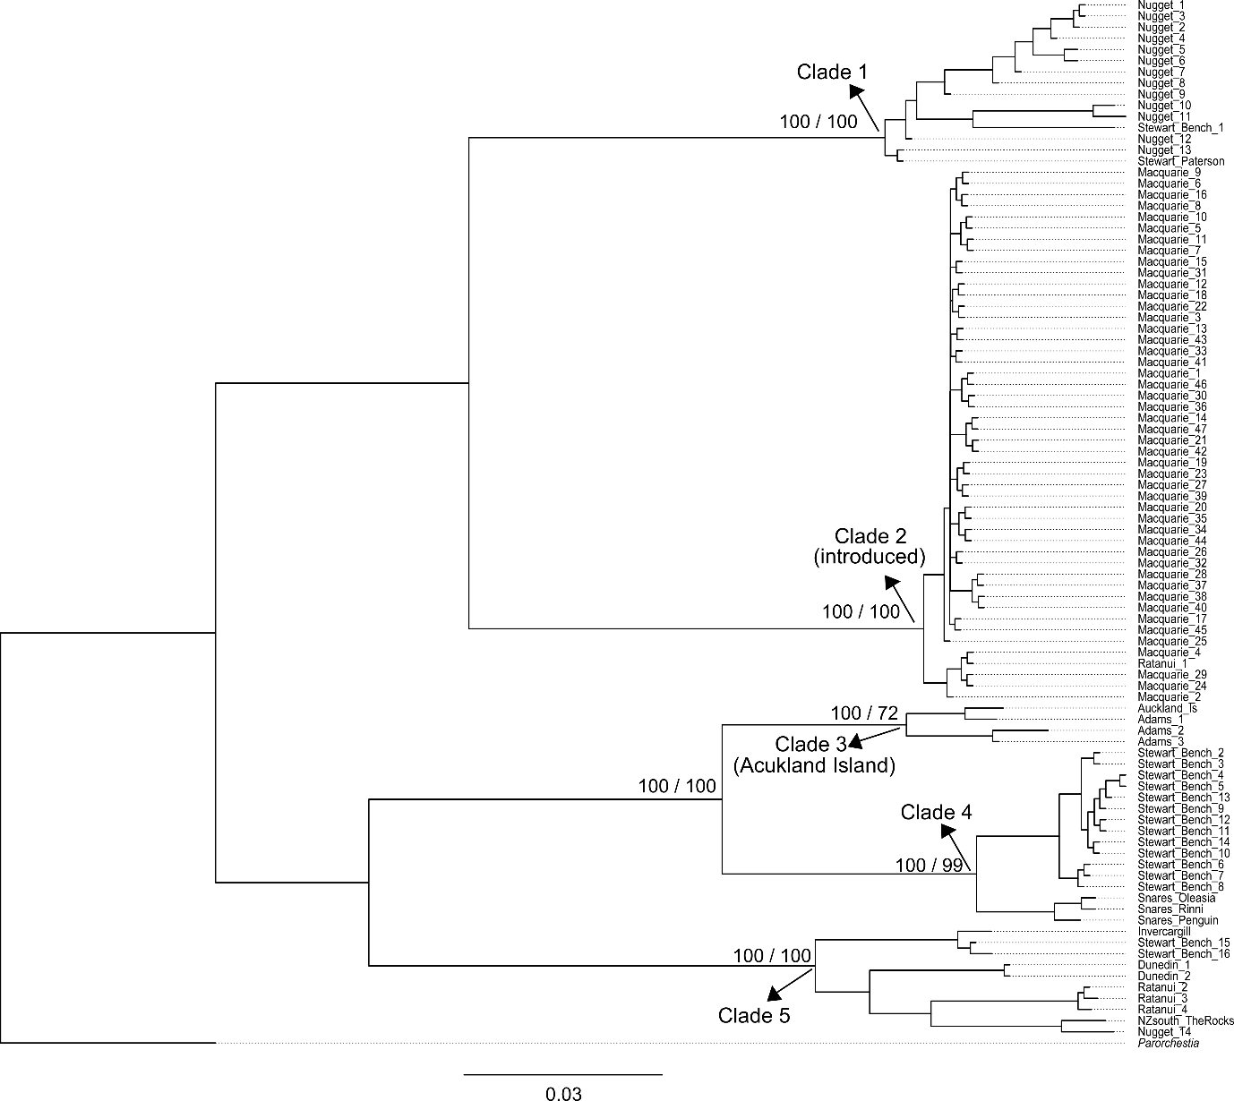
Figure S1. Phylogenetic tree of Puhuruhuru patersoni based on the COI mtDNA marker, with sample label details of each specimen corresponding to the specimen IDs provided in Table S1. Values on nodes indicate the posterior probabilities/bootstrap values obtained from Bayesian and maximum likelihood analyses, respectively.

