Supplementary file
Figure 1. Newly designed Dual inhibitors.
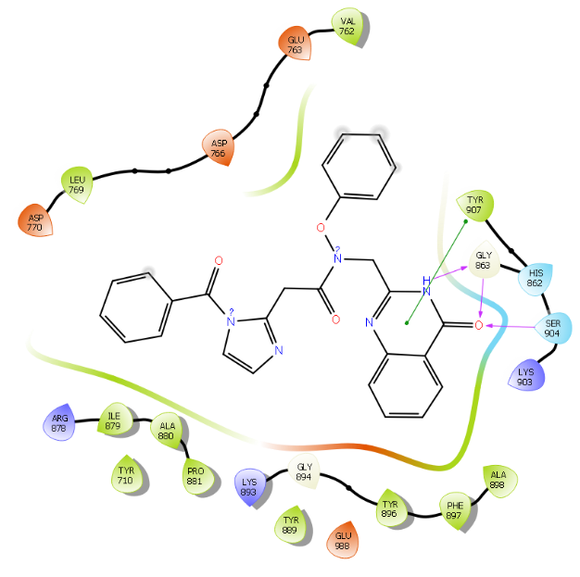
Figure 2. Fitting pose interactions of compound 1d in the pocket of 4ZZZ in 2D view.
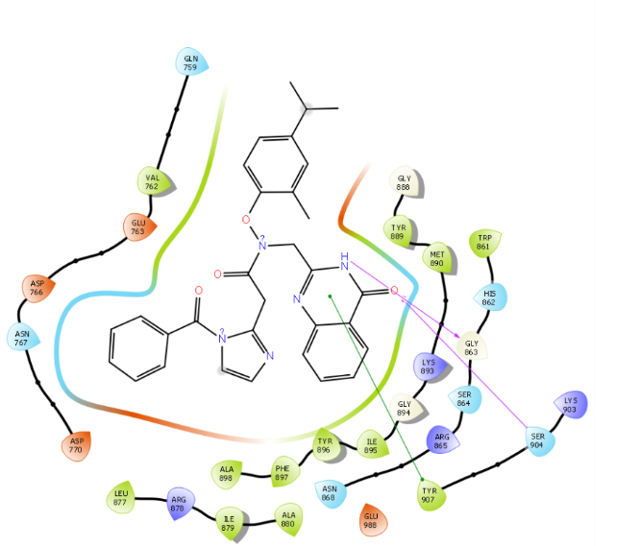
Figure 3. Fitting pose interactions of compound 1m in the pocket of 4ZZZ in 2D view.
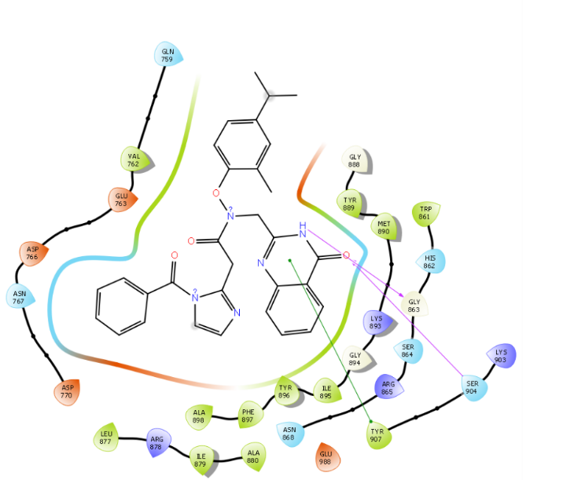
Figure 4. Fitting pose interactions of compound 2k in the pocket of 4ZZZ in 2D view.
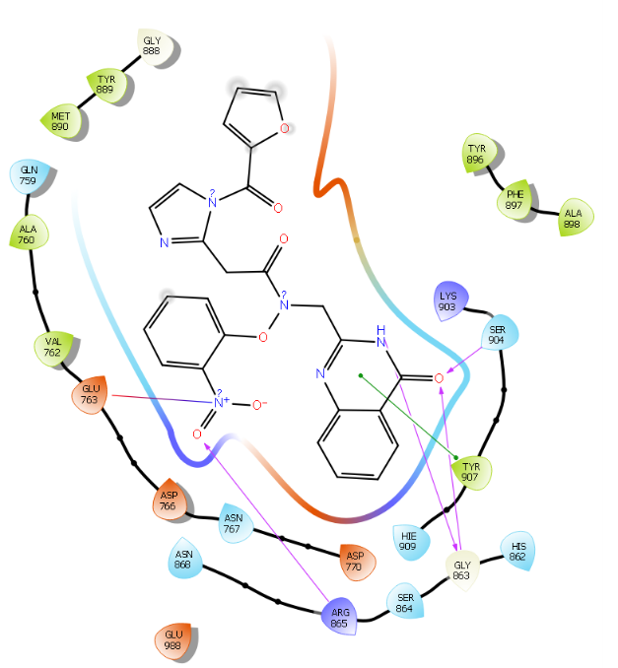
Figure 5. Fitting pose interactions of compound 2l in the pocket of 4ZZZ in 2D view.
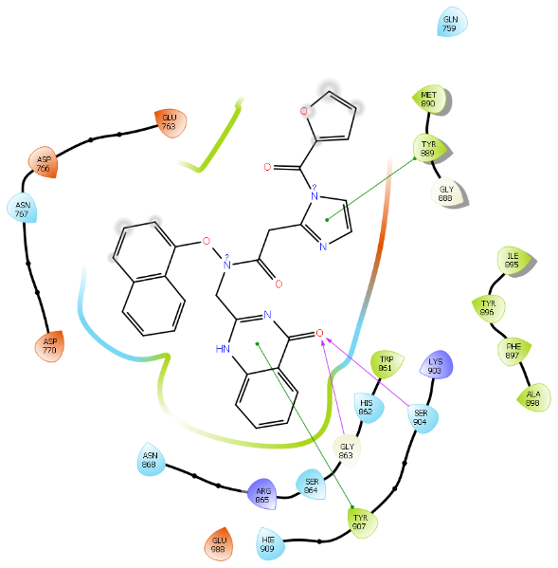
Figure 6. Fitting pose interactions of compound 2m in the pocket of 4ZZZ in 2D view.
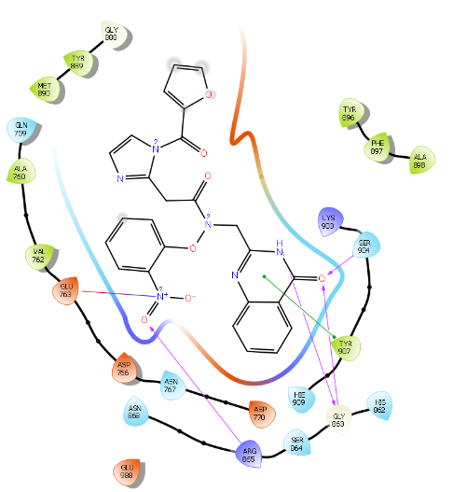
Figure 7. Fitting pose interactions of compound 3g in the pocket of 4ZZZ in 2D view.
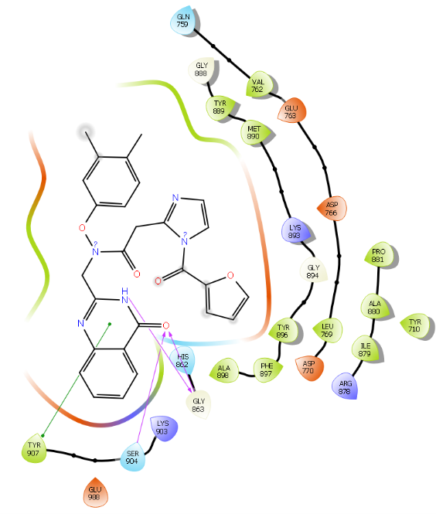
Figure 8. Fitting pose interactions of compound 3h in the pocket of 4ZZZ in 2D view.
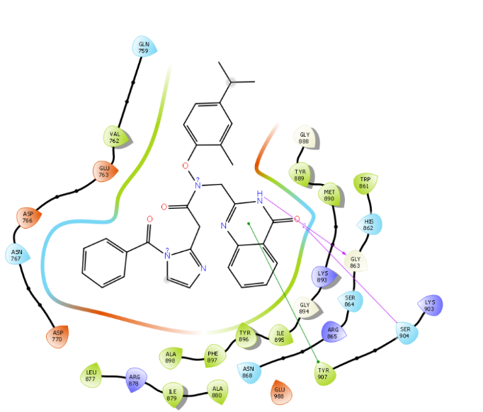
Figure 9. Fitting pose interactions of compound 3j in the pocket of 4ZZZ in 2D view.
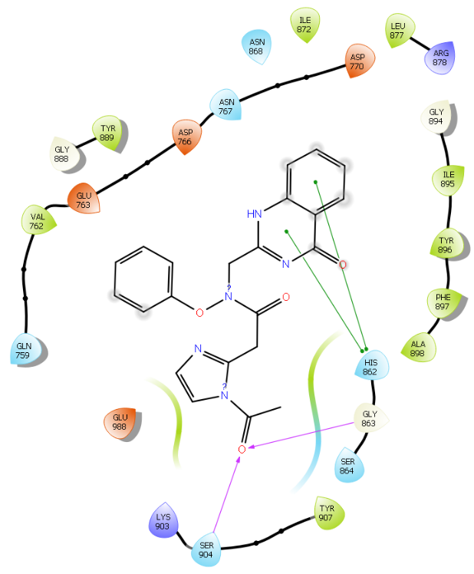
Figure 10. Fitting pose interactions of compound 3k in the pocket of 4ZZZ in 2D view.

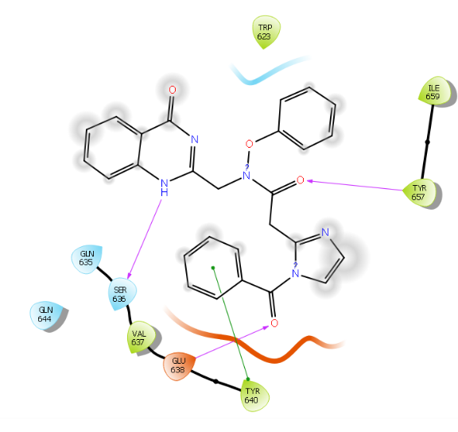
Figure 11. Fitting pose interactions of compound 1d in the pocket of 6NJS in 2D view.
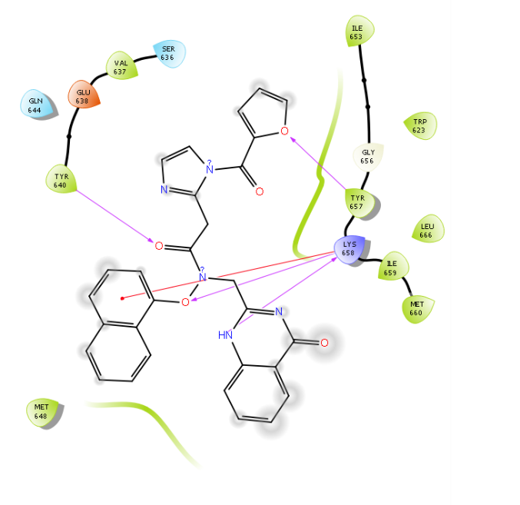
Figure 12. Fitting pose interactions of compound 1m in the pocket of 6NJS in 2D view.
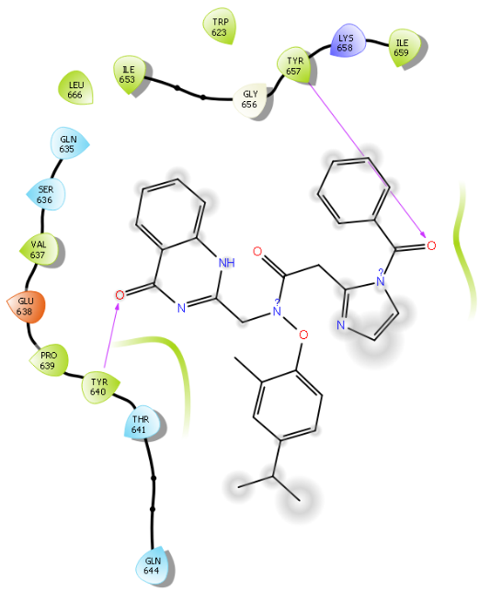
Figure 13. Fitting pose interactions of compound 2k in the pocket of 6NJS in 2D view.
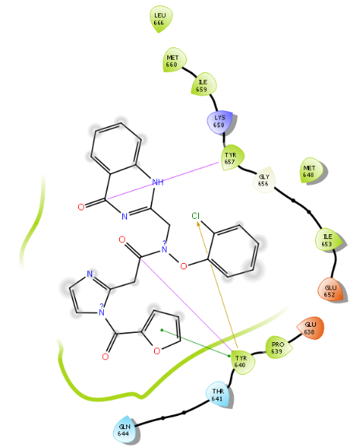
Figure 14. Fitting pose interactions of compound 2l in the pocket of 6NJS in 2D view.
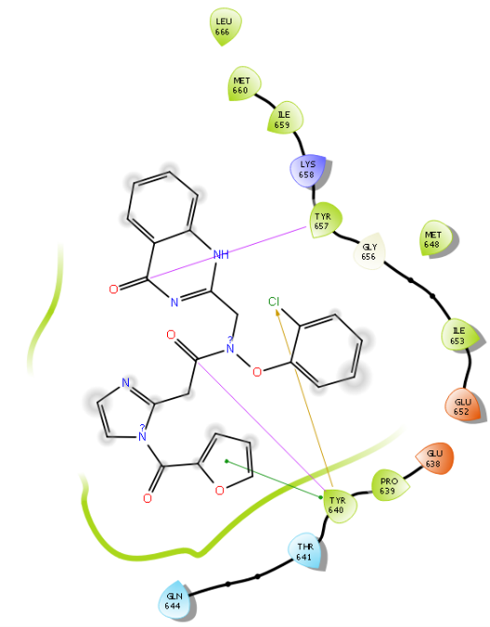
Figure 15. Fitting pose interactions of compound 2m in the pocket of 6NJS in 2D view.
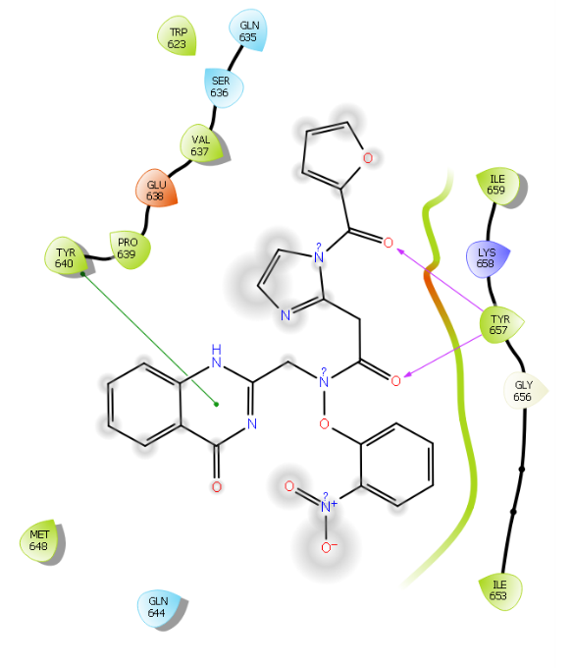
Figure 16. Fitting pose interactions of compound 3g in the pocket of 6NJS in 2D view.
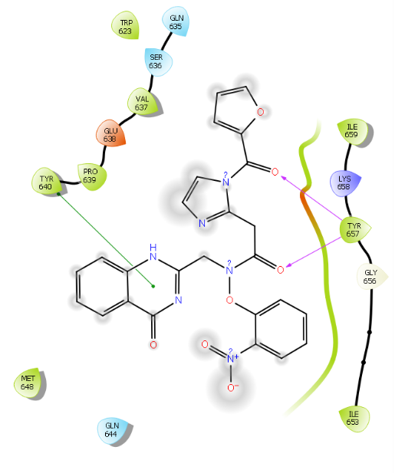
Figure 17. Fitting pose interactions of compound 3h in the pocket of 6NJS in 2D view.
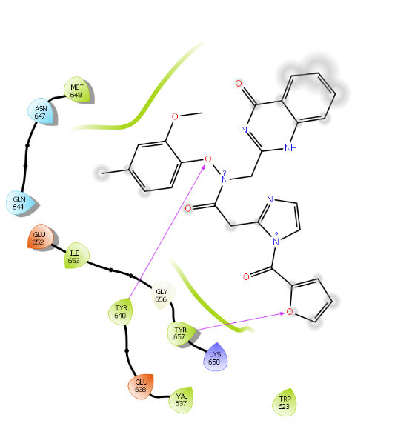
Figure 18. Fitting pose interactions of compound 3j in the pocket of 6NJS in 2D view.
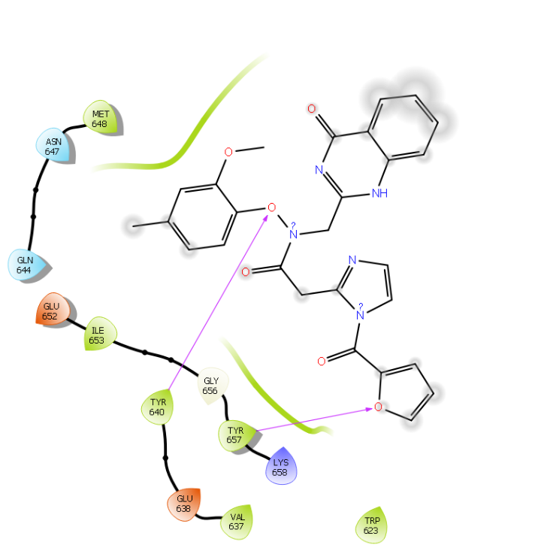
Figure 19. Fitting pose interactions of compound 3k in the pocket of 6NJS in 2D view.
Table 1. Compounds with PARP1 (PDB ID: 4ZZZ) (kcal/mol) have Gibbs (G) free energy of binding MM-GBSA.
Title | MMGBSA dG Bind | MMGBSA dG Bind Coulomb | MMGBSA dG Bind Covalent | MMGBSA dG Bind Hbond | MMGBSA dG Bind Lipo | MMGBSA dG Bin d Solv GB | MMGBSA dG Bind vdW
1d | -107. 03 | -41.60 | -3.51 | -0.44 | -24.24 | 23.39 | -71.58
1e | -108.21 | -51.65 | -0.59 | -1.93 | -24.01 | 32.10 | -57.11
1f | -115.89 | -34.53 | 2.29 | -1.85 | -18.18 | -3.40 | -63.08
1g | -101.34 | -46.86 | -19.30 | 0.99 | -15.01 | 8.68 | -40.85
1h | -101.67 | -40.41 | -10.14 | -1.25 | -11.71 | 25.72 | -44.96
1i | -114.31 | -39.14 | 5.76 | -1.35 | -22.54 | 58.18 | -62.94
1j | -100.91 | -42.97 | -7.63 | 0.36 | -15.88 | 6.00 | -48.25
1k | -107.94 | -49.04 | -13.92 | -1.48 | -13.37 | 6.71 | -52.76
1l | -103.77 | -44.25 | -1.23 | -0.61 | -18.97 | 39.32 | -69.00
1m | -104.10 | -47.08 | 4.55 | -3.09 | -22.05 | 53.05 | -66.94
2d | -94.86 | -36.54 | -2.28 | -2.04 | -18.54 | 38.22 | -59.98
2e | -98.52 | -47.61 | -0.86 | -0.86 | -15.67 | 26.41 | -44.54
2f | -107.77 | -44.15 | -1.90 | 0.57 | -13.85 | 35.88 | -53.74
2g | -105.79 | -41.71 | 3.92 | -2.26 | -21.13 | 27.54 | -72.54
2h | -103.77 | -44.25 | -1.23 | -0.61 | -18.97 | 39.32 | -69.00
2i | -112.31 | -45.18 | -6.74 | 0.55 | -21.79 | 2.69 | -58.76
2j | -79.33 | -33.84 | -2.79 | 0.61 | -18.90 | 28.70 | -50.74
2k | -119.11 | -46.37 | 1.22 | -0.36 | -19.63 | 34.62 | -60.61
2l | -100.19 | -32.80 | -5.62 | 1.07 | -12.58 | 26.15 | -53.94
2m | -104.10 | -47.08 | 4.55 | -3.09 | -22.05 | 53.05 | -66.94
3d | -99.64 | -36.50 | 3.02 | -0.54 | -10.91 | 15.38 | -46.41
3e | -106.93 | -50.71 | -2.32 | -2.29 | -11.16 | 18.35 | -42.40
3f | -103.96 | -37.78 | -5.48 | 0.68 | -17.69 | 32.55 | -58.19
3g | -107.90 | -32.73 | 1.56 | -2.20 | -17.92 | 32.82 | -58.12
3h | -115.23 | -43.54 | -8.18 | 0.30 | -25.11 | 29.42 | -73.29
3i | -99.15 | -42.43 | -13.67 | 1.02 | -10.23 | 5.05 | -48.84
3j | -111.61 | -53.95 | 1.63 | -2.36 | -20.87 | 12.66 | -58.93
3k | -102.49 | -36.97 | -5.57 | -2.48 | -19.88 | 18.00 | -57.36
3l | -107.94 | -49.04 | -13.92 | -1.48 | -13.37 | 6.71 | -52.76
3m | -103.77 | -44.25 | -1.23 | -0.61 | -18.97 | 39.32 | -69.00

Table 2. Compounds with STAT3 (PDB ID: 6NJS) (kcal/mol) have Gibbs (G) free energy of binding MM-GBSA.
Title | MMGBSA dG Bind | MMGBSA dG Bind Coulomb | MMGBSA dG Bind Covalent | MMGBSA dG Bind Hbond | MMGBSA dG Bind Lipo | MMGBSA dG Bind Solv GB | MMGBSA dG Bind vdW
1d | -79.90 | 6.64 | -3.51 | -0.44 | -24.24 | 23.39 | -71.58
1e | -66.13 | -4.38 | -0.59 | -1.93 | -24.01 | 32.10 | -57.11
1f | -89.38 | 5.34 | 2.29 | -1.85 | -18.18 | -3.40 | -63.08
1g | -69.64 | 6.42 | -19.30 | 0.99 | -15.01 | 8.68 | -40.85
1h | -79.81 | -28.21 | -10.14 | -1.25 | -11.71 | 25.72 | -44.96
1i | -73.74 | -42.55 | 5.76 | -1.35 | -22.54 | 58.18 | -62.94
1j | -67.42 | 3.96 | -7.63 | 0.36 | -15.88 | 6.00 | -48.25
1k | -82.92 | 0.63 | -13.92 | -1.48 | -13.37 | 6.71 | -52.76
1l | -71.93 | -14.30 | -1.23 | -0.61 | -18.97 | 39.32 | -69.00
1m | -81.86 | -35.43 | 4.55 | -3.09 | -22.05 | 53.05 | -66.94
2d | -79.60 | -22.70 | -2.28 | -2.04 | -18.54 | 38.22 | -59.98
2e | -67.24 | -23.16 | -0.86 | -0.86 | -15.67 | 26.41 | -44.54
2f | -75.71 | 7.89 | 2.37 | -2.05 | -19.98 | 4.11 | -60.29
2g | -78.46 | -1.60 | 3.92 | -2.26 | -21.13 | 27.54 | -72.54
2h | -71.93 | -14.30 | -1.23 | -0.61 | -18.97 | 39.32 | -69.00
2i | -72.50 | 20.56 | -6.74 | 0.55 | -21.79 | 2.69 | -58.76
2j | -46.31 | 19.18 | -4.10 | 1.76 | -19.09 | 7.32 | -43.19
2k | -83.45 | -30.57 | 1.22 | -0.36 | -19.63 | 34.62 | -60.61
2l | -69.34 | -15.57 | -5.62 | 1.07 | -12.58 | 26.15 | -53.94
2m | -81.86 | -35.43 | 4.55 | -3.09 | -22.05 | 53.05 | -66.94
3d | -76.55 | -28.16 | 3.02 | -0.54 | -10.91 | 15.38 | -46.41
3e | -87.42 | -39.78 | -2.32 | -2.29 | -11.16 | 18.35 | -42.40
3f | -71.36 | -14.85 | -2.29 | -0.71 | -21.23 | 33.27 | -56.05
3g | -65.26 | -10.19 | 1.56 | -2.20 | -17.92 | 32.82 | -58.12
3h | -85.46 | 0.90 | -8.18 | 0.30 | -25.11 | 29.42 | -73.29
3i | -69.56 | -13.18 | 7.98 | -0.51 | -16.15 | 23.39 | -62.16
3j | -76.90 | 1.64 | 1.63 | -2.36 | -20.87 | 12.66 | -58.93
3k | -81.33 | -2.76 | -5.57 | -2.48 | -19.88 | 18.00 | -57.36
3l | -82.92 | 0.63 | -13.92 | -1.48 | -13.37 | 6.71 | -52.76
3m | -71.93 | -14.30 | -1.23 | -0.61 | -18.97 | 39.32 | -69.00

Table 3. The details of the in-silico ADMET properties for the quinazolinone based derivatives
Title | MW | Donor HB | Acpt HB | Log P o/w | metab | % Human oral absorption | Rule of Five
1d | 479.49 | 1 | 11 | 2.689 | 3 | 83.987 | 0
1e | 513.93 | 1 | 11 | 2.813 | 3 | 76.706 | 1
1f | 524.49 | 1 | 12 | 1.900 | 4 | 84.996 | 2
1g | 493.52 | 1 | 11 | 3.050 | 4 | 96.355 | 0
1h | 431.450 | 1 | 11 | 1.902 | 4 | 87.074 | 0
1i | 523.54 | 1 | 11 | 2.672 | 5 | 78.751 | 1
1j | 461.47 | 1 | 11 | 2.045 | 5 | 84.874 | 0
1k | 433.42 | 2 | 11 | 0.815 | 4 | 66.535 | 0
1l | 467.48 | 1 | 11 | 2.518 | 3 | 88.358 | 0
1m | 519.51 | 1 | 11 | 3.128 | 4 | 76.688 | 1
2d | 469.45 | 1 | 11 | 2.353 | 4 | 91.978 | 0
2e | 499.48 | 1 | 12 | 2.207 | 5 | 77.298 | 1
2f | 462.42 | 1 | 12 | 0.842 | 4 | 83.667 | 1
2g | 483.48 | 1 | 11 | 2.457 | 5 | 86.277 | 0
2h | 467.48 | 1 | 11 | 2.518 | 3 | 88.358 | 0
2i | 445.47 | 1 | 11 | 1.617 | 5 | 83.150 | 0
2j | 473.53 | 1 | 11 | 2.607 | 5 | 87.581 | 0
2k | 535.60 | 1 | 11 | 4.189 | 5 | 90.287 | 1
2l | 485.45 | 2 | 12 | 1.587 | 5 | 60.700 | 1
2m | 519.51 | 1 | 11 | 3.128 | 4 | 76.688 | 1
3d | 417.42 | 1 | 11 | 1.498 | 3 | 82.949 | 0
3e | 447.44 | 1 | 11 | 1.756 | 4 | 83.277 | 0
3f | 503.90 | 1 | 11 | 1.944 | 4 | 70.653 | 1
3g | 514.45 | 1 | 12 | 1.442 | 5 | 80.390 | 2
3h | 497.50 | 1 | 11 | 2.263 | 6 | 88.192 | 0
3i | 445.47 | 1 | 11 | 1.617 | 5 | 83.150 | 0
3j | 513.50 | 1 | 12 | 2.504 | 6 | 66.092 | 2
3k | 525.56 | 1 | 11 | 2.686 | 6 | 74.197 | 1

