Supplementary Materials for “Mapping thermokarst lakes in different physical states on the central Tibetan Plateau”

- 5.2 Robustness of the proposed methods

5.2.2 Adapt to map lakes at a regional scale

Fig. S1 Location of the study site on the northern bank of the Chumarhe River and datasets. The Sentinel-2 image was acquired on (a) January 22, (b) April 27, (c) June 1, 2018 and (d) August 15, 2019, corresponding to the ice, ice-water mixture, low water level and high water level periods of thermokarst lakes, respectively. Sentinel-2 images are composed by the NIR, Red, and Green bands. (e) is the mask composed of rivers, mountain shadows and lakes with an area larger than 3 km². (f) is the masked Sentinel-2 image acquired on January 22, 2018.

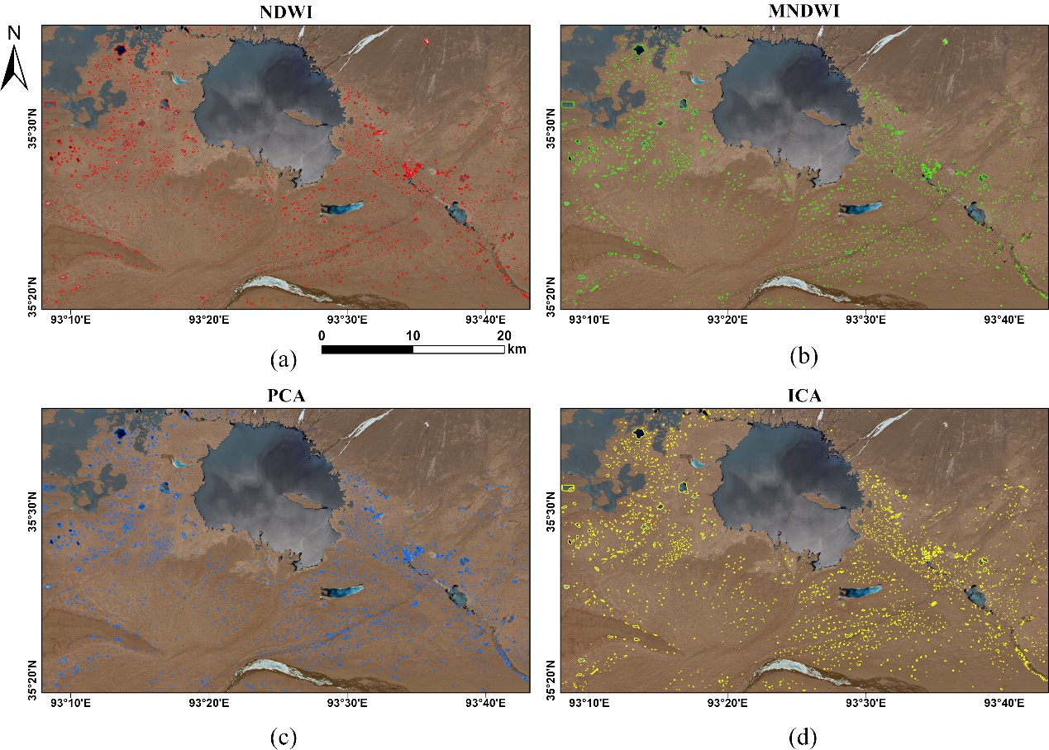
Fig. S2 Thermokarst lake mapping results on the northern bank of the Chumarhe River in ice-water mixture period. (a)–(d) Automatic results of NDWI-, MNDWI-, PCA-, and ICA-based MRF methods superimposed on the Sentinel-2 images acquired on April 27, 2018.
Fig. S3 Thermokarst lake mapping results on the northern bank of the Chumarhe River in low water level period. (a)–(d) Automatic results of NDWI-, MNDWI-, PCA-, and ICA-based MRF methods superimposed on the Sentinel-2 images acquired on June 1, 2018.

Fig. S4 Thermokarst lake mapping results on the northern bank of the Chumarhe River in high water level period. (a)–(d) Automatic results of NDWI-, MNDWI-, PCA-, and ICA-based MRF methods superimposed on the Sentinel-2 images acquired on August 15, 2019.

