Table S1: An overview of the SAR polarimetric parameters examined in this study.
Polarimetric parameters  (FP) | Description | Equation |  | Units
Span  HH, HV, VV  VV/HH  HV/HH  HV*HH, VV*HH  (CP) | Total power  Sigma naught (σ⁰) backscatter intensity  Co-polarization ratio  Cross-polarization ratio  Polarization multiplications | $$〈S_{HH}S_{HH}^{*}〉+ 〈S_{VV}S_{VV}^{*}〉+2〈S_{HV}S_{HV}^{*}〉$$  S = $\left[\begin{matrix}S_{HH} & S_{HV} \\ S_{VH} & S_{VV}\end{matrix}\right]$  $$σ_{VV/HH}^{0}$$  $$σ_{HV/HH}^{0}$$ |  | Power  Power  Power  Power  Power
S₀, S₁, S₂, S₃  RV, RH RR, RL  m  RR/RL  RV/RH  μ | Stokes vectors derived from the covariance matrix C  Sigma naught (σ⁰) backscatter intensity  Degree of polarization  Circular polarization ratio  Right co-polarized ratio  Conformity coefficient | $$C = \left[\begin{matrix}{\left|S_{HH}\right|}^{2} & \sqrt{2}S_{HH}S_{XX}^{*} & S_{HH}S_{VV}^{*} \\ \sqrt{2}S_{HH}^{*}S_{XX} & {\left|S_{XX}\right|}^{2} & \sqrt{2}S_{XX}S_{VV}^{*} \\ S_{HH}^{*}S_{VV} & \sqrt{2}S_{XX}^{*}S_{VV} & {\left|S_{VV}\right|}^{2}\end{matrix}\right]$$  m = $\frac{\sqrt{S_{1}^{2}+S_{2}^{2}+S_{3}^{2}}}{S_{0}}$  $$σ_{RR/RL}^{0}$$  $$σ_{RV/RH}^{0}$$  μ = $\frac{Re\left(S_{HH}S_{VV}^{*}\right)- {\left|S_{HV}\right|}^{2}}{({\left|S_{HH}\right|}^{2}+2 {\left|S_{HV}\right|}^{2}+{\left|S_{VV}\right|}^{2}}$ |  | Power  Power  Unitless  Power  Power  Unitless
$$α_{s}$$ | Alpha scattering angle | $α_{s}$ = $\frac{1}{2} \tan^{-1}\left(\frac{\sqrt{S_{1}^{2}+S_{2}^{2}}}{±S_{3}}\right)$ |  | Radians
mχ_{d} | mχ decomposition even bounce component | $$mχ_{d}= \sqrt{\frac{mS_{0 }(1+\sin{2χ)}}{2}}$$ |  | Power
mχ_{v}  mχ_{s} | mχ decomposition volumetric component  mχ decomposition odd bounce component | $$mχ_{v}= \sqrt{S_{0 }(1-m)}$$  $mχ_{s}= \sqrt{\frac{mS_{0}(1- \sin{2χ)}}{2}}$ |  | Power  Power

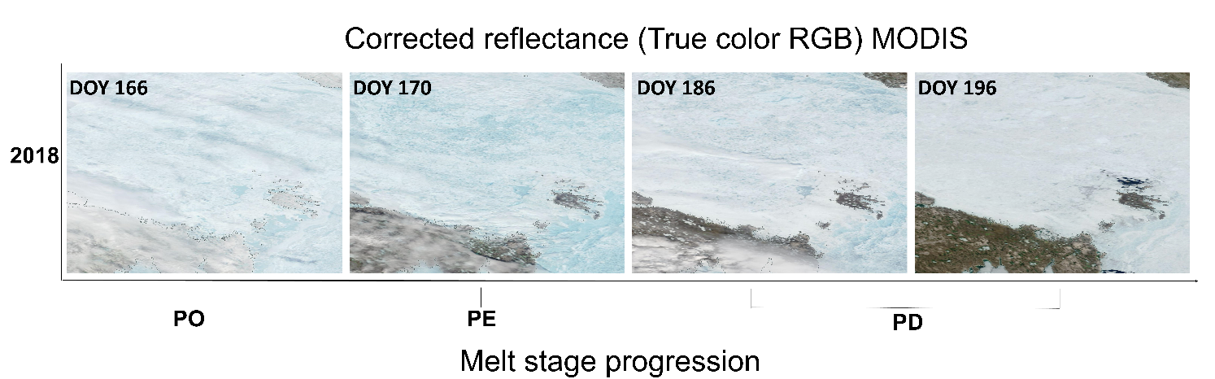
Figure S1: Moderate Resolution Imaging Spectroradiometer (MODIS) corrected reflectance, true color timeseries of the advanced melt sub-stage evolution, for 2018 over M’Clintock Channel. The seasonal stages shown are Pond Onset (PO), Pond Evolution (PE) and Pond Drainage (PD).

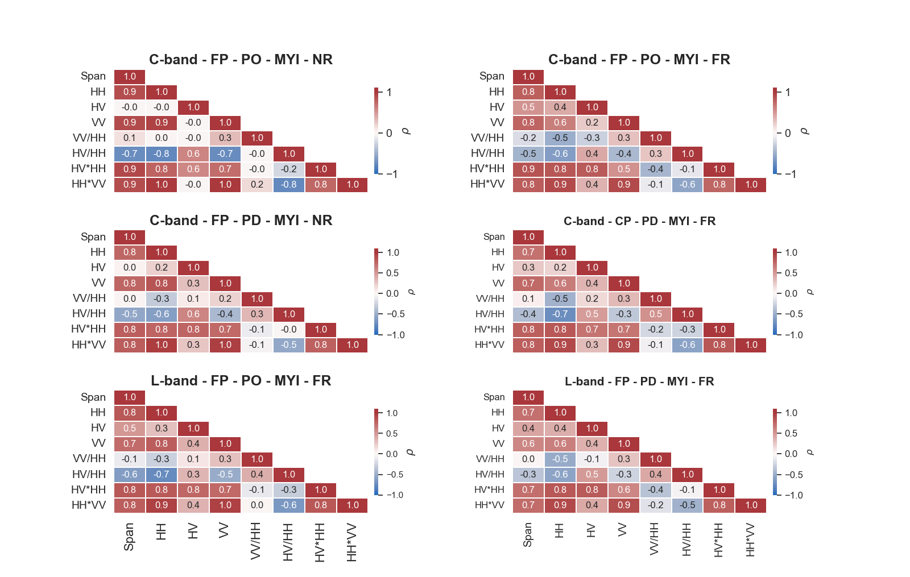

Figure S2: Spearman’s correlation matrices for the MYI FP mode. The heatmaps represent the correlation matrices from pond onset (PO) and pond drainage (PD) substages for each polarimetric parameter at C- and L-band. The effect of incidence angle is examined for the near and far range (NR, FR).

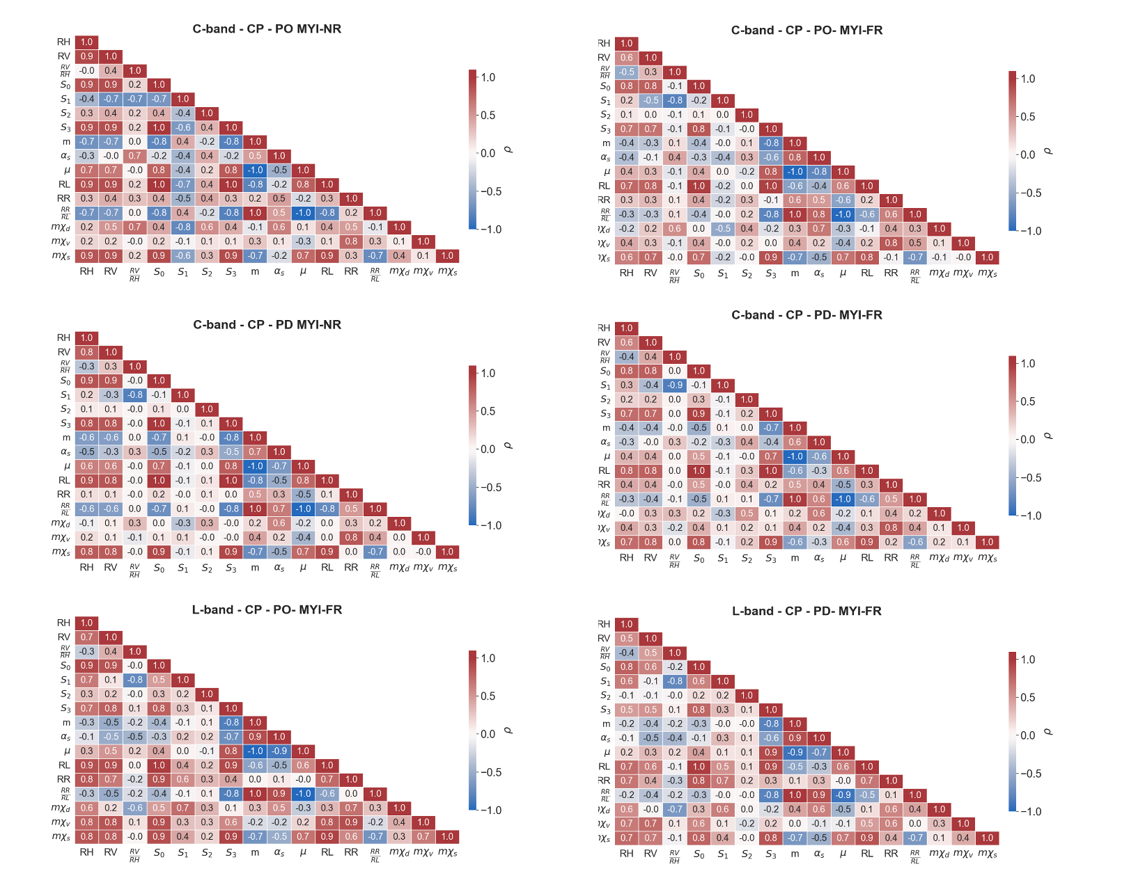
Figure S3: Spearman’s correlation matrices for the MYI CP mode. The heatmaps represent the correlation matrices from pond onset (PO) and pond drainage (PD) substages for each polarimetric parameter at C- and L-band. The effect of incidence angle is examined for the near and far range (NR, FR).

