Wintering and migration strategies of Slavonian Grebes Podiceps auritus breeding in Iceland

Thorkell Lindberg Thórarinsson¹, Benjamin Merkel², Adalsteinn Orn Snaethórsson¹ and Yann Kolbeinsson¹

¹Northeast Iceland Nature Research Centre, Hafnarstétt 3, 640 Húsavík, Iceland
²Akvaplan - niva AS, Fram Centre, NO - 9296 Tromsø, Norway
Corresponding author: E-mail: lindi@nna.is

Supplementary material

Figure S1. Individual wintering areas of 19 Slavonian Grebes nesting in Iceland (Azimuthal Equidistant projection centred on 60°N and 9°W). All shapes depict individual 75% kernel contours during mid-Winter (December and January). Different colours illustrate different individuals. Data from each winter 2009 – 2013 are shown on separate maps. Yellow diamonds show breeding sites, Lake Víkingavatn and Lake Ástjorn.

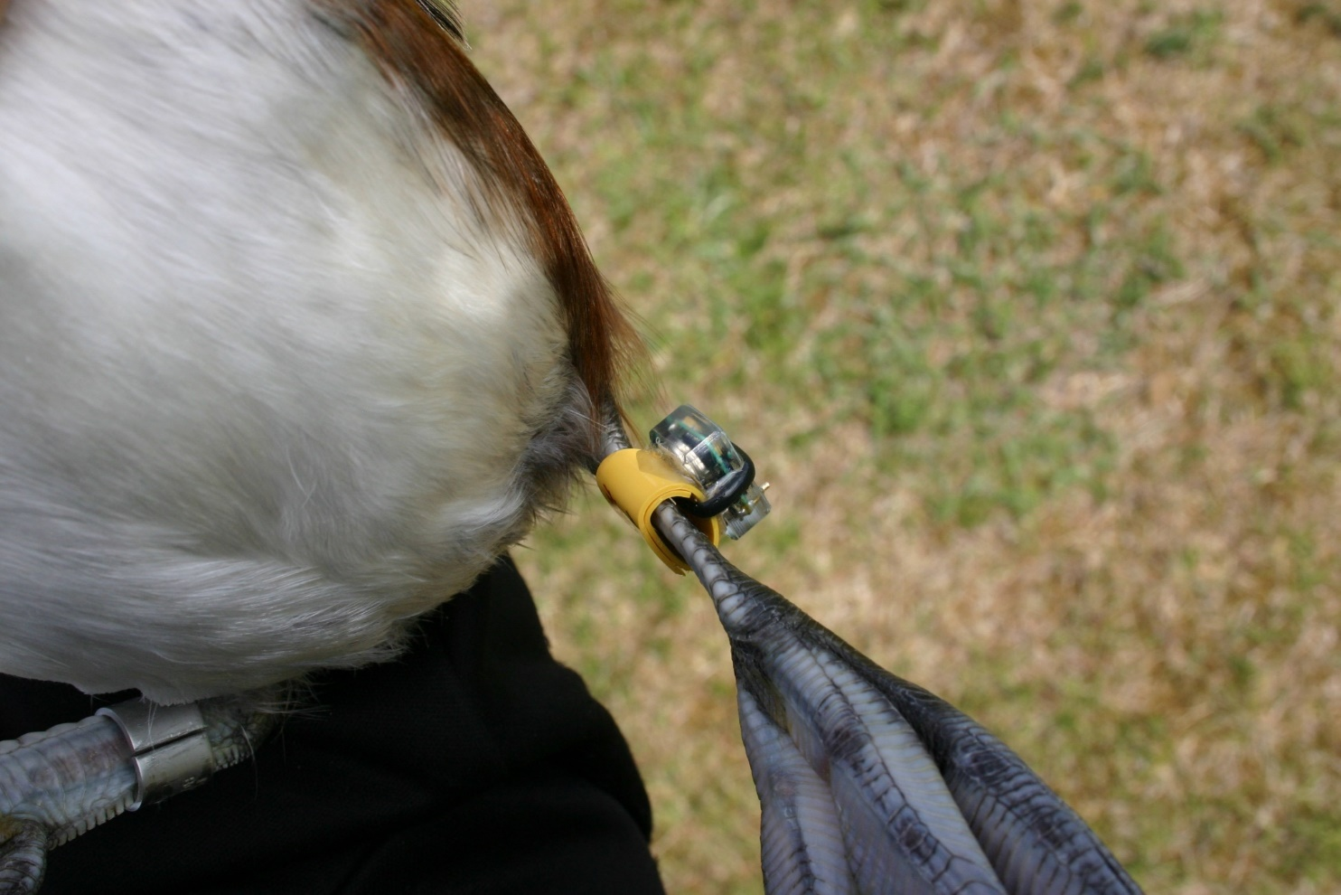
Figure S2. Geolocator (British Antarctic Survey Mk18) attached to a darvic ring with a cable tie and epoxy glue, attached to the tarsus of a Slavonian Grebe. Epoxy glue creates a seat for the Geolocator on the partially oval shaped darvic ring. A cable tie also keeps the Geolocator attached to the darvic ring. A numbered metal ring attached to the tarsus of the other leg.

