Appendix
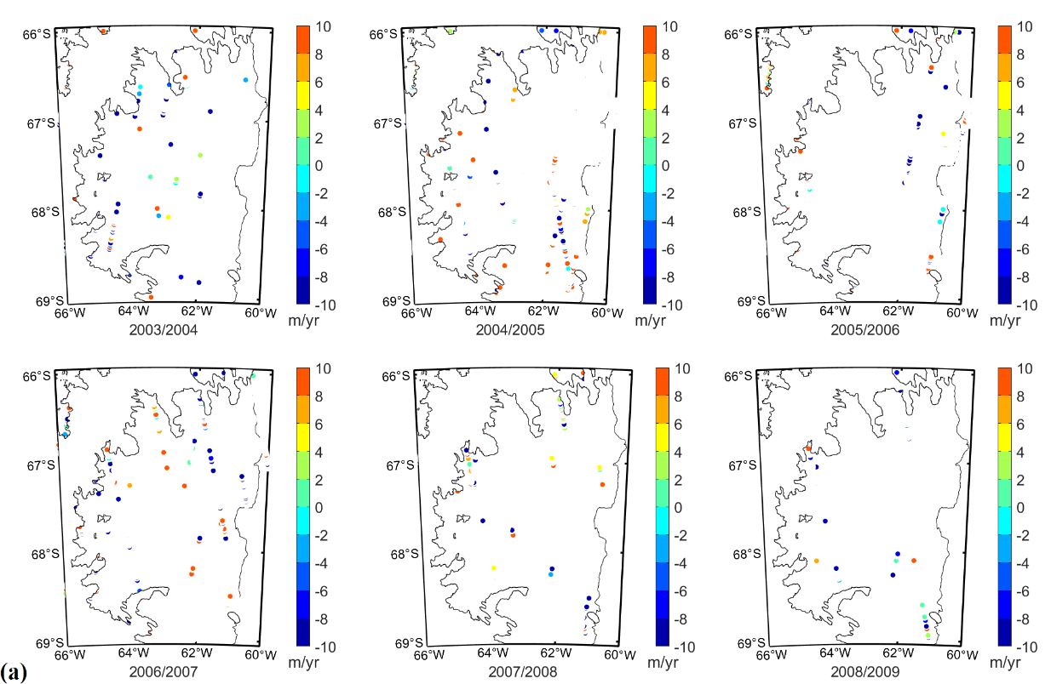
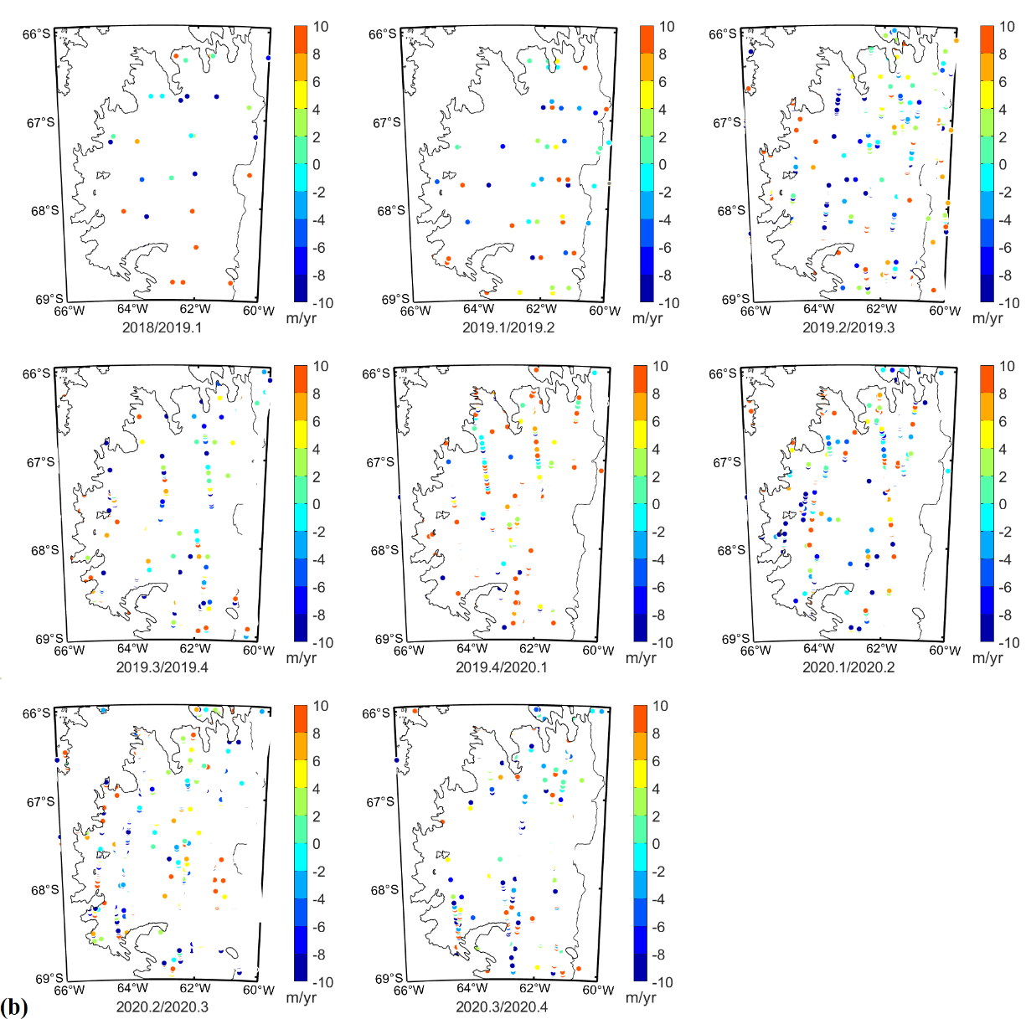
Figure S1. The basal melt rate of LIS was calculated from ICESat altimetry data; (a).Annual basal melt rate was calculated from ICESat-1 altimetry data from 2003 to 2009; (b). Seasonal basal melt rate was calculated from ICESat-2 altimetry data from 2018 to 2020.
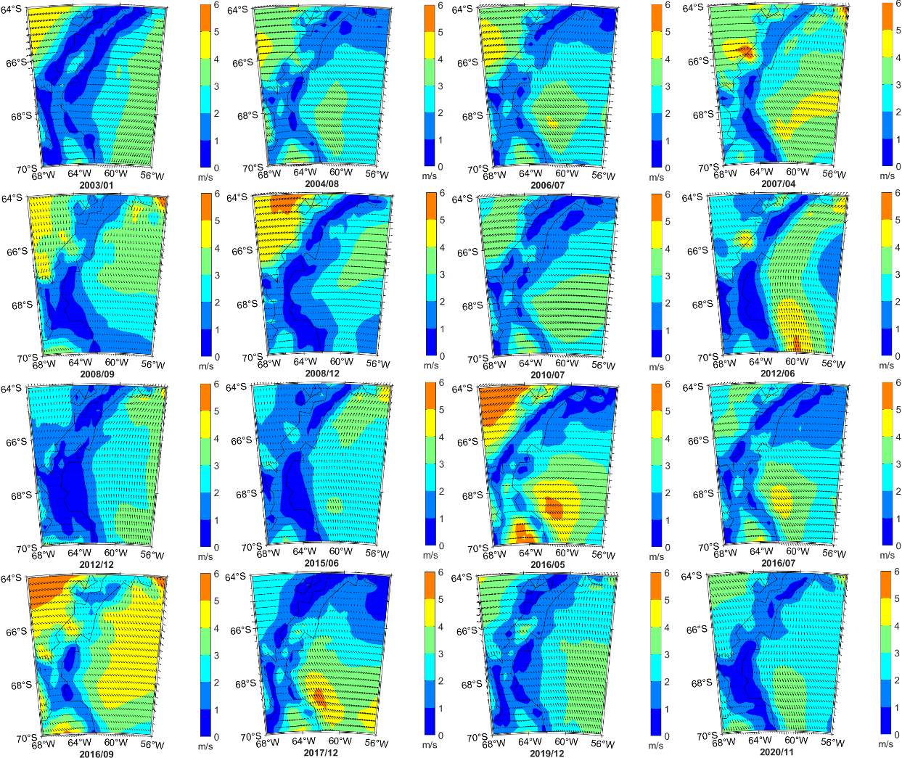
Figure S2. Abnormal monthly wind field around the LIS from 2003 to 2020, and the wind field data was ERA5 10m wind field data provided by European Centre for Medium Range Weather Forecasts (ECMWF).
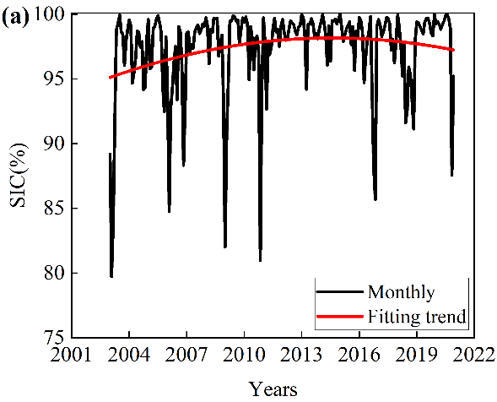 | 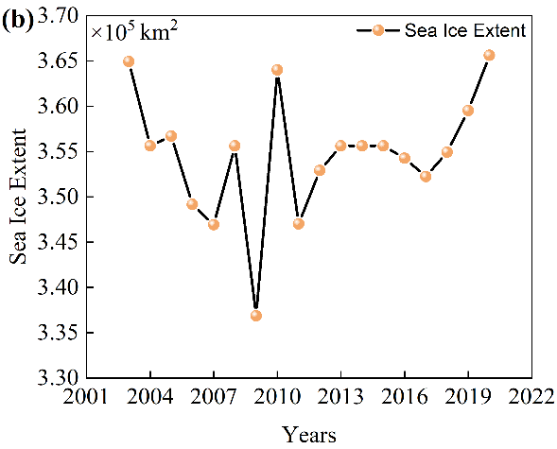
Figure S3. Sea ice concentrations and sea ice extent change in certain area in the front of LIS from 2003 to 2020. The sea ice concentrations was the version 4 data provided by NOAA/NSIDC (Meier et al. 2021), and the sea ice extent was calculated based on the sea ice concentrations. (a). Monthly average and fitted trend of sea ice concentration within the region (longitude(56W:60W), latitude(66S:69S)); (b). Annual average of sea ice extent within the region (longitude(50W:60.5W), latitude(64S:72S)).
Figure S4. (a). Grounding-line migration along LIS; (b) - (f). spatial extent of GLL change across the regions labelled in (a).

