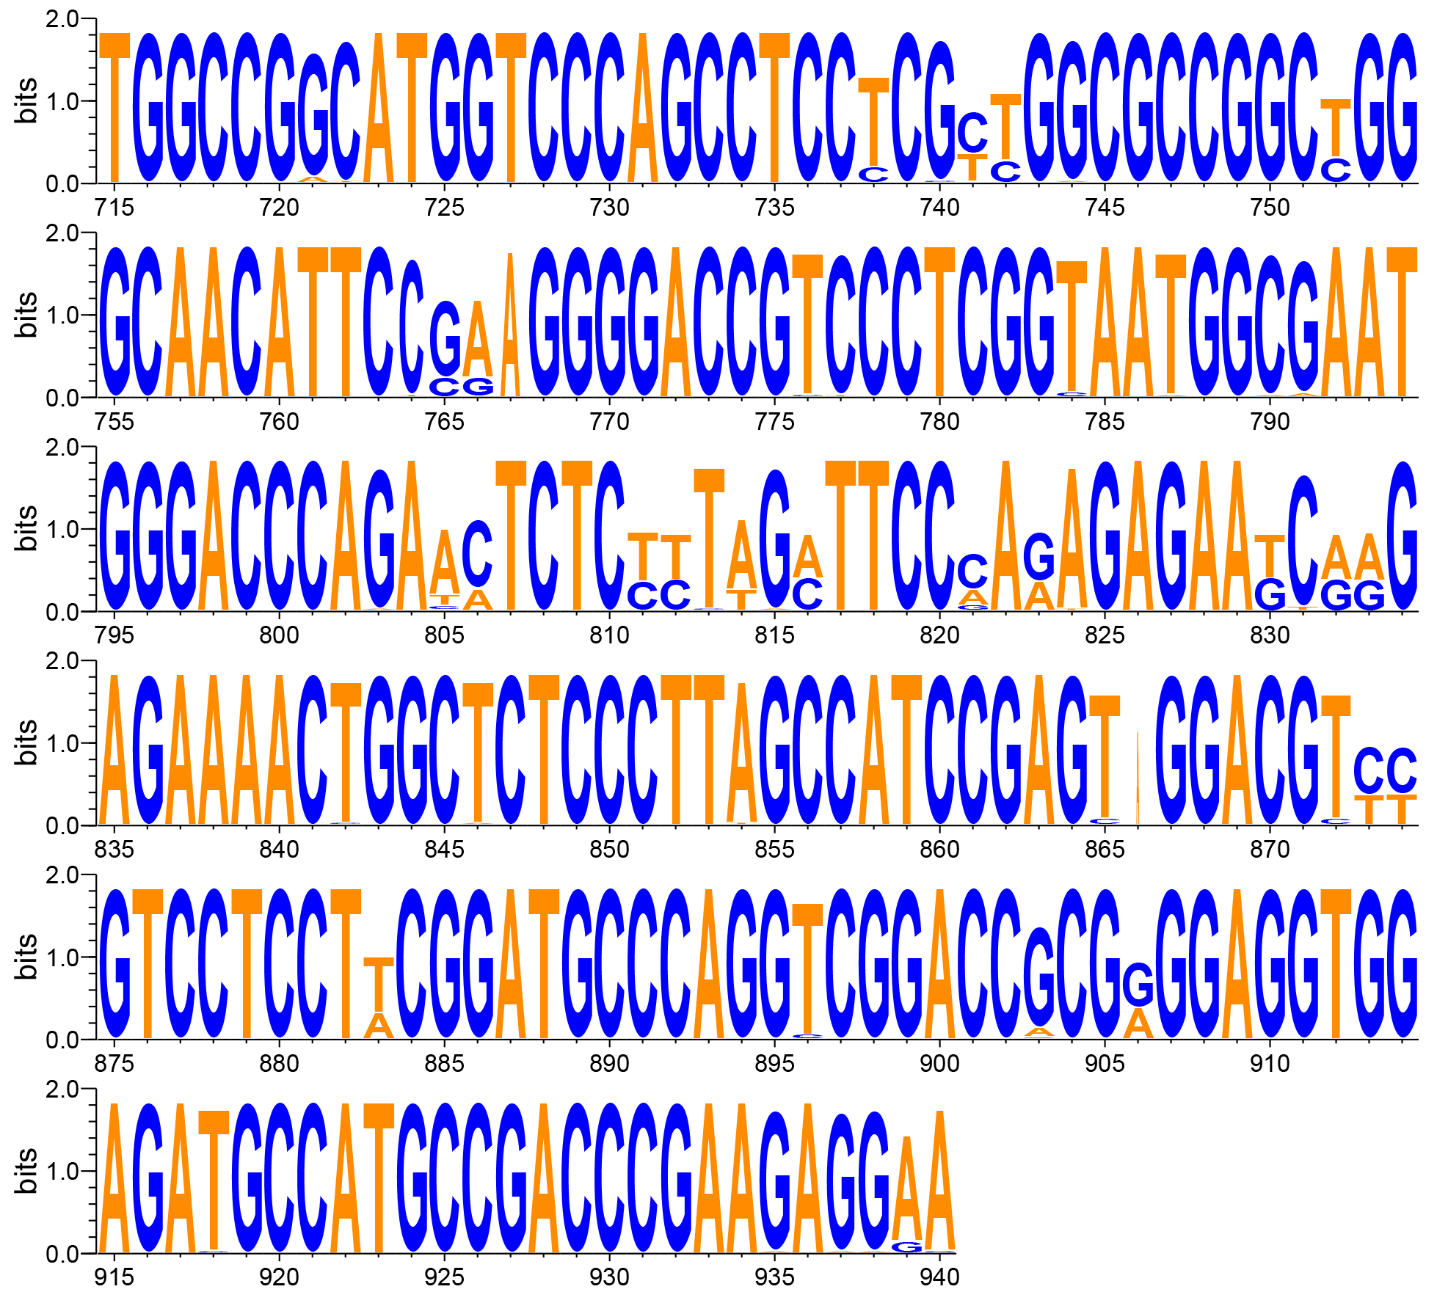

Figure S1. Conservative region analysis of HDV genome sequence. Alignments of relatively conservative position (715-940) of HDV 1-8 genotype are shown. All RT-PCR, RT-RAA primer pairs and crRNAs are screening in this position.

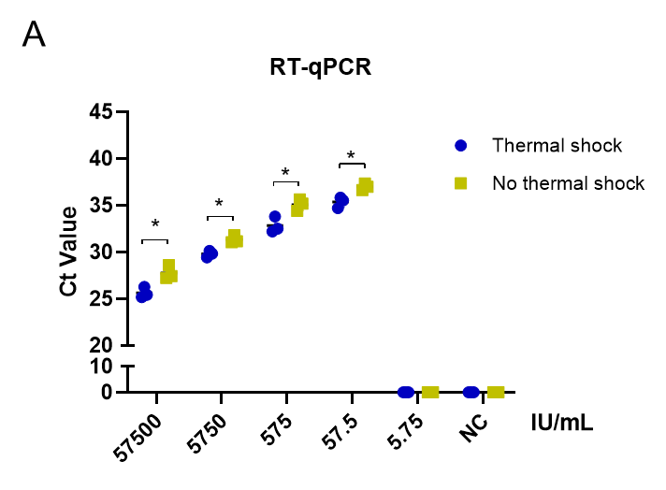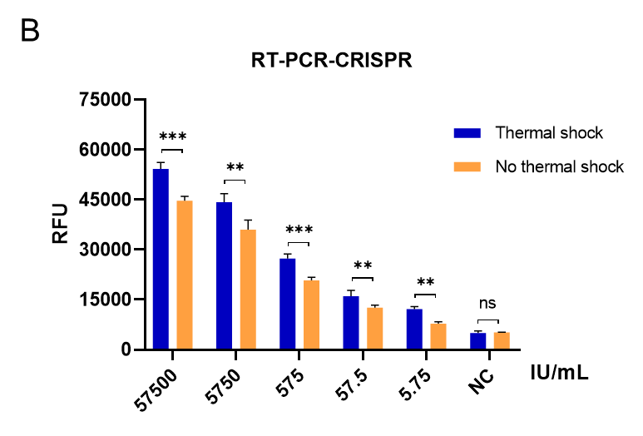
Figure S2. Comparison of the sensitivity of RT-qPCR and RT-PCR-CRISPR methods for the detection of WHO-HDV-IS. A. Ct values of RT‒qPCR for WHO-HDV-IS serial dilutions with and without thermal shock. B. Fluorescence values of RT‒PCR-CRISPR for WHO-HDV-IS serial dilutions with and without thermal shock at 60 min. Data are mean ± s.d. from triplicate measurements. WHO-HDV-IS, World Health Organization-HDV international standard. RFU, relative fluorescence units. NC, negative controls. *: p < 0.05, **: p < 0.01, ***: p < 0.001.

Supplementary Table1. Sequences and positions of HDV RT-PCR and RT-RAA primers.
name | Sequences | positions
RT-PCR-F1 | 5’-CTCGGTAATGGCGAATGGGA-3’ | 752-770
RT-PCR-R1 | 5’-GTCTCGCGTCCTTCTTTCCT-3’ | 926-907
RT-PCR-F2 | 5’-GTAATGGCGAATGGGACCCA-3’ | 756-775
RT-PCR-R2 | 5’-TTCTTTCCTCTTCGGGTCGG-3’ | 915-896
RT-PCR-F3 | 5’-GCGAATGGGACCCAGAACTC-3’ | 762-781
RT-PCR-R3 | 5’-CGTCCTTCTTTCCTCTTCGGG-3’ | 920-900
RT-RAA-F1 | 5’-TGGCCGGCATGGTCCCAGCCTCCTCGCTGG-3’ | 687-716
RT-RAA-R1 | 5’-GTCCACTCGGATGGCTAAGGGAGAGCCAGT-3’ | 841-812
RT-RAA-F2 | 5’-GCCGGCATGGTCCCAGCCTCCTCGCTGGCG-3’ | 689-718
RT-RAA-R2 | 5’-GGACGTCCACTCGGATGGCTAAGGGAGAGC-3’ | 845-816
RT-RAA-F3 | 5’-GGCATGGTCCCAGCCTCCTCGCTGGCGCCG-3’ | 692-721
RT-RAA-R3 | 5’-ACGGACGTCCACTCGGATGGCTAAGGGAGA-3’ | 847-818

Supplementary Table2. RT-PCR-CRISPR and RT-RAA-CRISPR related crRNA sequences.
name | Sequences
RT-PCR-crRNA1 | GGGAUUUAGACUACCCCAAAAACGAAGGGGACUAAAACUccacUcggaUggcUaagggagagccag
RT-PCR-crRNA2 | GGGAUUUAGACUACCCCAAAAACGAAGGGGACUAAAACacUcggaUggcUaagggagagccagUUU
RT-PCR-crRNA3 | GGGAUUUAGACUACCCCAAAAACGAAGGGGACUAAAACUcggaUggcUaagggagagccagUUUUc
RT-PCR-crRNA4 | GGGAUUUAGACUACCCCAAAAACGAAGGGGACUAAAACggaUggcUaagggagagccagUUUUcUc
RT-RAA-crRNA1 | GGGAUUUAGACUACCCCAAAAACGAAGGGGACUAAAACGAGGGACGGUCCCCUUCGGAAUGUUGCC
RT-RAA-crRNA2 | GGGAUUUAGACUACCCCAAAAACGAAGGGGACUAAAACGGGACGGUCCCCUUCGGAAUGUUGCCCA
RT-RAA-crRNA3 | GGGAUUUAGACUACCCCAAAAACGAAGGGGACUAAAACAGAGAGUUCUGGGUCCCAUUCGCCAUUA
RT-RAA-crRNA4 | GGGAUUUAGACUACCCCAAAAACGAAGGGGACUAAAACAAAGAGAGUUCUGGGUCCCAUUCGCCAU

Supplementary Table 3. Results of clinical patient plasma samples
Sample Number | HBV DNA (IU/mL) | Anti-HDV IgG | Anti-HDV IgM | HDV-RNA
 |  |  |  | RT-qPCR  (Ct value) | RT-ddPCR (copies/μL) | RT-PCR- CRISPR | RT-RAA- CRISPR
1 | 5.22E+03 | + | + | 30.28 | 936.2 | + | +
2 | 3.39E+06 | + | + | 23.72 | 8567.4 | + | +
3 | 6.38E+04 | + | - | 35.39 | 0 | + | -
4 | 2.43E+05 | + | + | 25.84 | 4301.5 | + | +
5 | 7.15E+05 | + | + | undetectable | 0 | - | -
6 | 4.82E+04 | + | + | 30.37 | 2428.6 | + | +
7 | 5.96E+03 | + | - | undetectable | 62.5 | + | +
8 | 6.43E+04 | + | + | 29.25 | 463.7 | + | +
9 | 1.55E+06 | + | - | undetectable | 0 | - | +
10 | 7.44E+05 | + | + | 24.61 | 3472.9 | + | +
11 | 3.62E+07 | + | + | 28.39 | 1038.8 | + | +
12 | 2.76E+06 | + | - | 37.35 | 0 | + | -
13 | 8.51E+04 | + | + | 24.73 | 4621.9 | + | +
14 | 3.72E+07 | + | + | 22.94 | 52717.2 | + | +
15 | 8.42E+04 | + | - | 32.6 | 153.8 | + | +
16 | 2.26E+03 | + | + | undetectable | 0 | - | -
17 | 1.42E+06 | + | + | undetectable | 428.5 | + | -
18 | 6.45E+05 | + | + | 27.1 | 5391.5 | + | +
19 | 6.70E+06 | + | - | undetectable | 42.6 | + | -
20 | 7.49E+06 | + | - | 32.6 | 749.5 | + | +
21 | 2.84E+03 | + | - | undetectable | 0 | - | -
22 | 3.32E+05 | + | + | 28.31 | 638.3 | + | +
23 | 3.13E+04 | + | - | undetectable | 0 | - | -
24 | 2.43E+07 | + | + | 26.49 | 2674.8 | + | +
25 | 8.52E+03 | + | + | undetectable | 0 | - | -
26 | 4.47E+05 | + | - | 35.7 | 85.4 | + | +
27 | 2.73E+04 | + | + | 32.1 | 0 | + | +
28 | 4.16E+06 | + | - | 34.5 | 537.2 | + | +
29 | 1.84E+05 | + | + | 26.17 | 6836.5 | + | +
30 | 3.44E+06 | + | + | 32.8 | 471.3 | + | +
31 | 5.29E+03 | + | + | undetectable | 0 | - | -
32 | 8.26E+06 | + | + | 26.7 | 5049.6 | + | +
33 | 1.72E+06 | + | - | undetectable | 592.5 | + | +
34 | 4.74E+05 | + | - | 31.83 | 742.9 | + | +
35 | 7.94E+05 | + | + | 29.4 | 623.2 | + | +
36 | 1.26E+07 | + | + | 25.58 | 3592.4 | + | +
37 | 1.6E+08 | + | + | 31.64 | 836 | + | +
38 | 3.35E+05 | + | - | 34.73 | 51.9 | + | +
39 | 2.52E+09 | + | + | 28.49 | 1346.8 | + | +
40 | 3.72E+05 | + | + | 27.39 | 3791 | + | +
41 | 7.28E+04 | + | + | undetectable | 0 | - | -
42 | 8.37E+07 | + | + | 25.74 | 6721.8 | + | +
43 | 6.41E+05 | + | + | undetectable | 415 | + | -
44 | 9.03E+06 | + | - | 35.48 | 426.7 | + | +
45 | 5.65E+05 | + | - | undetectable | 53.4 | - | -
46 | 2.49E+06 | + | - | 32.62 | 271 | + | +
47 | 4.36E+06 | + | + | 34.76 | 0 | + | +
48 | 3.75E+06 | + | + | undetectable | 0 | - | -
49 | 5.27E+05 | + | + | 29.5 | 853.4 | + | +
50 | 4.98E+06 | + | - | 31.84 | 572.4 | + | +
51 | 2.82E+03 | + | - | undetectable | 0 | - | -
52 | 1.76E+05 | + | + | 24.17 | 7387.2 | + | +
53 | 4.57E+06 | + | + | 28.39 | 941.7 | + | +
54 | 7.42E+05 | + | + | undetectable | 535.4 | + | +
55 | 8.81E+04 | + | - | undetectable | 34.8 | - | -
56 | 3.26E+06 | + | + | 26.47 | 3487.9 | + | +
57 | 5.42E+07 | + | + | 28.36 | 6271.8 | + | +
58 | 4.45E+03 | + | + | undetectable | 623.4 | + | +
59 | 6.70E+06 | + | + | undetectable | 0 | + | -
60 | 5.49E+06 | + | + | 32.46 | 318.5 | + | +
61 | 1.89E+05 | + | - | undetectable | 0 | - | -
62 | 2.37E+05 | + | + | 28.16 | 4721 | + | +
63 | 2.71E+06 | + | + | 29.41 | 3221.9 | + | +
64 | 8.43E+07 | + | + | 27.29 | 5278.4 | + | +
65 | 2.55E+04 | + | + | undetectable | 321.6 | + | -
66 | 2.48E+07 | + | + | 26.85 | 7328 | + | +
67 | 4.72E+06 | + | - | 35.74 | 638.3 | + | +
68 | 3.6E+06 | + | + | 25.9 | 5913.7 | + | +
69 | 3.18E+05 | + | - | undetectable | 0 | + | -
70 | 7.45E+06 | + | + | 28.43 | 932.6 | + | +
71 | 6.24E+05 | + | + | undetectable | 371 | + | +
72 | 1.52E+04 | + | + | 27.48 | 4261.5 | + | +
73 | 4.72E+06 | + | + | 27.13 | 6139.2 | + | +
74 | 2.74E+07 | + | + | 26.29 | 9371.3 | + | +
75 | 1.95E+05 | + | + | undetectable | 251.8 | + | +
76 | 4.26E+06 | + | + | undetectable | 0 | + | -
77 | 1.62E+06 | + | + | 34.7 | 249.6 | + | +
78 | 3.53E+05 | + | - | undetectable | 0 | - | -
79 | 2.82E+05 | + | + | 23.7 | 5384.7 | + | +
80 | 3.76E+05 | + | + | 28.68 | 4326.8 | + | +
81 | 1.28E+04 | + | + | 29.54 | 2366.8 | + | +
82 | 4.35E+05 | + | + | undetectable | 563.3 | + | -
83 | 3.41E+07 | + | + | 28.3 | 3527 | + | +
84 | 4.01E+06 | + | - | 36.52 | 447.9 | + | +
85 | 5.3E+06 | + | + | 23.31 | 6825.7 | + | +
86 | 2.49E+06 | + | - | undetectable | 0 | + | -
87 | 4.16E+07 | + | + | 26.85 | 1748.9 | + | +
88 | 3.45E+04 | + | + | undetectable | 463 | + | +
89 | 1.92E+06 | + | + | 28.54 | 3516.5 | + | +
90 | 1.98E+05 | + | + | 31.43 | 712.4 | + | +
91 | 2.74E+08 | + | + | 25.7 | 5328.3 | + | +
92 | 3.52E+05 | + | - | 36.9 | 0 | + | -
93 | 8.17E+06 | + | + | 24.73 | 4662.8 | + | +
94 | 3.46E+05 | + | + | undetectable | 0 | - | -
95 | 8.41E+04 | + | + | 31.67 | 442.9 | + | +
96 | 3.26E+05 | + | - | undetectable | 47.2 | + | +
97 | 9.42E+04 | + | + | 26.94 | 3165.6 | + | +
98 | 1.45E+07 | + | - | undetectable | 0 | - | +
99 | 2.73E+06 | + | + | 25.94 | 4721.9 | + | +
100 | 8.45E+07 | + | + | 28.41 | 3238.8 | + | +
101 | 1.84E+05 | + | - | 33.75 | 0 | + | -
102 | 3.38E+05 | + | + | 23.47 | 2649.9 | + | +
103 | 5.73E+04 | + | + | 24.57 | 1271.2 | + | +
104 | 6.43E+05 | + | - | 34.6 | 423.8 | + | +
105 | 6.57E+06 | + | + | undetectable | 0 | - | -
106 | 7.48E+05 | + | + | undetectable | 46.5 | + | -
107 | 1.72E+07 | + | + | 29.3 | 626.5 | + | +
108 | 3.12E+05 | + | - | undetectable | 73.1 | + | -
109 | 8.28E+05 | + | - | 33.82 | 527.5 | + | +
110 | 3.44E+04 | + | - | undetectable | 0 | - | -
111 | 2.36E+07 | + | + | 29.51 | 1657.7 | + | +
112 | 5.56E+06 | + | - | undetectable | 0 | - | -
113 | 2.72E+06 | + | + | 25.4 | 2628.5 | + | +
114 | 1.76E+05 | + | + | undetectable | 0 | - | -
115 | 7.94E+06 | + | - | 36.8 | 62.4 | + | +
116 | 5.21E+06 | + | + | 32.7 | 0 | + | +
117 | 2.63E+03 | + | - | 33.2 | 525.2 | + | +
118 | 3.93E+07 | + | + | 24.84 | 5573.5 | + | +
119 | 6.52E+05 | + | + | 31.5 | 692.3 | + | +
120 | 3.47E+02 | + | + | undetectable | 0 | - | -
121 | 7.28E+04 | + | + | 25.8 | 4217.6 | + | +
122 | 8.27E+04 | + | - | undetectable | 72.2 | + | +
123 | 5.48E+05 | + | - | 35.6 | 832.9 | + | +
124 | 2.13E+07 | + | + | 26.2 | 2463.2 | + | +
125 | 5.75E+06 | + | + | 24.19 | 6212.4 | + | +
126 | 1.42E+06 | + | + | 33.4 | 712 | + | +
127 | 2.36E+04 | + | - | 36.1 | 62.7 | + | +
128 | 3.75E+06 | + | + | 29.5 | 3184.2 | + | +
129 | 1.42E+07 | + | + | 26.4 | 4291 | + | +
130 | 2.91E+06 | + | + | undetectable | 0 | - | -
131 | 4.27E+07 | + | + | 27.3 | 5214.8 | + | +
132 | 3.56E+04 | + | + | undetectable | 31.7 | + | -
133 | 1.97E+06 | + | - | 37.3 | 52.6 | + | +
134 | 7.41E+05 | + | - | undetectable | 23.8 | - | -
135 | 3.42E+05 | + | - | 31.5 | 526.7 | + | +
136 | 8.26E+05 | + | + | 32.4 | 0 | + | +
137 | 6.41E+03 | + | + | undetectable | 0 | - | -
138 | 2.83E+07 | + | + | 27.3 | 5257.8 | + | +
139 | 3.75E+06 | + | - | 34.6 | 268.4 | + | +
140 | 5.49E+03 | + | - | undetectable | 0 | - | -
141 | 1.82E+04 | + | + | 31.75 | 426.2 | + | +
142 | 2.37E+05 | + | + | 27.46 | 527.9 | + | +
143 | 6.13E+05 | + | + | undetectable | 142.4 | + | +
144 | 4.82E+03 | + | - | undetectable | 22.5 | - | -
145 | 1.55E+04 |  | - | 0 | 0 | - | -
146 | 7.44E+03 |  | - | 0 | 0 | - | -
147 | 4.72E+02 |  | - | 0 | 0 | - | -
148 | 5.19E+03 |  | - | 0 | 0 | - | -
149 | 3.85E+02 |  | - | 0 | 0 | - | -
150 | 6.41E+04 |  | - | 0 | 0 | - | -
151 | 4.84E+03 |  | - | 0 | 0 | -
152 | 2.42E+05 |  | - | 0 | 0 | - | --
153 | 1.58E+04 |  | - | 0 | 0 | - | -
154 | 5.73E+03 |  | - | 0 | 0 | - | -

Supplementary Table 4. Results of clinical patient plasma samples with HBsAg positive and HDV-IgG negative
 | Sample Number | HDV-RNA
 |  | RT-qPCR  (Ct value) | RT-ddPCR (copies/μL) | RT-PCR- CRISPR | RT-RAA- CRISPR
HBsAg Positive | 1 | 34.25 | 274.2 | + | +
 | 2 | 31.46 | 436.6 | + | +
 | 3 | 22.37 | 3218.5 | + | +
 | 4 | 32.64 | 639.4 | + | +
 | 5 | 24.18 | 2536.9 | + | +
Anti-HDV  negative | 6 | undetectable | 0 | - | -
 | 7 | undetectable | 0 | - | -
 | 8 | undetectable | 0 | - | -
 | 9 | undetectable | 0 | - | -
 | 10 | undetectable | 0 | - | -
`

