Supplementary material

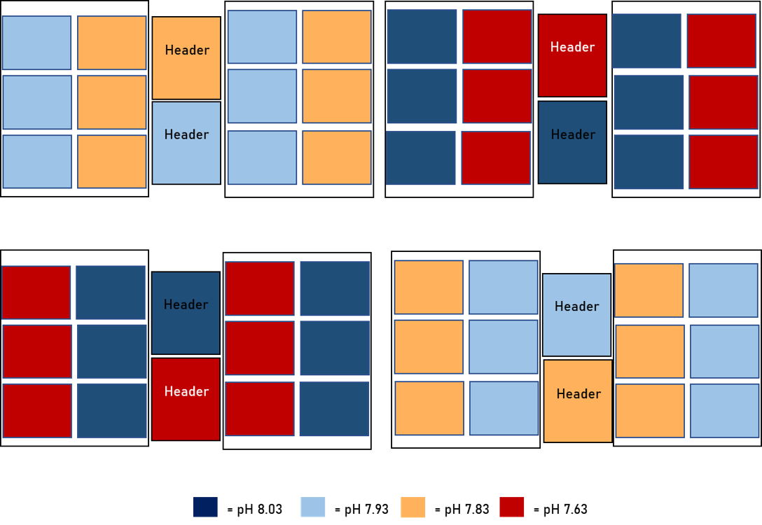
Figure S1. Schematic overview of the experimental setup. Color code for pH is used in figures throughout the text.

Table S2. The six timepoints in a 24-hour cycle in which pH changed in the experiment to mimic the natural pH variability in the kelp forest from where the seawater supply in the lab comes from. The table below is an example for pH 8.03 and the same is applied for all pH treatments except that pH variability will be different in each timepoint for other pH treatments.
CO₂  Fallback OFF  If Time 00:00 to 04:00 (Timepoint 1) Then ON  If pH_8 < 7.83 Then OFF  If Time 04:00 to 08:00 (Timepoint 2) Then OFF  If pH_8 > 7.93 Then ON  If Time 08:00 to 12:00 (Timepoint 3) Then OFF  If pH_8 > 8.03 Then ON  If Time 12:00 to 16:00 (Timepoint 4) Then OFF  If pH_8 > 8.23 Then ON  If Time 16:00 to 20:00 (Timepoint 5) Then ON  If pH_8 < 8.13 Then OFF  If Time 20:00 to 00:00 (Timepoint 6) Then ON  If pH_8 < 8.03 Then OFF | Air  Fallback OFF  If Time 00:00 to 04:00 Then OFF  If pH_8 < 7.63 Then ON  If Time 04:00 to 08:00 Then ON  If pH_8 > 7.73 Then OFF  If Time 08:00 to 12:00 Then ON  If pH_8 > 7.83 Then OFF  If Time 12:00 to 16:00 Then ON  If pH_8 > 8.03 Then OFF  If Time 16:00 to 20:00 Then ON  If pH_8 > 7.93 Then OFF  If Time 20:00 to 00:00 Then ON  If pH_8 > 7.83 Then OFF

Table S3. Summary of P values, standard error of the mean (SEM), and degrees of freedom (d.f.) between treatments for all measured responses during the experiment analysed using linear mixed effects models, with water bath as random factor. Bold values with asterisks indicate statistically significant P values (P < 0.05), while bold values indicate marginal statistical significance (P > 0.05).

 |  | C. brownii |  |  |  |  | C. geminata
Response | pH | Mean (± SEM) | Marginal R²/  Conditional R² | F value | P value | d.f. | Mean (± SEM) | Marginal R²/  Conditional R² | F value | P value | d.f.
Relative growth rates | 8.03 | 0.96 (0.36) | 0.077/0.098 | 1.1174 | 0.3576 | 30 | 0.62 (0.66) | 0.058 / 0.212 | 0.4734 | 0.7046 | 18
 | 7.93 | 0.99 (0.51) | n = 41 |  |  |  | -0.13 (0.4) | n = 29
 | 7.83 | 1.76 (0.26) |  |  |  |  | -0.26 (0.21)
 | 7.63 | 1.42 (0.3) |  |  |  |  | 0.14 (0.46)
FvFm T1 | 8.03 | 0.77 (0.008) | 0.058 / 0.067 | 0.8600 | 0.4724 | 33 | 0.73 (0.02) | 0.008 / 0.008 | 0.1030 | 0.9574 | 29
 | 7.93 | 0.76 (0.007) | n = 44 |  |  |  | 0.73 (0.01) | n = 40
 | 7.83 | 0.77 (0.01) |  |  |  |  | 0.74 (0.02)
 | 7.63 | 0.78 (0.004) |  |  |  |  | 0.74 (0.01)
FvFm T2 | 8.03 | 0.71 (0.006) | 0.190 / 0.234 | 2.6210 | 0.0750 | 23 | 0.72 (0.004) | 0.132 / 0.132 | 0.7110 | 0.5943 | 4
 | 7.93 | 0.70 (0.01) | n = 34 |  |  |  | 0.69 (0.018) | n = 15
 | 7.83 | 0.73 (0.004) |  |  |  |  | 0.70 (0.01)
 | 7.63 | 0.69 (0.013) |  |  |  |  | 0.67 (0.02)
Gross photosynthetic rates | 8.03 | 1.23 (0.17) | 0.052 / 0.152 | 0.3417 | 0.7957 | 11 | 0.67 (0.09) | 0.039 / 0.039 | 0.1770 | 0.9056 | 3
 | 7.93 | 1.01 (0.14) | n = 20 |  |  |  | 0.64 (0.6) | n = 14
 | 7.83 | 1.14 (0.17) |  |  |  |  | 0.48 (0.16)
 | 7.63 | 1.14 (0.13) |  |  |  |  | 0.61 (0.09)
DIC used | 8.03 | 0.93 (0.13) | 0.109 / 0.109 | 0.77 | 0.53 | 11 | 0.6 (1.08) | 0.643 / NA | 134 | 0.40 | 3
 | 7.93 | 0.76 (0.13) | n = 20 |  |  |  | 2.05 (1.17) | n = 14
 | 7.83 | 0.98 (0.13) |  |  |  |  | 2.71 (0.86)
 | 7.63 | 0.75 (0.13) |  |  |  |  | 0.25 (0.93)
Net photosynthetic rates | 8.03 | 1.11 (0.17) | 0.185 / 0.185 | 1.4354 | 0.2852 | 11 | 0.67 (0.18) | 0.185 / 0.185 | 0.9866 | 0.5043 | 3
 | 7.93 | 0.68 (0.17) | n = 20 |  |  |  | 0.73 (0.52) | n = 14
 | 7.83 | 1.08 (0.18) |  |  |  |  | 0.34 (0.10)
 | 7.63 | 1.00 (0.13) |  |  |  |  | 0.49 (0.09)
PQ | 8.03 | 1.71 (0.33) | 0.116 / 0.138 | 0.8200 | 0.5086 | 11 | 1.37 (0.02) | 0.900 / NA | 14.5500 | 0.0271* | 3
 | 7.93 | 1.76 (0.19) | n = 20 |  |  |  | 1.13 (1.03) | n = 14
 | 7.83 | 1.55 (0.16) |  |  |  |  | 0.28 (0.10)
 | 7.63 | 4.25 (2.82) |  |  |  |  | -0.18 (1.82)
ẟ¹³C | 8.03 | -32.06 (0.37) | 0.171 / 0.463 | 1.7960 | 0.2061 | 11 | -25.4 (0.29) | 0.225 / 0.524 | 1.5360 | 0.3143 | 5
 | 7.93 | -30.59 (0.95) | n = 22 |  |  |  | -24.54 (0.99) | n = 16
 | 7.83 | -31.83 (0.89) |  |  |  |  | -26.06 (0.30)
 | 7.63 | -31.12 (1.01) |  |  |  |  | -27.33 (1.05)
rETR_{max} | 8.03 | 13.87 (1.44) | 0.130 / 0.130 | 0.9925 | 0.4354 | 10 | 12.43 (3.07) | 0.208 / NA | 1.0811 | 0.4367 | 5
 | 7.93 | 14.26 (1.30) | n = 21 |  |  |  | 18.09 (3.18) | n = 16
 | 7.83 | 12.51 (0.76) |  |  |  |  | 12.50 (2.98)
 | 7.63 | 12.06 (0.71) |  |  |  |  | 11.23 (2.16)
alpha | 8.03 | 0.32 (0.01) | 0.227 / 0.227 | 1.9590 | 0.1842 | 10 | 0.24 (0.09) | 0.083 / 0.083 | 0.4553 | 0.7251 | 5
 | 7.93 | 0.36 (0.05) | n = 21 |  |  |  | 0.31 (0.05) | n = 16
 | 7.83 | 0.37 (0.02) |  |  |  |  | 0.31 (0.05)
 | 7.63 | 0.28 (0.03) |  |  |  |  | 0.27 (0.019)
E_{k} | 8.03 | 44.19 (5.88) | 0.102 / 0.102 | 0.7592 | 0.5421 | 10 | 71.56 (24.8) | 0.241 / NA | 1.3361 | 0.3616 | 5
 | 7.93 | 43.47 (7.01) | n = 21 |  |  |  | 59.59 (11.15) | n = 16
 | 7.83 | 35.07 (4.3) |  |  |  |  | 39.5 (8.1)
 | 7.63 | 44.71 (3.36) |  |  |  |  | 40.94 (7.9)
Chl a content | 8.03 | 1.40 (0.45) | 0.065 / 0.065 | 0.7654 | 0.5251 | 23 | 0.69 (0.15) | 0.372 / 0.372 | 2.5617 | 0.2301 | 3
 | 7.93 | 1.36 (0.3) | n = 34 |  |  |  | 0.26 (0.01) | n = 14
 | 7.83 | 1.31 (0.39) |  |  |  |  | 0.50 (0.06)
 | 7.63 | 0.80 (0.10) |  |  |  |  | 0.43 (0.08)
Chl b content | 8.03 | 0.70 (0.24) | 0.041 / 0.041 | 0.4703 | 0.7059 | 23 | 0.25 (0.003) | 0.109 / 0.109 | 0.5280 | 0.6935 | 3
 | 7.93 | 0.62 (0.13) | n = 34 |  |  |  | 0.12 (0.03) | n = 14
 | 7.83 | 0.61 (0.2) |  |  |  |  | 0.21 (0.02)
 | 7.63 | 0.43 (0.08) |  |  |  |  | 0.27 (0.10)
Total chl content | 8.03 | 2.08 (0.7) | 0.056 / 0.056 | 0.6578 | 0.5863 | 23 | 0.94 (0.15) | 0.238 / 0.238 | 1.3546 | 0.4045 | 3
 | 7.93 | 1.98 (0.42) | n = 34 |  |  |  | 0.38 (0.04) | n = 14
 | 7.83 | 1.92 (0.59) |  |  |  |  | 0.71 (0.08)
 | 7.63 | 1.23 (0.17) |  |  |  |  | 0.70 (0.17)

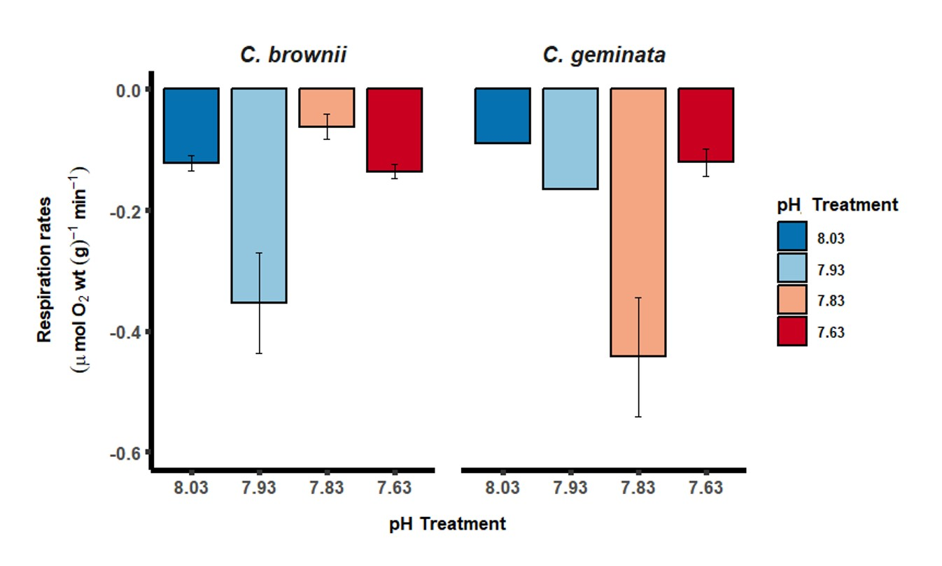
Figure S4. Mean (± SEM) for respiration rates (μmol O₂ wt(g)⁻¹ min⁻¹ for non-CCM C. brownii and CCM C. geminata across the different OA scenarios (n = 5 except for C. geminata under pH treatment 8.03 that had n = 2 and 7.93 pH treatment that had n = 1 at the end of the experiment).

