Additional Material

Below are summaries of model output for each relationship of interest. In most of the models (all except A.), the variance explained by the Site random effect appears to be so small it is negligible.

- Organic thickness vs. Alder biomass

Linear mixed model fit by REML ['lmerMod']
Formula: sqrt(Organic.thickness) ~ Biomass + (1 | Site)
Data: soil_shrubs

REML criterion at convergence: 78.9

Scaled residuals:
Min 1Q Median 3Q Max
-2.2756 -0.4406 -0.1244 0.6020 2.3176

Random effects:
Groups Name Variance Std.Dev.
Site (Intercept) 0.0146 0.1208
Residual 0.8392 0.9161
Number of obs: 28, groups: Site, 5

Fixed effects:
Estimate Std. Error t value
(Intercept) 2.89197 0.22591 12.8
Biomass -0.13915 0.04639 -3.0

Correlation of Fixed Effects:
(Intr)
Biomass -0.591

- Organic thickness vs. Alder cover

Linear mixed model fit by REML ['lmerMod']
Formula: sqrt(Organic.thickness) ~ Alder.cover + (1 | Site)
Data: soil_shrubs

REML criterion at convergence: 74.7

Scaled residuals:
Min 1Q Median 3Q Max
-1.8926 -0.6455 -0.1875 0.5771 1.9576

Random effects:
Groups Name Variance Std.Dev.
Site (Intercept) 0.0000 0.0000
Residual 0.6443 0.8027
Number of obs: 28, groups: Site, 5

Fixed effects:
Estimate Std. Error t value
(Intercept) 3.132288 0.208421 15.029
Alder.cover -0.040328 0.008923 -4.519

Correlation of Fixed Effects:
(Intr)
Alder.cover -0.686
- C stock vs. Alder biomass

Linear mixed model fit by REML ['lmerMod']
Formula: sqrt(C.stock) ~ Biomass + (1 | Site)
Data: soil_shrubs

REML criterion at convergence: 19.7

Scaled residuals:
Min 1Q Median 3Q Max
-1.93918 -0.48494 -0.07893 0.34267 2.59058

Random effects:
Groups Name Variance Std.Dev.
Site (Intercept) 0.00000 0.0000
Residual 0.08737 0.2956
Number of obs: 28, groups: Site, 5

Fixed effects:
Estimate Std. Error t value
(Intercept) 0.76027 0.07028 10.818
Biomass -0.03379 0.01485 -2.276

Correlation of Fixed Effects:
(Intr)
Biomass -0.607

- C stock vs. Alder cover

Linear mixed model fit by REML ['lmerMod']
Formula: sqrt(C.stock) ~ Alder.cover + (1 | Site)
Data: soil_shrubs

REML criterion at convergence: 17.6

Scaled residuals:
Min 1Q Median 3Q Max
-1.5532 -0.5399 -0.2187 0.4701 2.3047

Random effects:
Groups Name Variance Std.Dev.
Site (Intercept) 0.00000 0.0000
Residual 0.07165 0.2677
Number of obs: 28, groups: Site, 5

Fixed effects:
Estimate Std. Error t value
(Intercept) 0.828457 0.069505 11.919
Alder.cover -0.010318 0.002976 -3.467

Correlation of Fixed Effects:
(Intr)
Alder.cover -0.686

- N stock vs. Alder biomass
Linear mixed model fit by REML ['lmerMod']
Formula: sqrt(N.stock) ~ Biomass + (1 | Site)
Data: soil_shrubs

REML criterion at convergence: -59.3

Scaled residuals:
Min 1Q Median 3Q Max
-1.86666 -0.47005 0.03456 0.39418 2.47293

Random effects:
Groups Name Variance Std.Dev.
Site (Intercept) 0.00000 0.00000
Residual 0.00418 0.06465
Number of obs: 28, groups: Site, 5

Fixed effects:
Estimate Std. Error t value
(Intercept) 0.158487 0.015373 10.310
Biomass -0.006828 0.003247 -2.103

Correlation of Fixed Effects:
(Intr)
Biomass -0.607

- N stock vs. Alder cover

Linear mixed model fit by REML ['lmerMod']
Formula: sqrt(N.stock) ~ Alder.cover + (1 | Site)
Data: soil_shrubs

REML criterion at convergence: -62

Scaled residuals:
Min 1Q Median 3Q Max
-1.78678 -0.60093 -0.08477 0.47756 2.21046

Random effects:
Groups Name Variance Std.Dev.
Site (Intercept) 0.000000 0.00000
Residual 0.003355 0.05792
Number of obs: 28, groups: Site, 5

Fixed effects:
Estimate Std. Error t value
(Intercept) 0.1744559 0.0150397 11.60
Alder.cover -0.0022216 0.0006439 -3.45

Correlation of Fixed Effects:
(Intr)
Alder.cover -0.686

For each relationship, models with site as a random effect and transect as a random effect (but not both) had the same coefficients; thus, the same AIC (Table R1). We chose to focus on site as the random effect in the manuscript as it is the easiest to conceptualize.

Table R1.
Small sample-corrected Akaike Information Criterion (AICc), delta AIC (dAICc), degrees of freedom (df), and weight of comparable models for each relationship shown in Fig. 3a-f.

 | AICc | dAICc | df | weight
mix.bio.org.site | 88.6 | 0 | 4 | 0.45
mix.bio.org.transect | 88.6 | 0 | 4 | 0.45
mix.bio.org.sitetransect | 91.6 | 3 | 5 | 0.1
mix.bio.Cstock.site | 29.5 | 0 | 4 | 0.45
mix.bio.Cstock.transect | 29.5 | 0 | 4 | 0.45
mix.bio.Cstock.sitetransect | 32.4 | 3 | 5 | 0.1
mix.bio.Nstock.site | -49.6 | 0 | 4 | 0.45
mix.bio.Nstock.transect | -49.6 | 0 | 4 | 0.45
mix.bio.Nstock.sitetransect | -46.6 | 3 | 5 | 0.1
mix.cov.org.site | 84.4 | 0 | 4 | 0.45
mix.cov.org.transect | 84.4 | 0 | 4 | 0.45
mix.cov.org.sitetransect | 87.4 | 3 | 5 | 0.1
mix.cov.Cstock.site | 27.3 | 0 | 4 | 0.45
mix.cov.Cstock.transect | 27.3 | 0 | 4 | 0.45
mix.cov.Cstock.sitetransect | 30.3 | 3 | 5 | 0.1
mix.cov.Nstock.site | -52.3 | 0 | 4 | 0.45
mix.cov.Nstock.transect | -52.3 | 0 | 4 | 0.45
mix.cov.Nstock.sitetransect | -49.3 | 3 | 5 | 0.1

Key: Predicting variables bio = Alder biomass; cov = Alder cover. Response variables org = Organic thickness; Cstock = C stock; Nstock = N stock. .site indicates only site considered as random effect, .transect indicates only transect considered as a random effect, .sitetransect indicates both site and transect considered as random effects.

Fig. R1, which illustrates the marginal prediction + conditional residuals as points and the marginal fit line of each of the relationships shown in Fig. 3a-f, shows no obvious grouping by site.

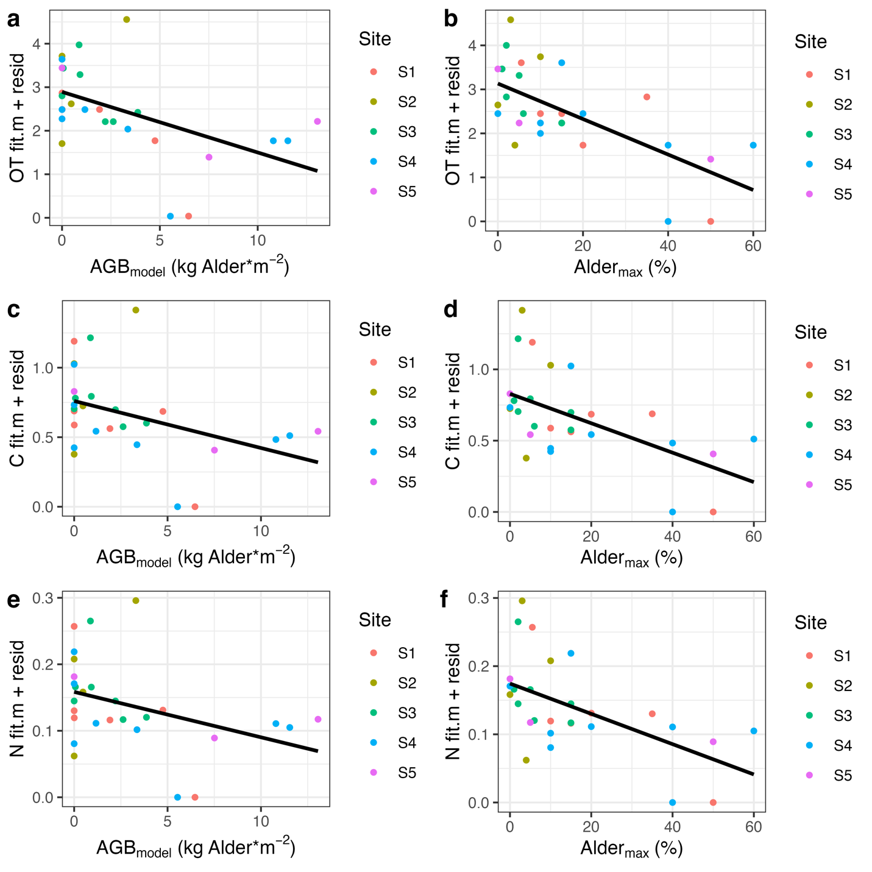

Figure R1. Marginal fit from chosen LME models with points showing the marginal fit with random intercepts according to site plus the conditional residuals.

