Enzymatic synthesis of tyrosol esters in organic solvents and ionic liquids: Correlation between enzyme activity and solvent properties

Kang-Hong Wang¹, Shuangfei Li¹, Ying-Fen Meng², Yong Zou², Guo-Bin Liang¹, Cheng Yang¹, Zhen Yang¹*

¹College of Life Sciences and Oceanography, Shenzhen University, Shenzhen, Guangdong 518055, China.
²School of Pharmaceutical Sciences, Sun Yat-Sen University, Guangzhou, Guangdong 510006, China

*Corresponding author: Zhen Yang, Ph.D., Professor
Address: College of Life Sciences and Oceanography, Shenzhen University, 1066 Xue Yuan Avenue, Shenzhen, Guangdong 518055, China.
Tel.: +86 755 2641 2791
Fax: +86 755 2653 4277
E-mail: zyang@szu.edu.cn

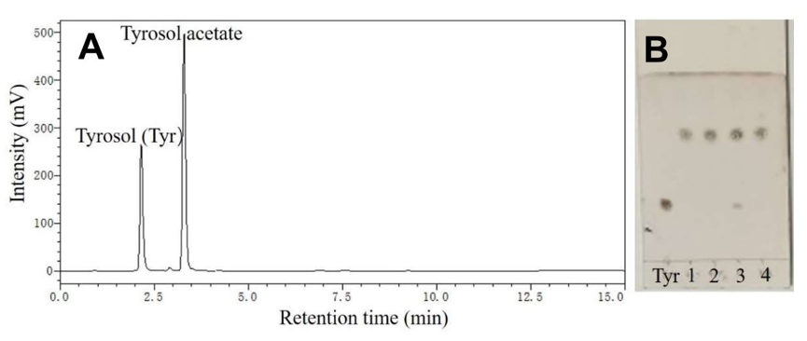
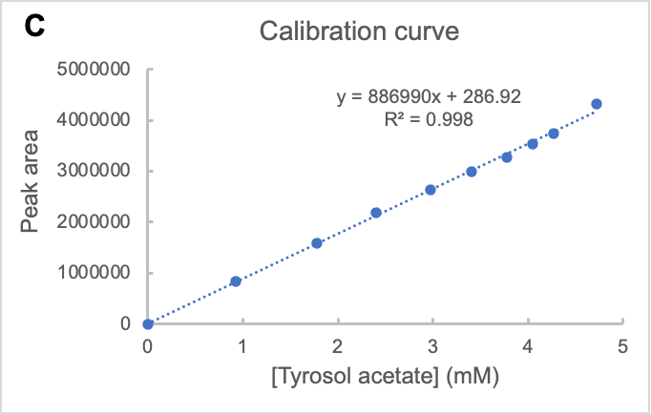

Figure S1. HPLC (A) and TLC (B) of the samples obtained from the enzymatic reaction in MTBE. (C) is the HPLC calibration curve used for determination of the tyrosol acetate concentration.
In the TLC plate (B), the label “Tyr” refers to the standard sample tyrosol, whereas “1, 2, 3, 4” refer to the samples obtained from the above 4 reactions, respectively. The reactions were performed in a 5 mL solution containing tyrosol (5 mM) and vinyl acetate (25 mM) in MTBE, with agitation of 250 rpm at 40 ºC for 2 h, by adding:
- Novozym 435 (10 mg)
- Novozym 435 (10 mg) + 4Å molecular sieves (250 mg)
- Lipozyme TLIM (10 mg)
- Lipozyme TLIM (10 mg) + 4Å molecular sieves (250 mg)

- ¹H NMR (500 MHz, DMSO-d₆) spectrum
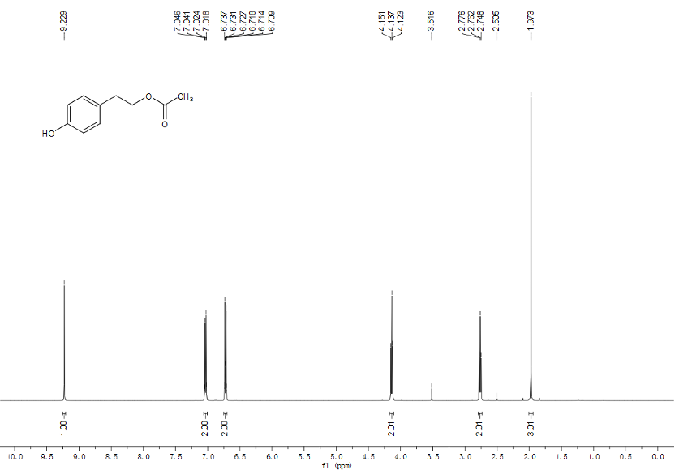

- ¹H NMR (500 MHz, DMSO-d₆) spectrum
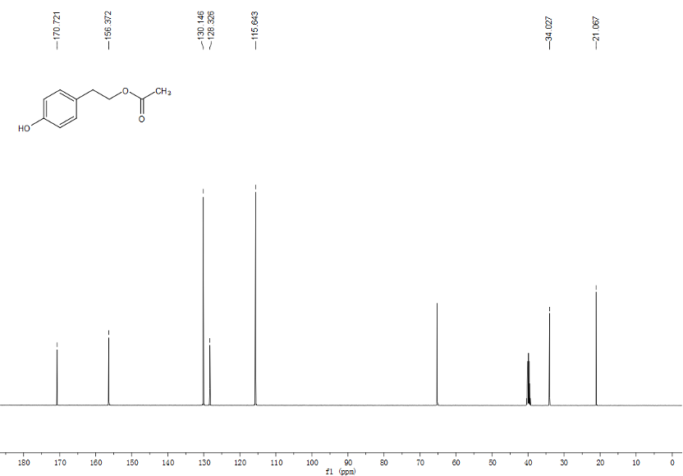
Figure S2. Characterization of the product, tyrosol acetate, via ¹H-NMR (A) and ¹³C-NMR (B).
¹H NMR (500 MHz, DMSO-d₆) δ 9.23 (s, 1H), 7.06-7.01 (d, J = 8.5 Hz, 2H), 6.75-6.70 (d, J = 8.5 Hz, 2H), 4.14 (t, J = 7.0 Hz, 2H), 2.76 (t, J = 7.0 Hz, 2H), 1.97 (s, 3H).
¹³C NMR (125 MHz, DMSO-d₆) δ 170.72, 156.37, 130.15, 128.33, 115.64, 65.19, 34.03, 21.07.
Table S1. Organic solvents used in this study and their corresponding log P values.

No. | Solvent | Abbreviation | *log P
1 | Dimethyl sulfoxide | DMSO | -1.3
2 | N,N-Dimethylformamide | DMF | -1
3 | Acetonitrile |  | -0.33
4 | Acetone |  | -0.23
5 | tert-Butanol | tert-BuOH | 0.35
6 | Tetrahydrofuran | THF | 0.46
7 | 2-Methyl-2-butanol | 2M2B | 0.89
8 | Methyl tert-butyl ether | MTBE | 0.94
9 | Heptanone |  | 1.8
10 | Benzene |  | 2.0
11 | Octanone |  | 2.4
12 | Toluene |  | 2.5
13 | Chlorobenzene |  | 2.8
14 | Nonanone |  | 2.9
15 | Cyclohexane |  | 3.2
16 | n-Hexane |  | 3.5
17 | n-Heptane |  | 4.0
18 | Isooctane |  | 4.5
*log P values were obtained from (Laane et al., 1987).

