One-carbon metabolism nutrients impact the interplay between DNA methylation and gene expression in liver, enhancing protein synthesis in Atlantic Salmon

Takaya Saito, Marit Espe, Vibeke Vikeså, Christoph Bock, Tårn H. Thomsen, Anne‐Catrin Adam, Jorge M.O. Fernandes, and Kaja H. Skjaerven

Supplementary tables

Table S1. Composition of the experimental diets (g/kg).

Ctrl | 1C+ |  | 1C+
Wheat | 54.22 | 50.64 | 47.05
Wheat gluten | 132.03 | 132.03 | 132.03
Sunflower meal | 10.0 | 10.0 | 10.0
Dehulled faba beans | 30.0 | 30.0 | 30.0
Pea concentrate | 150.0 | 150.0 | 150.0
Soy protein concentrate | 240.0 | 240.0 | 240.0
Krill meal | 20.0 | 20.0 | 20.0
Fish meal | 120.0 | 120.0 | 120.0
Rapeseed oil | 81.24 | 81.24 | 81.24
Fish oil | 126.9 | 126.9 | 126.9
Water | 11.43 | 11.84 | 12.26
DL-methionine | 0.05 | 3.12 | 6.19
Choline | 0.92 | 0.92 | 0.92
NRC mineral mix | 2.0 | 2.0 | 2.0
NRC Vitamin mix | 1.0 | 1.0 | 1.0
Vitamin B12 | 0.156 | 0.179 | 0.203
Folate | 0.023 | 0.053 | 0.083
Vitamin B6 | 0.077 | 0.107 | 0.137
Taurine | 2.8 | 2.8 | 2.8
Micronutrients | 17.16 | 17.17 | 17.19

Table S2. Growth performance measured at four sampling points.

Sampling point | Measure† | Ctrl |  | 1C+ |  | 1C++ |  | p-value
S1 | BW (g) | 31.62±0.78 |  | 32.16±0.47 |  | 32.74±0.35 |  | 0.43
S2 | BW (g) | 85.81±3.14 |  | 90.54±1.24 |  | 87.59±4.64 |  | 0.62
 | CF | 1.29±0.02 |  | 1.32±0.00 |  | 1.31±0.03 |  | 0.51
S3 | HSI | 1.09±0.04 |  | 0.99±0.00 |  | 1.02±0.01 |  | 0.06
 | BW (g) | 90±3.67 |  | 93.73±2.42 |  | 97.70±4.23 |  | 0.36
S4 | BW (g) | 462.53±19.23 | b | 539.20±8.49 | a | 474.17±3.95 | b | 0.009
 | CF | 1.46±0.01 | b | 1.55±0.01 | a | 1.53±0.02 | a | 0.006
 | HSI | 1.64±0.08 | b | 1.32±0.04 | a | 1.42±0.05 | ab | 0.025
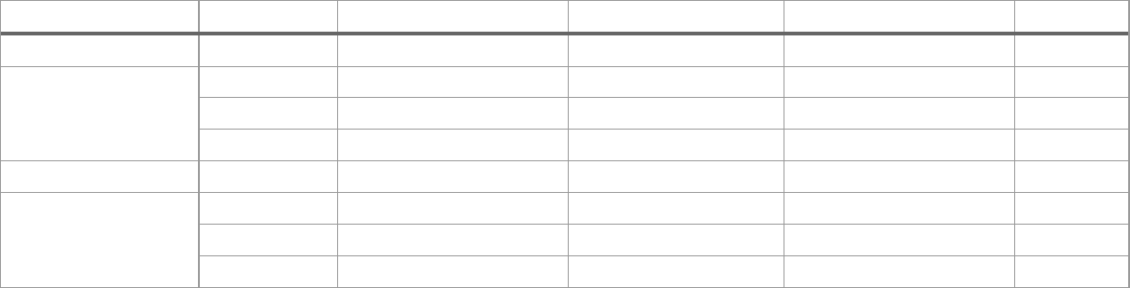

Mean values of three tanks are followed by SEM and the compact letter display of Tukey's post hoc test (p < 0.05, ANOVA followed by Tukey’s post hoc test).

†BW (body weight), CF (condition factor), and HSI (hepatosomatic index).

Table S3. Read counts of RNA-seq samples after initial quality control, alignment, and quantification.

Sample | Sex | Treatment | M Seqs¹ | M Aligned² | % Aligned² | M Assigned³ | % Assigned³
1Cp1 | M | 1C+ | 14.6 | 12 | 82.1% | 10.8 | 58.9%
1Cp2 | M | 1C+ | 11.8 | 9.6 | 81.8% | 8.6 | 57.5%
1Cp3 | M | 1C+ | 16.8 | 13.7 | 81.7% | 12.3 | 58.2%
1Cp4 | F | 1C+ | 14.4 | 11.7 | 80.7% | 10.5 | 55.4%
1Cp5 | F | 1C+ | 15.8 | 12.9 | 81.8% | 11.7 | 58.5%
1Cp6 | M | 1C+ | 14.5 | 11.6 | 79.8% | 10.4 | 53.9%
1Cp7 | F | 1C+ | 16.8 | 13.7 | 81.9% | 12.3 | 58.6%
1Cp8 | F | 1C+ | 16.8 | 13.2 | 78.5% | 12 | 56.4%
1Cp9 | F | 1C+ | 15.5 | 12.7 | 82.1% | 11.4 | 58.8%
1Cpp1 | F | 1C++ | 14.5 | 11.9 | 82.3% | 10.8 | 60.3%
1Cpp2 | M | 1C++ | 16.5 | 13.4 | 81.2% | 12.2 | 57.7%
1Cpp3 | F | 1C++ | 16.6 | 13.4 | 80.8% | 12.2 | 57.1%
1Cpp4 | F | 1C++ | 16.1 | 13.2 | 82.1% | 11.8 | 57.8%
1Cpp5 | F | 1C++ | 16.6 | 13.3 | 80.2% | 11.9 | 54.8%
1Cpp6 | M | 1C++ | 14.3 | 11.6 | 81.3% | 10.4 | 56.9%
1Cpp7 | F | 1C++ | 14.5 | 11.5 | 79.3% | 10.4 | 53.0%
1Cpp8 | M | 1C++ | 14.6 | 12 | 82.2% | 10.8 | 58.9%
1Cpp9 | M | 1C++ | 16.2 | 13.2 | 81.8% | 12 | 58.5%
Ctrl1 | F | Ctrl | 17.1 | 13.9 | 81.4% | 12.5 | 57.3%
Ctrl2 | F | Ctrl | 12.4 | 10.3 | 82.8% | 9.2 | 60.3%
Ctrl3 | M | Ctrl | 15.4 | 12.6 | 81.8% | 11.3 | 58.1%
Ctrl4 | F | Ctrl | 18 | 14.9 | 82.7% | 13.4 | 59.8%
Ctrl5 | M | Ctrl | 15.8 | 13.1 | 82.9% | 11.8 | 60.4%
Ctrl6 | M | Ctrl | 18.3 | 14.6 | 79.6% | 13 | 52.2%
Ctrl7 | F | Ctrl | 15.5 | 12.9 | 83.1% | 11.6 | 60.4%
Ctrl8 | M | Ctrl | 17.9 | 14.7 | 82.2% | 13.3 | 59.2%
Ctrl9 | F | Ctrl | 16.4 | 13.3 | 81.3% | 11.9 | 56.5%

¹Total read count after initial quality control by Trim Galore!.
²Count of aligned reads to the reference genome by STAR and the percentage of the aligned reads to the total reads.
³Count of the reads associated with known RNAs by featureCount with the percentage of the assigned reads among the total aligned sites, which include both unique and multiple aligned reads.

Table S4. Number of DEGs identified by three comparisons.

Comparison | Control | # DEGs | # Down-regulated | # Up-regulated
1C+ vs Ctrl | Ctrl | 874 | 513 | 361
1C++ vs Ctrl | Ctrl | 759 | 395 | 364
1C++ vs 1C+ | 1C+ | 20 | 10 | 10
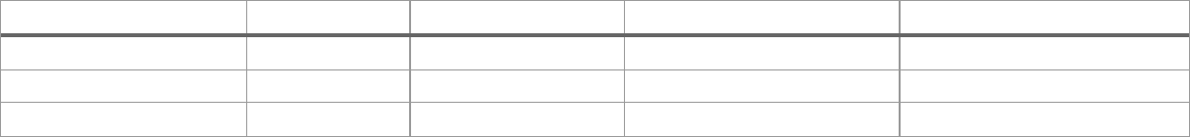

Table S5. Enriched KEGG pathways for the genes in DEG C1 and DEG C2 clusters by ORA.

Cluster | ID | Description | GeneRatio¹ | BgRatio³ | p.adjust³ | GSEA⁴
DEG C1 | sasa01240 | Biosynthesis of cofactors | 17/213 | 201/7462 | 7.48E-03 | Y
 | sasa00270 | Cysteine and methionine | 10/213 | 86/7462 | 1.03E-02 | Y
 |  | metabolism
 | sasa00220 | Arginine biosynthesis | 6/213 | 34/7462 | 1.54E-02 | N
 | sasa01230 | Biosynthesis of amino acids | 11/213 | 127/7462 | 2.98E-02 | Y
 | sasa00982 | Drug metabolism - cytochrome | 6/213 | 42/7462 | 2.98E-02 | N
DEG C2 |  | P450
 | sasa00591 | Linoleic acid metabolism | 4/144 | 19/7462 | 2.15E-02 | Y
 | sasa04141 | Protein processing in | 16/144 | 321/7462 | 2.15E-02 | Y
 |  | endoplasmic reticulum
 | sasa03060 | Protein export | 5/144 | 40/7462 | 3.15E-02 | Y
 | sasa00980 | Metabolism of xenobiotics by | 5/144 | 43/7462 | 3.30E-02 | N
 |  | cytochrome P450

^{1,2,3}Output of the enrichKEGG function provided by the clusterProfiler package. GeneRatio: gene ratio, BgRatio:
background ratio, p.adjust: adjusted p-value by the Benjamini-Hochberg procedure.
⁴Y: the pathway is also enriched by one of the GSEA results. N: the pathway is not enriched by GSEA.

Table S6. Enriched KEGG pathways for the C1+ vs Ctrl comparison by GSEA.

ID | Description | setSize¹ | NES² | p.adjus³ | Support⁴
sasa03010 | Ribosome | 255 | 2.09E+00 | 5.33E-09 | GSEA
sasa04141 | Protein processing in endoplasmic reticulum | 378 | 1.95E+00 | 5.33E-09 | ORA,
sasa04110 |  |  |  |  | GSEA
 | Cell cycle | 275 | -1.94E+00 | 5.33E-09 | GSEA
sasa04115 | p53 signaling pathway | 145 | -1.82E+00 1.04E-04
sasa04510 | Focal adhesion | 470 | 1.48E+00 | 1.51E-04
sasa03060 | Protein export | 44 | 2.10E+00 | 1.70E-04 | ORA
sasa04216 | Ferroptosis | 108 | -1.84E+00 1.84E-04
sasa04260 | Cardiac muscle contraction | 191 | 1.72E+00 | 1.84E-04
sasa04068 | FoxO signaling pathway | 331 | -1.58E+00 | 2.24E-04
sasa04218 | Cellular senescence | 373 | -1.57E+00 | 2.24E-04
sasa04914 | Progesterone-mediated oocyte maturation | 203 | -1.67E+00 2.58E-04
sasa00190 | Oxidative phosphorylation | 245 | 1.61E+00 | 3.20E-04
sasa00100 | Steroid biosynthesis | 31 | -2.02E+00 | 5.46E-04 | GSEA
sasa01230 | Biosynthesis of amino acids | 167 | -1.64E+00 | 7.34E-04 | ORA
sasa00240 | Pyrimidine metabolism | 103 | -1.74E+00 | 7.68E-04

^{1,2,3}Output of the gseKEGG function provided by the clusterProfiler package. setSize: the number of genes that
contributed for enrichment, NES: normalized enrichment score that indicates up-regulation (positive) or down-
regulation (negative), p.adjust: adjusted p-value by the Benjamini-Hochberg procedure.

⁴ORA: the pathway is also enriched by ORA. GSEA: the pathway is also enriched by at least one of the other GSEA results.

Table S7. Enriched KEGG pathways for the C1++ vs Ctrl comparison by GSEA.

ID | Description | setSize¹ | NES² | p.adjust³ | Support⁴
sasa03010 | Ribosome | 255 | 2.63E+00 | 1.60E-08 | GSEA
sasa00970 | Aminoacyl-tRNA biosynthesis | 62 | -2.26E+00 | 4.86E-07 | GSEA
sasa04110 | Cell cycle | 275 | -1.83E+00 | 1.52E-06 | GSEA
sasa00190 | Oxidative phosphorylation | 247 | 1.79E+00 | 6.07E-06
sasa03030 | DNA replication | 55 | -2.01E+00 | 1.47E-04
sasa01230 | Biosynthesis of amino acids | 164 | -1.81E+00 | 1.47E-04
sasa00270 | Cysteine and methionine metabolism | 107 | -1.85E+00 | 1.87E-04
sasa00100 | Steroid biosynthesis | 32 | -2.04E+00 | 3.83E-04 | GSEA
sasa01232 | Nucleotide metabolism | 164 | -1.72E+00 | 5.59E-04
sasa01240 | Biosynthesis of cofactors | 260 | -1.62E+00 | 5.59E-04 | ORA
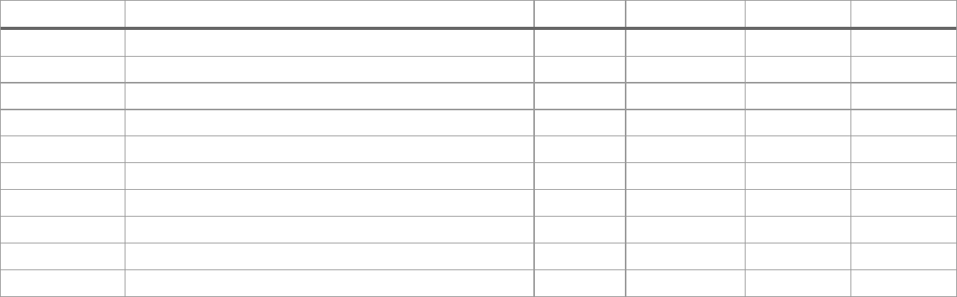

^{1,2,3}Output of the gseKEGG function provided by the clusterProfiler package. setSize: the number of genes that
contributed for enrichment, NES: normalized enrichment score that indicates up-regulation (positive) or down-
regulation (negative), p.adjust: adjusted p-value by the Benjamini-Hochberg procedure.

⁴ORA: the pathway is also enriched by ORA. GSEA: the pathway is also enriched by at least one of the other GSEA results.

Table S8. Enriched KEGG pathways for the C1+ vs Ctrl comparison by GSEA.

ID | Description | setSize¹ | NES² | p.adjust³ | Support⁴
sasa03010 | Ribosome | 257 | 1.88E+00 | 3.43E-07 | GSEA
sasa00970 | Aminoacyl-tRNA biosynthesis | 61 | -2.24E+00 | 4.56E-07 | GSEA
sasa03015 | mRNA surveillance pathway | 179 | -1.66E+00 | 2.76E-04
sasa04141 | Protein processing in endoplasmic | 375 | -1.54E+00 | 4.17E-04 | ORA,GSEA
sasa03013 | reticulum
 | Nucleocytoplasmic transport | 209 | -1.67E+00 | 4.33E-04

^{1,2,3}Output of the gseKEGG function provided by the clusterProfiler package. setSize: the number of genes that
contributed for enrichment, NES: normalized enrichment score that indicates up-regulation (positive) or down-
regulation (negative), p.adjust: adjusted p-value by the Benjamini-Hochberg procedure.

⁴ORA: the pathway is also enriched by ORA. GSEA: the pathway is also enriched by at least one of the other GSEA results.

Table S9. Read counts of RRBS samples after initial quality control and alignment percentage.

Sample Name | Sex | Treatment | M Seqs¹ | % Aligned²
1Cp1 | F | 1C+ | 67.4 | 47.5%
1Cp2 | F | 1C+ | 44.7 | 47.5%
1Cp3 | M | 1C+ | 74.2 | 47.1%
1Cp4 | F | 1C+ | 46.7 | 47.1%
1Cp5 | M | 1C+ | 51.6 | 47.8%
1Cp6 | M | 1C+ | 49.1 | 47.1%
1Cp7 | F | 1C+ | 42.3 | 46.7%
1Cp8 | M | 1C+ | 66.3 | 47.0%
1Cp9 | F | 1C+ | 58.6 | 46.8%
1Cpp1 | M | 1C++ | 61.8 | 48.3%
1Cpp2 | M | 1C++ | 61.6 | 49.0%
1Cpp3 | M | 1C++ | 54.4 | 48.1%
1Cpp4 | F | 1C++ | 66.3 | 47.5%
1Cpp5 | F | 1C++ | 47.8 | 48.4%
1Cpp6 | M | 1C++ | 36.5 | 47.7%
1Cpp7 | F | 1C++ | 59.6 | 46.9%
1Cpp8 | F | 1C++ | 50.7 | 46.4%
1Cpp9 | F | 1C++ | 59.7 | 47.2%
Ctrl1 | F | Ctrl | 63 | 48.0%
Ctrl2 | M | Ctrl | 59 | 47.8%
Ctrl3 | F | Ctrl | 65.9 | 47.9%
Ctrl4 | F | Ctrl | 42.4 | 47.0%
Ctrl5 | F | Ctrl | 60.3 | 46.7%
Ctrl6 | M | Ctrl | 50.5 | 46.7%
Ctrl7 | F | Ctrl | 46.4 | 47.4%
Ctrl8 | M | Ctrl | 55 | 47.9%
Ctrl9 | M | Ctrl | 45.4 | 47.6%

¹Total read count after initial quality control by Trim Galore!.
- Percentage of the aligned reads to the reference genome by Bismark.

Table S10. Comparisons of two methylation rate distributions in different regions by KS tests.

Region | Size | X | Y | Alternative | p-value | Significance†
All mapped CpGs | 157 201 | 1C+ | Ctrl | less | 0 | *
 |  |  |  | greater | 0.81
 |  | 1C++ | Ctrl | less | 0 | *
 |  |  |  | greater | 0.93
 |  | 1C+ | 1C++ | less | 0 | *
 |  |  |  | greater | 0.85
GB | 87 215 | 1C+ | Ctrl | less | 0 | *
 |  |  |  | greater | 0.83
 |  | 1C++ | Ctrl | less | 0 | *
 |  |  |  | greater | 0.91
 |  | 1C+ | 1C++ | less | 8.88e-16 | *
 |  |  |  | greater | 0.85
P | 3 091 | 1C+ | Ctrl | less | 0.04 | *
 |  |  |  | greater | 0.81
 |  | 1C++ | Ctrl | less | 0.02 | *
 |  |  |  | greater | 0.9
 |  | 1C+ | 1C++ | less | 0.72
 |  |  |  | greater | 0.47
Flank | 48 148 | 1C+ | Ctrl | less | 0 | *
 |  |  |  | greater | 0.88
 |  | 1C++ | Ctrl | less | 0 | *
 |  |  |  | greater | 0.84
 |  | 1C+ | 1C++ | less | 9.55e-10 | *
 |  |  |  | greater | 0.93
IGR | 47 748 | 1C+ | Ctrl | less | 0 | *
 |  |  |  | greater | 0.93
 |  | 1C++ | Ctrl | less | 0 | *
 |  |  |  | greater | 0.98
 |  | 1C+ | 1C++ | less | 0 | *
 |  |  |  | greater | 0.94

†’*’ indicates that KS test result is statistically significant with p-value < 0.05.

Table S11. Number of DMCs identified by three comparisons in four different regions.

Comparison | Region | #Mapped CpGs | #DMCs | (%)¹ | #DMCs (hypo)² | #DMCs (hyper)³
1C+ vs Ctrl | GB | 107366 | 3061 | 2.9% | 933 | 2128
 | P | 4189 | 154 | 3.7% | 49 | 105
 | Flank | 74773 | 2390 | 3.2% | 793 | 1597
1C++ vs Ctrl | IGR | 67078 | 2112 | 3.1% | 636 | 1476
 | GB | 108055 | 2969 | 2.7% | 978 | 1991
 | P | 4110 | 131 | 3.2% | 58 | 73
 | Flank | 75504 | 2145 | 2.8% | 729 | 1416
1C++ vs 1C+ | IGR | 67018 | 2044 | 3% | 652 | 1392
 | GB | 105087 | 2488 | 2.4% | 1359 | 1129
 | P | 4103 | 134 | 3.3% | 84 | 50
 | Flank | 74515 | 1973 | 2.6% | 1048 | 925
 | IGR | 65076 | 1766 | 2.7% | 967 | 799
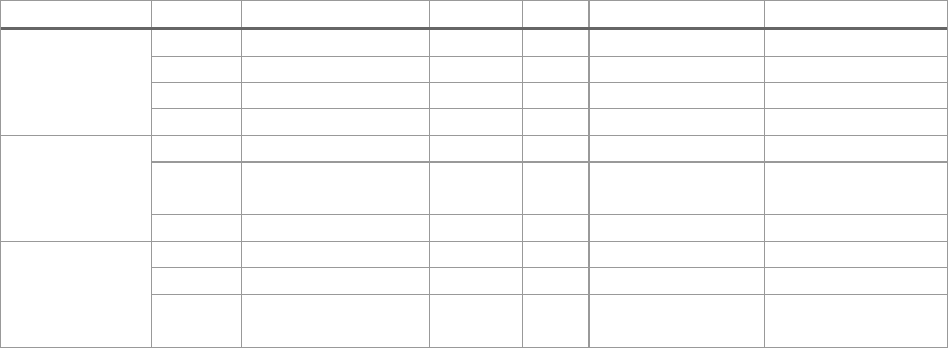

¹Percentage of the DMC count calculated by (#DMCs)/(#Mapped CpGs) * 100.
^{2 ,3}Number of hypo-methylated and hyper-methylated DMCs receptively.

Table S12. List of genes that have multiple DMCs in the promoter (P) regions.

Comparison | Gene ID¹ | Gene symbol² | Gene name | #DMCs³
1C+ vs Ctrl | 100195955 | rn182 | RING finger protein 182 | 6 (0/6)
 | 106572013 | LOC106572013 | uncharacterized LOC106572013 | 4 (0/4)
 | 106602923 | LOC106602923 | serine/threonine/tyrosine-interacting protein | 3 (0/3)
1C++ vs Ctrl |  |  | A-like
 | 100195955 | rn182 | RING finger protein 182 | 4 (0/4)
 | 100196228 | yars | tyrosyl-tRNA synthetase | 4 (4/0)
1C++ vs 1C+ | 106605303 | LOC106605303 | lysyl oxidase homolog 3-like | 3 (0/3)
 | 100195786 | nca11 | Neural cell adhesion molecule 1-A | 3 (3/0)
 | 106572013 | LOC106572013 | uncharacterized LOC106572013 | 4 (4/0)
 | 106588671 | LOC106588671 | DNA topoisomerase 2-beta-like | 2 (0/2)
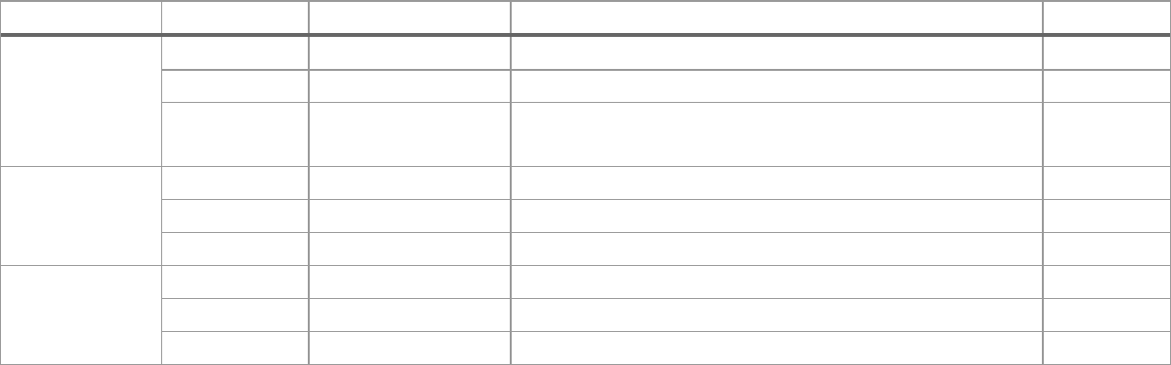

^{1,2}Gene ID and gene symbol from NCBI,
³Number of DMCs identified in the promoter region with (hypo-methylated/hyper-methylated).

Table S13. List of genes that have multiple DMCs in the RS (5K) regions.

Select¹ | Comparison | Gene ID² | Gene symbol³ | Gene name | #DMCs⁴
Direct | 1C+ vs Ctrl | 106574560 | LOC106574560 | cysteine/serine-rich nuclear | 5 (5/0)
 |  |  |  | protein 3-like
 |  | 106577634 | LOC106577634 | uncharacterized LOC106577634 | 6 (0/6)
 |  | 106586627 | LOC106586627 | vang-like protein 1 | 5 (0/5)
 | 1C++ vs Ctrl | 106577634 | LOC106577634 | uncharacterized LOC106577634 | 4 (0/4)
 |  | 106604632 | LOC106604632 | WD40 repeat-containing protein | 3 (0/3)
 |  |  |  | SMU1
 |  | 106610962 | LOC106610962 | transcription factor IIIB 90 kDa | 4 (4/0)
 |  |  |  | subunit-like
 | 1C++ vs 1C+ | 106586604 | tbx15 | T-box 15 | 3 (1/2)
 |  | 106591533 | btg4 | B-cell translocation gene 4 | 8 (0/8)
In-direct |  | 106609646 | LOC106609646 | hepatocyte growth factor-like | 4 (0/4)
 | 1C+ vs Ctrl | 106591533 | btg4 | B-cell translocation gene 4 | 2 (2/0)
 |  | 106604632 | LOC106604632 | WD40 repeat-containing protein | 1 (0/1)
 |  |  |  | SMU1
 |  | 106610962 | LOC106610962 | transcription factor IIIB 90 kDa | 2 (2/0)
 |  |  |  | subunit-like
 | 1C++ vs Ctrl | 106609646 | LOC106609646 | hepatocyte growth factor-like | 1 (0/1)
 | 1C++ vs 1C+ | 106574560 | LOC106574560 | cysteine/serine-rich nuclear | 2 (0/2)
 |  |  |  | protein 3-like
 |  | 106604632 | LOC106604632 | WD40 repeat-containing protein | 2 (0/2)
 |  |  |  | SMU1

¹”Direct” and “In-direct” show how the genes are identified. Direct selection is liked to top 3 genes when the genes are sorted by the number of DMCs by descendent order within one of the three comparisons. In-direct selection is simply added when a gene is identified by the “direct” selection and has at least one DMC in the RS (5K) region within other comparisons.
^{2,3}Gene ID and gene symbol from NCBI,
⁴Number of DMCs identified in the RS (5K) region with (hypo-methylated/hyper-methylated).

Table S14. List of genes that have multiple DMCs in the GB (exon) regions.

Select¹ | Comparison | Gene ID² | Gene symbol³ | Gene name | #DMCs⁴
Direct | 1C+ vs Ctrl | 106571647 | st8sia4 | ST8 alpha-N-acetyl-neuraminide | 5 (5/0)
 |  |  |  | alpha-2,8-sialyltransferase 4
 |  | 106574559 | LOC106574559 | xin actin-binding repeat-containing | 5 (5/0)
 |  |  |  | protein 2-like
 |  | 106577636 | LOC106577636 | RING finger protein 186-like | 6 (0/6)
 | 1C++ vs Ctrl | 106577636 | LOC106577636 | RING finger protein 186-like | 4 (0/4)
 |  | 106590562 | LOC106590562 | complement C3-like | 4 (4/0)
 |  | 106608642 | LOC106608642 | CD276 antigen-like | 5 (5/0)
 | 1C++ vs 1C+ | 106564966 | LOC106564966 | beta-1,3-galactosyl-O-glycosyl- | 4 (0/4)
 |  |  |  | glycoprotein beta-1,6-N-
 |  |  |  | acetylglucosaminyltransferase 3-
 |  |  |  | like
 |  | 106571647 | st8sia4 | ST8 alpha-N-acetyl-neuraminide | 6 (0/6)
 |  |  |  | alpha-2,8-sialyltransferase 4
In-direct |  | 106599566 | LOC106599566 | protein LBH-like | 4 (4/0)
 | 1C+ vs Ctrl | 106590562 | LOC106590562 | complement C3-like | 4 (4/0)
 |  | 106599566 | LOC106599566 | protein LBH-like | 4 (0/4)
 | 1C++ vs Ctrl | 106564966 | LOC106564966 | beta-1,3-galactosyl-O-glycosyl- | 3 (0/3)
 |  |  |  | glycoprotein beta-1,6-N-
 |  |  |  | acetylglucosaminyltransferase 3-
 |  |  |  | like
 |  | 106599566 | LOC106599566 | protein LBH-like | 2 (2/0)
 | 1C++ vs 1C+ | 106608642 | LOC106608642 | CD276 antigen-like | 4 (4/0)

¹”Direct” and “In-direct” show how the genes are identified. Direct selection is liked to top 3 genes when the genes are sorted by the number of DMCs by descendent order within one of the three comparisons. In-direct selection is simply added when a gene is identified by the “direct” selection and has at least one DMC in the GB (exon) region within other comparisons.
^{2,3}Gene ID and gene symbol from NCBI,

⁴Number of DMCs identified in the GB (exon) region with (hypo-methylated/hyper-methylated).

Table S15. List of genes that are DEGs and contain DMRs around their TSSs.

Comp | Region | Gene ID¹ | Gene symbol² | Gene name | Dist³ | LFC⁴ | Mdiff⁵
1C+ vs | GB | 106560487 | angptl3 | angiopoietin-like 3 | 553 | -1.53 | 23.80
Ctrl | (exon) | 106600884 | LOC106600884 | 3-mercaptopyruvate | 971 | 0.34 | 19.57
 |  |  |  | sulfurtransferase-like
 | P | 106593742 | LOC106593742 | group 10 secretory | -636 | 1.08 | 15.19
 |  |  |  | phospholipase A2-like
 |  | 106604118 | LOC106604118 | PRELI domain-containing | -829 | 0.31 | 24.21
 |  |  |  | protein 1, mitochondrial-
 |  |  |  | like
 |  | 106603181 | LOC106603181 | organic solute | -869 | -0.62 | -16.06
 |  |  |  | transporter subunit
 |  |  |  | alpha-like
1C++ vs |  | 106584206 | LOC106584206 | FYN-binding protein 1 | -451 | 1.39 | -16.21
 | GB | 106580755 | LOC106580755 | cytochrome P450 2M1- | 280 | -8.41 | 15.14
Ctrl | (exon) |  |  | like
 |  | 100380841 | slc3a1 | solute carrier family 3 | 157 | -0.99 | 17.94
 |  |  |  | (amino acid transporter
 |  |  |  | heavy chain), member 1
 | P | 106604118 | LOC106604118 | PRELI domain-containing | -829 | 0.34 | 18.16
 |  |  |  | protein 1, mitochondrial-
 |  |  |  | like
 |  | 106611251 | LOC106611251 | HHIP-like protein 1 | -183 | -0.93 | -16.79

^{1,2}Gene ID and gene symbol from NCBI.
³Distance from TSS.
⁴Log fold changes of DEGs.

⁵Methylation differences of DMRs.

Table S16. List of DEGs from three comparisons: 1C+ vs Ctrl, 1C++ vs Ctrl, and 1C++ vs 1C+.

File: 01_degs_total.xlsx (provided in Excel format)

Sheets: | 1C+ vs Ctrl, 1C++ vs Ctrl, 1C++ vs 1C+
Fields: | gene_id | Entrez Gene ID from NCBI
 | lfc | Log fold change produced by DESeq2
 | padj | Adjusted p-value produced by DESeq2
 | type | RNA type
 | gene_symbol | Gene symbol from NCBI
 | gene_name | Gene name from NCBI
 | orgdb_gene_symbol | Gene symbol from BioConductor OrgDB
 | orgdb_gene_name | Gene name from BioConductor OrgDB
 | orgdb_alias | Gene alias from BioConductor OrgDB

Table S17. List of DEGs from three comparisons: 1C+ vs Ctrl, 1C++ vs Ctrl, and 1C++ vs 1C+.

File: 02_degs_stringent.xlsx (provided in Excel format)

Sheets: | 1C+ vs Ctrl, 1C++ vs Ctrl
Fields: | gene_id | Entrez Gene ID from NCBI
 | lfc | Log fold change produced by DESeq2
 | padj | Adjusted p-value produced by DESeq2
 | gene_symbol | Gene symbol from NCBI
 | gene_name | Gene name from NCBI

Table S18. List of DEGs from three comparisons: 1C+ vs Ctrl, 1C++ vs Ctrl, and 1C++ vs 1C+.

File: 03_degs_stringent_relaxed.xlsx (provided in Excel format)

Sheets: | 1C+ vs Ctrl, 1C++ vs Ctrl, 1C++ vs 1C+
Fields: | gene_id | Entrez Gene ID from NCBI
 | lfc | Log fold change produced by DESeq2
 | padj | Adjusted p-value produced by DESeq2
 | gene_symbol | Gene symbol from NCBI
 | gene_name | Gene name from NCBI

Table S19. List of DEG clusters identified by DBSCAN.

File: 04_dbscan_clusters.xlsx (provided in Excel format)

Sheet: DBSCAN

Fields: | gene_id | Entrez Gene ID from NCBI
 | cluster | Cluster name identified by DBSCAN
 | type | RNA type
 | gene_symbol | Gene symbol from NCBI
 | gene_name | Gene name from NCBI
 | orgdb_gene_symbol | Gene symbol from BioConductor OrgDB
 | orgdb_gene_name | Gene name from BioConductor OrgDB
 | orgdb_alias | Gene alias from BioConductor OrgDB

Table S20. List of enriched KEGG pathways identified by ORA and GSEA.

File: | 05_kegg_rna.xlsx | (provided in Excel format)
Sheets: | ORA DEG C1, ORA DEG C2
Fields: | ID | KEGG ID
 | Description | KEGG pathway
 | GeneRatio | Gene ratio used in ORA calculation
 | BgRatio | Back ground ratio used in ORA calculation
 | pvalue | p-value calculated by clusterProfiler
 | p.adjust | Adjusted p-value calculated by clusterProfiler
 | qvalue | Q-value calculated by clusterProfiler
 | geneID | Gene IDs of DEGs involvoed in the corresponding KEGG
 |  | pathway
 | Count | Count of DEGs involvoed in the corresponding KEGG pathway
Sheets: | GSEA 1C+, GSEA 1C++, GSEA 1C++ vs 1C+
Fields: | Comparison | Comparison result used for GSEA analysis
 | ID | KEGG ID
 | Description | KEGG pathway
 | setSize | The size of gene set used in GSEA calculation
 | enrichmentScore | Enrichment score calcualted by clusterProfiler
 | NES | Normalised enrichment score calcualted by clusterProfiler
 | pvalue | p-value calculated by clusterProfiler
 | p.adjust | Adjusted p-value calculated by clusterProfiler
 | qvalue | Q-value calculated by clusterProfiler
 | rank | Rank calculated by clusterProfiler
 | leading_edge | Leading edge analysis performed by clusterProfiler
 | core_enrichment | Gene names that contibuted to enrichemnt

Table S21. List of DMCs from three comparisons: 1C+ vs Ctrl, 1C++ vs Ctrl, and 1C++ vs 1C+.

File: 06_dmc_md15.xlsx (provided in Excel format)

Sheets: | 1C+ vs Ctrl, 1C++ vs Ctrl, 1C++ vs 1C+
Fields: | chrom | Chromosome of DMC
 | start | Start position of DMC
 | end | end position of DMC
 | strand | Strand of DMC
 | pvalue | p-value calculated by methylKit
 | qvalue | Q-value calculated by methylKit
 | meth.diff | Difference of methylation rate (%)
 | region | Region
 | gene_id | Gene ID from NCBI
 | gene_symbol | Gene symbol from NCBI
 | gene_name | Gene name from NCBI
 | refseq | Refseq ID
 | dist | Distance from TSS

Table S22. List of DMRs from three comparisons: 1C+ vs Ctrl, 1C++ vs Ctrl, and 1C++ vs 1C+.

File: 07_dmr_md15.xlsx (provided in Excel format)

Sheets: | 1C+ vs Ctrl, 1C++ vs Ctrl, 1C++ vs 1C+
Fields: | chrom | Chromosome of DMR
 | start | Start position of DMR
 | end | end position of DMR
 | strand | Strand of DMR
 | pvalue | p-value calculated by methylKit
 | qvalue | Q-value calculated by methylKit
 | meth.diff | Difference of methylation rate (%)
 | region | Region
 | gene_id | Gene ID from NCBI
 | gene_symbol | Gene symbol from NCBI
 | gene_name | Gene name from NCBI
 | refseq | Refseq ID
 | dist | Distance from TSS

Supplementary figure
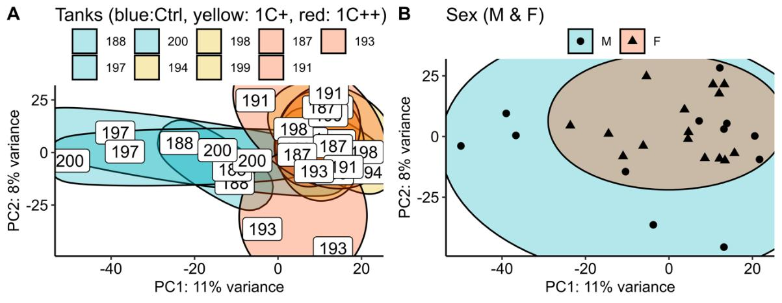

Fig S1. Clustering analysis of gene expression differences among tanks and sex.

- A PCA plot displaying the clusters of nine tanks: Ctrl (blue, semi-transparent), 1C+ (yellow, semi-transparent), and 1C++ (red, semi-transparent) - using 27 RNA-seq samples. The labels represent tank numbers, 188, 197, 200 for the control group, 194, 198, 199 for the 1C+ group, and 187, 191, 193 for the 1C++ group. Top 1000 high variance genes were used as input data. (B) A PCA plot displaying the clusters of sex of the fish: M (mele, blue, semi-transparent) and F (female, yellow, semi-transparent. Top 1000 high variance genes were used as input data.

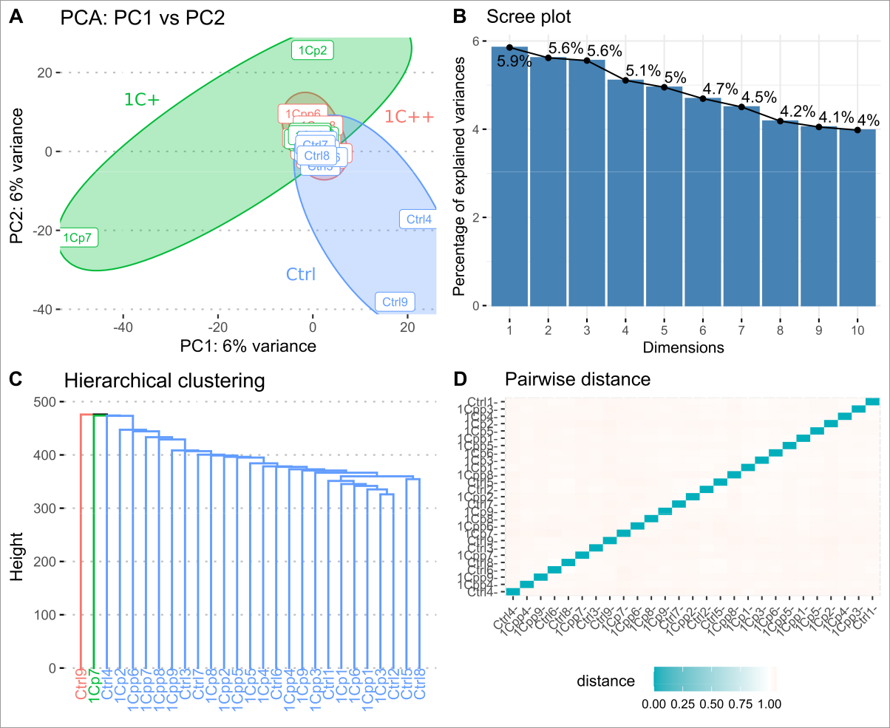

Fig S2. Clustering analysis on the methylation rates of mapped CpG.

Four different plots show the results of clustering analysis performed on the CpG sites with top 50% high variances. (A) PCA (principal component analysis) plot showing PC1 and PC2 components with three ellipses representing 1C+ (green), 1C++ (red), and Ctrl (blue). (B) Scree plot showing the percentage of explained variances for 10 principal components (PC1 ~ PC10). (C) The dendrogram showing the result of hierarchical clustering analysis. (D) Heatmap showing pairwise distances as the results of pairwise correlation analysis.

