Table S1: Acronyms and their definitions, as in the manuscript
Acronym | Definition
AERONET | AErosol RObotic NETwork
AGE | aerosol/gas emissions
AOD | aerosol optical depth
ASTER | Advanced Spaceborne Thermal Emission and Reflection Radiometer
BC | black carbon
BG | background
CH4 | methane
CO | carbon monoxide
CO2 | carbon dioxide
ECMWF | European Centre for Medium-range Weather Forecast
ER | Enhancement ratio
ERA5 | 5th generation ECMWF model
ERF | Fraction of expected responces
EU | European Union
FC | fire count
FRP | fire radiative power
HCHO | formaldehyde
MAX-DOAS | Multi-AXis Differential Optical Absorption Spectroscopy
MODIS | Moderate Resolution Imaging Spectroradiometer
MOPITT | Measurement of Pollution in the Troposphere
MP | meteorological parameters
MZ | Middle Zone, 55º–65º N
N | nitrogen
NASA | National Aeronautics and Space Administration
NOx | nitrogen oxides
NZ | Northern Zone, 65º–73º N
O3 | Ozone
OMI | Ozone Monitoring Instrument
OC | Organic carbon
OH | hydroxyl radical
PEEX | Pan-Eurasian Experiment
PM | particulate matter
QA4ECV | Quality Assurance for Essential Climate Variables, project
SILAM | System for Integrated Modelling of Atmospheric Composition
SSA | single scattering albedo
SSZ | south from SZ
SZ | Southern zone, 45º–55º N
TEMIS | Tropospheric Emission Monitoring Internet Service
VOC | volatile organic compound

Table S2: Coordinates (latitude, lat; longitude, lon) of the areas as in Figure 1
area, N | lat, min | lat, max | lon, min | lon, max
1 | 56 | 72 | 5 | 30
2 | 65 | 73 | 30 | 50
3 | 65 | 73 | 50 | 70
4 | 65 | 73 | 70 | 90
5 | 65 | 73 | 90 | 110
6 | 65 | 73 | 110 | 130
7 | 65 | 73 | 130 | 150
8 | 55 | 65 | 30 | 50
9 | 55 | 65 | 50 | 70
10 | 55 | 65 | 70 | 90
11 | 55 | 65 | 90 | 110
12 | 55 | 65 | 110 | 130
13 | 55 | 65 | 130 | 150
14 | 45 | 55 | 30 | 50
15 | 45 | 55 | 50 | 70
16 | 45 | 55 | 70 | 90
17 | 45 | 55 | 90 | 110
18 | 45 | 55 | 110 | 130
19 | 35 | 45 | 110 | 130
20 | 45 | 55 | 130 | 150
21 | 50 | 60 | 150 | 165
22 | 60 | 73 | 150 | 180
23 | 73 | 78 | 85 | 115

Figure S1: Median FRP, temperature (T), precipitation (P), soil moisture (SM), AOD, HCHO, CO, and NO₂ for August, for the period 2005–2017 over the PEEX domain.

Figure S2: Monthly cumulative FRP for months May to August (panels left to right), 2002–2011 (panels top down).

Figure S3: Same as Fig. S2, 2012–2022 (panels top down).

Figure S4: For predominant cropland fires (May 2008, August 2008, panels top down): ln(FRP) (a), absolute anomalies for temperature T (b), precipitation P (c), soil moisture SM (d), AOD (e), HCHO (f), CO (g), NO₂ (h).

Figure S5: For predominant forest fires (August 2017 and July 2019, panels top down): ln(FRP) (a), absolute anomalies for temperature T (b), precipitation P (c), soil moisture SM (d), AOD (e), HCHO (f), CO (g), NO₂ (h).

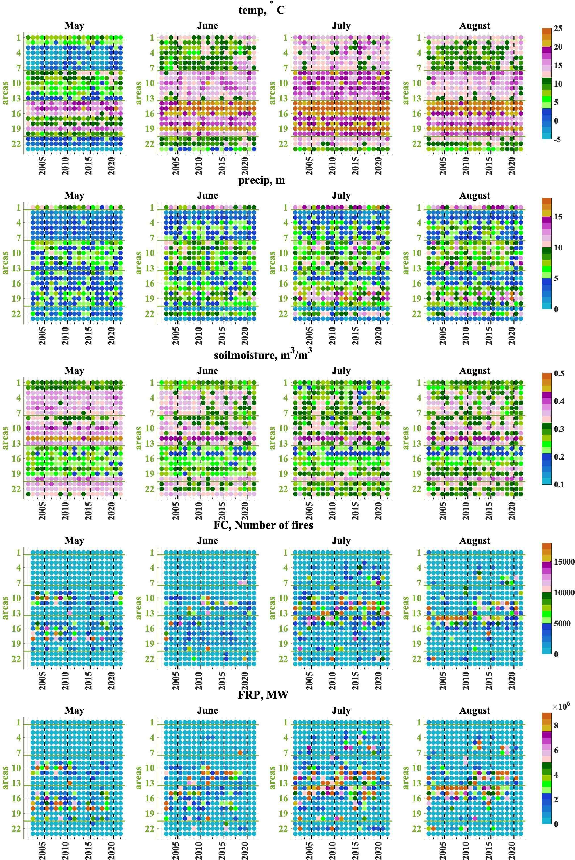
Figure S6: Temporal and spatial distribution of temperature, precipitation, soil moisture, FC, and FRP (panels top down) for May–August (panels left to right). Y-axis shows the areas defined in Figure 1 (manuscript), while x-axis shows time (years).
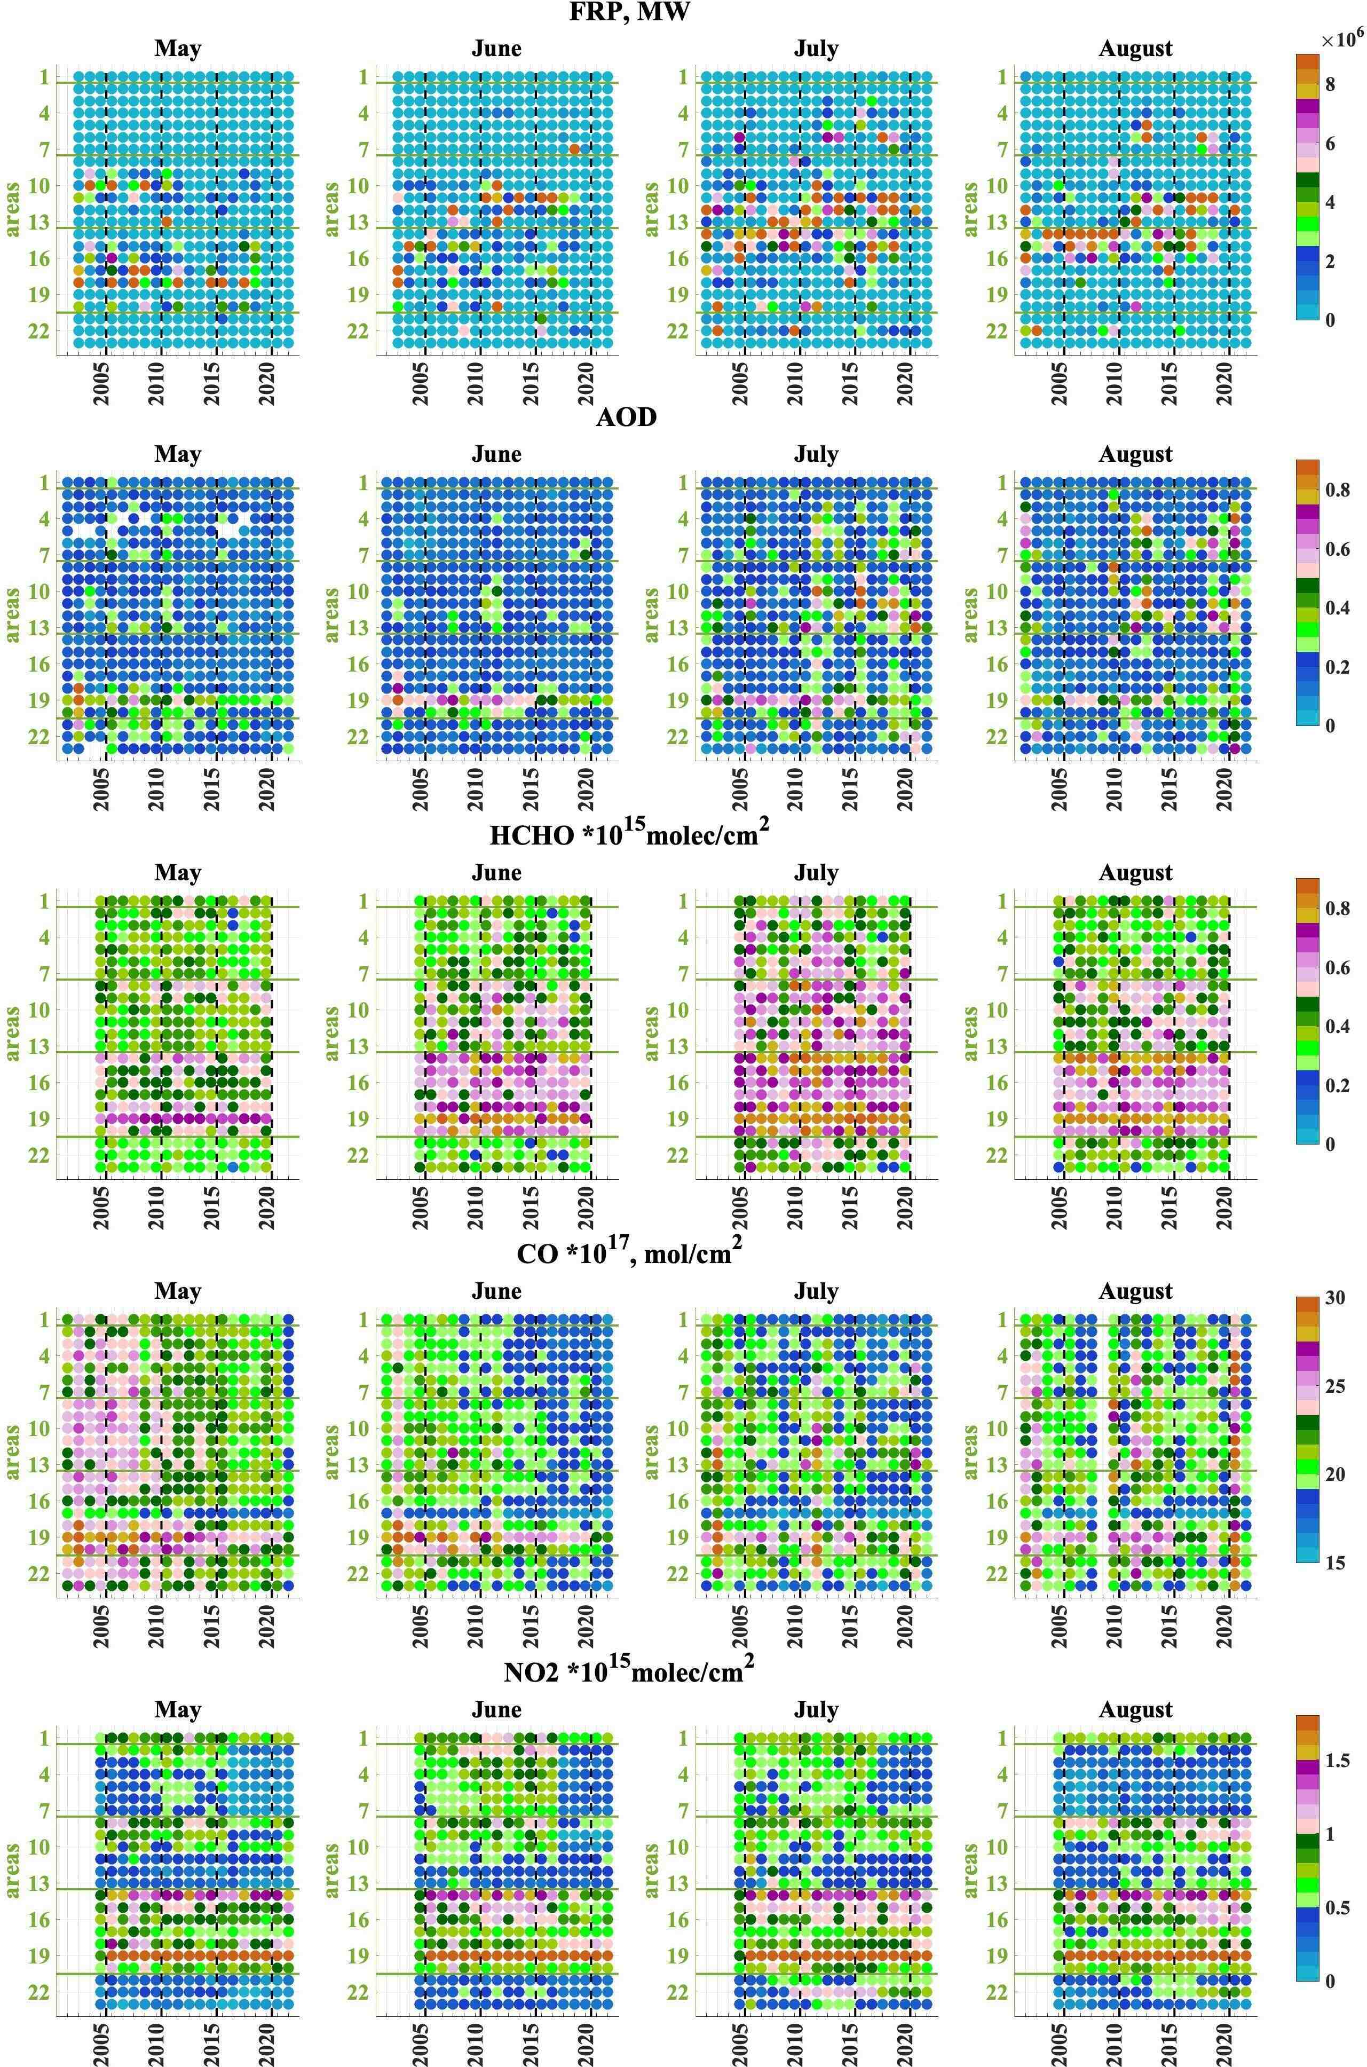
Figure S7: Temporal and spatial distribution of FRP, AOD, HCHO, CO, and NO2 (panels top down) for May–August (panels left to right) for the areas defined in Figure 1 (manuscript), while x-axis shows time (years).
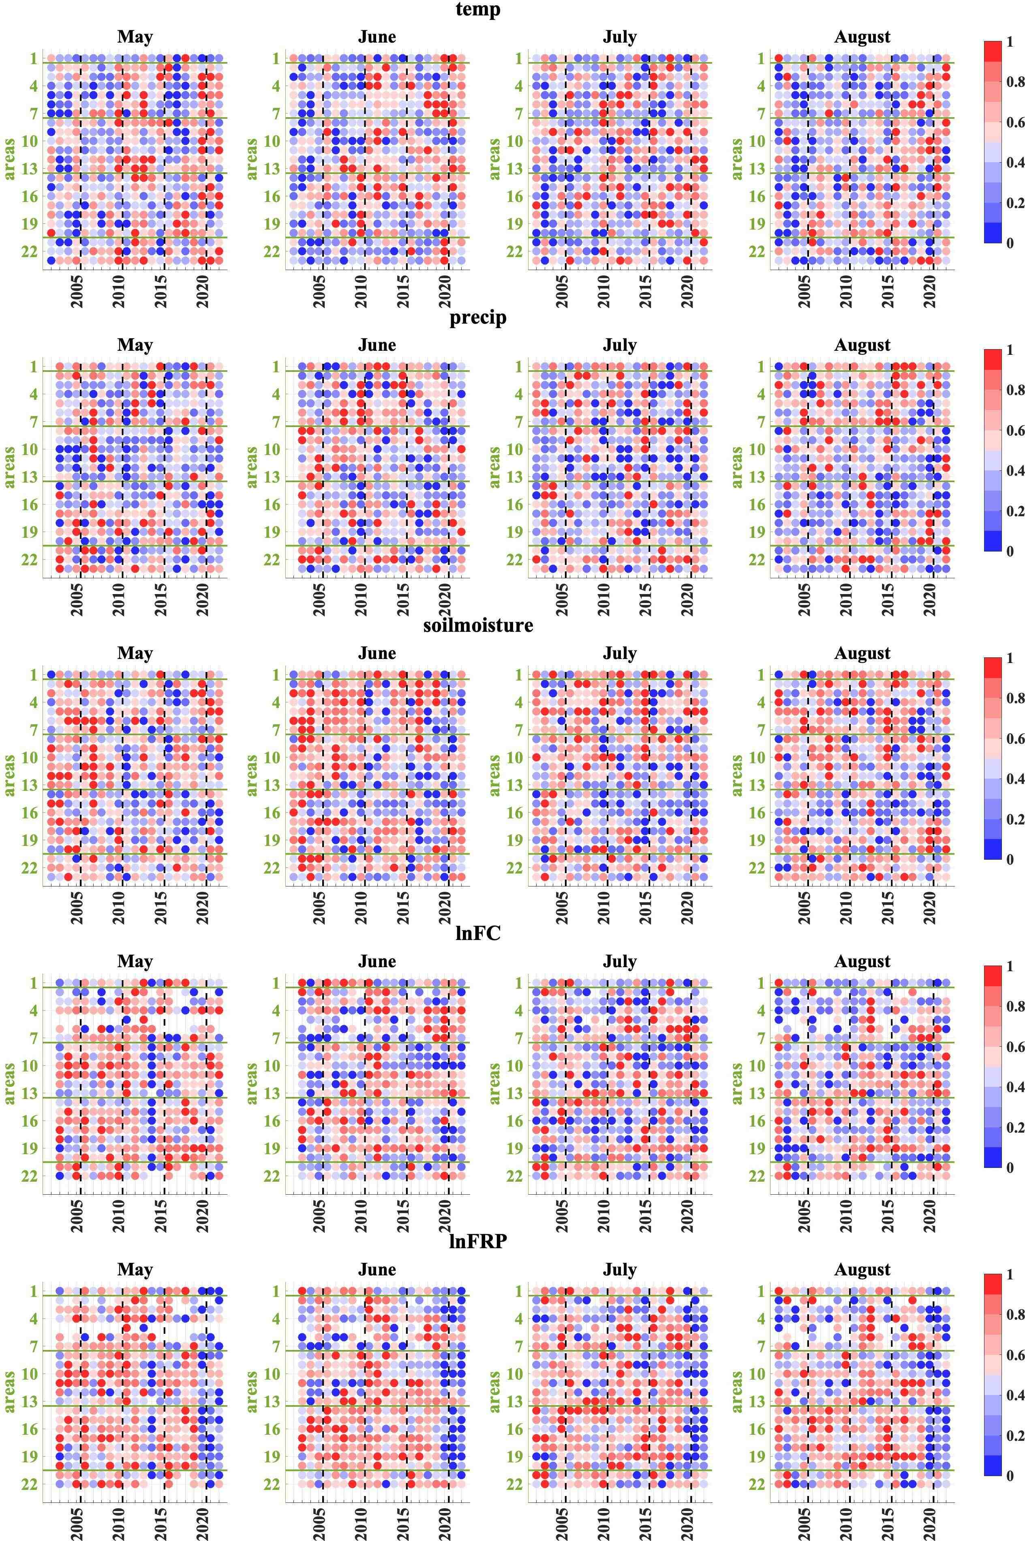
Figure S8: As Figure S6, for scaled anomalies.

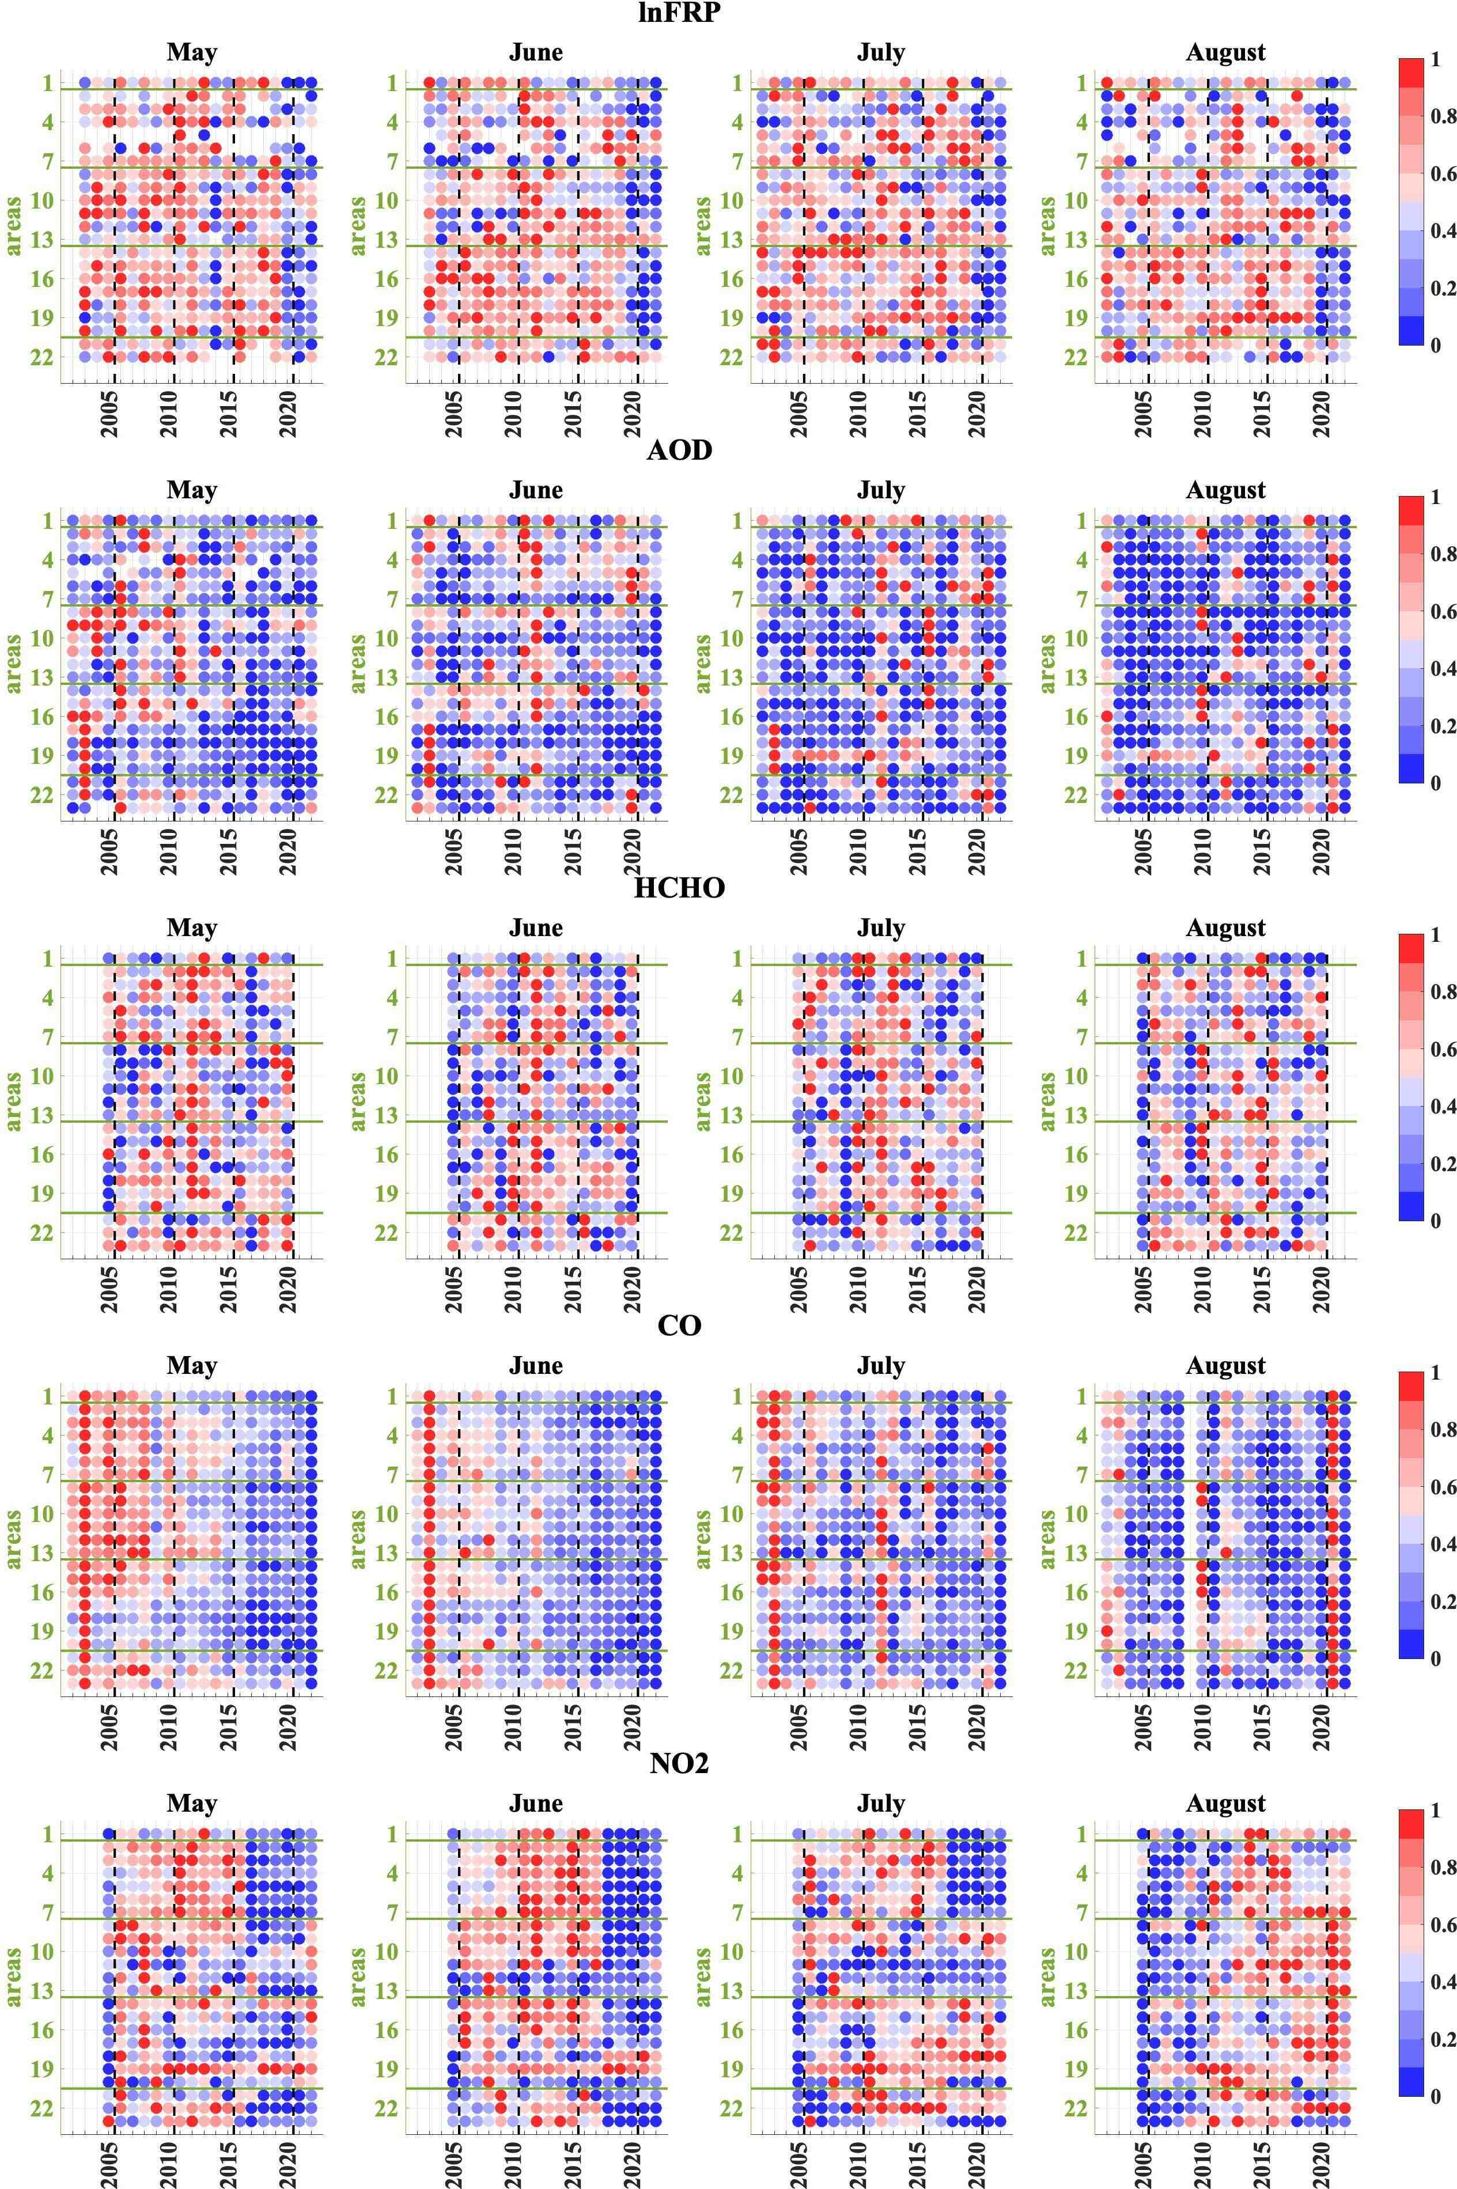
Figure S9: as Figure S7, for scaled anomalies

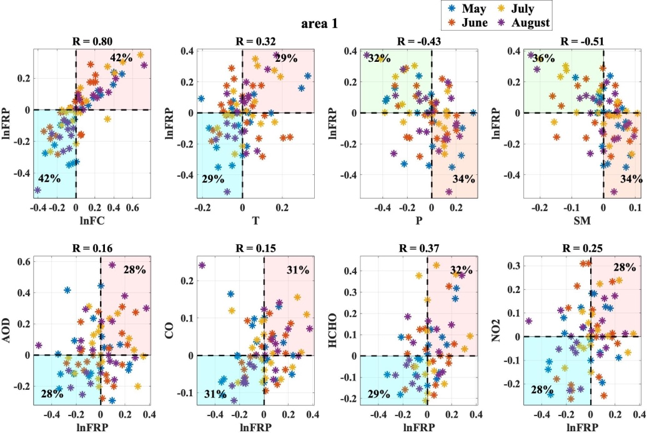
Figure S10: For Scandinavia (area 1), upper panel: Scatterplots for lnFC, temperature (T), precipitation (P), and soil moisture (SM) monthly relative anomalies (x-axis) for years 2002–2022 and FRP relative anomalies (y-axis). Lower panel: Scatterplots for different combinations of lnFRP relative anomalies (x-axis) and AOD, CO, HCHO, and NO2 (y-axis) relative anomalies. Pearson correlation coefficient R is given on top of each panel. Percentages of points (from the total number of points) are shown in the “expected” quarters (e.g., for precipitation and soil moisture “expected” quarters are sector 90º–180º (T<0 or P <0, and FRP>0, coloured light yellow) and sector 270º–360º (T>0 or P >0 , FRP<0, coloured light orange); for other variables “expected” quarters are sector 0º–90º (anomalies are positive for both variables ,coloured light red) and sector 180º–270º (anomalies are negative for both variables ,coloured light blue) ). The color of the dots shows the month (see the legend).
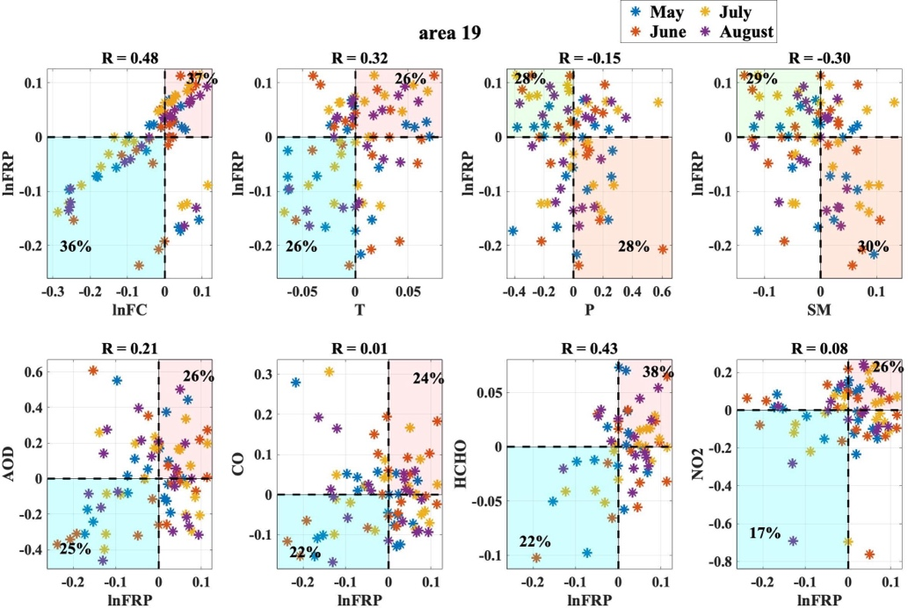
Figure S11: For central China (area 19), as Figure S10

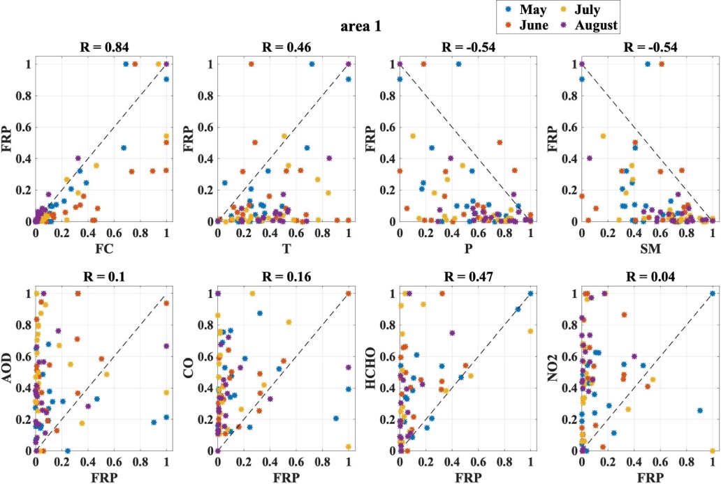
Figure S12: For Scandinavia (area 1), Upper panel: Scatterplots of scaled FC, temperature (T), precipitation (P), soil moisture (SM) (x-axis), and scaled lnFRP (y-axis). Lower panel: Scatterplots scaled lnFRP (x-axis) and scaled AOD, CO, HCHO, and NO₂ (y-axis). The Pearson correlation coefficient R is shown on top of each panel. The color of each fit shows the month (see the legend).
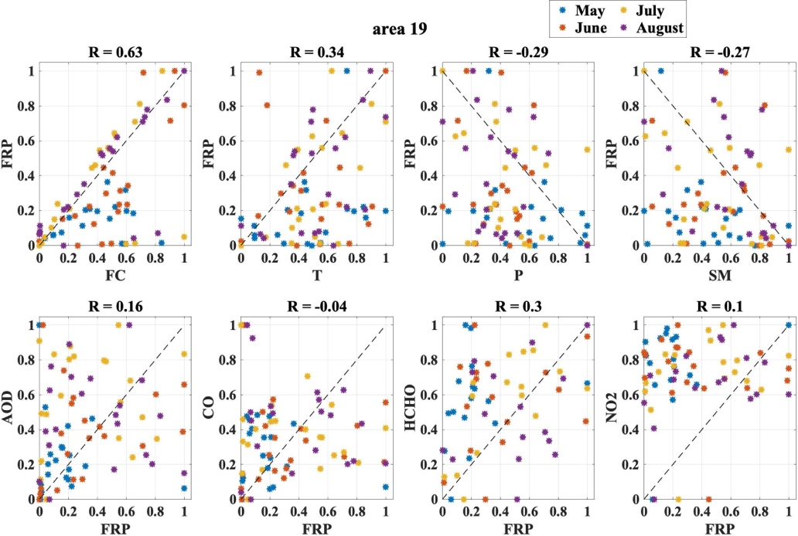
Figure S13: For Scandinavia (area 1), as Figure S12

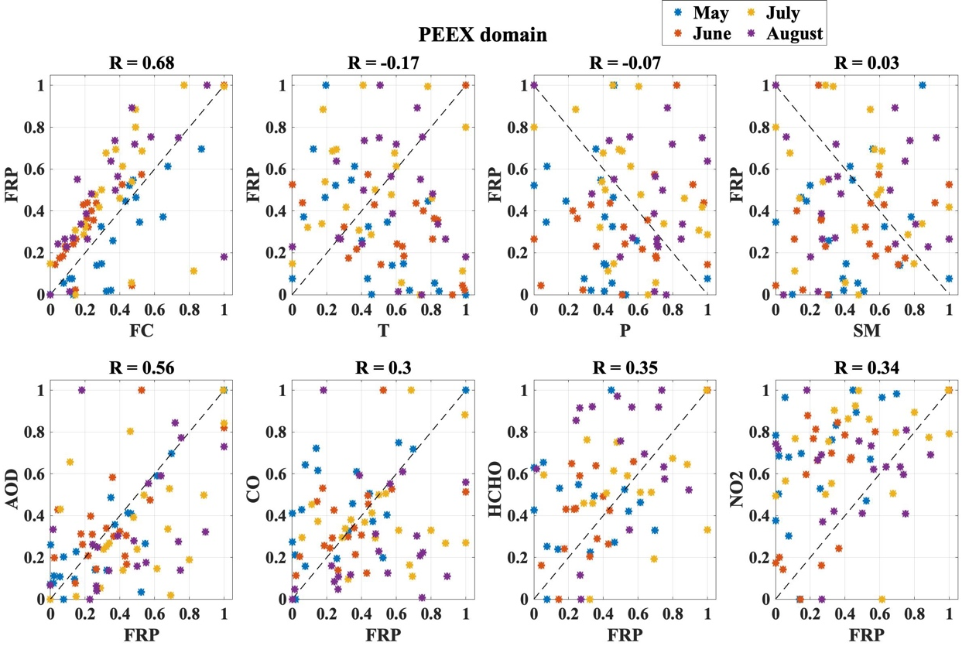
Figure S14: For the PEEX domain, as Figure S12
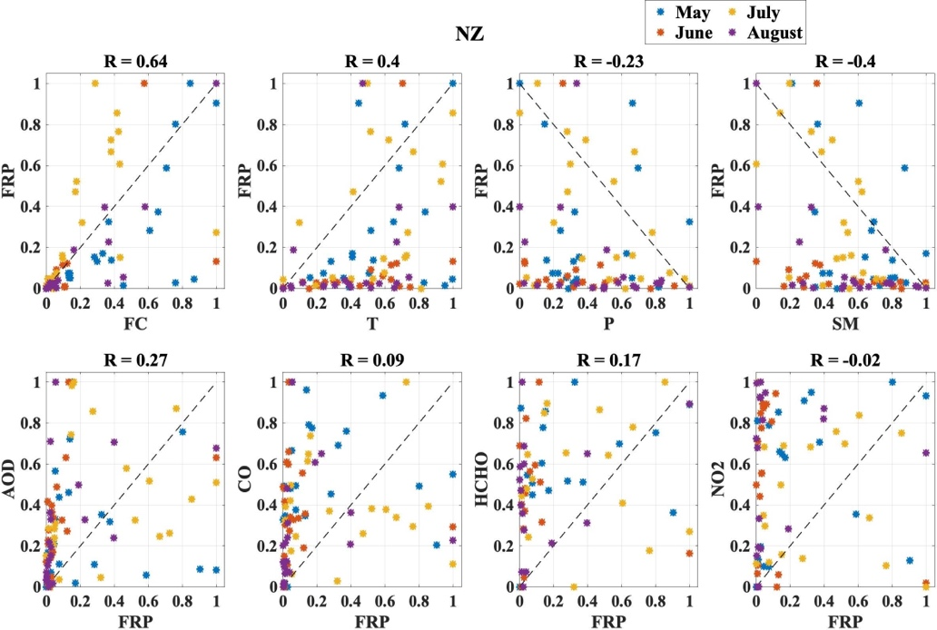
Figure S15: For NZ, as Figure S12
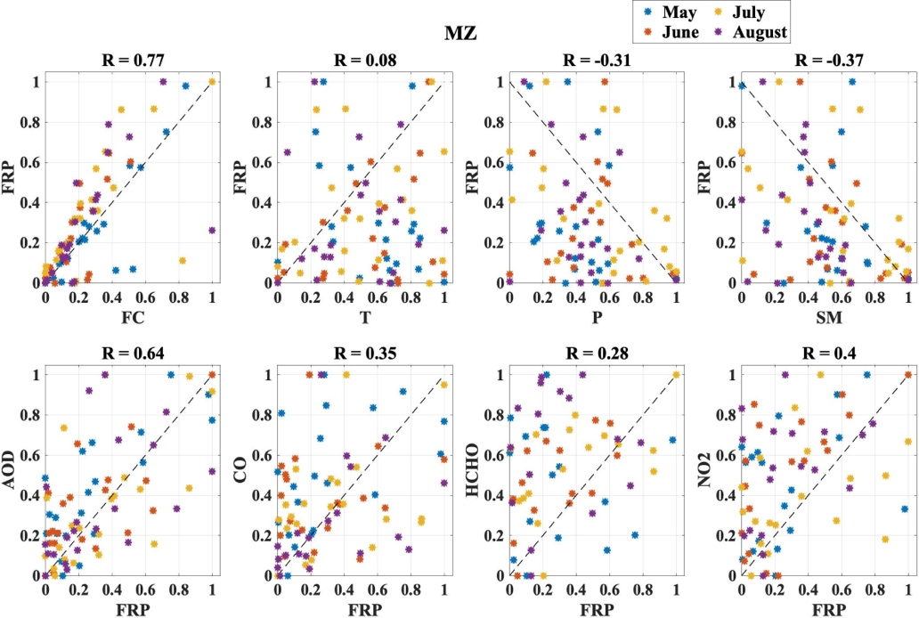
Figure S16: For MZ, as Figure S12
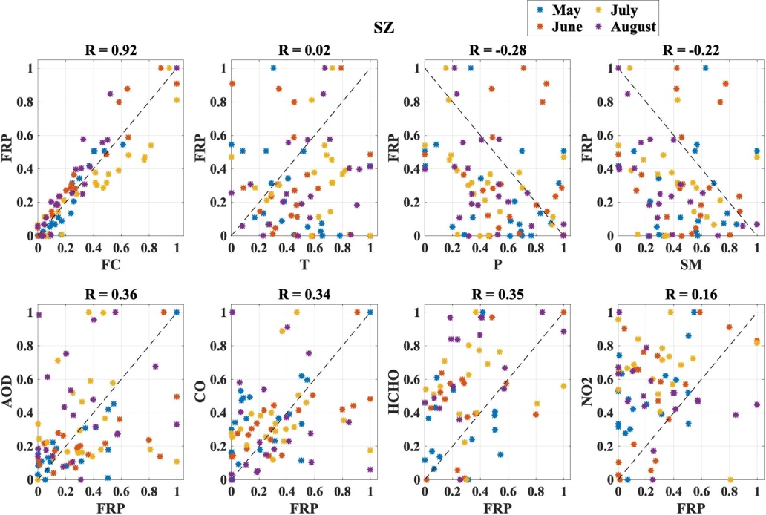
Figure S17: For SZ, as Figure S12

