Supplementary Data
Assessment of metal pollution in the surface sediments of a dried lake in Schirmacher Oasis, East Antarctica

Table S1: Pearson’s coefficients for the parameters used in the study (n=25). Significant correlations (p<0.05) are highlighted in bold.
 | Al | As | Ba | Ca | Co | Cr | Fe | Li | Mg | Mn | Ni | Pb | Sr | Zn | Na | Sand | Silt | Clay | TOC | TIC
Al | 1.00
As | 0.08 | 1.00
Ba | 0.73 | 0.24 | 1.00
Ca | 0.60 | 0.07 | 0.60 | 1.00
Co | 0.22 | 0.28 | 0.33 | 0.07 | 1.00
Cr | 0.21 | 0.27 | 0.28 | -0.05 | 0.98 | 1.00
Fe | 0.27 | 0.33 | 0.36 | 0.09 | 0.98 | 0.98 | 1.00
Li | 0.39 | 0.35 | 0.57 | 0.11 | 0.87 | 0.87 | 0.87 | 1.00
Mg | 0.35 | 0.33 | 0.48 | 0.13 | 0.95 | 0.95 | 0.95 | 0.94 | 1.00
Mn | 0.02 | 0.20 | 0.08 | -0.05 | 0.78 | 0.80 | 0.80 | 0.53 | 0.75 | 1.00
Ni | -0.02 | 0.10 | 0.17 | -0.25 | 0.88 | 0.89 | 0.83 | 0.77 | 0.83 | 0.72 | 1.00
Pb | 0.01 | 0.23 | 0.50 | 0.36 | 0.35 | 0.28 | 0.37 | 0.32 | 0.34 | 0.31 | 0.24 | 1.00
Sr | 0.78 | 0.02 | 0.82 | 0.80 | 0.08 | 0.01 | 0.11 | 0.25 | 0.20 | -0.05 | -0.10 | 0.27 | 1.00
Zn | 0.40 | 0.17 | 0.33 | 0.14 | 0.57 | 0.58 | 0.58 | 0.45 | 0.54 | 0.43 | 0.49 | 0.17 | 0.25 | 1.00
Na | 0.62 | 0.34 | 0.61 | 0.81 | -0.09 | -0.16 | -0.02 | 0.12 | 0.01 | -0.26 | -0.42 | 0.28 | 0.68 | 0.01 | 1.00
Sand | -0.12 | -0.03 | -0.25 | -0.04 | -0.01 | 0.01 | 0.01 | -0.18 | -0.05 | 0.20 | -0.08 | -0.12 | -0.31 | -0.18 | -0.06 | 1.00
Silt | 0.20 | 0.15 | 0.45 | 0.22 | 0.24 | 0.21 | 0.23 | 0.36 | 0.30 | -0.02 | 0.21 | 0.38 | 0.42 | 0.42 | 0.15 | -0.87 | 1.00
Clay | -0.09 | -0.20 | -0.26 | -0.28 | -0.39 | -0.37 | -0.40 | -0.23 | -0.39 | -0.37 | -0.20 | -0.39 | -0.08 | -0.35 | -0.12 | -0.54 | 0.05 | 1.00
TOC | 0.24 | 0.10 | 0.35 | 0.00 | 0.82 | 0.82 | 0.80 | 0.78 | 0.79 | 0.54 | 0.79 | 0.20 | 0.06 | 0.55 | -0.13 | -0.14 | 0.30 | -0.23 | 1.00
TIC | 0.31 | 0.13 | 0.27 | -0.09 | 0.74 | 0.78 | 0.74 | 0.73 | 0.72 | 0.45 | 0.69 | 0.03 | 0.04 | 0.55 | -0.15 | -0.10 | 0.20 | -0.14 | 0.84 | 1.00

Table S2: Loading data along with variance for the significant principal components. Significant components have been highlighted in bold.
 | PC 1 | PC 2
Al | 0.39 | 0.70
As | 0.32 | 0.14
Ba | 0.53 | 0.74
Ca | 0.17 | 0.83
Co | 0.96 | -0.19
Cr | 0.95 | -0.27
Fe | 0.96 | -0.14
Li | 0.92 | 0.05
Mg | 0.97 | -0.06
Mn | 0.72 | -0.35
Ni | 0.83 | -0.43
Pb | 0.41 | 0.30
Sr | 0.26 | 0.88
Zn | 0.66 | 0.08
Na | 0.04 | 0.87
Sand | -0.12 | -0.32
Silt | 0.38 | 0.41
Clay | -0.40 | -0.04
TOC | 0.85 | -0.17
TIC | 0.78 | -0.20
Eigenvalue | 8.63 | 4.17
%variance | 43.16 | 20.86

Table S3: Range of environmental pollution indices
EF | Degree of enrichment
<2 | Minimal enrichment
2-5 | Moderate enrichment
5-20 | Significant enrichment
20-40 | Very high enrichment
>40 | Extremely high enrichment
CF | Degree of contamination
<1 | Low contamination
1-3 | Moderate contamination
3-6 | Considerable contamination
>6 | Very high contamination
Igeo | Level of contamination
<0 | No to weak contamination
0 to 1 | Weak to moderate contamination
1 to 2 | Moderate contamination
2 to 3 | Moderate to strong contamination
3 to 4 | strong contamination
4 to 5 | strong to extreme contamination
>5 | extreme contamination
$$E_{r}^{i}$$ | Ecological risk posed by individual metals
<40 | Low risk
40 - 80 | Moderate risk
80 - 160 | Considerable risk
160 - 320 | High risk
> 320 | Very high risk
PERI | Overall ecological risk
< 150 | Low risk
150 - 300 | Moderate risk
300 - 600 | Considerable risk
> 600 | Very high risk
Table S4: Concentrations of studied metals (in ppm) for each sample along with the mean and standard deviation.
 | Al | As | Ba | Ca | Co | Cr | Fe | Li | Mg | Mn | Ni | Pb | Sr | Zn | Na
DLS_1 | 68132.83 | 4.00 | 1023.38 | 29178.18 | 32.93 | 69.35 | 24999.89 | 13.90 | 7150.93 | 394.96 | 19.71 | 21.17 | 211.51 | 155.05 | 21831.58
DLS_2 | 53816.09 | 5.40 | 747.48 | 26352.05 | 24.31 | 50.74 | 19507.32 | 7.68 | 4861.99 | 336.71 | 13.10 | 18.06 | 156.68 | 111.58 | 19322.61
DLS_3 | 60359.75 | 6.16 | 1060.12 | 27593.21 | 31.06 | 65.64 | 23620.16 | 12.55 | 7493.04 | 471.63 | 19.66 | 20.08 | 218.69 | 136.08 | 20171.11
DLS_4 | 57060.21 | 7.23 | 790.85 | 24599.00 | 24.23 | 55.75 | 22217.37 | 9.12 | 5990.27 | 429.44 | 9.39 | 20.12 | 149.77 | 116.31 | 20349.15
DLS_5 | 62625.41 | 5.67 | 889.06 | 26308.01 | 36.89 | 76.26 | 26435.97 | 14.92 | 9329.31 | 492.37 | 22.39 | 16.85 | 187.25 | 165.95 | 20190.46
DLS_6 | 53469.76 | 7.41 | 766.45 | 22654.78 | 27.07 | 61.84 | 23097.63 | 11.49 | 4676.99 | 320.94 | 14.86 | 17.43 | 140.68 | 136.76 | 20907.48
DLS_7 | 55532.06 | 5.54 | 763.01 | 29039.83 | 38.46 | 73.63 | 26841.11 | 13.16 | 7808.28 | 458.96 | 21.45 | 17.92 | 174.37 | 196.09 | 19576.29
DLS_8 | 62945.61 | 6.81 | 943.53 | 25230.57 | 44.64 | 95.34 | 30392.54 | 18.98 | 10568.94 | 505.69 | 31.97 | 18.58 | 192.86 | 222.33 | 20001.98
DLS_9 | 40681.04 | 3.53 | 547.74 | 19357.67 | 22.99 | 45.86 | 17280.29 | 6.45 | 3004.43 | 323.88 | 26.28 | 17.75 | 122.24 | 119.28 | 14993.18
DLS_10 | 50236.90 | 10.11 | 713.08 | 23911.07 | 36.34 | 74.84 | 25781.36 | 12.72 | 7407.62 | 475.48 | 19.54 | 20.12 | 143.57 | 177.28 | 19848.29
DLS_11 | 57922.16 | 5.10 | 739.01 | 21664.26 | 29.62 | 64.91 | 22270.00 | 9.61 | 6111.94 | 410.59 | 19.59 | 16.16 | 150.75 | 142.03 | 17215.76
DLS_12 | 60104.25 | 6.00 | 740.40 | 24940.53 | 22.29 | 48.21 | 20149.70 | 5.72 | 2944.54 | 374.94 | 10.92 | 15.50 | 186.20 | 194.27 | 19457.66
DLS_13 | 66010.64 | 5.28 | 848.10 | 27875.26 | 26.47 | 52.72 | 21068.09 | 8.99 | 5147.99 | 367.24 | 13.55 | 15.43 | 206.40 | 129.56 | 21271.07
DLS_14 | 64374.98 | 4.99 | 827.87 | 22013.06 | 42.68 | 92.85 | 29645.07 | 15.44 | 9152.79 | 500.81 | 30.99 | 16.47 | 162.67 | 191.72 | 16824.17
DLS_15 | 62763.79 | 3.52 | 689.37 | 24966.62 | 17.86 | 42.47 | 17401.99 | 7.03 | 3673.68 | 378.01 | 9.75 | 15.33 | 180.80 | 88.42 | 19420.33
DLS_16 | 52249.49 | 3.45 | 521.35 | 23295.56 | 29.56 | 67.20 | 23094.08 | 4.89 | 4783.07 | 473.37 | 16.81 | 16.43 | 135.71 | 230.21 | 16160.15
DLS_17 | 65773.26 | 4.37 | 845.42 | 23778.92 | 42.58 | 97.93 | 29677.40 | 15.31 | 9788.67 | 516.42 | 30.21 | 17.34 | 168.80 | 366.25 | 18663.34
DLS_18 | 69918.23 | 6.87 | 1008.21 | 28169.74 | 20.34 | 41.38 | 17881.03 | 8.97 | 4810.57 | 283.69 | 9.39 | 15.87 | 213.89 | 275.43 | 21628.80
DLS_19 | 61528.74 | 6.18 | 970.20 | 23902.78 | 19.09 | 40.64 | 17886.98 | 8.49 | 3875.71 | 309.07 | 7.95 | 18.55 | 200.31 | 179.34 | 19371.42
DLS_20 | 68239.77 | 8.65 | 836.94 | 28787.84 | 31.28 | 62.91 | 24477.72 | 9.26 | 6155.51 | 423.35 | 14.18 | 18.94 | 204.33 | 242.75 | 22077.12
DLS_21 | 50414.25 | 5.91 | 676.53 | 21821.33 | 28.84 | 66.17 | 23299.44 | 8.22 | 6190.01 | 563.70 | 26.00 | 18.10 | 147.99 | 202.58 | 16617.25
DLS_22 | 54195.76 | 7.03 | 681.50 | 24833.95 | 34.72 | 73.91 | 25274.04 | 9.56 | 7509.41 | 507.37 | 21.94 | 17.19 | 169.74 | 176.05 | 18384.67
DLS_23 | 64204.03 | 8.86 | 965.05 | 23495.75 | 51.35 | 117.29 | 34551.69 | 24.34 | 13895.72 | 522.62 | 41.91 | 18.11 | 181.08 | 285.51 | 17834.09
DLS_24 | 58320.55 | 3.01 | 827.43 | 27315.97 | 29.35 | 59.73 | 22726.21 | 10.71 | 6185.26 | 379.82 | 16.98 | 19.37 | 211.19 | 214.17 | 19883.46
DLS_25 | 63420.36 | 6.26 | 1116.72 | 28889.45 | 44.20 | 88.90 | 30581.71 | 14.64 | 9713.83 | 545.49 | 30.05 | 24.95 | 214.51 | 282.54 | 20363.57
Mean | 59372.00 | 5.89 | 821.55 | 25199.02 | 31.57 | 67.46 | 24006.35 | 11.29 | 6729.22 | 430.66 | 25.74 | 18.07 | 177.28 | 189.50 | 19294.60
Standard Deviation | 6883.01 | 1.77 | 150.64 | 2684.74 | 8.85 | 19.50 | 4549.81 | 4.43 | 2623.50 | 80.65 | 21.15 | 2.15 | 28.61 | 65.56 | 1831.69

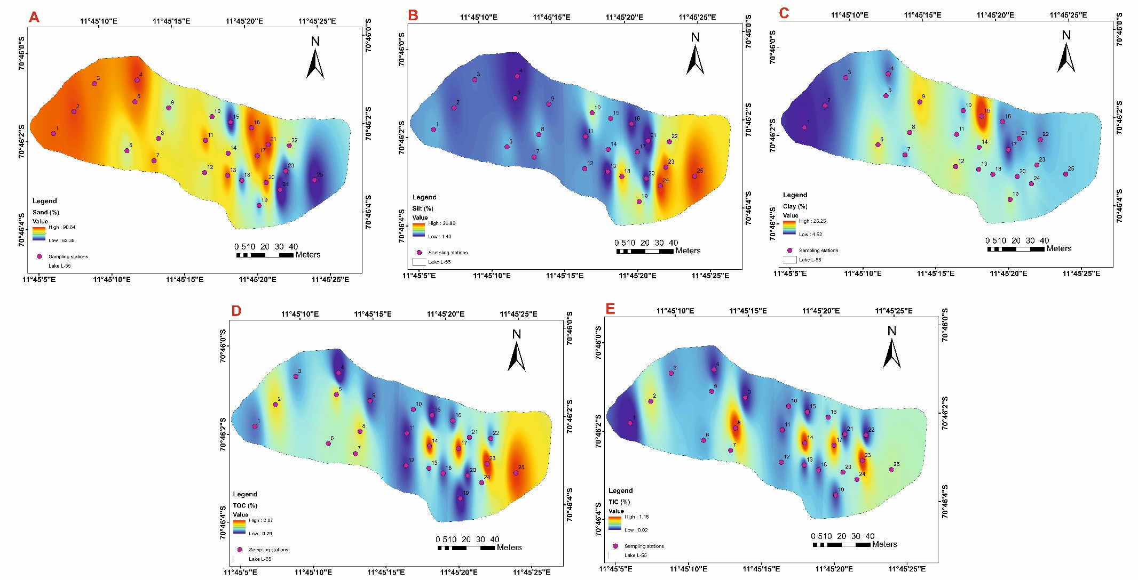

Figure S1: Spatial distribution of %sand, %silt, %clay along with TOC (%) and TIC (%)

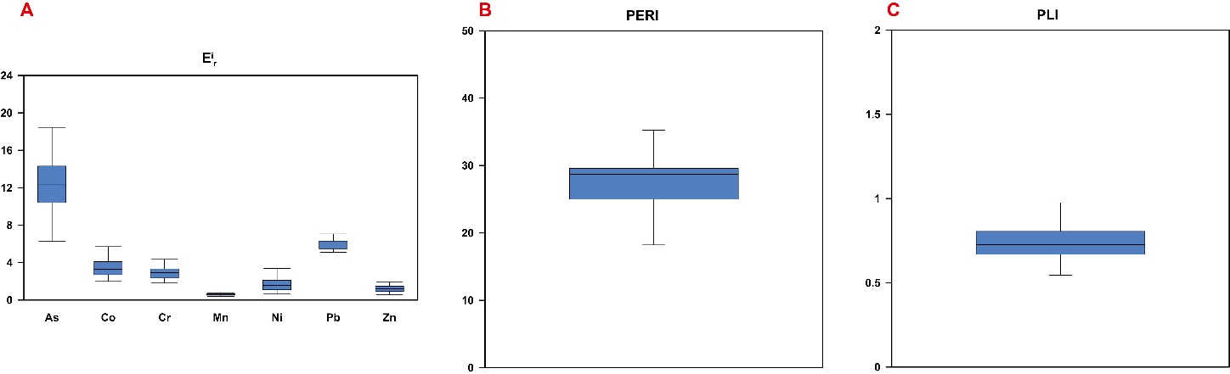

Figure S2: E^{i}_{r}, PERI and PLI

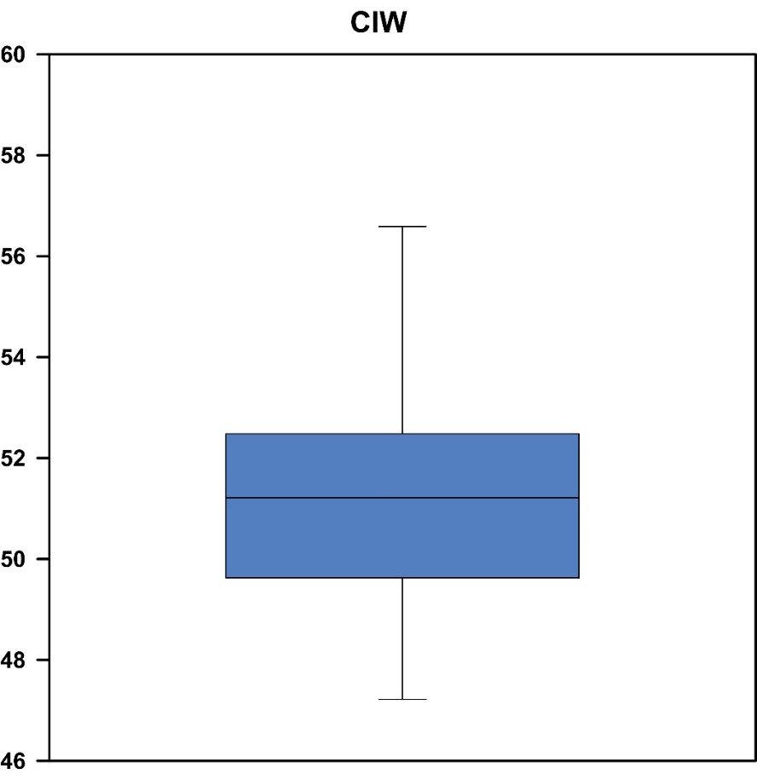

Figure S3: Chemical Index of weathering (CIW) for the sediments of lake L55

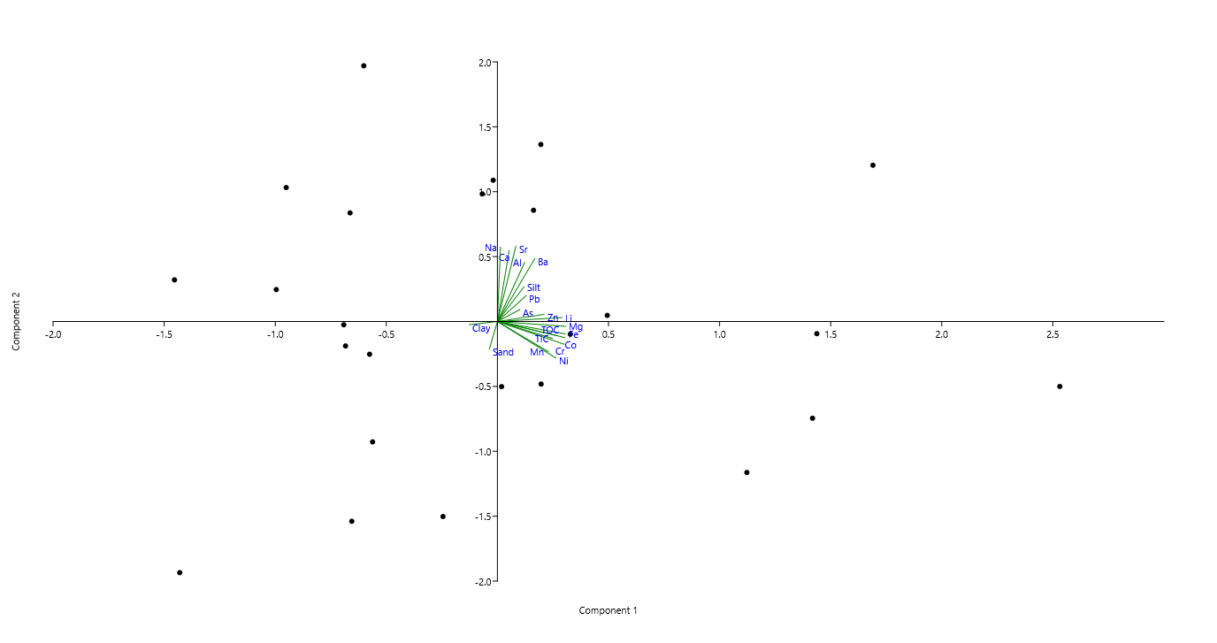
Figure S4: Scatter plot for the principal component analysis

