Supplementary Information for

Comparative evaluation of vegetation greenness trends over circumpolar arctic tundra using multi-sensors satellite datasets

Supplementary Figures

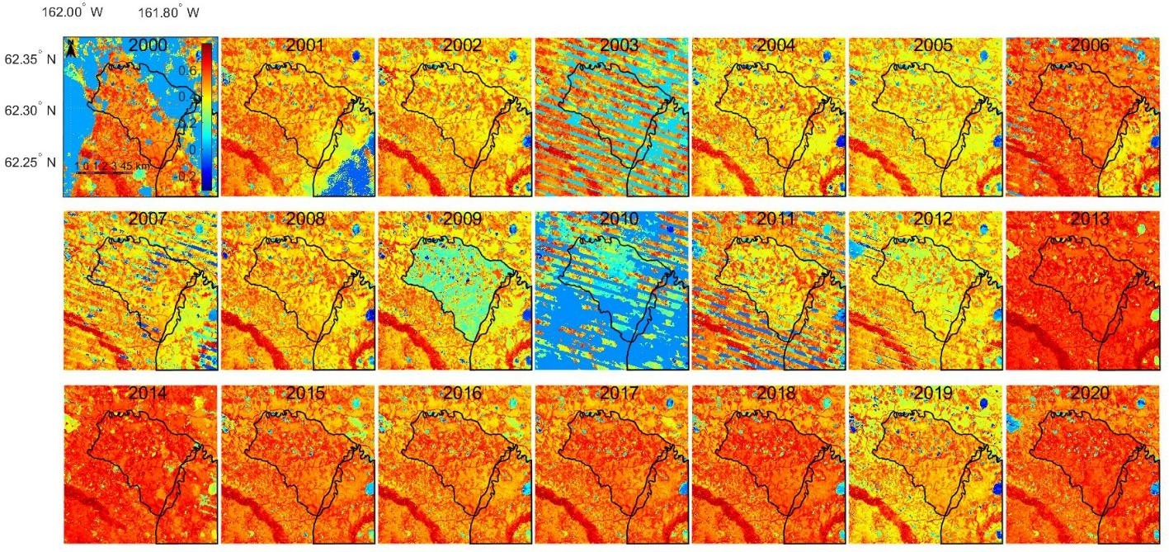
Supplementary Figure 1 Annual maximum NDVI around Allman Lake fire scar in Alaska.

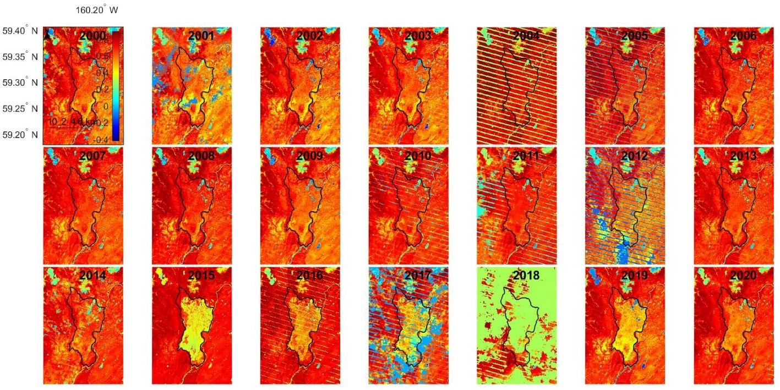
Supplementary Figure 2 Annual maximum NDVI around Gechia Lake fire scar in Alaska.

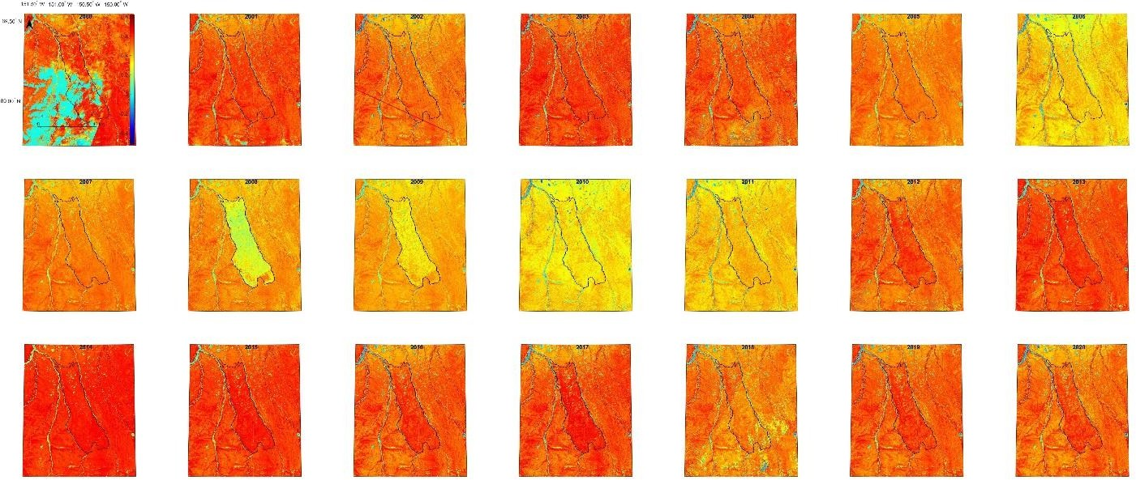

Supplementary Figure 3 Annual maximum NDVI around Anaktuvuk_River fire scar in Alaska.

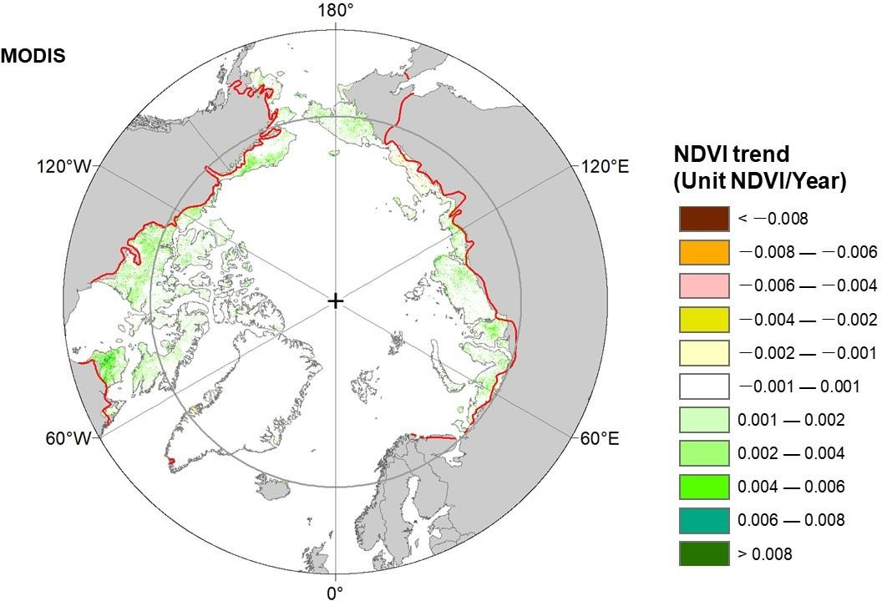
Supplementary Figure 4 Significant greening and browning over circumpolar tundra acquired with MODIS NDVI from 2002 to 2022

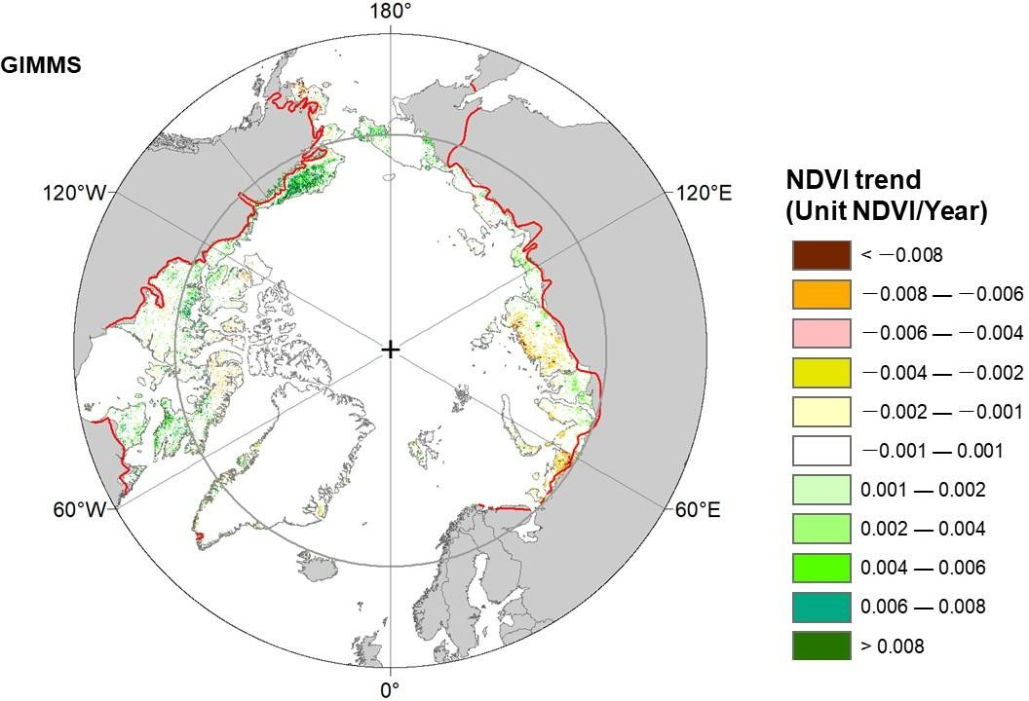

Supplementary Figure 5 Significant greening and browning over circumpolar tundra acquired with GIMMS NDVI from 2000 to 2015

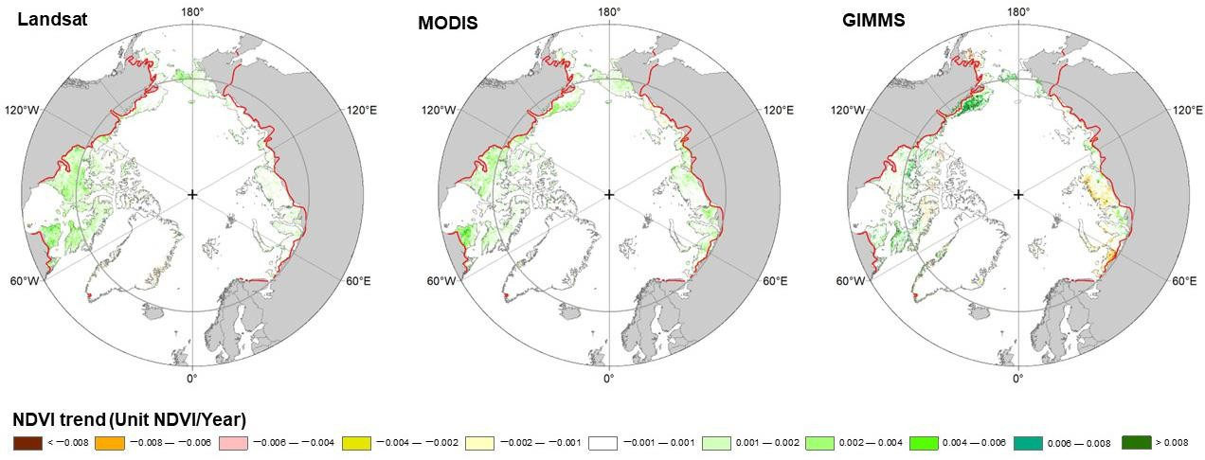
Supplementary Figure 6 Comparison of ssignificant greening and browning over circumpolar tundra acquired with the three datasets

