An efficient continuous kinetic resolution of racemic 2-aminobutanol over immobilized penicillin G acylase

Jianxin Wang, Na Liu, Xiaobo Cheng, Ligong Chen*

Supporting Information

*Corresponding author: Professor Ligong Chen
School of Chemical Engineering and Technology, Tianjin University, Tianjin 300072, People's Republic of China
Tel.: +86 22 27406314
fax: +86 22 27406314
e-mail: lgchen@tju.edu.cn

- Experimental
1.1 General
Penicillin G acylase from Bacillus megaterium immobilized on polymethacrylate was purchased from NovoCata (200U/g). all the other chemicals were purchased from Tianjin Jiangtian Chemical Co., Ltd., Tianjin, China. NMR spectra were recorded on a Bruker 400 MHz spectrometer. Chiral HPLC was performed using a SP-086 Series HPLC (Baseline) with a UV detector and Daicel Chiralpak AS-H column 5×250 mm.

1.2 preparation of N-acylated derivative of racemic 2-aminobutanol -General process
The carboxylic esters (0.08mol) were respectively heated with racemic 2-aminobutanol (0.08 mol) in a 50ml round bottomed flask at 140°C. The reaction was followed by TLC. After the reaction, the residue was then recrystallised from chloroform–hexane.

1.3 Batch experiment – General Procedure
The racemic substrate 3b (0.08g, 0.4mmol) was dissolved in 4ml water by warming, the pH was adjusted to 7.8 with ammonia and immobilized PGA (0.04g) was added. The reaction mixture was stirred at 100 rpm with an overhead stirrer at 40°C. The conversion during the hydrolysis was followed by HPLC.

1.4 Fixed-bed experiment- General Procedure
Immobilized PGA(0.3 g) mixed with silica sand(3.0g) was packed into a glass column with a water-bath for maintaining temperature at 40 °C. it was then fed with 0.1mol/L 3b in ammonia solution (pH=7.8) at various flow rates (0.12, 0.10, 0.08, 0.06, 0.04 and 0.02 mL/min),0.5mL of samples were collected for HPLC analysis.

1.5 Determination of ee value of 2-aminobutanol
Unreacted amide was extracted with ethyl acetate (3×8ml) and the reaction mixture was then acidified to pH 2.5 with 4N HCl. Phenylacetic acid formed during the reaction was extracted with ethyl acetate (3×8ml). The aqueous solution was dealt with equivalent benzoyl chloride at 0℃ for 0.5h. at last, the N-benzoyl-S-2-aminobutanol was collected and determined by chiral HPLC using a chiral HPLC column (Chiralcel AS-H, 5×250 mm, Daicel Chemical Industries Ltd,Japan). Detection wavelength: 254 nm; mobile phase: 20% isopropanol–80% hexane; flow rate: 0.8ml/min; retention times: S 6.0, R 10.4 min.

1.6 Determination of ee value of unreacted substrates(3a-d)
The ethyl acetate layer was washed with 10% Na2CO3 solution to remove traces of phenylacetic acid. The organic layer was dried over magnesium sulphate and evaporated to collect unreacted substrates(3a-d). they were determined by chiral HPLC using a chiral HPLC column (Chiralcel AS-H, 5×250 mm, Daicel Chemical Industries Ltd,Japan). Detection wavelength: 254 nm; mobile phase: 20% isopropanol–80% hexane ( the retention times of 3a: S 6.0, R 10.4 min; the retention times of 3b: S 8.7, R 11.4 min; the retention times of 3c: S 7.9, R 11.1min; the retention times of 3d: S 7.4, R 10.0min.).

2. ¹HNMR spectrum
2.1 2-aminobutanol ¹H NMR (400MHz, CD₃OD)
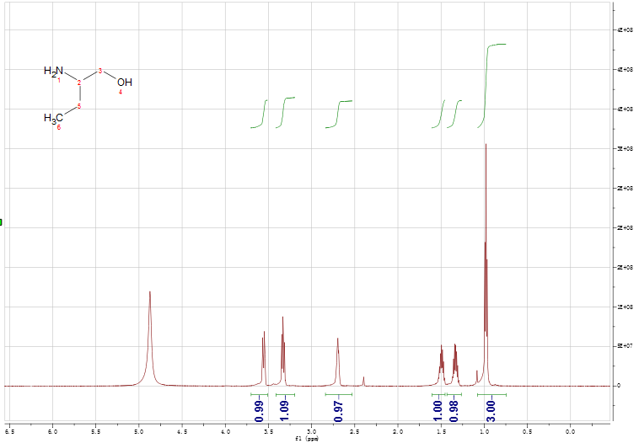

2.2 3a ¹H NMR (400MHz, CDCl₃)
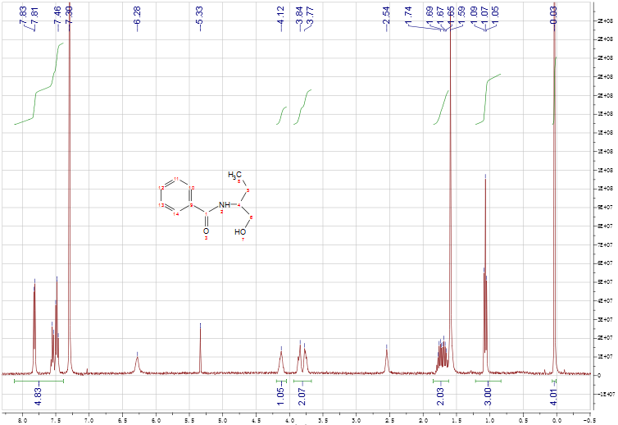

2.3 3b ¹H NMR (400MHz, CD₃OD)
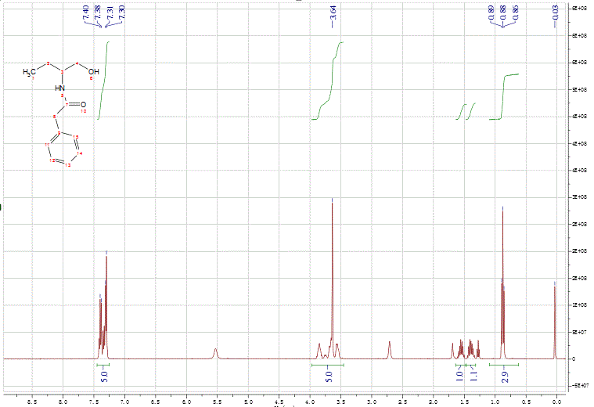

2.4 3c ¹H NMR (400MHz, CD₃OD)
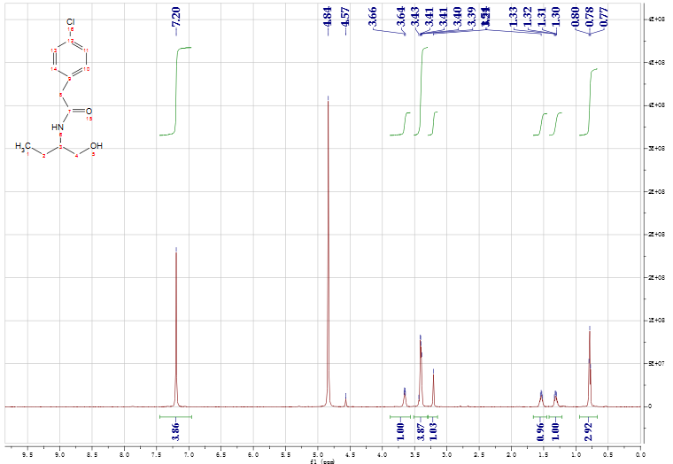

2.5 3d ¹H NMR (400MHz, CD₃OD)
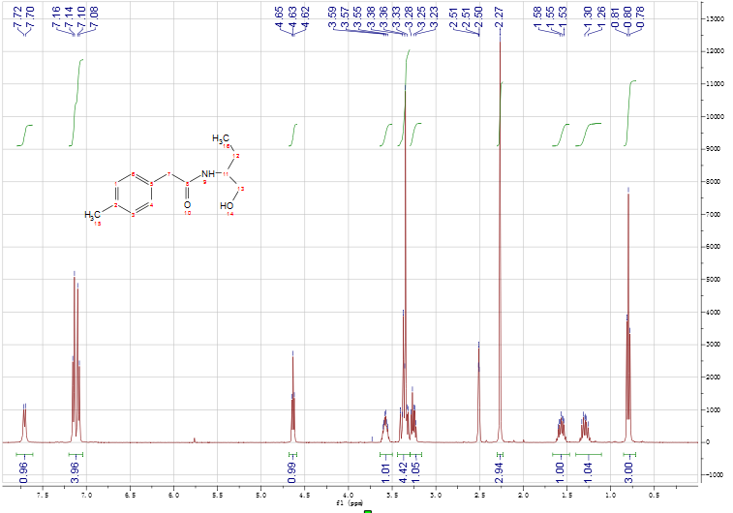

3. The equipment of fixed-bed reactor

