***Support Information***

**Synthesis of pyrido-[2,3-d]pyrimidines’ derivatives (7b-k)**

**5-(4-Chlorophenyl)-2-(ethylthio)-7-(1-methyl-1*H*-pyrrol-2-yl)-4-oxo-3,4,5,8-tetrahydro pyrido[2,3-*d*]pyrimidine-6-carbonitrile (7b)**

White powder, IR (KBr): 3329, 3122 (N-H ), 2191 (C≡N), 1645 (C=O and C=C), 1543, 1495, 1446, 1087 (C-Cl), 800, 731, 703 cm-1; 1H NMR (400 MHz, DMSO-d6): δ 12.46, 10.15 (s, br, 2H, NH), 7.42 (d, 2H, *J* = 8.6 Hz, ArH), 7.34 (d, 2H, *J* = 8.6 Hz, ArH), 6.97 (t, 1H, *J* = 2.2 Hz, ArH), 6.38 (dd, 1H, *J* = 3.8, 1.8 Hz, ArH), 6.11 (dd, 1H, *J* = 3.8, 2.6 Hz, ArH), 4.71 (s, 1H, CH), 3.61 (s, 3H, CH3), 3.12 (q, 2H, *J* = 7.2 Hz, CH2), 1.30 (t, *J* = 7.2 Hz, 3H, CH3); 13C NMR (100 MHz, DMSO-d6): δ 161.9 (C=O), 152.2, 144.4, 142.2, 132.1, 129.7, 129.0, 128.0, 126.4, 124.5, 120.4, 113.0, 108.0, 95.1, 86.0, 39.3 35.0, 24.7, 15.1. mp = 293-295 ºC. Anal. Calcd for C21H18ClN5OS: C, 59.50; H, 4.27; N, 16.52. Found: C, 59.33; H, 4.12, N, 16.36. (Fig S4, S5, S6).

**2-(Ethylthio)-7-(3-hydroxyphenyl)-7-(1-methyl-1*H*-pyrrol-2-yl)-4-oxo-3,4,5,8 tetrahydropyrido[2,3-*d*]pyrimidine-6-carbonitrile (7c)**

Yellow powder; IR (KBr): 3290 (O-H and N-H), 2197 (C≡N), 1645 (C=O), 1606 (C=C), 1380 (C-H bend, CH3), 1242 (C-O, phenol), 870, 789, 733, 687 cm-1. 1H NMR (400 MHz, DMSO-d6): δ 12.42, 10.09 (s, 2H, N-H), 9.42 (s, 1H, OH), 7.13 (t, 1H, *J* = 7.6 Hz, ArH), 6.96 (d, 1H, *J* = 2.0 Hz, ArH), 6.76-6.72 (m, 2H, ArH), 6.64 (dd, 1H, *J* = 7.8, 1.4 Hz, ArH), 6.37 (dd, 1H, *J* = 3.8, 1.8 Hz, ArH), 6.11 (dd, 1H, *J* = 3.6, 2.8 Hz, ArH), 4.57 (s, 1H, CH), 3.60 (s, 3H, CH3), 3.11 (q, 2H, *J* = 7.2 Hz, CH2), 1.30 (t, 3H, *J* = 7.2 Hz, CH3). 13C NMR (100 MHz, DMSO-d6): δ 161.0 (C=O), 158.0, 146.9, 141.9, 130.0, 126.3, 124.7, 120.6, 118.4, 114.6, 112.9, 108.0, 95.4, 86.3, 35.0, 24.7, 15.1. mp = 288-290 ºC. Anal. Calcd for C21H19N5O2S: C, 61.69; H, 4.68; N, 17.13. Found: C, 61.54; H, 4.49; N, 17.25. (Fig S7, S8, S9).

**2-(Ethylthio)-5-(4-(trifluoromethyl)phenyl-7-(1-methyl-1*H*-pyrrol-2-yl)-4-oxo-3,4,5,8- tetrahydropyrido[2,3-*d*]pyrimidine-6-carbonitrile (7d)**

White powder; IR (KBr): 3435, 3248 (N-H), 2202 (C≡N), 1647 (C=O and C=C), 1382 (C-H bend, CH3), 1163 (C-F), 872, 808, 729 cm-1. 1H NMR (400 MHz, DMSO-d6): δ; 12.49, 10.19 (s, br, 2H, N-H), 7.74 (d, 2H, *J* = 8.0 Hz, ArH), 7.56 (d, 2H, *J* = 8.0 Hz, ArH), 6.98 (t, 1H, *J* = 2.0 Hz, ArH), 6.39 (dd, 1H,*J* = 3.8, 1.8 Hz, ArH), 6.11 (dd, 1H, *J* = 3.6, 2.8 Hz, ArH), 4.82 (s, 1H, CH), 3.63 (s, 3H, CH3), 3.11 (q, 2H, *J* = 7.2 Hz, CH2), 1.30 (t, 3H, *J* = 7.2 Hz, CH3). mp = 248-250 ºC. Anal. Calcd for C22H18F3N5OS: C, 59.86; H, 4.11; N, 15.86. Found: C, 59.68; H, 4.21; N, 15.65. (Fig S10, S11).

**5-(4- Bromophenyl)-2-(ethylthio)-7-(1-methyl-1*H*-pyrrol -2- yl)-4-oxo-3,4,5,8-tetrahydro pyrido[2,3-*d*] pyrimidine-6-carbonitrile (7e)**

Yellow powder; IR (KBr): 3379, 3223, 3176 (N-H), 2199 (C≡N), 1645 (C=O and C=C), 1373 (C-H bend, CH3), 1061 (C-Br), 837, 797, 725 cm-1; 1H NMR (400 MHz, DMSO-d6): δ 12.45, 10.15 (s, br, 2H, N-H), 7.56 (d, 2H, *J* = 8.4 Hz, ArH), 7.28 (d, 2H, *J* = 8.4 Hz, ArH), 6.97 (t, 1H, *J* = 2.2 Hz, ArH), 6.37 (dd, 1H, *J* = 3.8, 1.8 Hz, ArH), 6.11 (dd, 1H, *J* = 3.6, 2.8 Hz, ArH), 4.69 (s, 1H, CH), 3.61 (s, 3H, CH3), 3.12 (q, 2H, *J* = 7.2 Hz, CH2), 1.30 (t, 3H, *J* = 7.2 Hz, CH3); 13C NMR (100 MHz, DMSO-d6): δ 161.0 (C=O), 152.2, 144.8, 142.2, 132.0, 130.1, 126.4, 124.5, 120.6, 120.4, 120.1, 113.0, 108.0, 95.0, 85.9, 35.0, 24.7, 15.0. mp = 293-295 ºC Anal. Calcd for C21H18BrN5OS: C, 53.85; H, 3.87; N, 14.95. Found: C, 53.95; H, 3.71; N, 14.78. (Fig S12, S13, S14).

**2-(Ethylthio)-7-(1-methyl-1*H*-pyrrol-2-yl)-5-(3-nitrophenyl)-4-oxo-3,4,5,8-tetrahydropyrido[2,3-*d*]pyrimidine-6-carbonitrile (7f)**

Yellow powder; IR (KBr): 3326, 3223, 3117 (N-H), 2191 (C≡N), 1649 (C=O, and C=C), 1529, 1340 (NO2), 825, 810, 775, 729 cm-1; 1H NMR (400 MHz, DMSO-d6): δ 12.51, 10.27 (s, 2H, N-H), 8.16-8.13 (m, 2H, ArH), 7.85 (d, 1H, *J* = 7.6 Hz, ArH), 7.69 (d, 1H, *J* = 7.6, 0.8 Hz, ArH), 6.99 (t, 1H, *J* = 2.2 Hz, ArH), 6.42 (dd, 1H, *J* = 3.6, 1.6 Hz, ArH), 6.12 (dd, 1H, *J* = 3.8, 2.6 Hz, ArH), 4.94 (s, 1H, CH), 3.65 (s, 3H, CH3), 3.12 (m, 2H, CH2), 1.32 (t, 3H, *J* = 7.2 Hz, CH3); 13C NMR (100 MHz, DMSO-d6): δ 161.8 (C=O), 152.2, 148.4, 142.9, 134.7, 130.7, 126.6, 122.6, 122.3, 120.2 (C≡N), 113.2, 108.0, 94.8, 85.2, 35.0, 24.7, 15.0 ppm. mp˃ 300 ˚C. Anal. Calcd for C21H18N6O3S: C, 58.06; H, 4.18; N, 19.34. Found: C, 58.25; H, 4.02; N, 19.12. (Fig S15, S16, S17).

**5-(2-Chlorophenyl)-2-(ethylthio)-7-(1-methyl-1*H*-pyrrol-2-yl)-4-oxo-3,4,5,8-tetrahydropyrido [2,3-*d*]pyrimidine-6-carbonitrile (7g)**

Yellow powder; IR (KBr): 3288 (N-H), 2158 (C≡N stretch), 1641 (C=O and C=C), 1043 (C-Cl), 879, 827, 737, 694 cm-1; 1H NMR (400 MHz, DMSO-d6): δ 12.38, 10.13 (s, 2H, N-H), 7.40-7.22 (m, 4H, ArH), 6.94 (t, 1H, *J* = 2.2 Hz, ArH), 6.33 (dd, 1H, *J* = 3.6, 1.6 Hz, ArH), 6.09 (dd, 1H, *J* = 3.6, 2.8 Hz, ArH), 5.23 (s, 1H, CH), 3.59 (s, 3H, CH3), 3.12 (m, 2H, CH2), 1.31 (t, 3H, *J* = 7.4 Hz, CH3); 13C NMR (100 MHz, DMSO-d6): δ 162.8 (C=O), 152.9, 142.8, 142.4, 132.2, 131.4, 129.9, 129.1, 128.3, 126.2, 124.6, 119.9 (C≡N), 112.7, 108.0, 94.8, 85.6, 37.5, 34.9, 24.7, 15.1 ppm. mp = 280-281 ºC. Anal. Calcd for C21H18ClN5OS: C, 59.50; H, 4.27; N, 16.52. Found: C, 59.37; H, 4.15, N, 16.32. (Fig S18, S19, S20).

**2-(Ethylthio)-7-(1-methyl-1*H*-pyrrol-2-yl)-4-oxo-3,4,5,8- tetrahydro-5-phenylpyrido[2,3-*d*] pyrimidine-6-carbonitrile (7h)**

Yellow powder; IR (KBr): 3306 (N-H), 2197 (C≡N), 1645 (C=O and C=C), 1380 (C-H bend, CH3), 829, 727, 694 cm-1; 1H NMR (400 MHz, DMSO-d6): δ; 12.43, 10.12 (s, 2H, N-H), 7.38-7.24 (m, 5H, ArH), 6.96 (t, 1H, *J* = 2.0 Hz, ArH), 6.37 (dd, 1H, *J* = 3.6, 1.6 Hz, ArH), 6.11 (dd, 1H, *J* = 3.6, 2.8 Hz, ArH), 4.67 (s, 1H, CH), 3.60 (s, 3H, CH3), 3.12 (q, 2H, *J* = 7.2 Hz, CH2), 1.30 (t, 3H, *J* = 7.2 Hz, CH3); 13C NMR (100 MHz, DMSO-d6): δ 159.6 (C=O), 154.2, 145.5, 142.0, 129.1, 127.8, 127.5, 126.4, 125.4, 124.6, 120.5 (C≡N), 112.9, 108.0, 95.4, 86.4, 35.0, 30.9, 24.7, 15.1. mp = 296-298 ºC. Anal. Calcd for C21H19N5OS: C, 64.76; H, 4.92; N, 17.98. Found: C, 64.58; H, 4.81; N, 17.76. (Fig S21, S22, S23).

**2-(Ethylthio)-7-(1-methyl-1*H*-pyrrol-2-yl)-5-(4-nitro-phenyl)-4-oxo-3,4,5,8-tetrahydropyrido [2,3-*d*]pyrimidine-6-carbonitrile (7i)**

Yellow powder; IR (KBr): 3337, 3220 (N-H), 2193 (C≡N), 1645 (C=O and C=C), 1533, 1342 (NO2), 866, 822, 739, 692 cm-1; 1H NMR (400 MHz, DMSO-d6): δ 12.51, 10.24 (s, 2H, N-H), 8.25 (d, 2H, *J* = 8.8 Hz, ArH), 7.61 (d, 2H, *J* = 8.8 Hz, ArH), 6.98 (t, 1H, *J* = 2.0 Hz, ArH), 6.39 (dd, 1H, *J* = 3.6, 1.6 Hz, ArH), 6.11 (dd, 2H, *J* = 3.4, 2.6 Hz, ArH), 4.89 (s, 1H, CH), 3.62 (s, 3H, CH3), 3.12 (q, 2H, *J* = 7.2 Hz, CH2), 1.32 (t, 3H, *J* = 7.2 Hz, CH3); 13C NMR (100 MHz, DMSO-d6): δ 162.8 (C=O), 152.4, 147.0, 142.8, 129.3, 126.6, 124.4, 124.3, 123.4, 120.2 (C≡N), 113.1, 108.1, 94.9, 85.2, 36.3, 35.0, 24.8, 15.0. mp = 292-294 ºC. Anal. Calcd for C21H18N6O3S: C, 58.06; H, 4.18; N, 19.34. Found: C, 57.91; H, 4.06; N, 19.17. (Fig S24, S25, S26).

**2-(Ethylthio)-7-(1-methyl-1*H*-pyrrole-2-yl)-4-oxo-3,4,5,8-tetra hydro-5-phenyl Pyrido[2, 3 - *d*] pyrimidine-6-carbonitrile (4j)**

Yellow powder; IR (KBr): 3230, 3174 (N-H), 2198 (C≡N), 1647 (C=O and C=C), 1380 (C-H bend, CH3), 846, 795, 698 cm-1; 1H NMR (400 MHz, DMSO-d6): δ; 12.53, 10.27 (s, 2H, N-H), 7.40 (t, 1H, *J* = 2.0 Hz, ArH), 7.04-6.88 (m, 3H, ArH), 6.41 (dd, 1H, *J* = 3.8, 1.8 Hz, ArH), 6.13 (dd, 1H, *J* = 3.8, 2.6 Hz, ArH), 5.02 (s, 1H, CH), 3.61 (s, 3H, CH3), 3.10 (1, 2H, *J* = 7.3 Hz, CH2), 1.28 (t, 3H, *J* = 7.3 Hz, CH3) ppm; 13C NMR (100 MHz, DMSO-d6): δ 162.8 (C=O), 151.9, 149.5, 142.3, 139.7, 127.5, 126.7, 125.6, 125.4, 124.4, 120.5 (C≡N), 113.2, 108.1, 95.5, 85.3, 35.1, 30.9, 24.7, 15.0. mp = 275-277 ºC. Anal. Calcd for C19H17N5OS2: C, 57.70; H, 4.33; N, 17.71. Found: C, 57.48; H, 4.12; N, 17.55. (Fig S27, S28, S29).

**2-(Ethylthio)-7-(1-methyl-1*H*-pyrrol-2-yl)-4-oxo-3,4,5,8-tetrahydro-5-phenylpyrydo[2,3-*d*] pyrimidine-6-carbonitrile (7k)**

White powder, mp˃ 300 ºC. IR (KBr): 3234, 3186 (N-H), , 2841 (OMe), 2197 (C≡N), 1645 (C=O and C=C), 1385 (C-H bend, CH3), 1244, 1028 (C-O-C), 843, 802, 727 cm-1; 1H NMR (400 MHz, DMSO-d6): δ 12.40, 10.05 (s, 2H, N-H), 7.22 (d, 2H, *J* = 8.4 Hz, ArH), 6.96 (s, 1H, ArH), 6.91 (d, 2H, *J* = 8.4 Hz, ArH), 6.35 (d, 1H, *J* = 2.0 Hz, ArH), 6.11 (t, 1H, *J* = 3.2 Hz, ArH), 4.60 (s, 1H, CH), 3.74 (s, 3H, CH3), 3.61 (s, 3H, CH3), 3.10 (q, 2H, *J* = 7.2 Hz, CH3), 1.29 (t, 3H, *J* = 7.2 Hz, CH3); 13C NMR (100 MHz, DMSO-d6): δ; 162.8 (C=O), 158.7, 151.9, 141.8, 137.9, 128.8, 126.2, 125.4, 124.7, 120.7 (C≡N), 114.4, 112.8, 108.0, 95.8, 86.6. 55.5, 38.9, 35.0, 24.7, 15.1. Anal. Calcd for C22H21N5O2S: C, 62.99; H, 5.05; N, 16.69. Found: C, 62.72; H, 4.81; N, 16.47. (Fig S30, S31, S32).

**7a: 1H NMR**

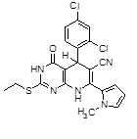

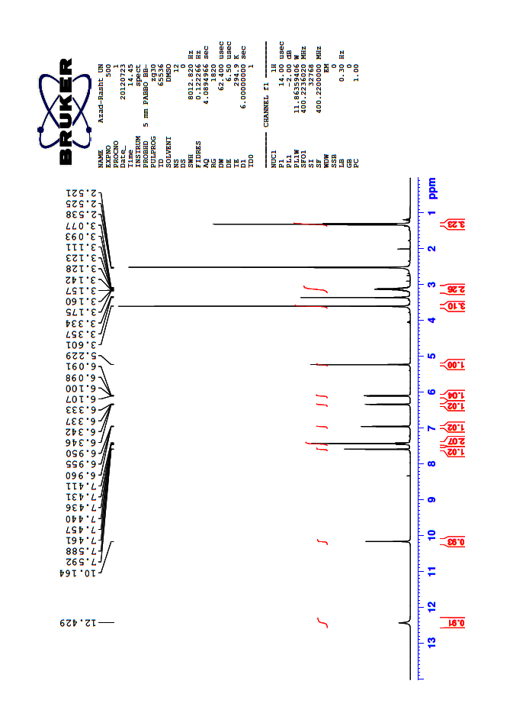

**Fig S1.**

**7a: 13C NMR**

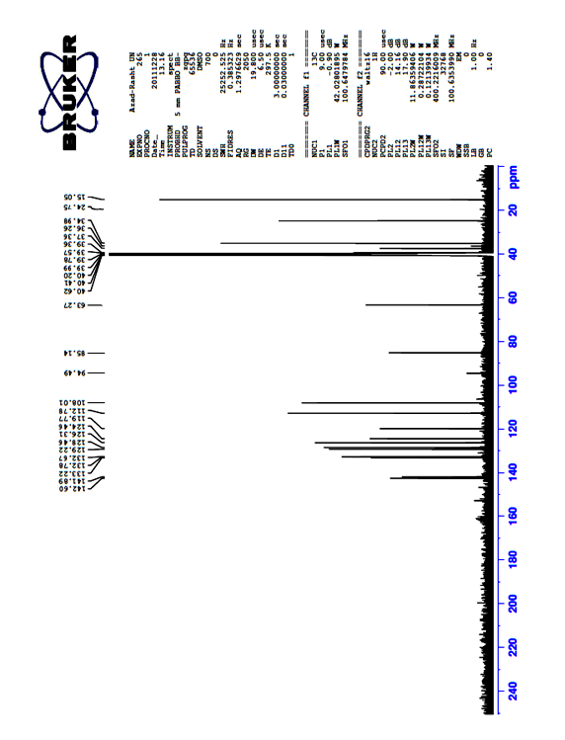



**Fig S2.**

**7a: IR**

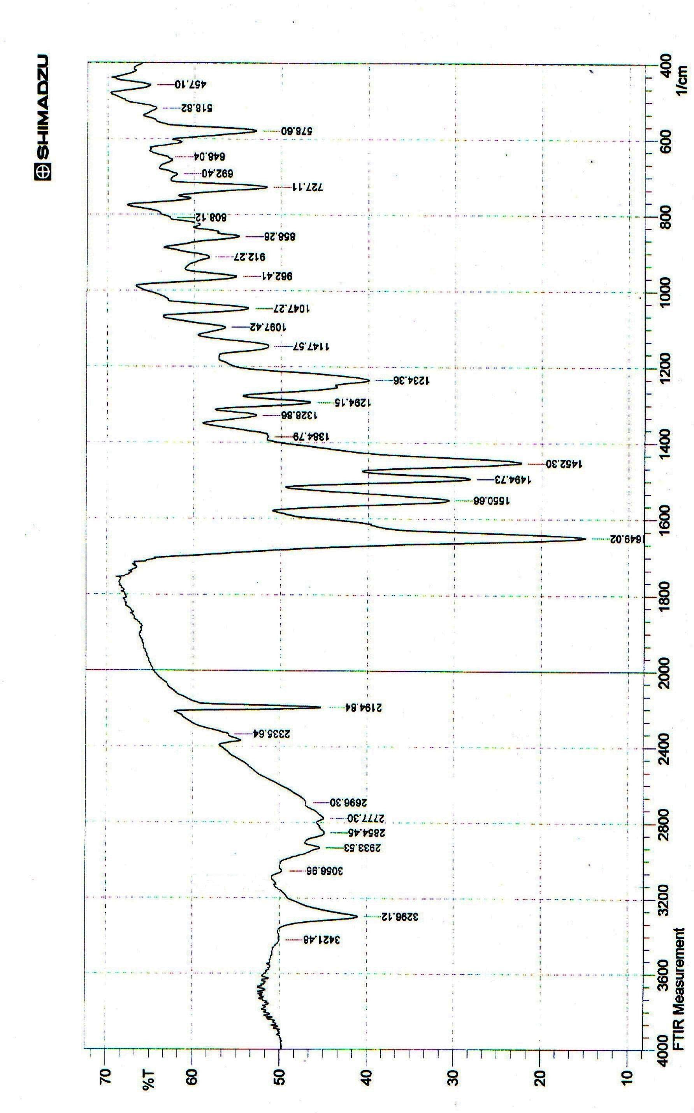



**Fig S3.**

**7b: 1H NMR**

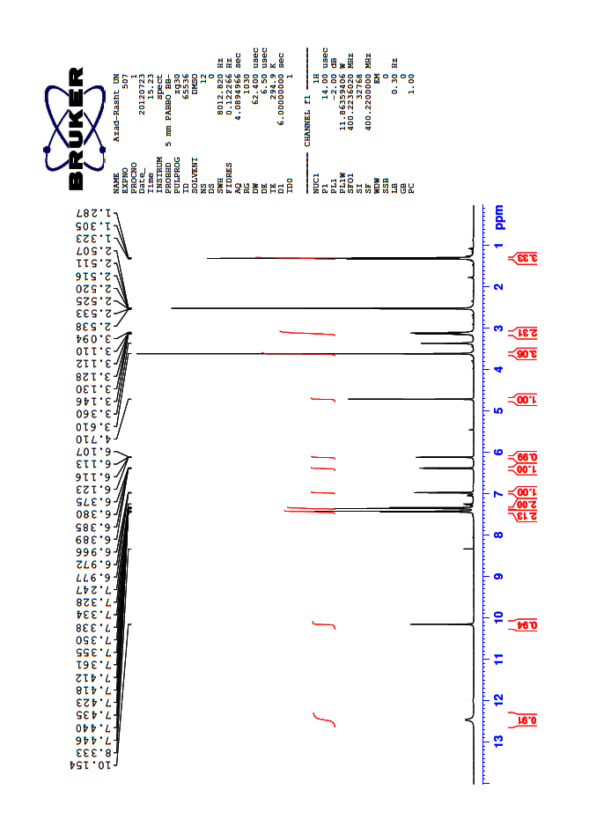

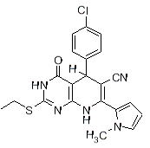

**Fig S4.**

**7b: 13C NMR**

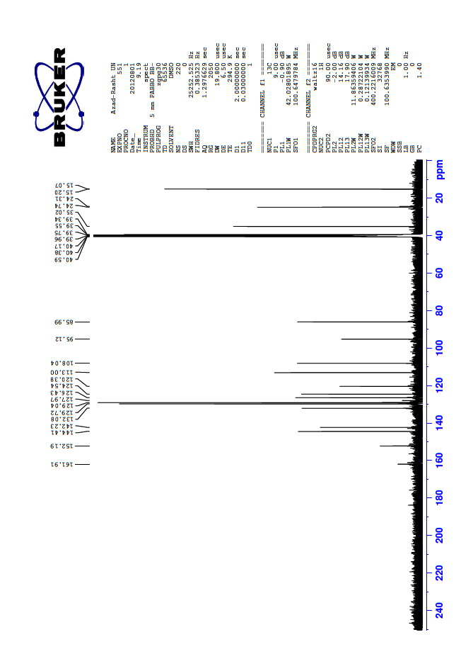



**Fig S5.**

**7b: IR**

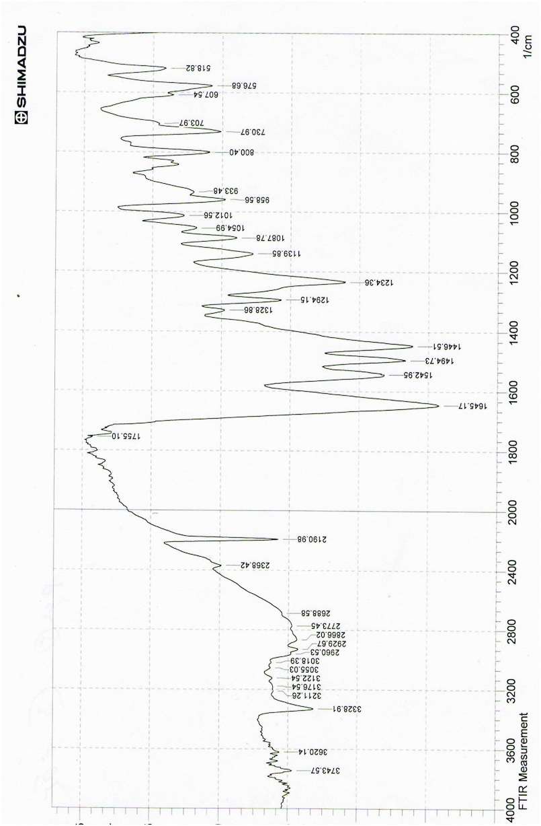



**FigS6.**

**7c: 1H NMR**

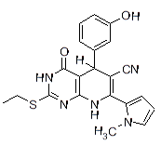

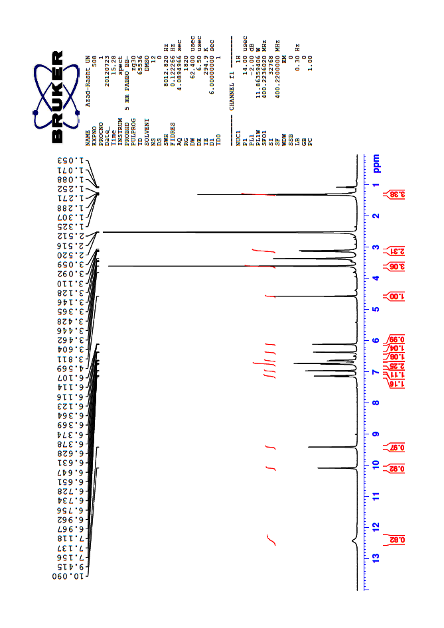

**Fig S7.**

**7c: 13C NMR**

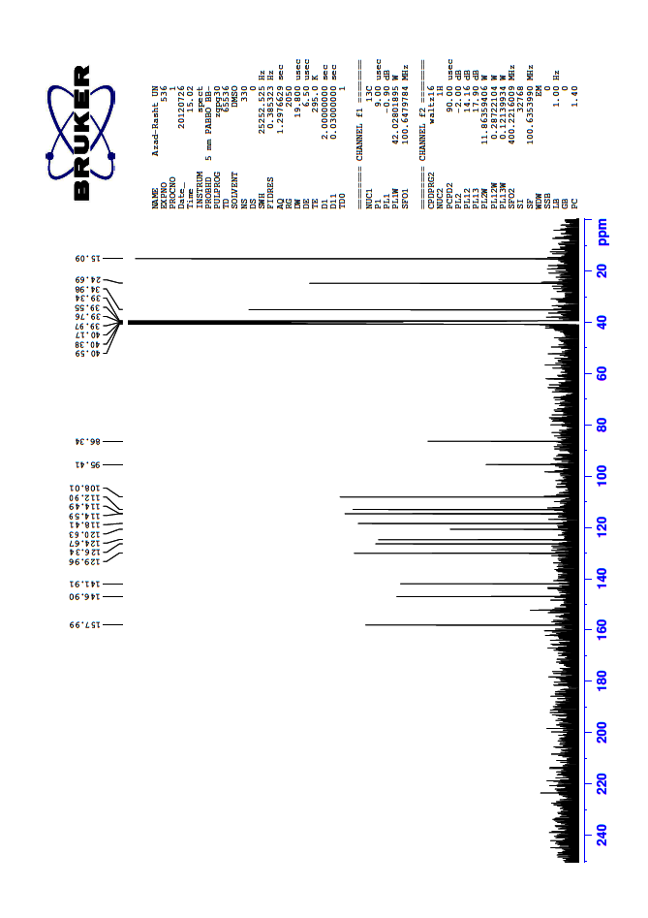



**Fig S8.**

**7c: IR**

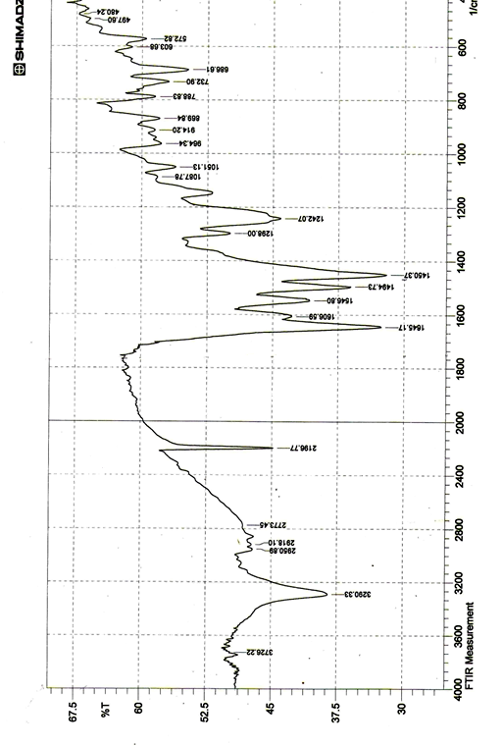



**Fig S9.**

**7d: 1H NMR**

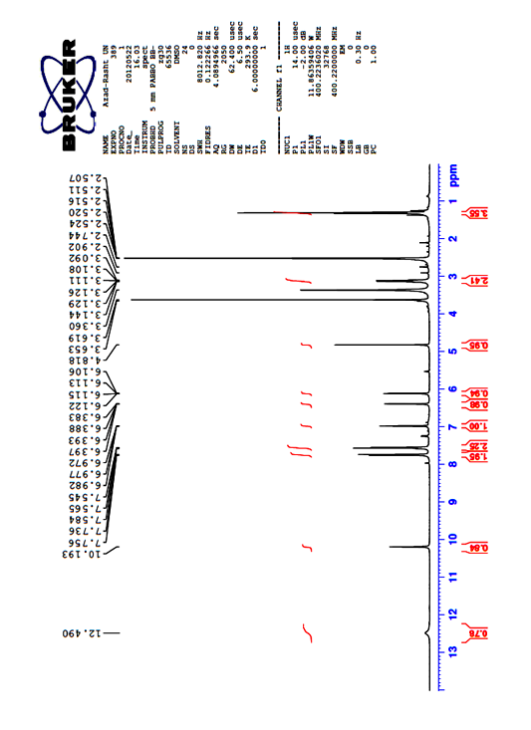



**Fig S10.**

**7d:IR**

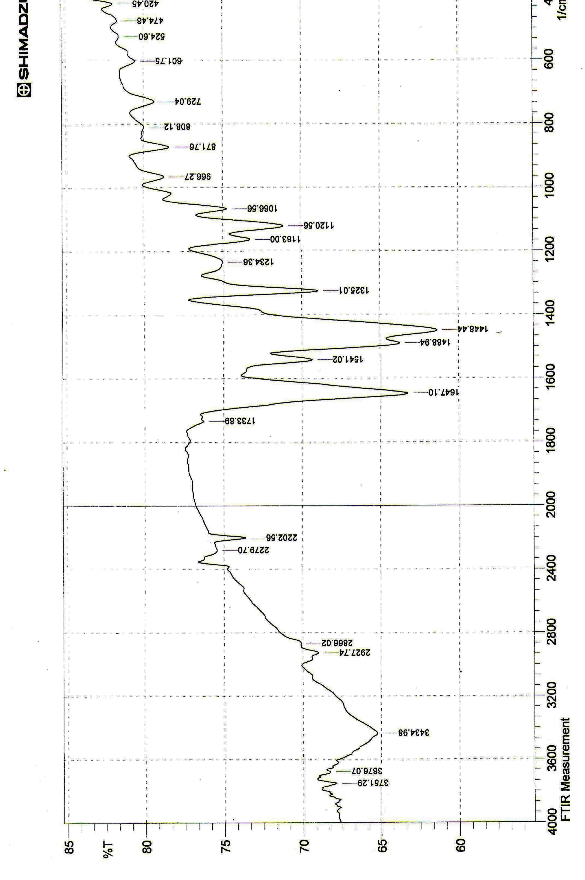



**Fig S11.**

**7e: 1H NMR**

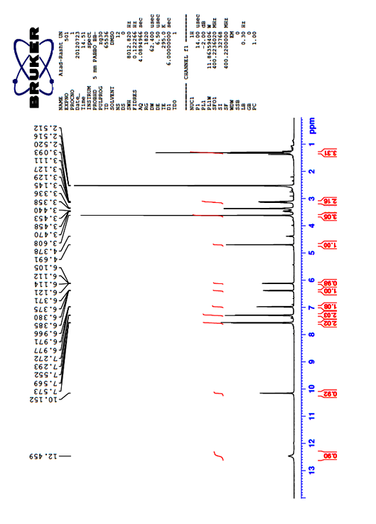



**Fig S12.**

**7e: 13C NMR**

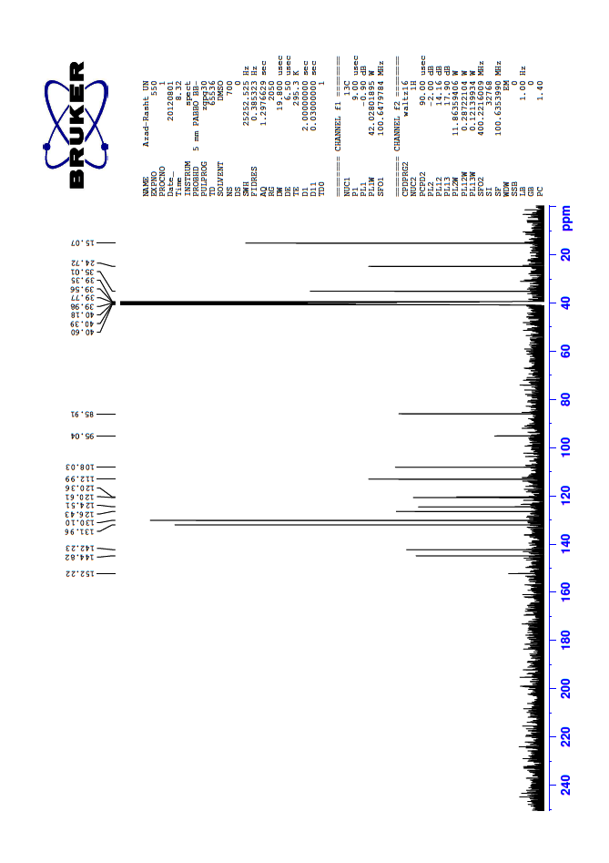



**Fig S13.**

**7e:IR**

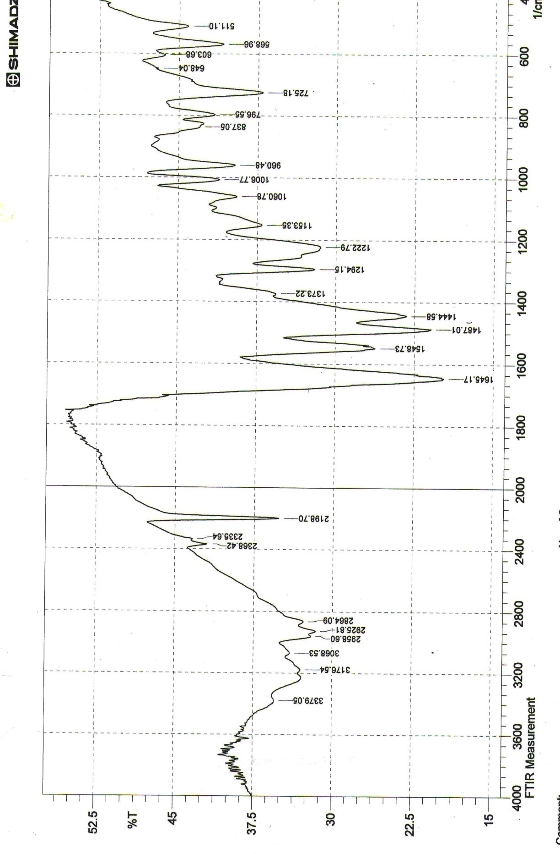



**Fig S14.**

**7f: 1H NMR**

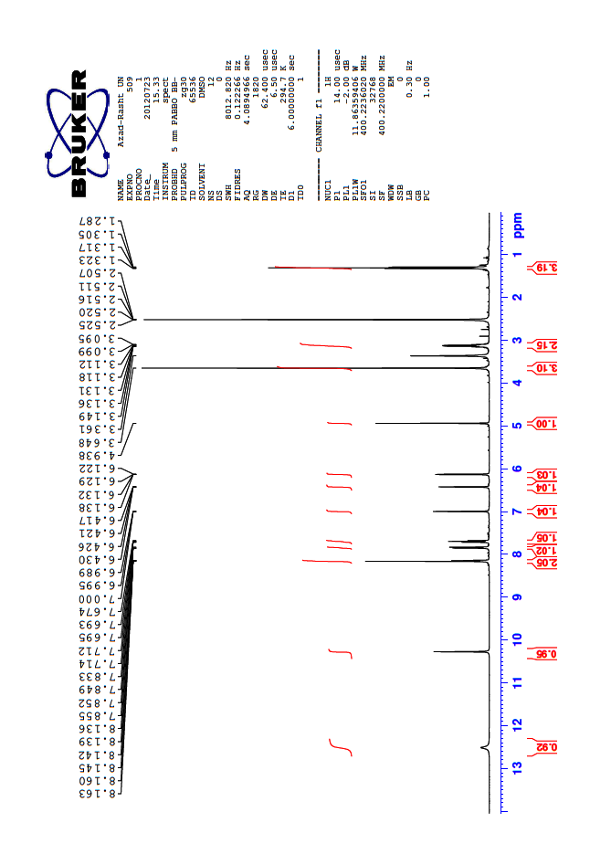

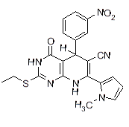

**Fig S15.**

**7f: 13C NMR**

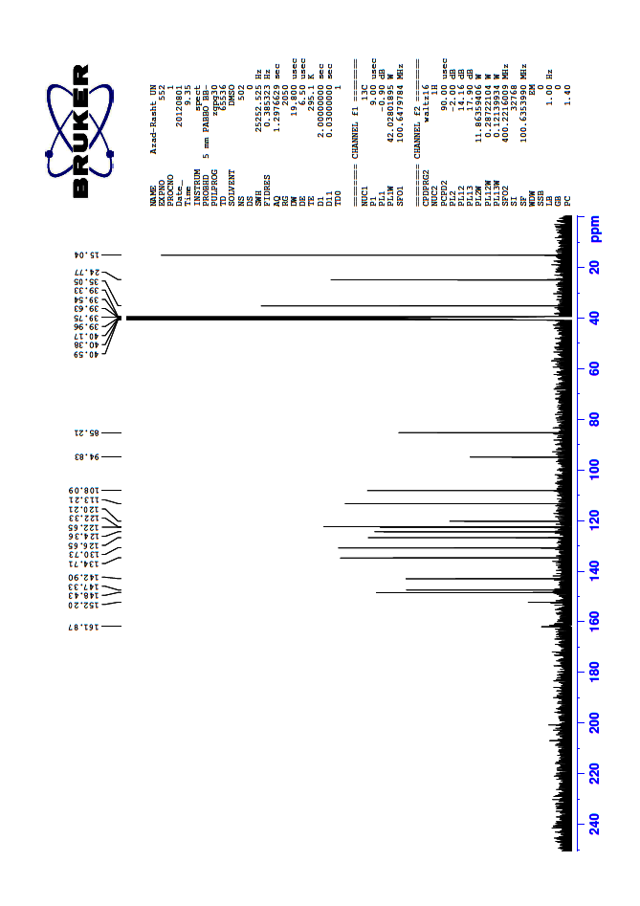



**Fig S16.**

**7f: IR**

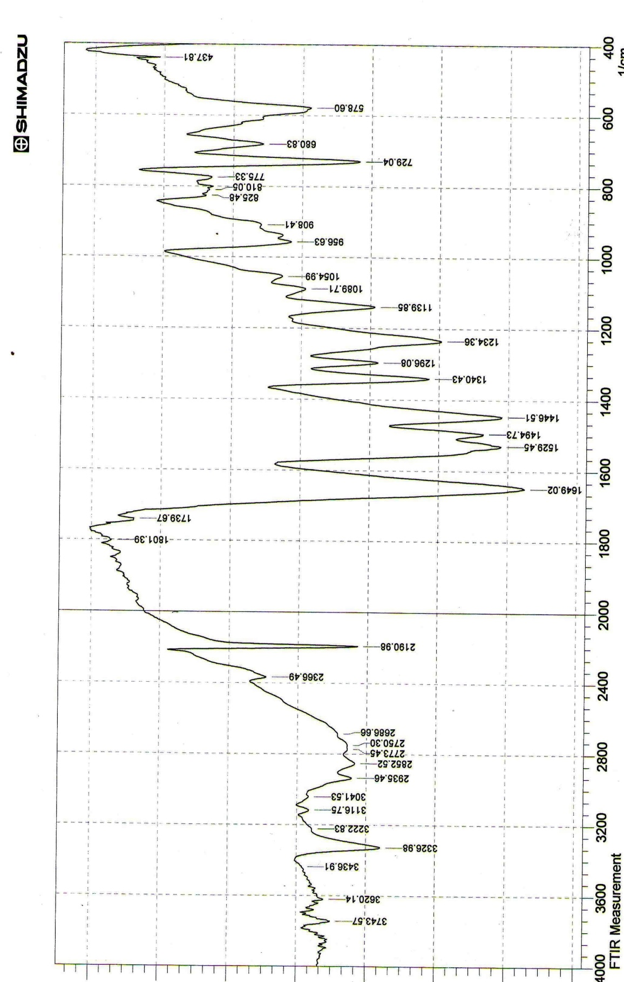



**Fig S17.**

**7g: 1H NMR**

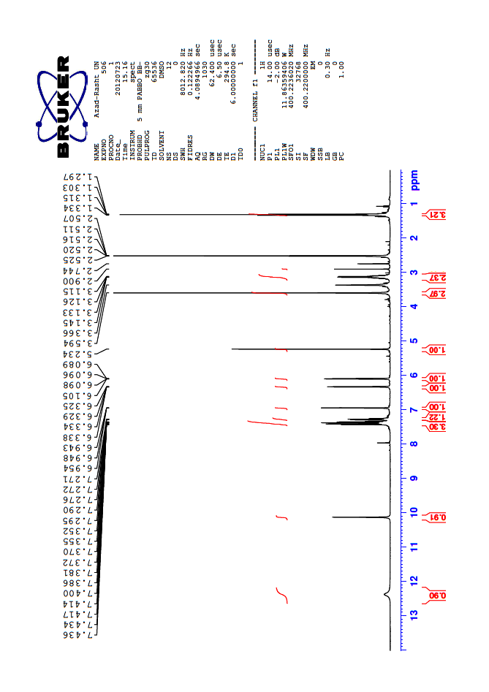

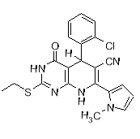

**Fig S18.**

**7g: 13C NMR**

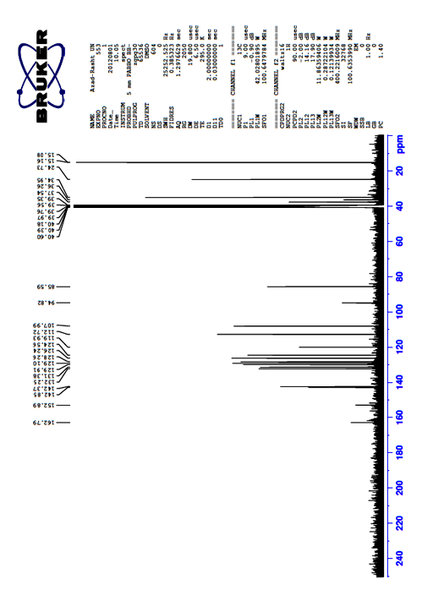



**Fig S19.**

**7g: IR**

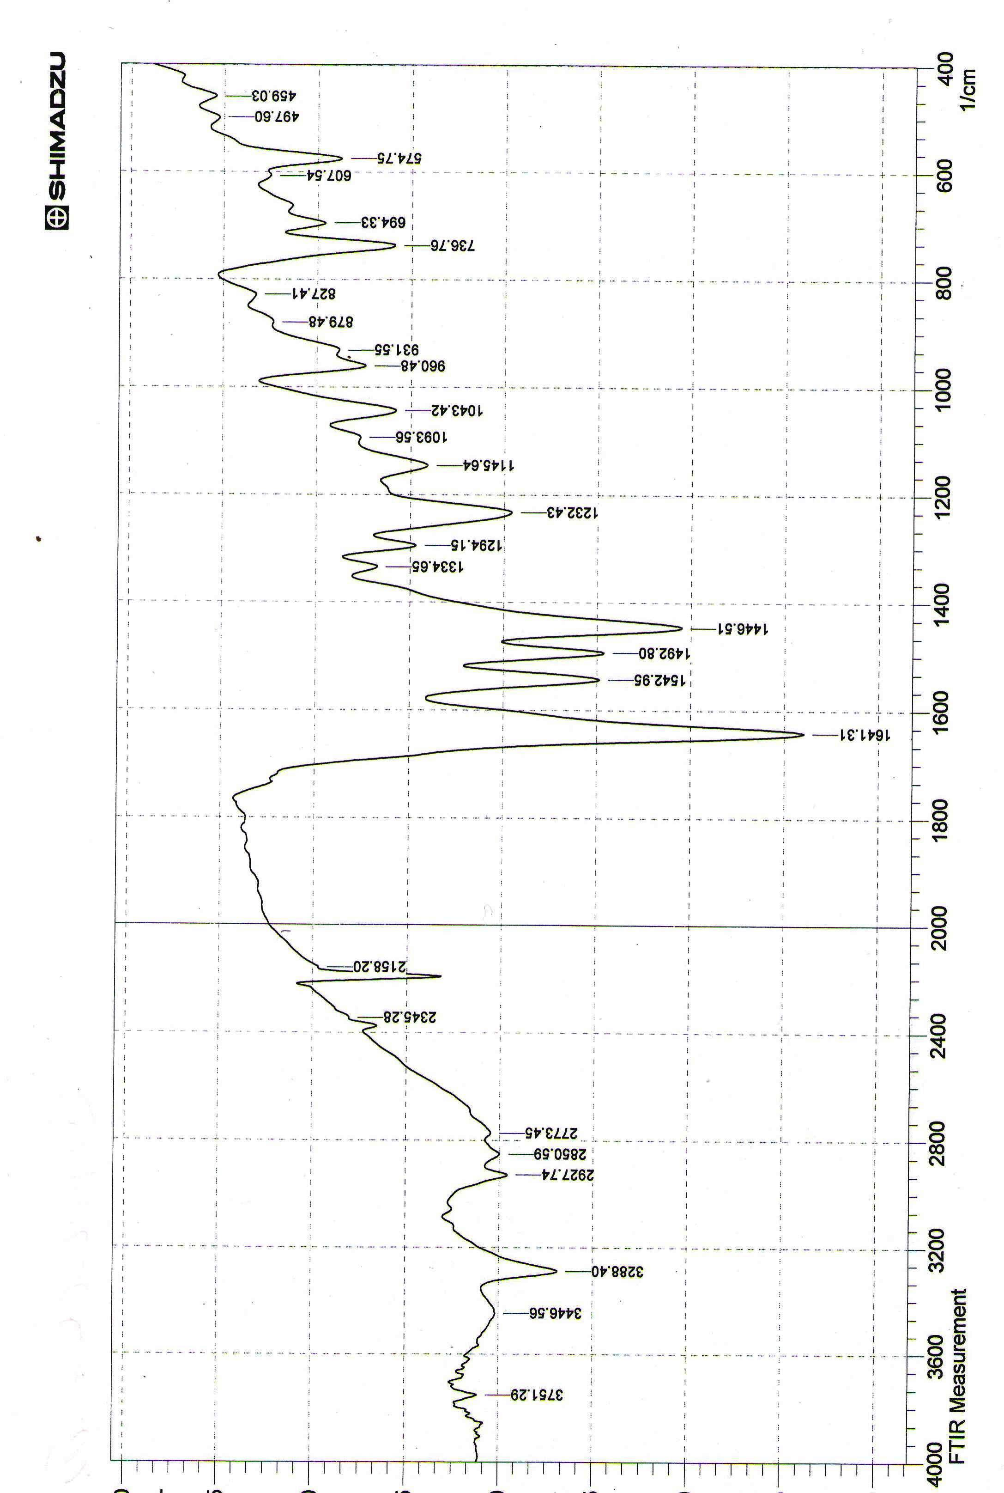



**Fig S20.**

**7h: 1H NMR**

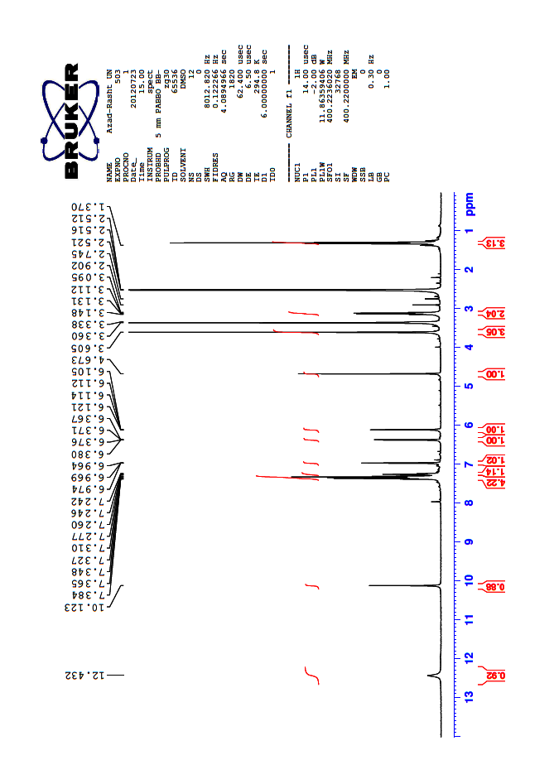

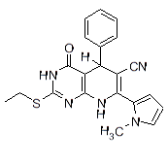

**Fig S21.**

**7h: 13C NMR**

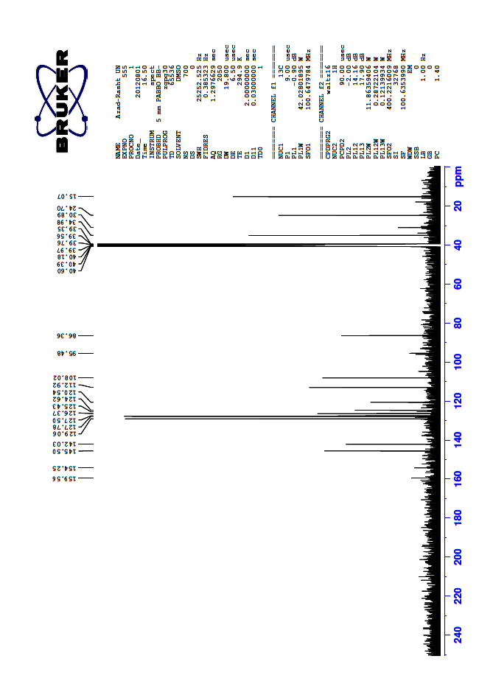



**Fig S22.**

**7h: IR**

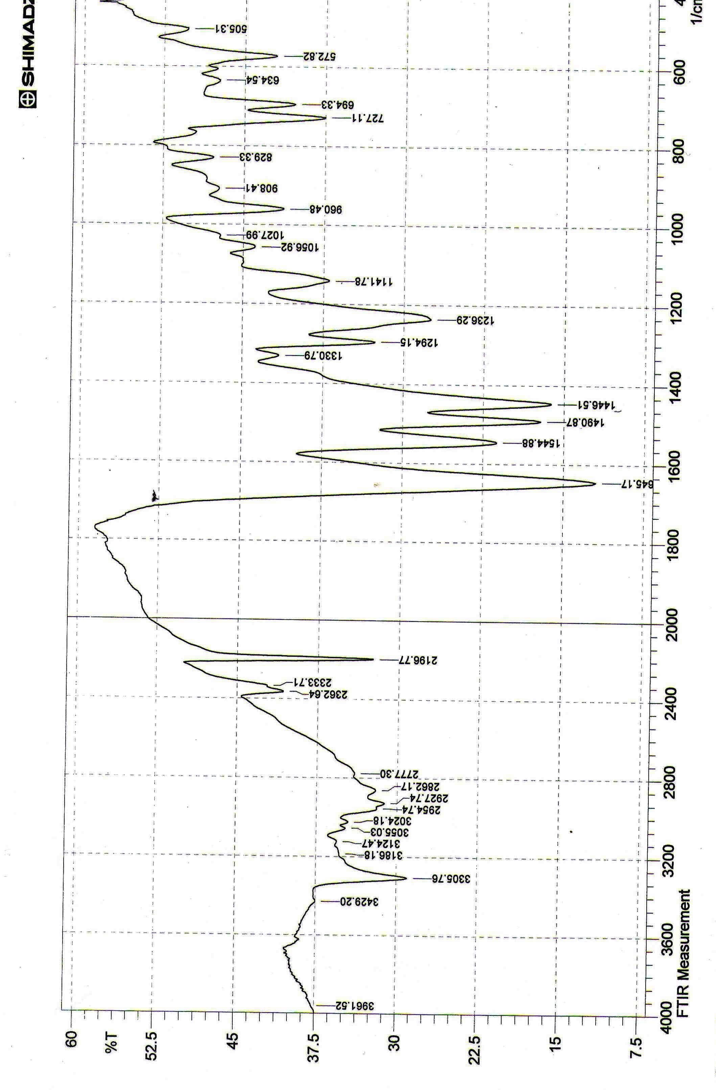



**Fig S23.**

**7i: 1H NMR**

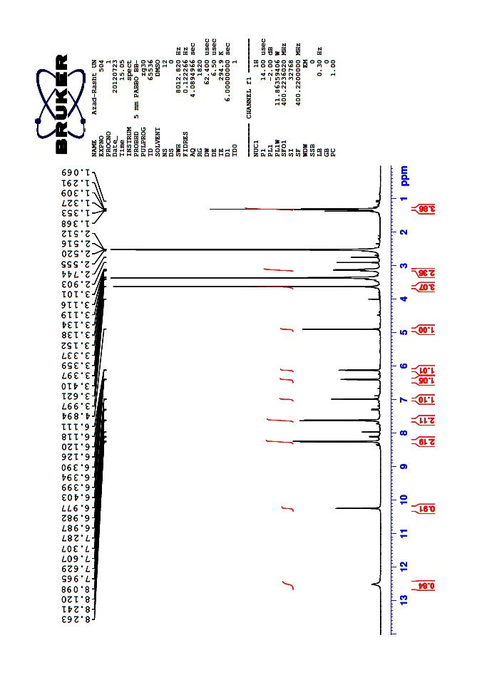

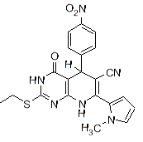

**Fig S24.**

**7i: 13C NMR**

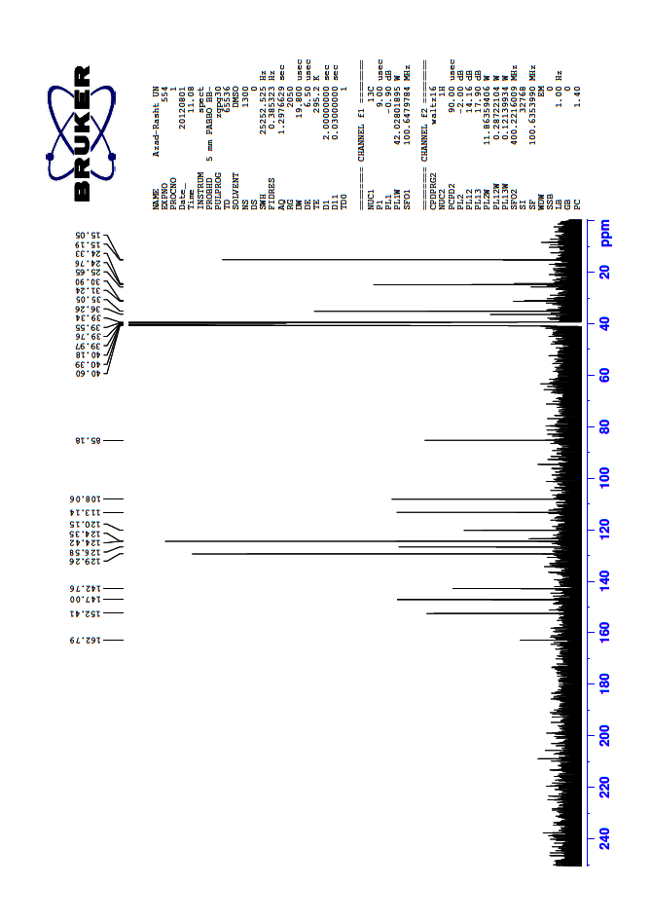



**Fig S25.**

**7i: IR**

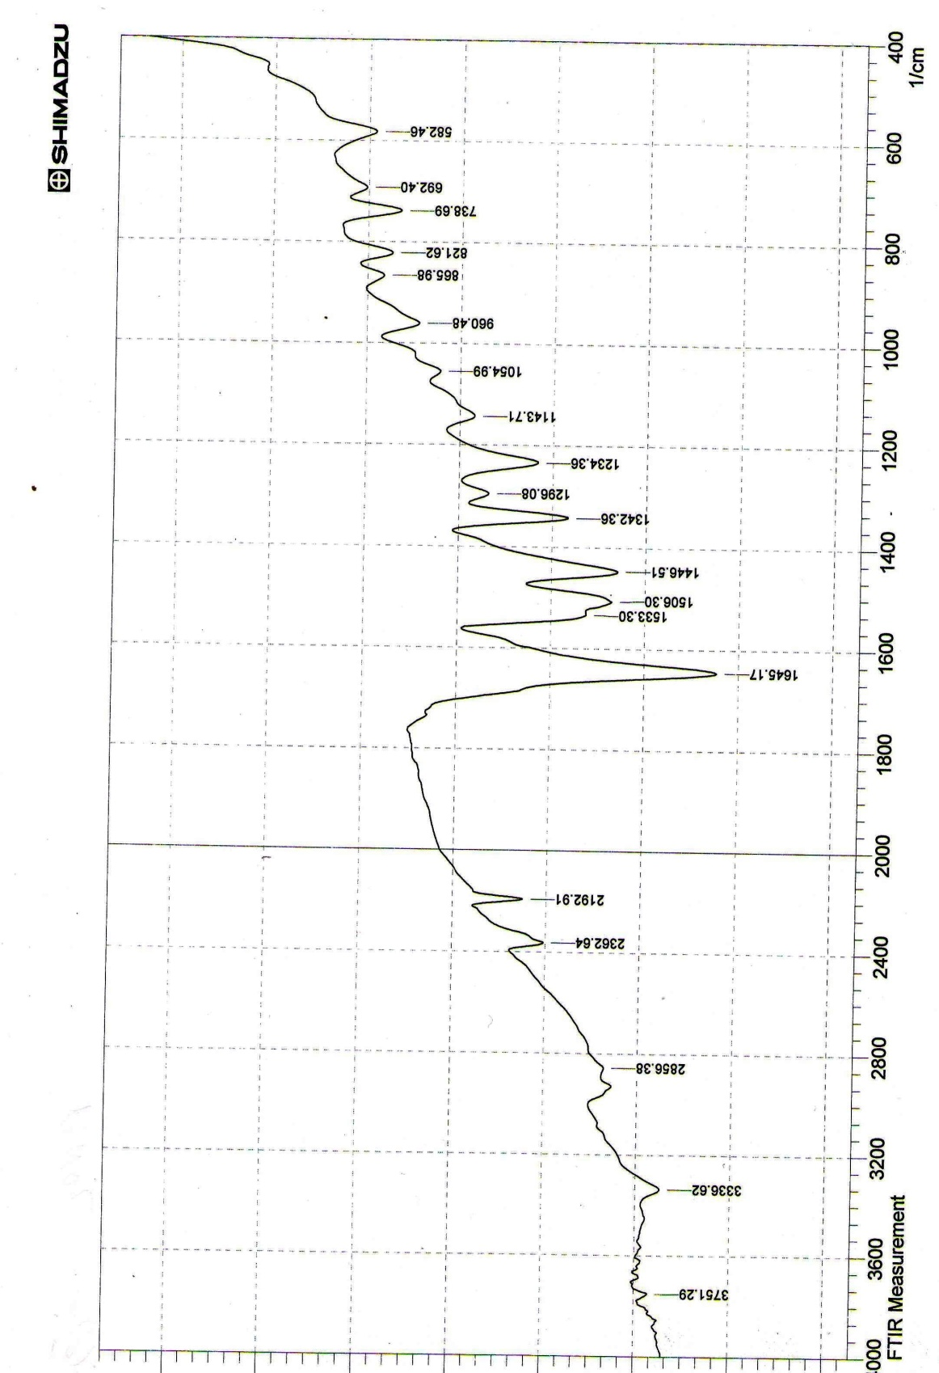



**Fig S26.**

**7j:  1H NMR**

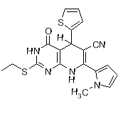

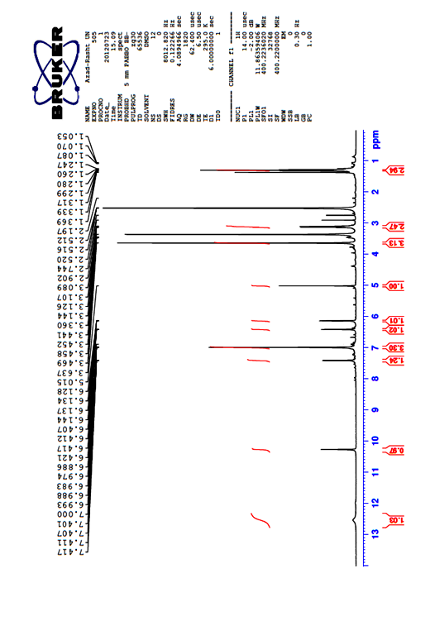

**Fig S27.**

**7j: 13C NMR**

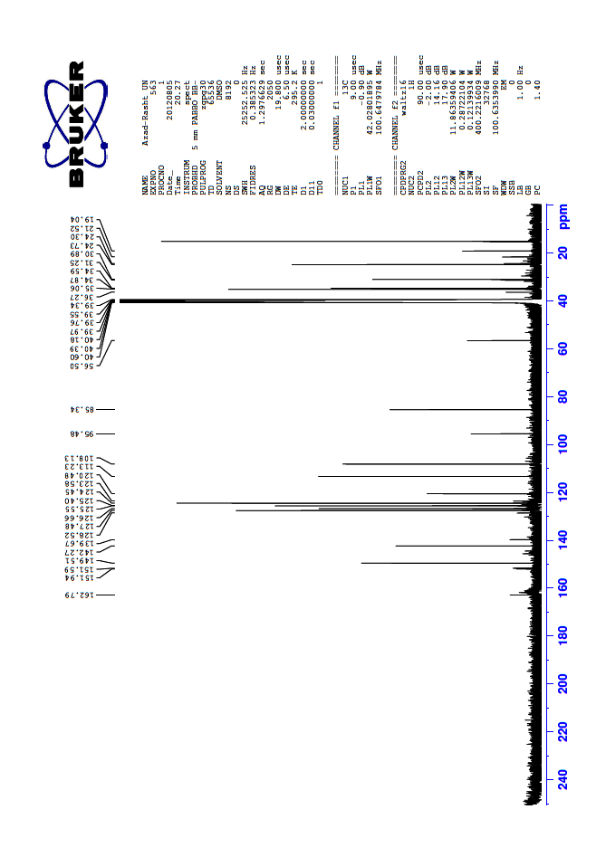



**Fig S28.**

**7j: IR**



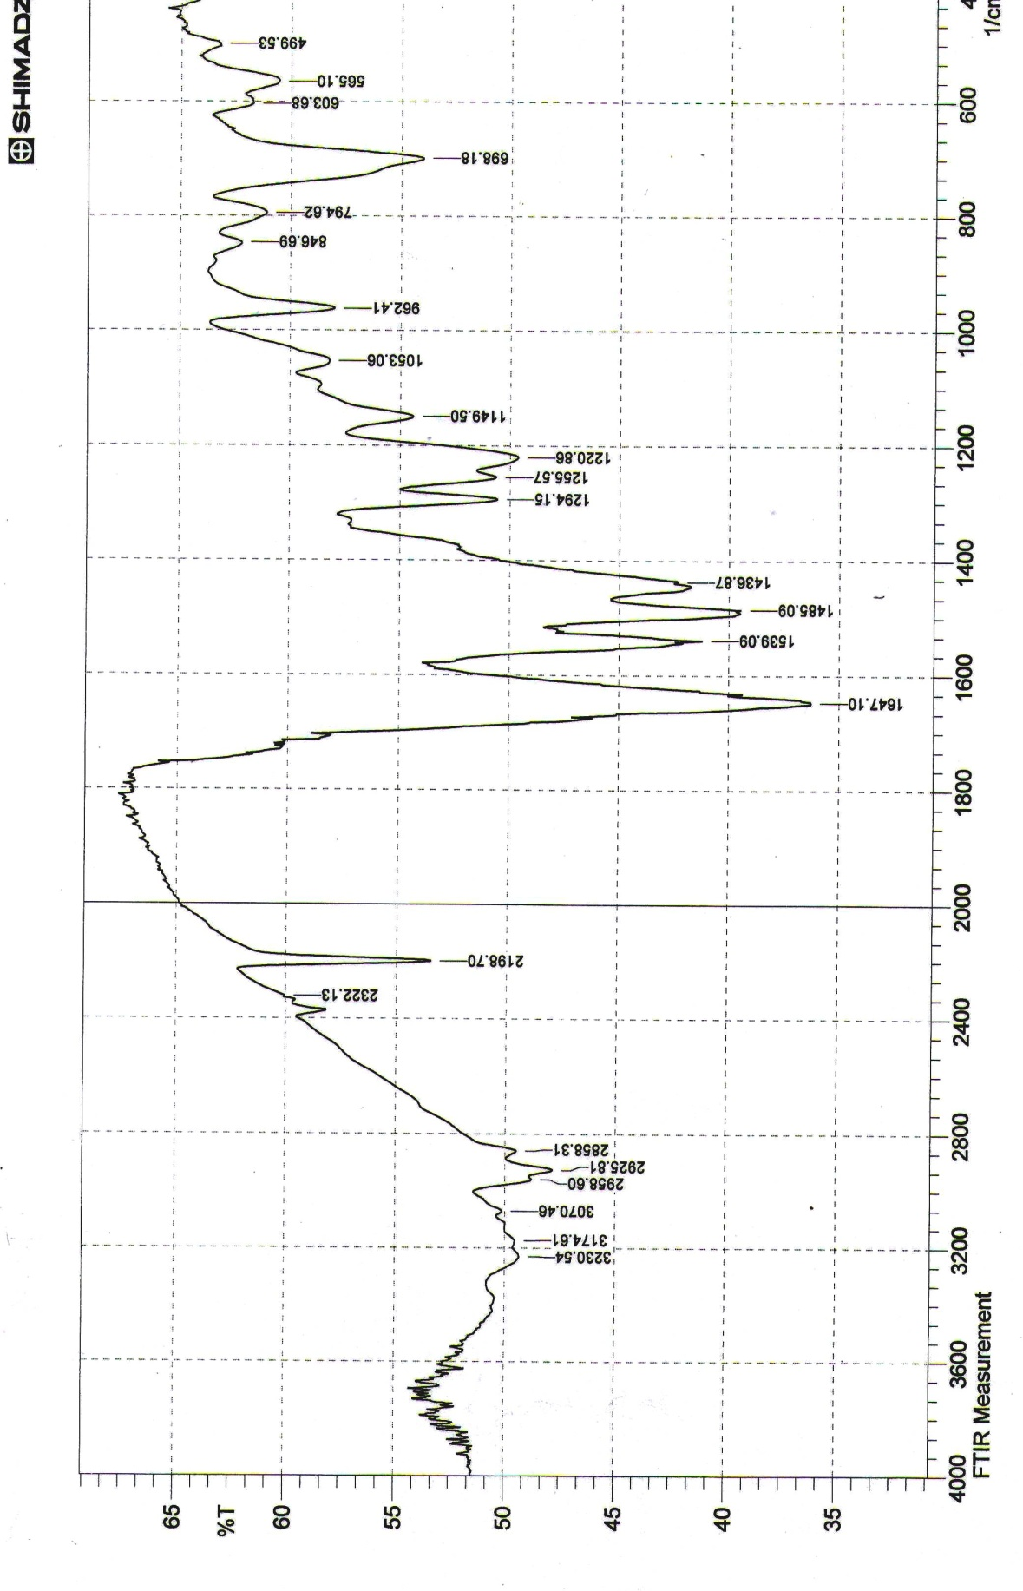

**Fig S29.**

**7k: 1H NMR**

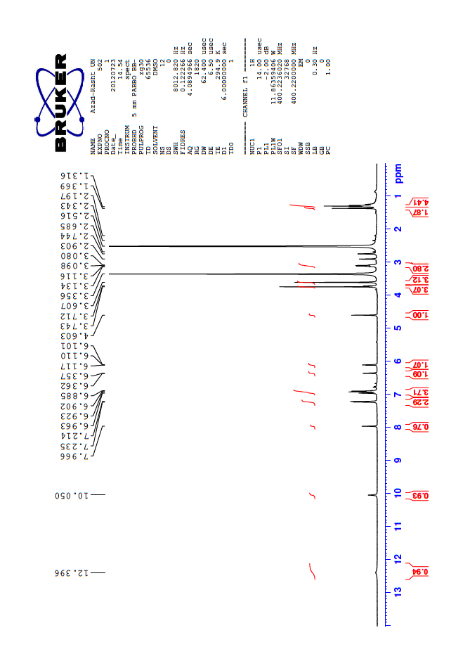

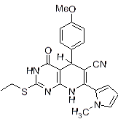

**Fig S30.**

**7k: 13C NMR**



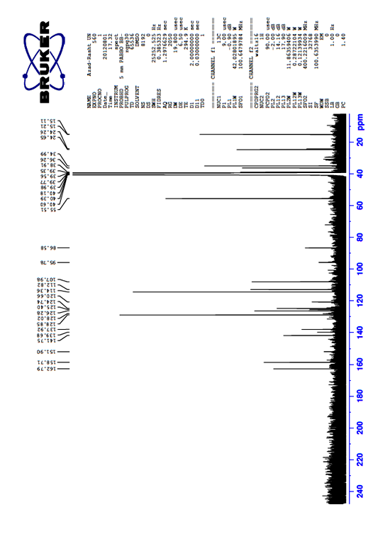

**Fig S31.**

**7k: IR**



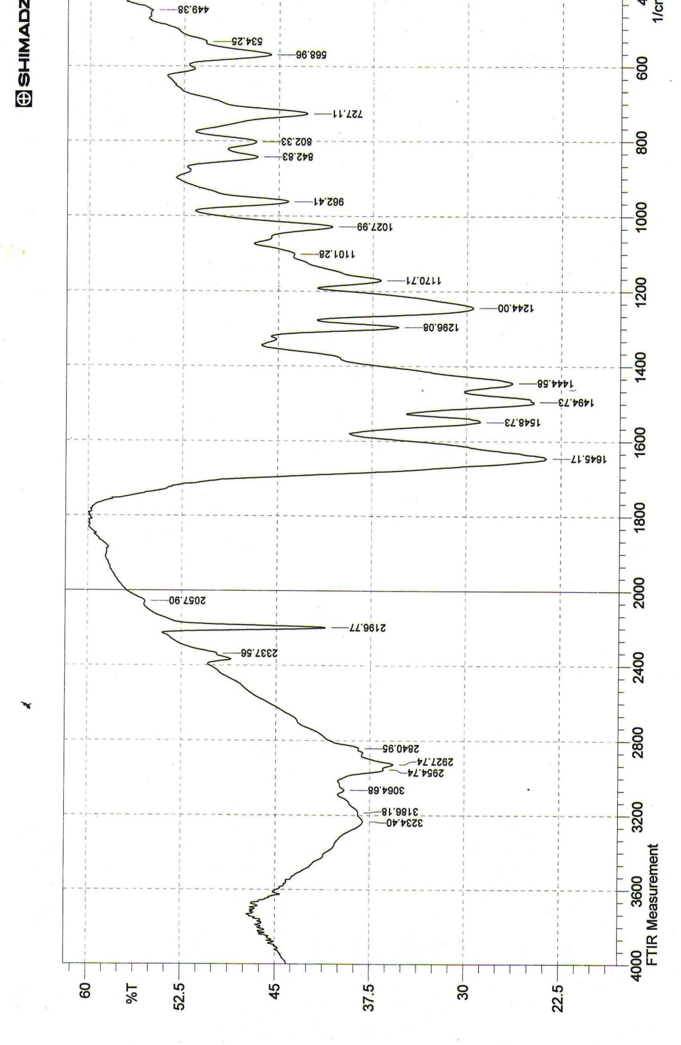

**Fig S32.**