Electron Ionization Mass Spectra of Organophosphorus Compounds Part V: Mass Fragmentation Modes of Some Azolyl, Azinyl and Azepinyl Phosphonates as Cyclic α-Aminophosphonates

Tarik E. Ali and Somaia M. Abdel-Kariem*
Department of Chemistry, Faculty of Education, Ain Shams University, Roxy, Cairo, Egypt,
Email: somaia_mohamed85@yahoo.com
Supplemental Materials
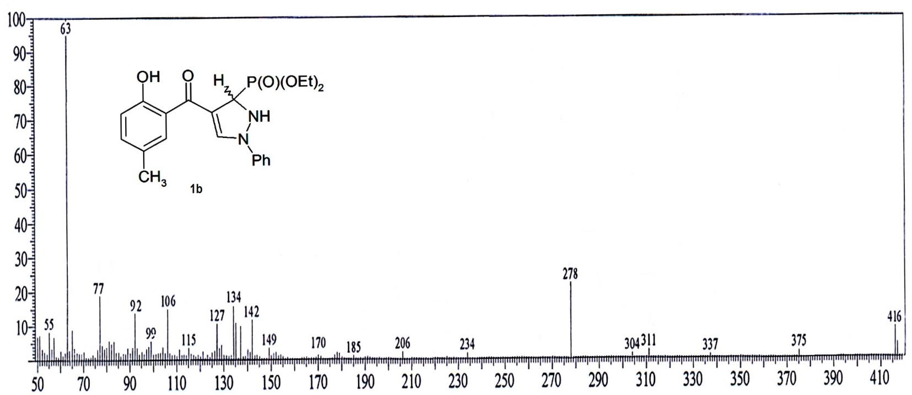
Figure S 1: Mass spectrum of compound 1b

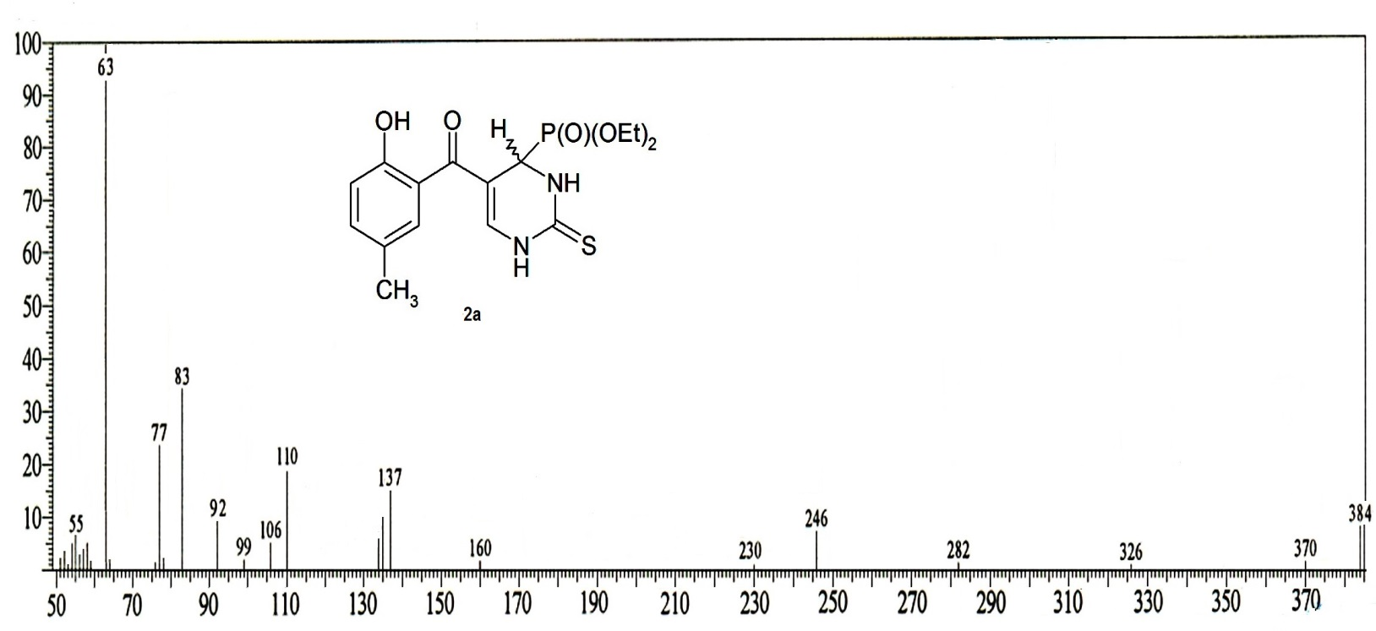
Figure S 2: Mass spectrum of compound 2a

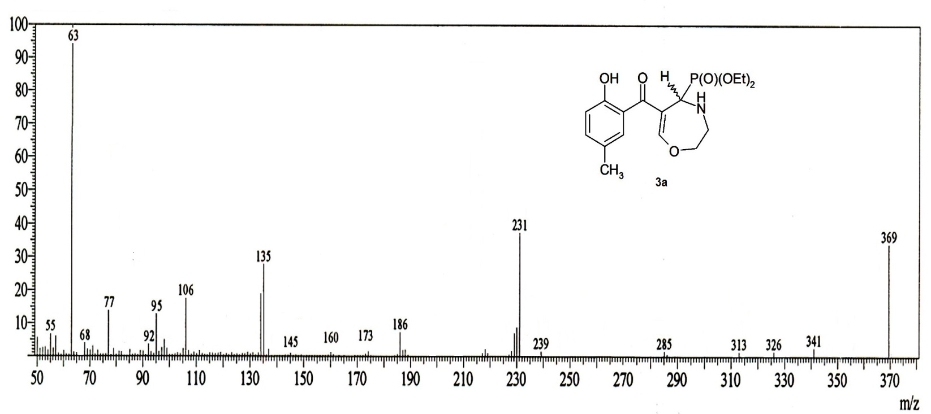Figure S 3: Mass spectrum of compound 3a
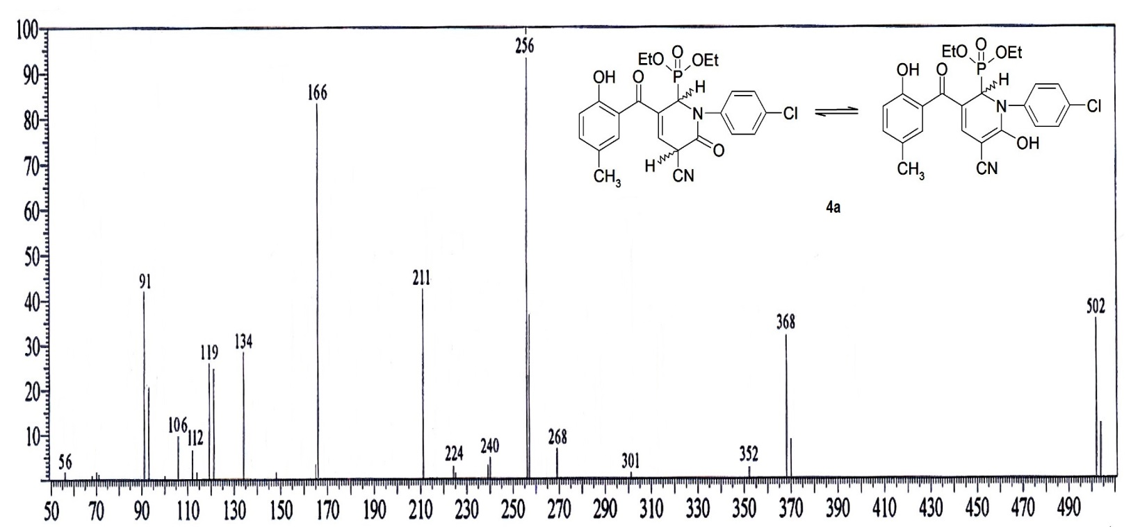
Figure S 4: Mass spectrum of compound 4a

