Figure S1. The cells were first synchronized at G0/G1 phase by serum starvation for 1 day. Following serum starvation for 1 day, 72% cells were in G0/G1 phase, which had 10% cells more than untreated control. All SMF groups were compared with the GMF of 0.05 mT group. n=3. Data shown are mean ± SD. * P<0.05.

Determination of internal reference gene
In order to identify suitable reference genes in osteoclasts under SMFs, qPCR was adopted to quantify expressions of four candidate genes commonly used housekeeping genes, including GAPDH, 18s RNA, tubulin and actin (Table S1). Briefly, the differentiating osteoclasts were treated with SMFs for 4 days and were harvested for RNA extraction. 0.3 μg RAN was reverse transcribed to cDNA. Then, qPCR was performed according to the manufacture of SYBR Green Premix Ex TaqTM II (Takara, Dilian, China). The Ct values were transformed to quantities (relative to the highest expression of the group). The highest relative quantities for each gene were set to 1. Then, the gene quantities were got as the below chart:

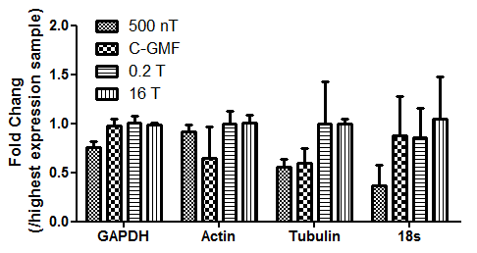
The most stable genes were chosen based on algorithms GeNorm (Vandesompele, 2002). The results were illustrated as the following figure:
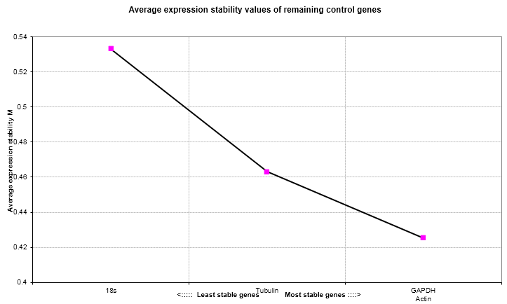
The smaller the M value is, more stable the internal reference is. The results showed that GAPDH and actin were the most stable genes. Therefore, GAPDH is a proper internal reference gene for this study.

Table S1 Primers sequences used for quantitative real time PCR
Gene name (Genebank No.) | Primer sequences (5’- 3’) | Annealing temperature (ºC)
β-Actin (NM_001101.3) | Forward: AGCGAGCATCCCCCAAAGTT  Reverse: GGGCACGAAGGCTCATCATT | 55
GAPDH (NM_008084.2) | Forward: TGCACCACCAACTGCTTAG  Reverse: GGATGCAGGGATGATGTTC | 51
Tubulin (NM_011655.4) | Forward: TGGCAAGTATGTCCCTCG  Reverse: AGCCTCGTTGTCAATGCAGTAG | 55
18 s (NR_003286.1) | Forward: CCAAGATCCAACTACGAGCT  Reverse: AATCAGGGTTCGATTCCGGA | 55

Reference
Vandesompele, J., De Preter, K., Pattyn, F., et al. (2002). Accurate normalization of real-time quantitative RT-PCR data by geometric averaging of multiple internal control genes. Genome Biol. 3(7): RESEARCH0034.

