Novel calix[4]arene based metallo-supramolecular complex for recognition of CN⁻ ions in aqueous medium
Mohammad Shahid, Har Mohindra Chawla and Pooja Bhatia
Department of Chemistry, Indian Institute of Technology Delhi,
Hauz Khas, New Delhi-110 016

Material and Methods:
All the reagents and solvents were purchased from Merck and Sigma-Aldrich and were used without any further purification. IR spectra in KBr were recorded on Agilent/ Perkin Elmer FT-IR spectrometer. ¹H NMR spectra (chemical shifts in δ ppm) were recorded on a Bruker 300 FT–NMR (300 MHz) spectrometer, using TMS as internal standard. The UV-Vis absorption spectra were recorded on Perkin Elmer Lambda 35 spectrophotometer using a quartz curette (path length = 1 cm). Fluorescence spectra were recorded on a Horiba Fluoromax 4 spectrophotometer. HRMS were recorded on Brukar MICROTOF Q II in aqueous acetonitrile.
The fluorescence titration data were employed to estimate the binding affinity for 1:1 and 1:2 stoichiometry by modified Benesi-Hildebrand method employing equations given below--

1/(I - I_{o}) = 1/(I - I_{f}) + 1/K (I - I_{f}) [M] (1)
1/(I - I_{o}) = 1/(I - I_{f}) + 1/K (I - I_{f}) [M]² (1I)

Where, K is the association constant, I is fluorescence intensity/absorbance of free receptor 4, I_{o} is the observed fluorescence intensity/absorbance of complex, 4-Cu²⁺ and I_{f} is the fluorescence intensity/absorbance at saturation.
Figure S1: ¹H NMR spectrum of compound 2 in CDCl₃.

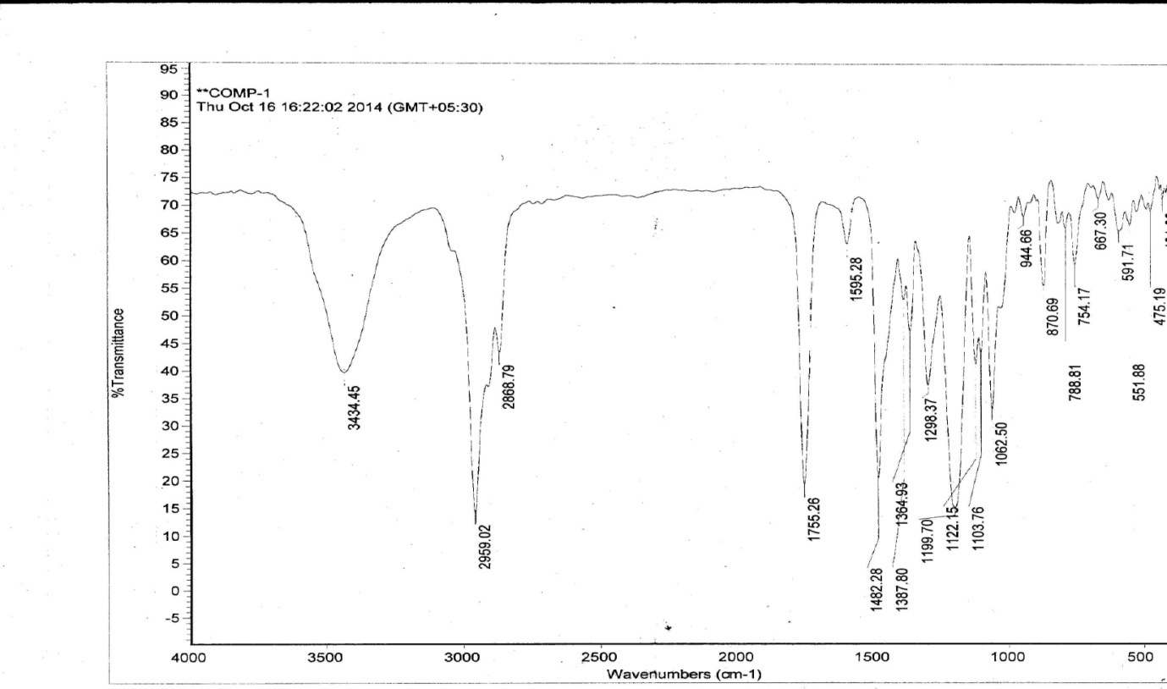
Figure S2: FT-IR spectrum of compound 2.
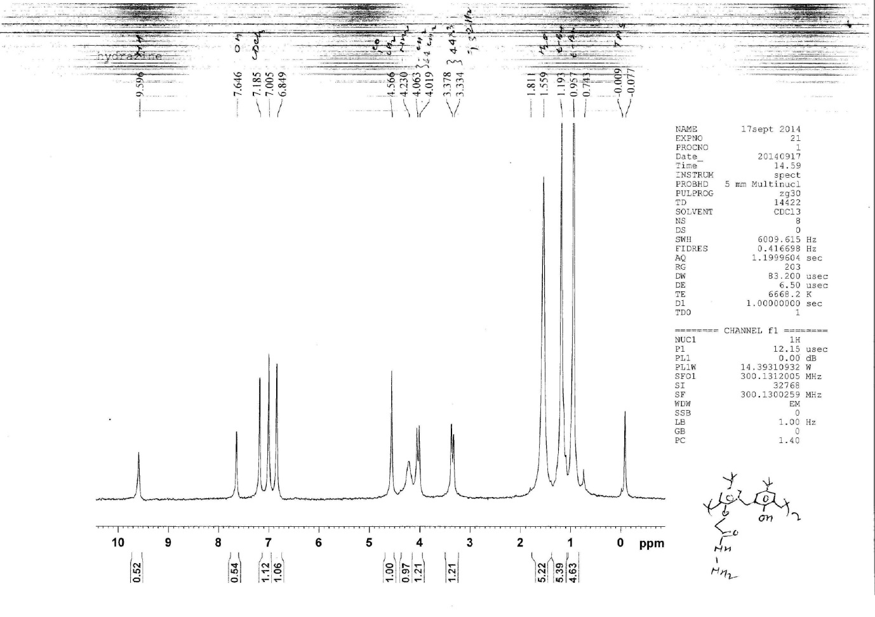
Figure S3: ¹H NMR spectrum of compound 3 in CDCl₃.

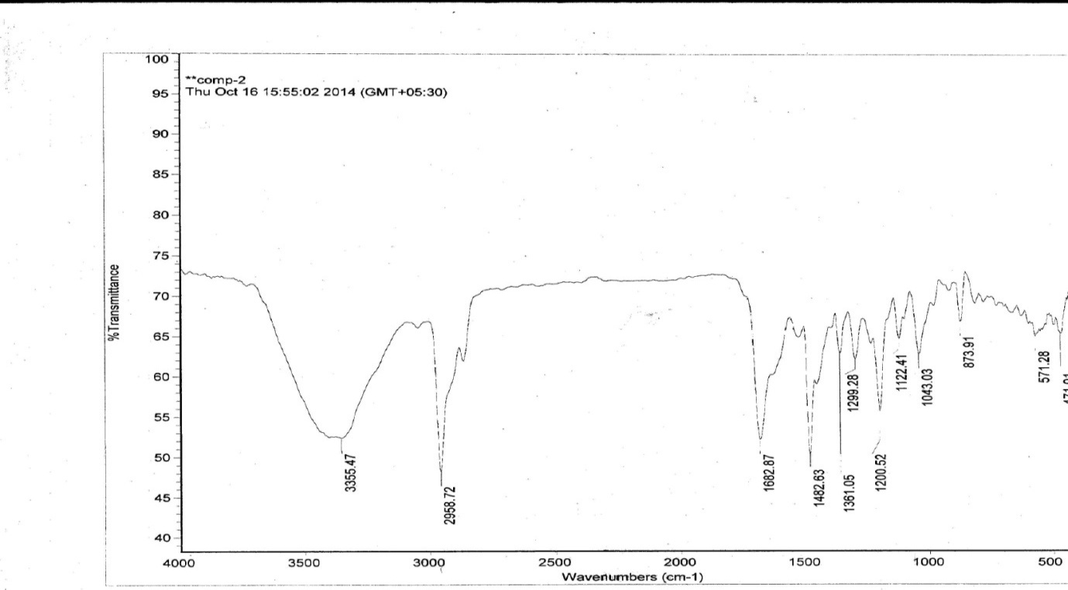
Figure S4: FT-IR spectrum of compound 3.
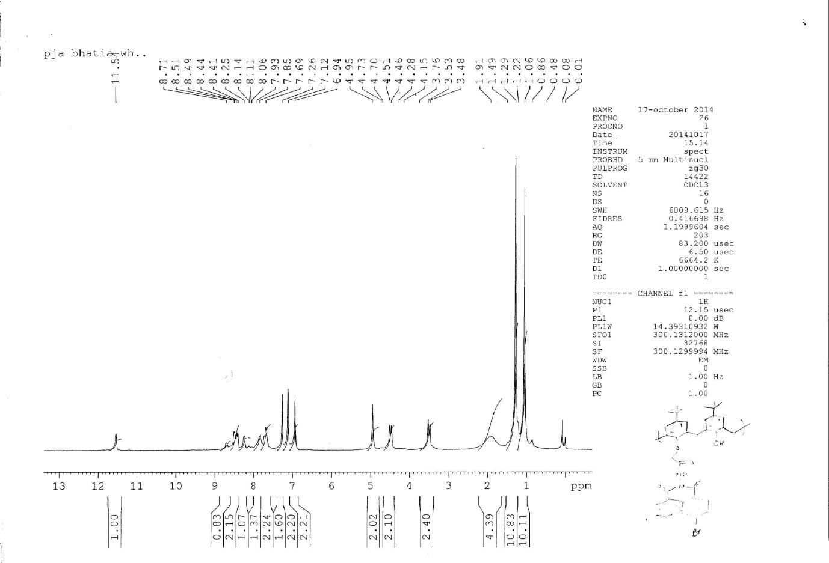
Figure S5: ¹H NMR spectrum of compound 4 in CDCl₃.

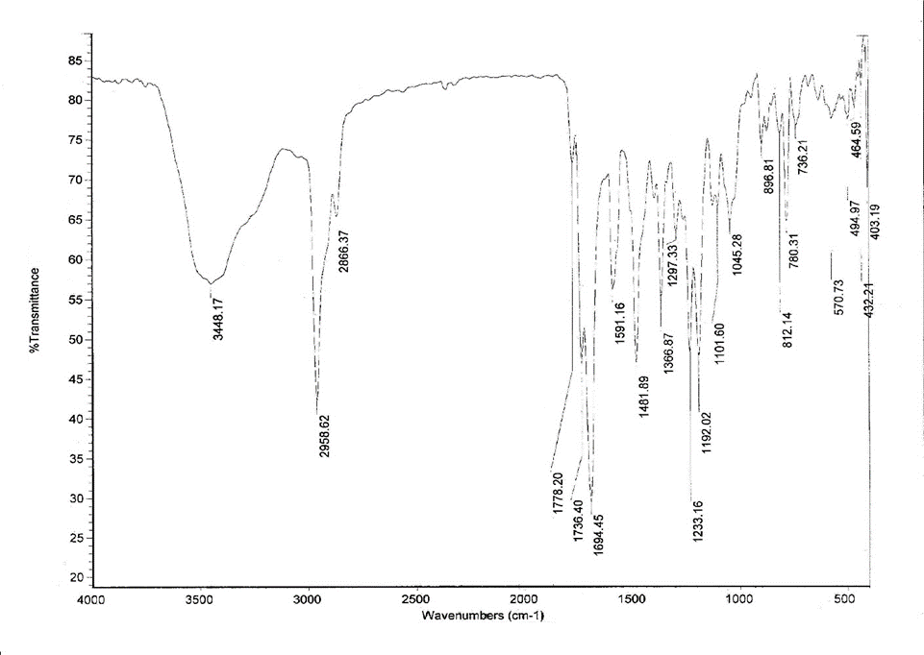
Figure S6: FT-IR spectrum of compound 4.
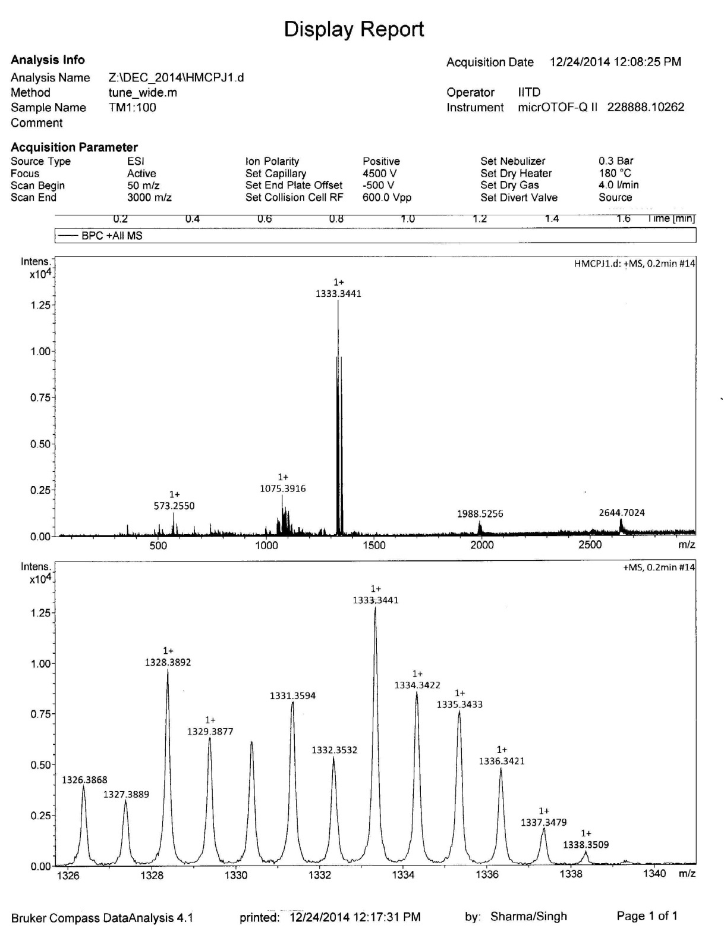
Figure S7: HRMS mass spectrum of compound 4.

Figure S8: Interference studies on 4 with different metal ions (20 equiv) in aqueous-acetonitrile solution (20%, v/v).

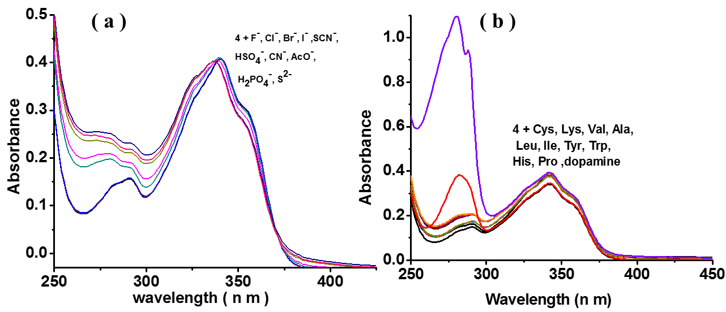
Figure S9: Interaction of 4 (10 µM) with different (a) anions (20 equiv) and (b) amino acids (20 equiv) in aqueous-acetonitrile solution (20%, v/v).

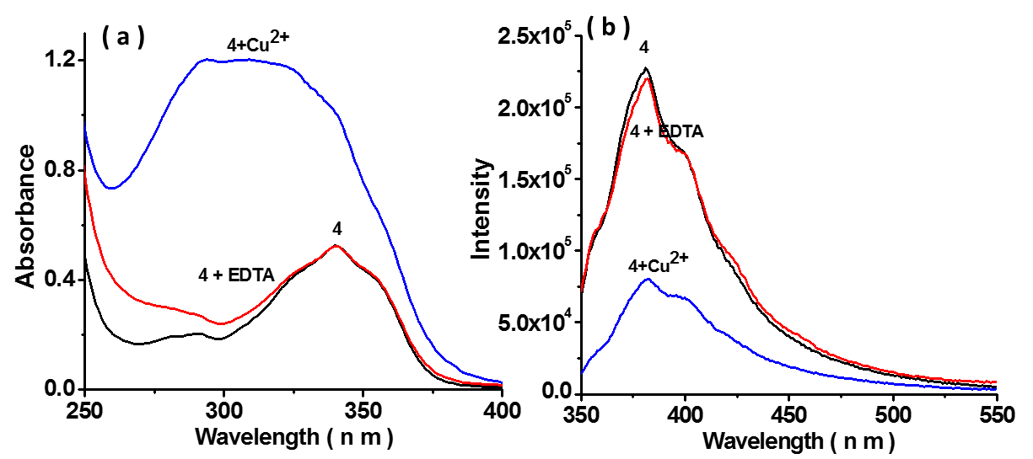
Figure S10: Re-usability of 4, 4-Cu²⁺ on treatment with EDTA in aqueous-acetonitrile solution (20%).

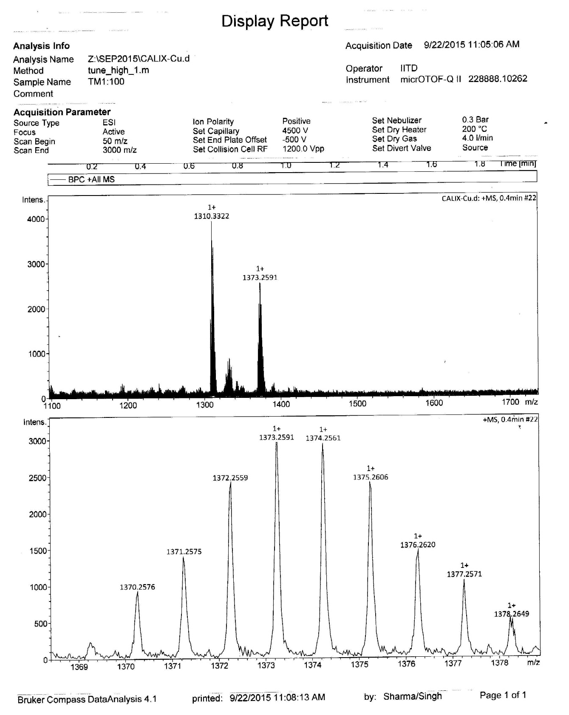
Figure S11: HRMS spectrum of 4-Cu²⁺ which showed the molecular ion peak at m/z 1373.2591; 1371.2575, calculated for [C₇₂H₇₀Br₂N₄O₁₀Cu]⁺ m/z = 1373.2834; 1371.2844.

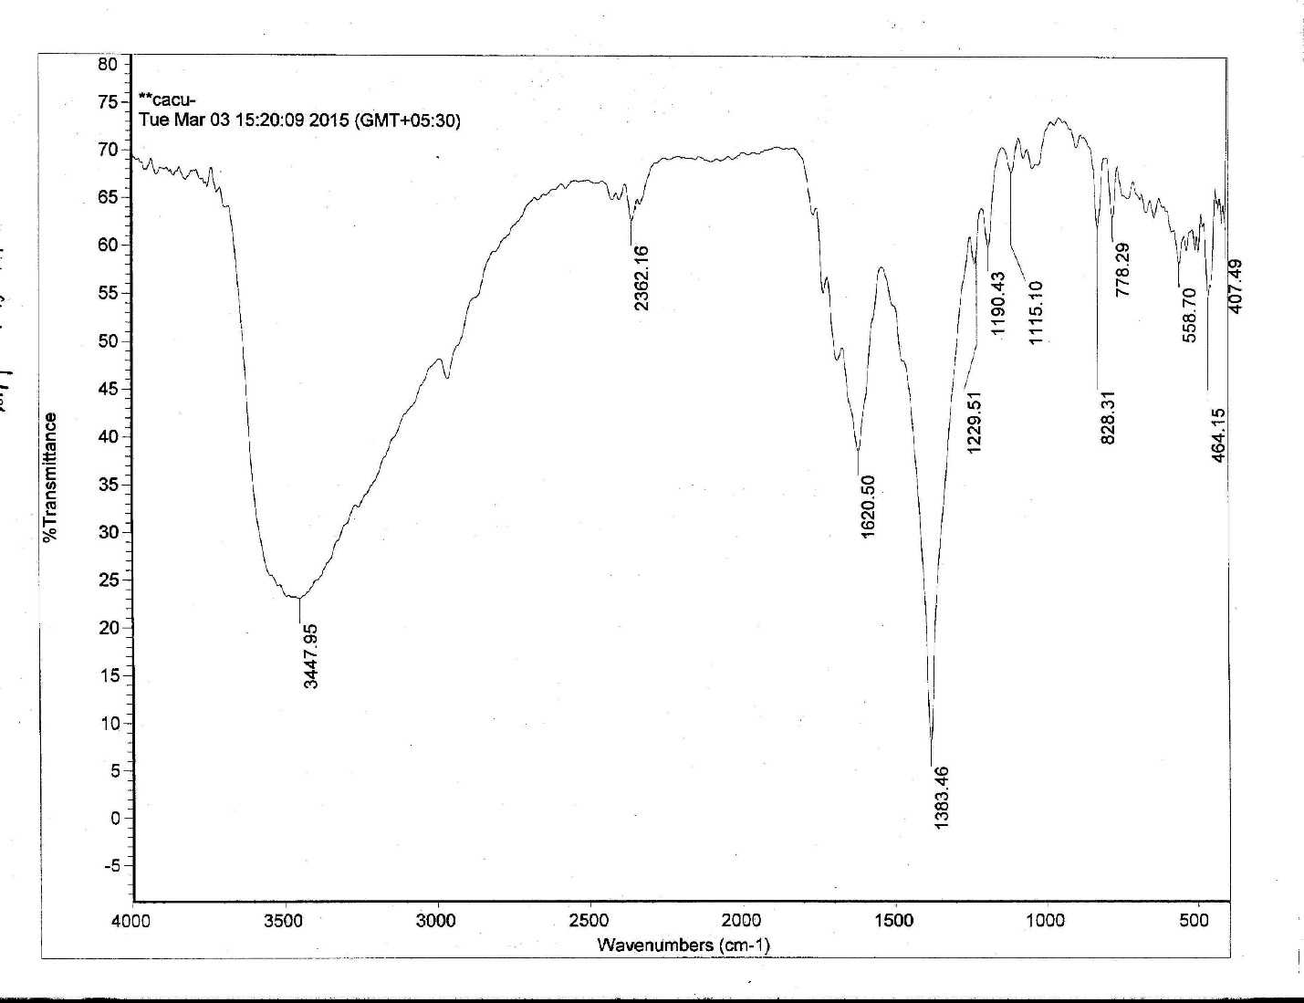
Figure S12: FT-IR spectrum of 4-Cu²⁺ complex in KBr.

Figure S13: Interaction studies on 4-Cu²⁺ complex with different anions (20 equiv) in aqueous-acetonitrile solution (20%, v/v).

Figure S14: Fluorescence interaction of 4-Cu²⁺ with anions (20 equiv) in aqueous-acetonitrile solution (20%, v/v).

