Supplementary on line Material

Toward the understanging of the action of tetrahydroquinolines in Aedes aegypti: larvicide or adulticide?

Juliana de O. S. Giacoppoª, Juliano B. Carregal^{b}, Moacyr C. Junior^{b}, Elaine F. F da Cunhaª, Teodorico C. Ramalho^{a,c*}

ªDepartment of Chemistry, Federal University of Lavras, 37200-000 Lavras, MG, Brazil
^{b}Department of Chemistry, Federal University of São João del Rey, 35501-296, Divinópolis, MG, Brazil
^{c} Center for Basic and Applied research, University Hradec Kralove, Hradec Kralove, Czech Republic

Figure 1S. Target receptor Backbones of overlap (AaEcR) and the mold receptor (1R1K) .

Figure 2S. Docking validation. Redocking of the 20E hormone within the AaEcR (a) and the compound Z within the BK channel (b).

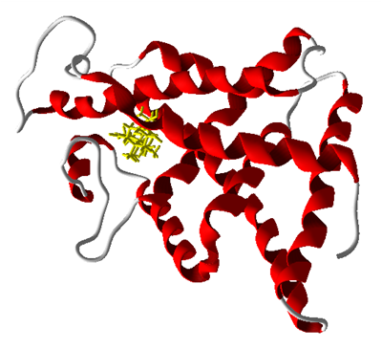
Figure 3S. AaEcR obtained by homology modeling.
Figure 4S. Intermolecular energy values from the docking analysis and experimental data* (SOIN et al., 2010 e PALLI et al., 2005)

Figure 5S. Interactions observed between the compound 1 and AaEcR receiver.

Figure 6S. The three-dimensional structure of the interaction model between the BK channel subunits. The cavity is represented in green.
Figure 7S. Compound 4 (Green) docked inside the BK channel and S0 portion (red) introduced by modeling.

Figure 8S. Variation of total energy for the hormonal system 3/AaEcR.

Figure 9S. Change in the total energy to the system 20E/AaEcR.
Figure 10S. Change in the total energy to the system 1/AaEcR.

Figure 11S. Change in the total energy to the system 2/AaEcR.

Figure 12S. Change in the total energy to the system 4/AaEcR.
Figure 13S. Change in the total energy to the system 5/AaEcR
Figure 14S. Change in the total energy to the system 6/AaEcR.
Figure 15S. Change in the total energy to the system JG2/AaEcR.

Figure 16S. Map pharmacophore after the MD simulation for Compound 20E.
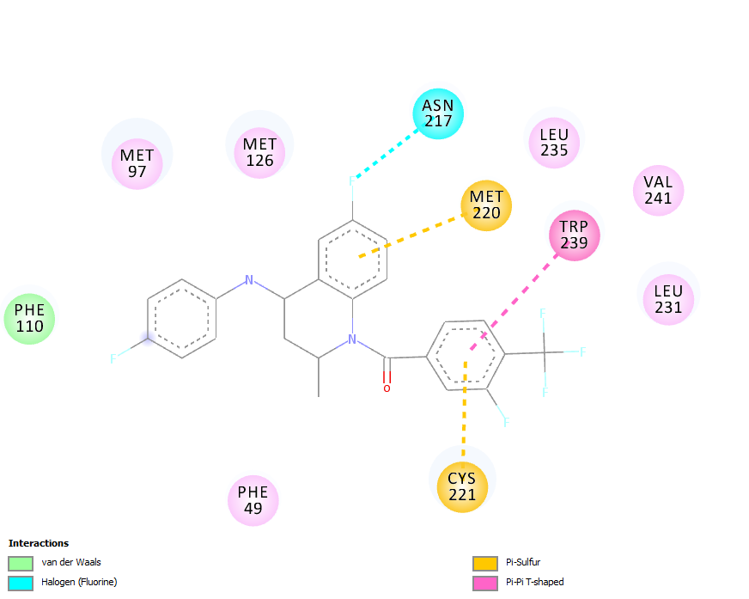
Figure 17S. Map pharmacophore after the MD simulation for Compound 1.

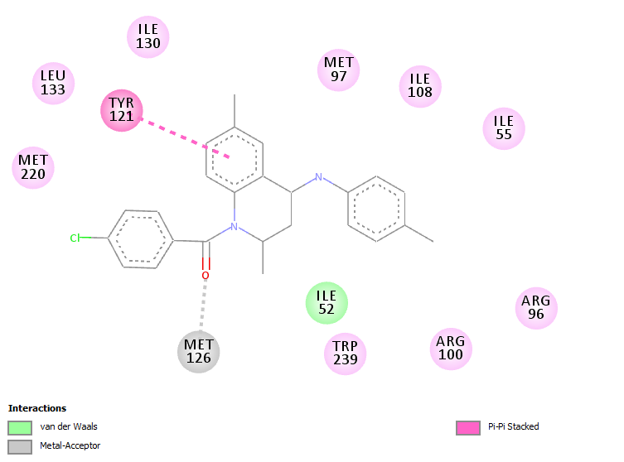
Figure 18S. Map pharmacophore after the MD simulation for Compound 2.

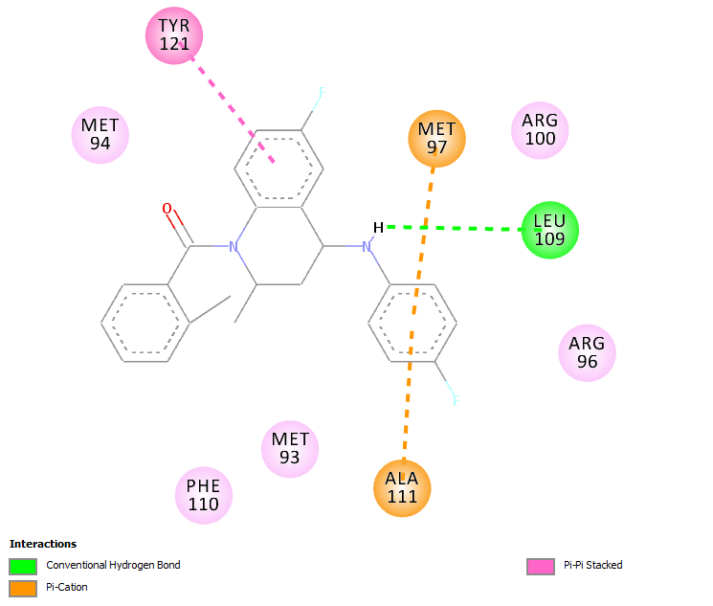
Figure 19S. Map pharmacophore after the MD simulation for Compound 3.
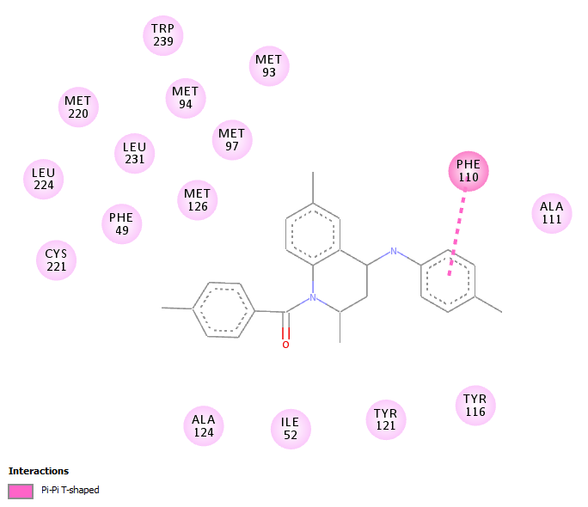
Figure 20S. Map pharmacophore after the MD simulation for Compound 4.

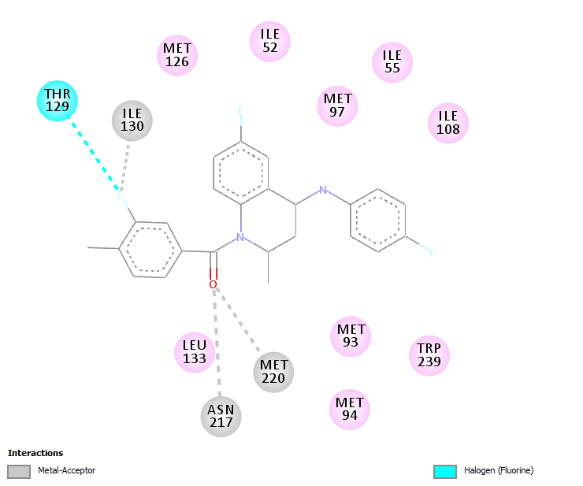
Figure 21S. Map pharmacophore after the MD simulation Compound 5.
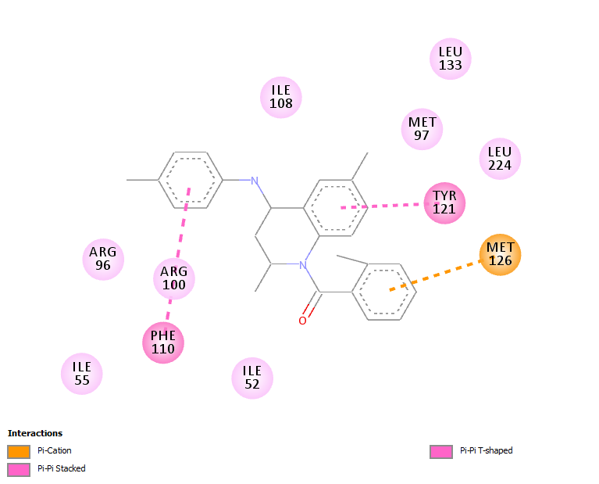
Figure 22S. Map pharmacophore after the MD simulation for Compound 6.
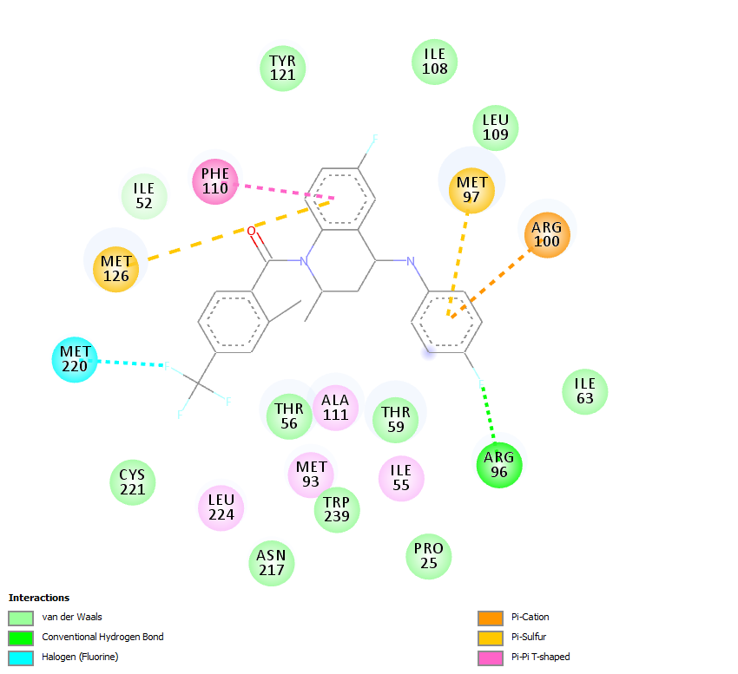
Figure 23S. Map pharmacophore after the MD simulation for JG2.
Figure 24S. Interaction between hydrogen and amino JG2 the ecdysone receptor (a) and BK channel (b).

Figure 25S. DRMQ versus Time for the simulation of compound JG2/AaEcR. The receptor curve is represented in black and the compounds in red.
Figure 26S. Variation of total energy for the hormonal system JG2 / AaEcR.

