Double-armed and tetra-armed cyclen-based cryptands

Mari Ikeda,ª Ajay Kumar Sah,^{b} Rina Murashige,^{c} Miki Iwase,^{c} Shunsuke Kuwahara^{c,d} and Yoichi Habata*^{c,d}

ª Education Centre, Faculty of Engineering, Chiba Institute of Technology, 2-1-1 Shibazono, Narashino, Chiba 275-0023, Japan
^{b} Department of Chemistry, Birla Institute of Technology and Science, Pilani-333031, Rajasthan, India
^{c} Department of Chemistry, Faculty of Science, Toho Unviersity, 2-2-1 Miyama, Funabashi, Chiba 274-8510; E-mail: habata@chem.sci.toho-u.ac.jp
^{d} Research Centre for Materials with Integrated Properties, Toho University, 2-2-1 Miyama, Funabashi, Chiba 274-8510, Japan Fax: +81 47 472 4322

Table of Contents
Fig. S1. ¹H NMR of 1a in CD₂Cl₂. 2
Fig. S2. ¹H NMR of 1b in CD₂Cl₂. 2
Fig. S3. ¹H NMR of 1d in CD₂Cl₂. 3
Fig. S4. ¹H NMR of 2 in CD₂Cl₂ 3
Fig. S5. ¹H NMR of 1a-pre in CD₂Cl₂. 4
Fig. S6. ¹H NMR of 1b-pre in CD₂Cl₂. 4
Fig. S7. ¹H NMR of 1d-pre in CD₂Cl₂. 5
Fig. S8. ¹H NMR of 3a in CD₂Cl₂. 5
Fig. S9. ¹H NMR of 3b in CD₂Cl₂. 6
Fig. S10. ¹H NMR of 3a-pre in D₂O in the presence of NaOD. 6
Fig. S11. ¹H NMR of 3b-pre in D₂O in the presence of NaOD. 7
Fig. S12. Ag⁺-ion-induced UV spectral changes of 1a. 8
Fig. S13. Ag⁺-ion-induced UV spectral changes of 1b. 8
Fig. S14. Ag⁺-ion-induced UV spectral changes of 1d. 8
Fig. S15. Ag⁺-ion-induced UV spectral changes of 2. 8
Fig. S16. UV titration curve of Ag⁺/1a system at 287.5 nm. 8
Fig. S17. UV titration curve of Ag⁺/1b system at 290 nm. 8
Fig. S18. UV titration curve of Ag⁺/1c system at 285 nm. 9
Fig. S19. UV titration curve of Ag⁺/1d system at 259 nm. 9
Fig. S20. UV titration curve of Ag⁺/2 system at 288.5 nm. 9
Fig. S21. UV titration curve of Ag⁺/3a system at 288.5 nm. 9
Fig. S22. UV titration curve of Ag⁺/3b system at 262 nm. 10
Fig. S23. UV titration curve of Ag⁺/3c system at 263 nm. 10
Fig. S24. UV titration curve of Ag⁺/4 system at 259.5 nm. 10
Fig. S25. Ag⁺-ion-induced-¹H NMR spectral changes of 1a. 11
Fig. S26. Ag⁺-ion-induced-¹H NMR spectral changes of 1b. 11
Fig. S27. Ag⁺-ion-induced-¹H NMR spectral changes of 1d. 12
Fig. S28. Ag⁺-ion-induced-¹H NMR spectral changes of 3a. 12
Fig. S29. Ag⁺-ion-induced-¹H NMR spectral changes of 3b. 13
Fig. S30. HOMOs and LUMOs of 1a, 1b, and 1d. 13
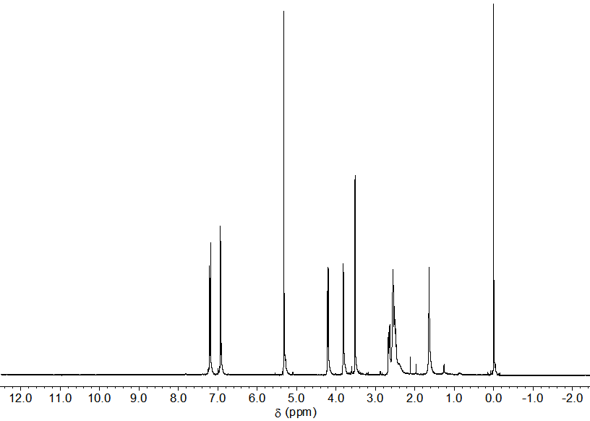
Fig. S1. ¹H NMR of 1a in CD₂Cl₂.
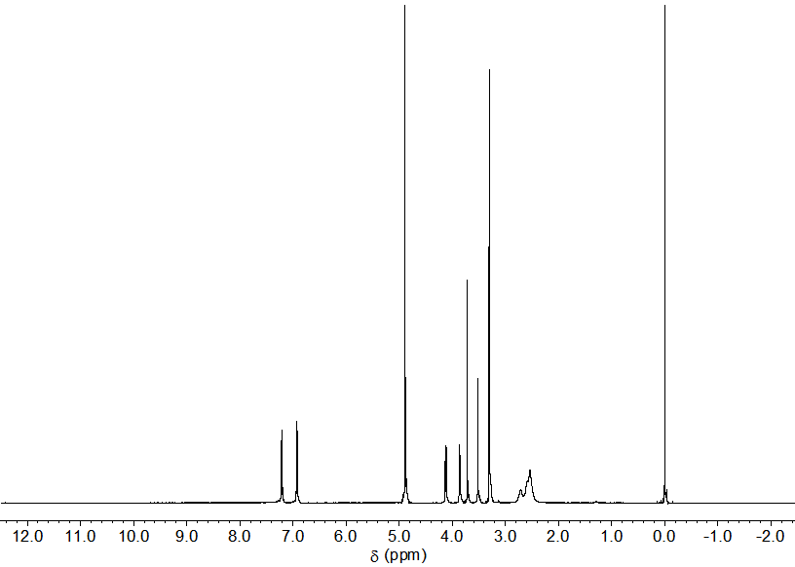
Fig. S2. ¹H NMR of 1b in CD₂Cl₂.

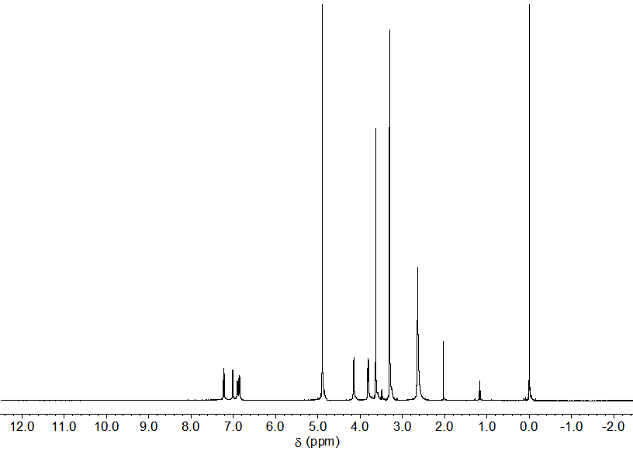
Fig. S3. ¹H NMR of 1d in CD₂Cl₂.
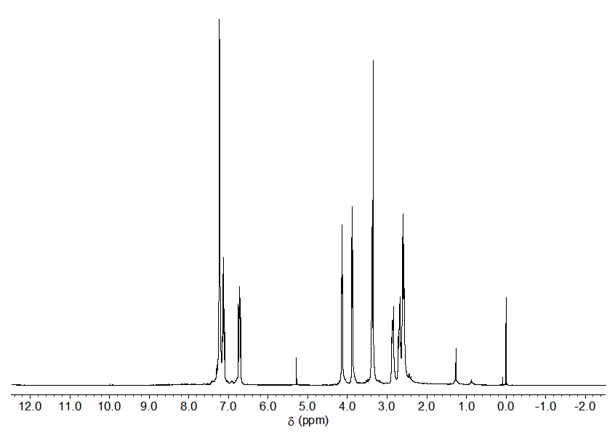
Fig. S4. ¹H NMR of 2 in CD₂Cl₂.
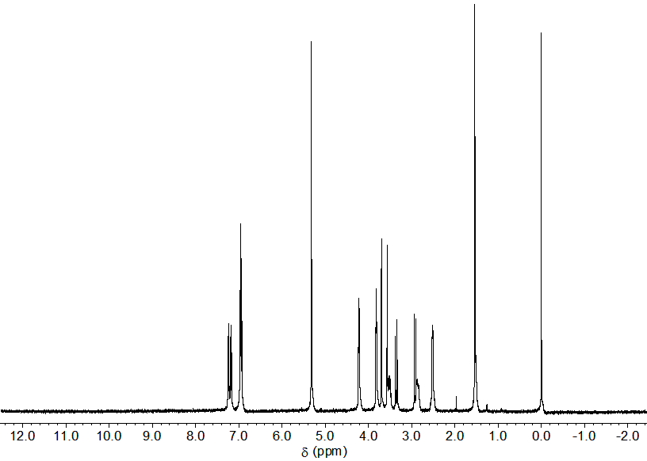
Fig. S5. ¹H NMR of 1a-pre in CD₂Cl₂.

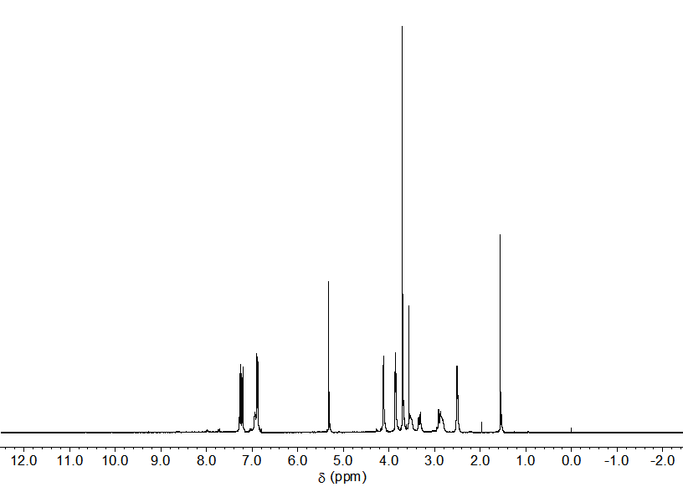
Fig. S6. ¹H NMR of 1b-pre in CD₂Cl₂.
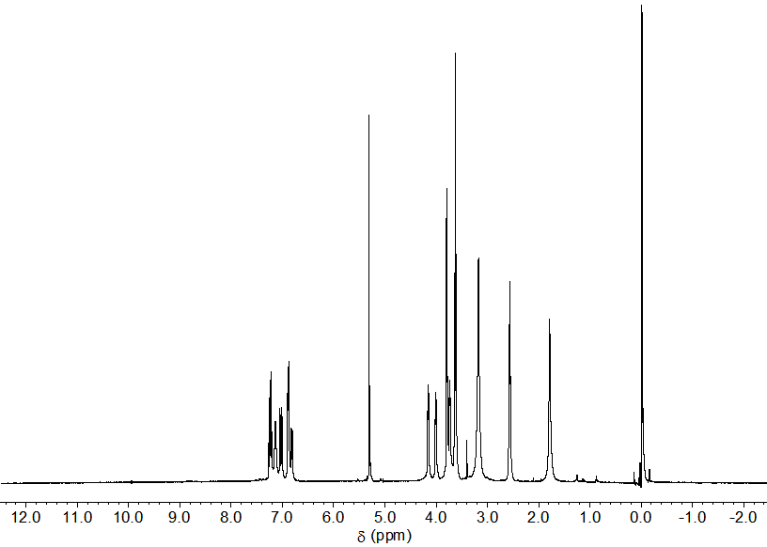
Fig. S7. ¹H NMR of 1d-pre in CD₂Cl₂.

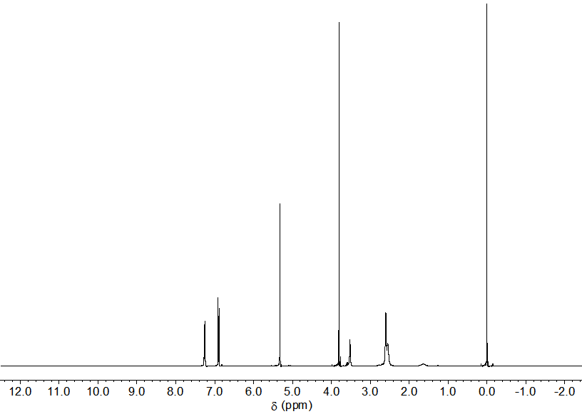
Fig. S8. ¹H NMR of 3a in CD₂Cl₂.
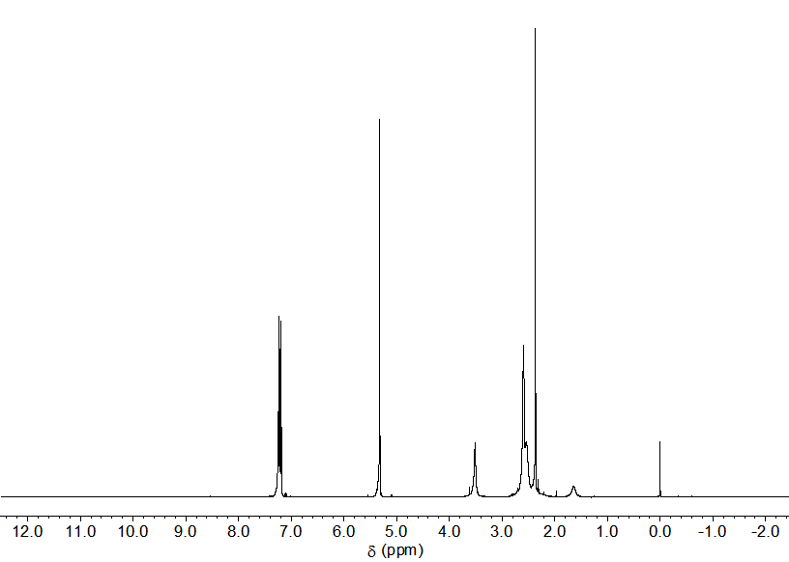
Fig. S9. ¹H NMR of 3b in CD₂Cl₂.

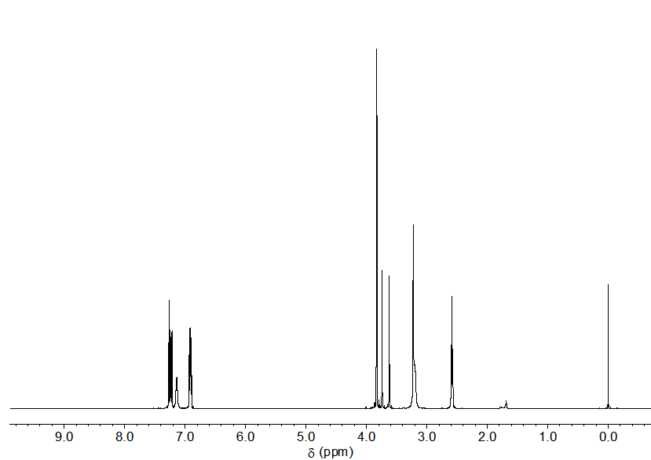
Fig. S10. ¹H NMR of 3a-pre in D₂O in the presence of NaOD.
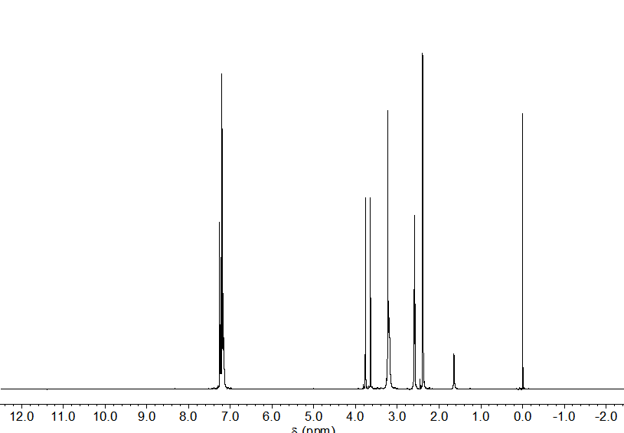
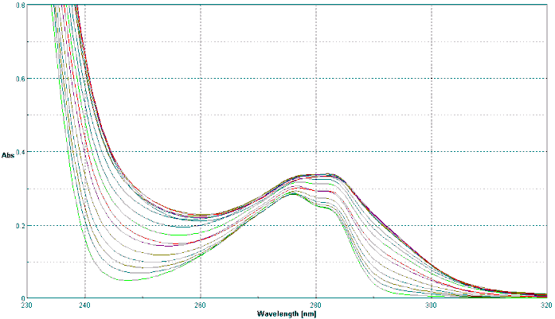
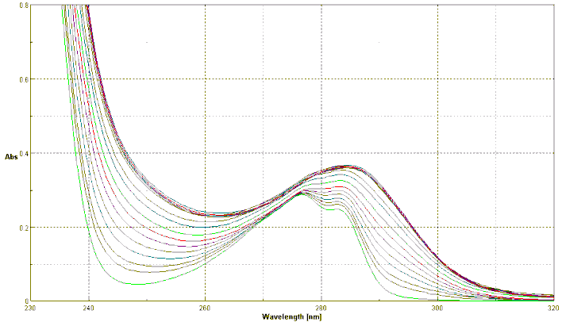
Fig. S11. ¹H NMR of 3b-pre in D₂O in the presence of NaOD.
Fig. S12. Ag⁺-ion-induced UV spectral changes of 1a. Fig. S13. Ag⁺-ion-induced UV spectral changes of 1b.
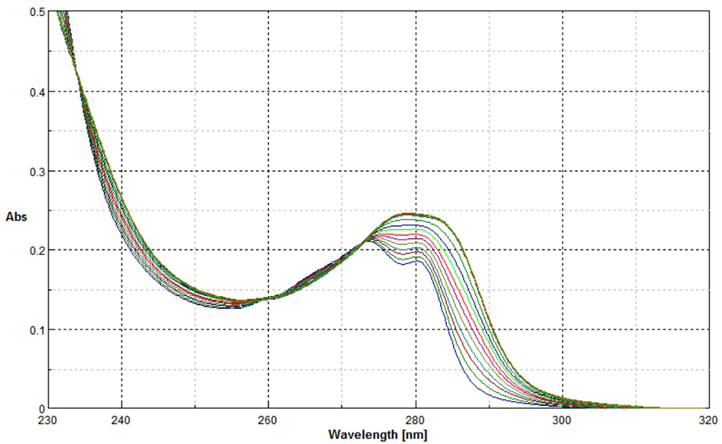
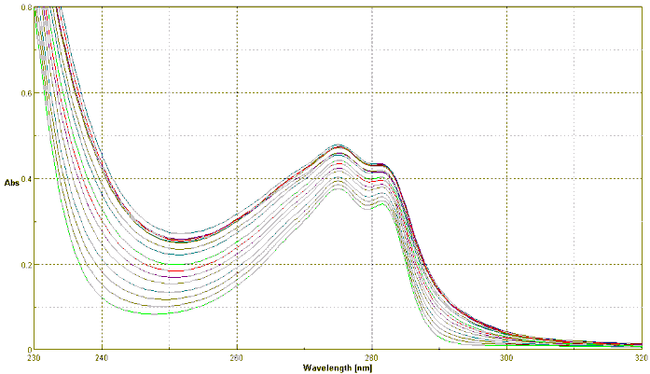
Fig. S14. Ag⁺-ion-induced UV spectral changes of 1d. Fig. S15. Ag⁺-ion-induced UV spectral changes of 2.
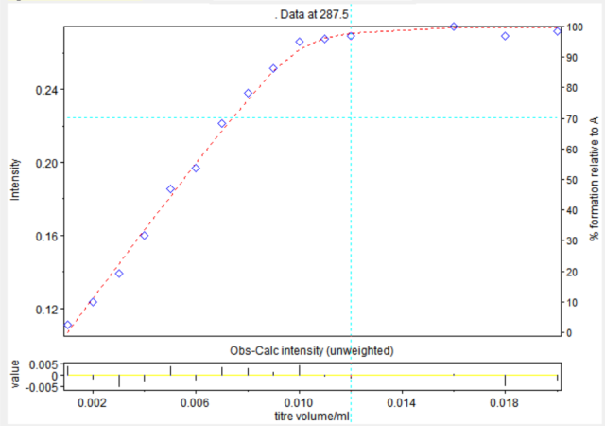

Converged in 1 iterations with sigma = 3.4080E-03

standard
Log beta value deviation
AB 6.1089 0.0121

Fig. S16. UV titration curve of 1a/Ag⁺ system at 287.5 nm. ♢: Observed. ----: Calculated.
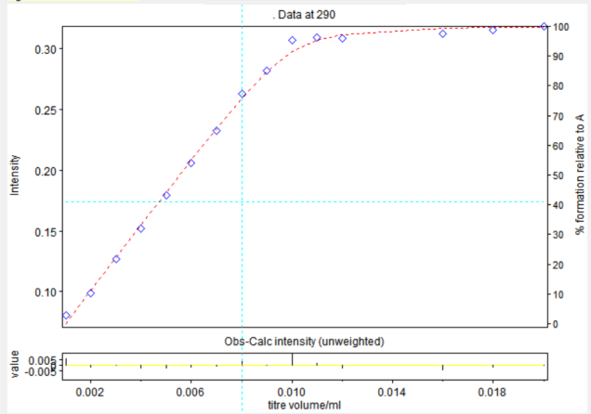
Converged in 1 iterations with sigma = 2.9043E-03

standard
Log beta value deviation
AB 6.085 0.0101

Fig. S17. UV titration curve of 1b/Ag⁺ system at 290 nm. ♢: Observed. ----: Calculated.
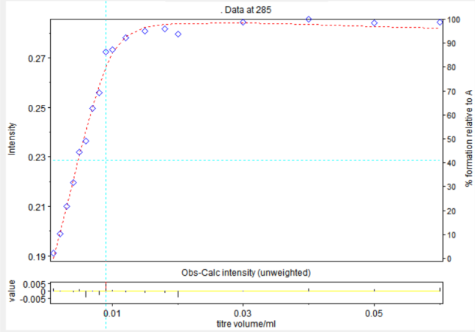
Converged in 1 iterations with sigma = 3.8735E-03

standard
Log beta value deviation
AB 5.6671 0.0324

Fig. S18. UV titration curve of 1c/Ag⁺ system at 285 nm. ♢: Observed. ----: Calculated.
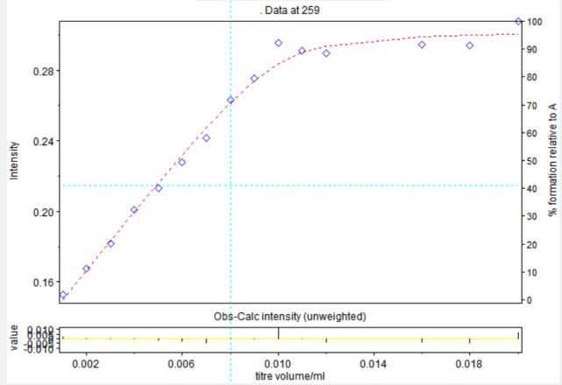
Converged in 1 iterations with sigma = 2.6978E-03

standard
Log beta value deviation
AB 5.8053 0.0093

Fig. S19. UV titration curve of 1d/Ag⁺ system at 259 nm. ♢: Observed. ----: Calculated.

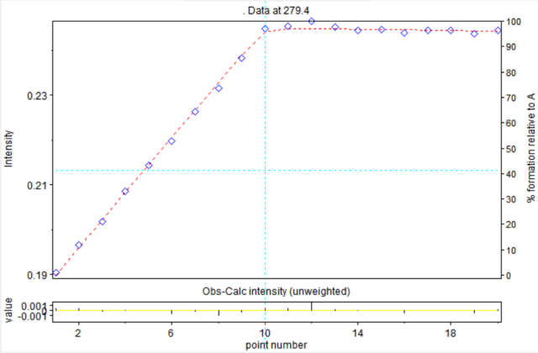
Converged in 1 iterations with sigma = 1.3159E-03

standard
Log beta value deviation
AB 7.9219 0.0313
Fig. S20. UV titration curve of 2/Ag⁺ system at 279.4 nm. ♢: Observed. ----: Calculated.

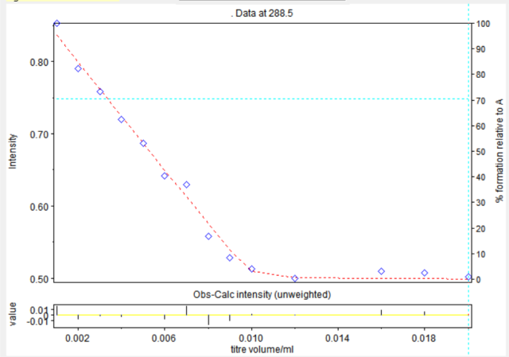
Converged in 1 iterations with sigma = 3.1942E-03

standard
Log beta value deviation
AB 7.1555 0.0721

Fig. S21. UV titration curve of 3a/Ag⁺ system at 288.5 nm. ♢: Observed. ----: Calculated.
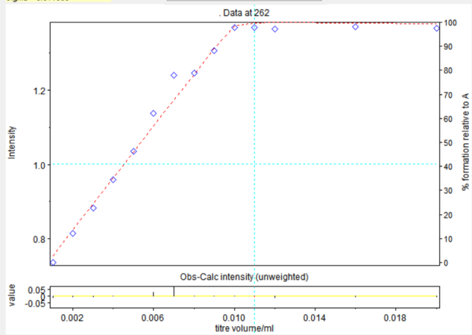
Converged in 1 iterations with sigma = 6.8238E-03

standard
Log beta value deviation
AB 7.6289 0.0606

Fig. S22. UV titration curve of 3b/Ag⁺ system at 262 nm. ♢: Observed. ----: Calculated.
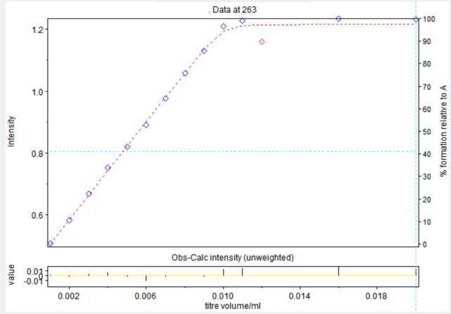
Converged in 1 iterations with sigma = 3.8410E-03

standard
Log beta value deviation
AB 7.1124 0.0298

Fig. S23. UV titration curve of 3c/Ag⁺ system at 263 nm. ♢: Observed. ----: Calculated.
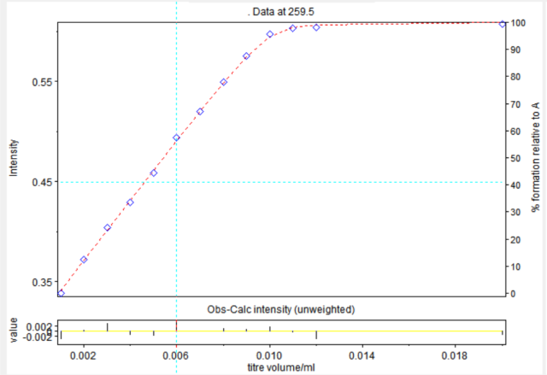
Converged in 1 iterations with sigma =2.4159E-03

standard
Log beta value deviation
AB 6.451 0.0227

Fig. S24. UV titration curve of 4/Ag⁺ system at 259.5 nm. ♢: Observed. ----: Calculated.
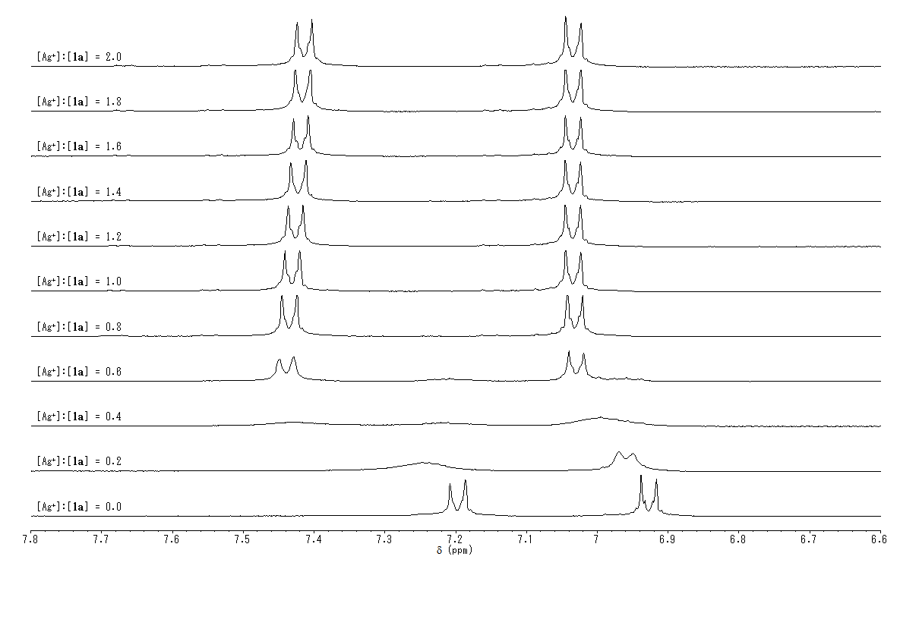
Fig. S25. Ag⁺-ion-induced-¹H NMR spectral changes (aromatic regin) of 1a.

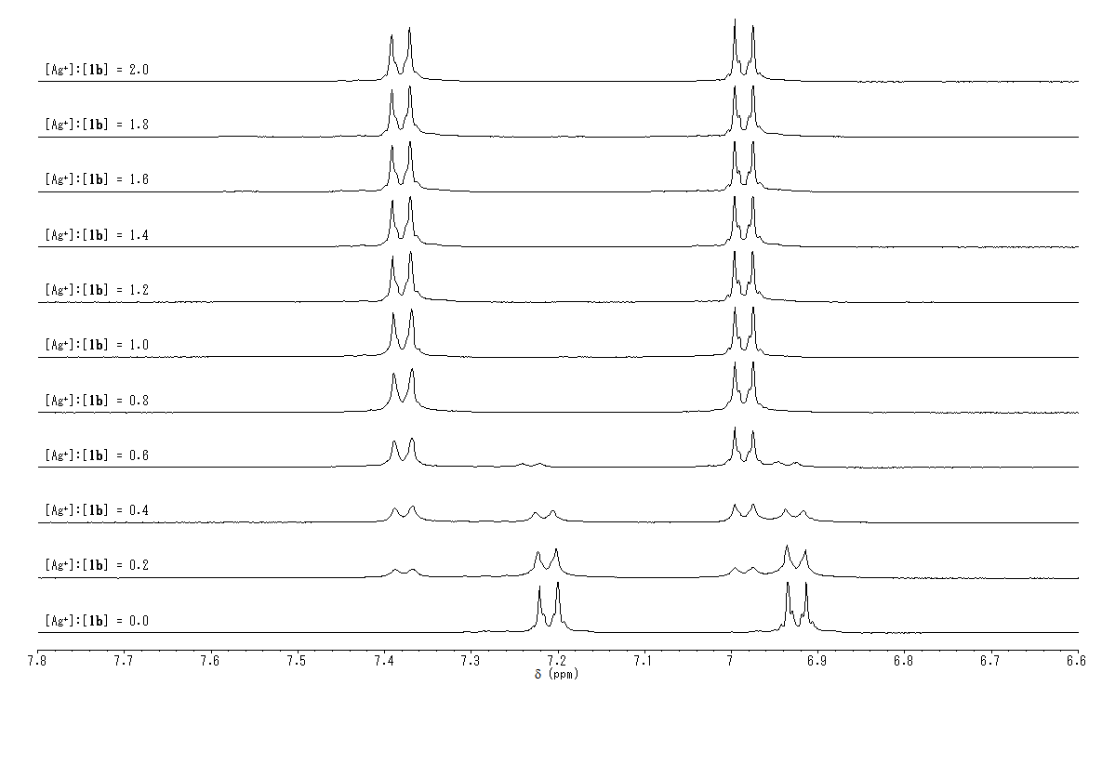
Fig. S26. Ag⁺-ion-induced-¹H NMR spectral changes (aromatic regin) of 1b.
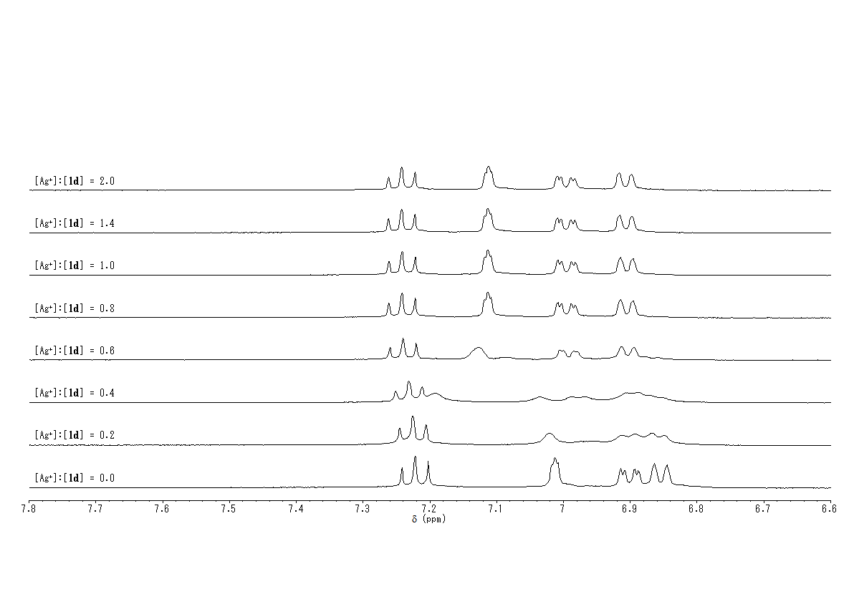
Fig. S27. Ag⁺-ion-induced-¹H NMR spectral changes (aromatic regin) of 1d.

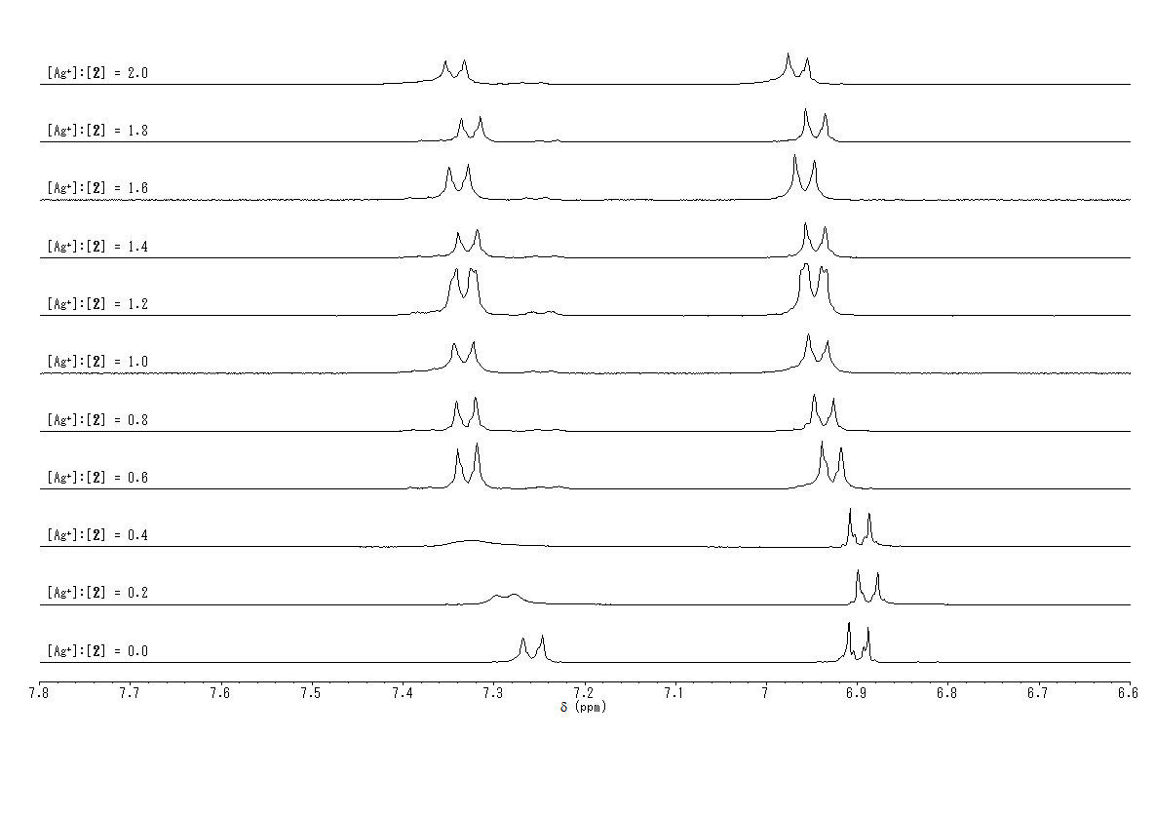
Fig. S28. Ag⁺-ion-induced-¹H NMR spectral changes (aromatic regin) of 3a.
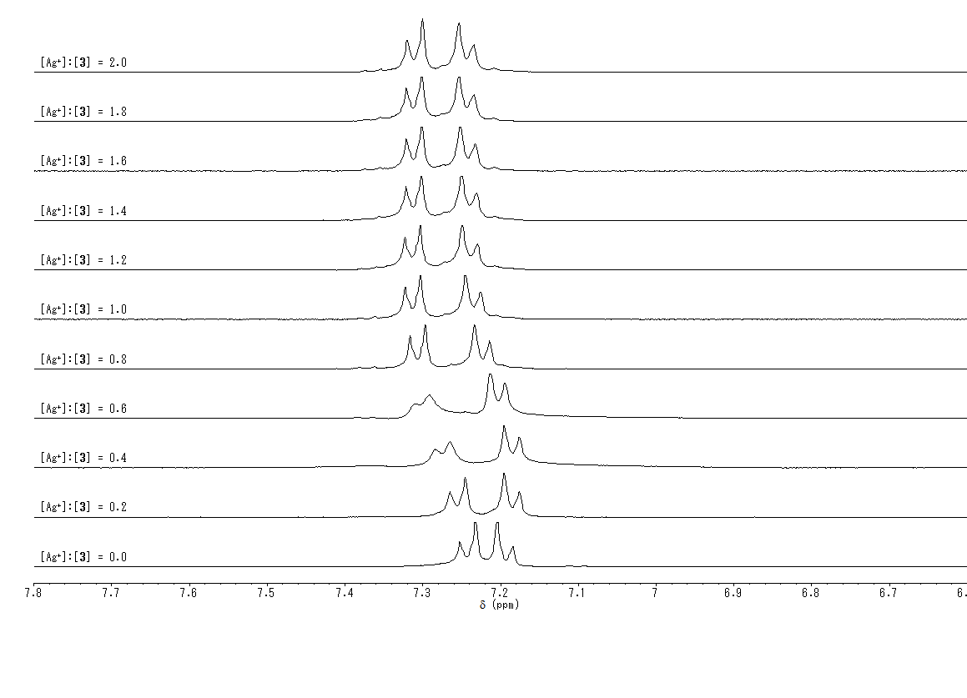
Fig. S29. Ag⁺-ion-induced-¹H NMR spectral changes (aromatic regin) of 3b.

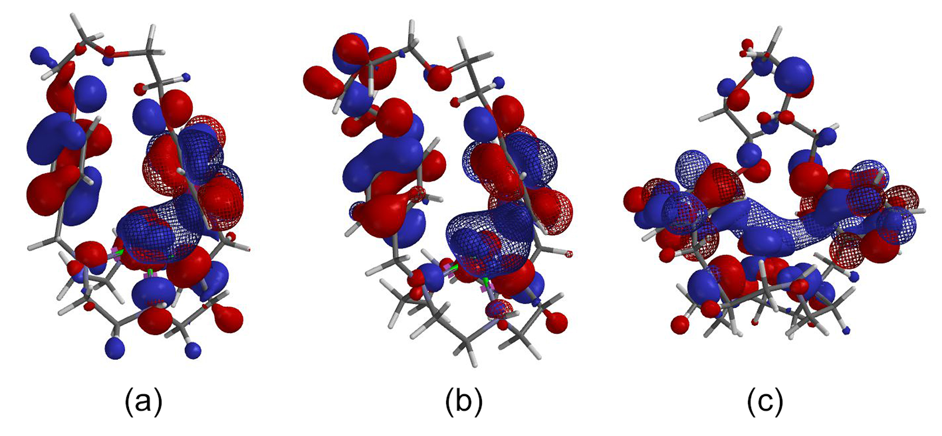
Fig. S30. LUMO (mesh) and HOMOs (solid) of 1a/Ag⁺, 1b/Ag⁺, and 1d/Ag⁺ complexes. These structures were optimized using the DFT (the B3LYP/3-21G*). (a) LUMO, HOMO[–1], and HOMO[–2] of 1a/Ag⁺, (b) LUMO, HOMO[–1], and HOMO[–2] of 1b/Ag⁺, and (c) LUMO, HOMO[–1], and HOMO[–4] of 1d/Ag⁺.

