Supplementary information

Probing the interaction of thionine with human serum albumin by multispectroscopic studies and its in vitro cytotoxic activity towards MCF-7 breast cancer cells

Perumal Manivelª, Manickam Paulpandi^{b}, Kadarkarai Murugan^{b}, Giovanni Benelli ^{c,d}, and
Malaichamy Ilanchelianª*

ª Department of Chemistry, Bharathiar University, Coimbatore – 641046, Tamil Nadu, India.
^{b} Proteomics Lab, Department of Zoology, Bharathiar University, Coimbatore – 641046, Tamil Nadu, India.
^{c} Insect Behavior Group, Department of Agriculture, Food and Environment, University of Pisa, via del Borghetto 80, 56124 Pisa, Italy.
^{d} The BioRobotics Institute, Sant’Anna School of Advanced Studies, Viale Rinaldo Piaggio 34, 56025 Pontedera, Italy.

* Corresponding author: Tel: +91 422 2428317. Fax: +91 - 422 2422 387. E-mail address: chelian73@yahoo.com, manivelchemist.p@gmail.com

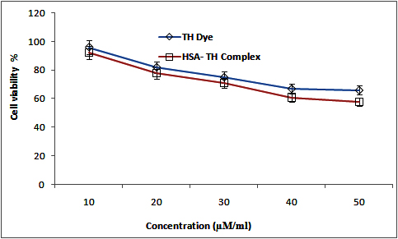

Figure S1. In vitro cytotoxicity of TH dye and TH-HSA complex against human breast epithelial cell lines (HBL-100) after incubation for 48 h.

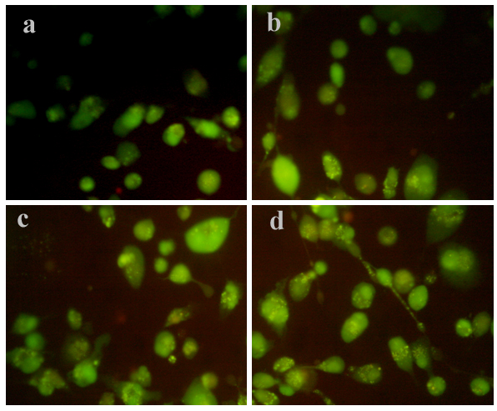
Figure S2. Fluorescence microscopy images of HBL-100 cells ((a) Control (untreated cells), (b) TH dye (35 μM), (c) Control, (d) HSA-TH complex (25 μM) for 24 h). The fluorescent spectrum was detected at 360 nm/470 nm excitation/emission.

LDH assay
1. Methods
For LDH assay 50 μl/well supernatant, collected after exposing the cells MCF-7 and HBL-100 to dye and dye protein complex, were incubated with an equivalent volume of substrate solution. After incubating the plate for 30 minutes at RT, 50 μl/well stop solution was pipetted and data were acquired by spectrophotometry at 490 nm. Results are expressed as mean LDH release (expressed as experimental LDH release at 490 nm/maximum LDH release at 490 nm ± Standard Deviation (SD).

2. Results and discussion
LDH release has been considered as a very reliable marker of cell lysis due to membrane damage, indicating cytotoxicity. LDH leakage assay is based on the release of the enzyme into the culture medium after cell membrane damage. In vitro cytotoxicity (LDH) of TH dye and TH-HSA complex against MCF-7 human breast cancer cells are investigated and the results were shown in Figure S3. It could be noticed that significant release of LDH in the medium treated with MCF-7 cells. The increase in LDH release was started at 10 μM of TH-HSA complex and was found to be significantly high at increased concentrations. Further, this effect may exert due to the mitochondrial dysfunction upon treated with TH/TH-HSA complex. Interestingly, the TH-HSA complex shows higher level of cytotoxic effect on MCF-7 cells when compared to TH treated cancer cells. It further validates the experimental finding observed from MTT assay. LDH release was also examined on HBL-100 cells in the presence and absence of TH/TH-HSA complex and the corresponding results were shown in Figure S4. It was found that insignificant release of LDH upon the treatment confirms that the TH/TH-HSA complex are not toxic to the normal epithelial cells (HBL-100).

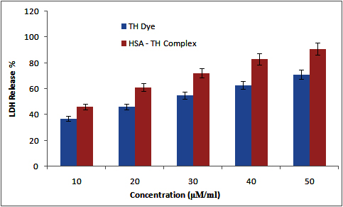

Figure S3. In vitro cytotoxicity (LDH) of TH dye and TH-HSA complex against MCF-7 human breast cancer cells after incubation for 48 h.

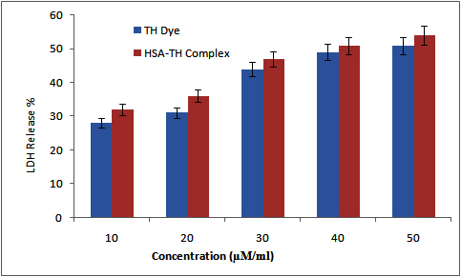

Figure S4. In vitro cytotoxicity (LDH) of TH dye and TH-HSA complex against HBL-100 human breast epithelial cells after incubation for 48 h.

