**Supplementary Information**

Kinetics and mechanism of interaction of Pt(II) complex with bio-active ligands and *in vitro* Pt(II)-sulfur adduct formation in aqueous medium: Bio‑activity and computational study

AVRADEEP SAMANTA, ISHANI MITRA, VENKATA P. REDDY B., SUBHAJIT MUKHERJEE, SUJAY MAHATA, WOLFGANG LINERT, BASHKIM MISINI, ASHISH BHATTACHARJEE, SUKHAMOY DHABAL, GOUTAM KR. GHOSH and SANKAR CH. MOI*

**Table of contents:**

|  |  |  |
| --- | --- | --- |
| **Sl.No** | **Fig. No.** | **Figure caption** |
| 1 | Scheme 1 | Equilibrium for the formation of zwitter ionic form for DL-meth and DL-pen |
| 2 | S1Fig. S1 | FTIR spectra of Complex **1** in KBr disk (400 cm-1-4000 cm-1) |
| 3 | SI Fig. S2 | 1H NMR spectrum of [Pt(pic)Cl2] |
| 4 | SI Fig. S3 | 13C NMR of complex **1** |
| 5 | SI Fig. S4 | IR spectrum of [Pt(pic)(OH2)2]2+ **2** complex |
| 6 | SI Fig. S5 | Spectral difference between reactant (**2**) [Pt(pic)(OH2)2]2+ and product (**3**) [Pt(pic)(OH2)2]2+ [DL-meth] at pH 4.0. |
| 7 | SI Fig. S6 | Spectral difference between reactant (**2**) [Pt(pic)(OH2)2]2+ and product (**4**) [Pt(pic)(OH2)2]2+ [DL-pen] at pH 4.0. |
| 8 | SI Fig. S7 | Job’s Plot of Abs versus [L]/{[L]+[M]} for [DL-meth] |
| 9 | SI Fig. S8 | Job’s Plot of Abs versus [L]/{[L]+[M]} for [DL-pen] |
| 10 | SI Fig. S9 | a. FT-IR spectrum of [Pt(pic)(DL-meth)]  b. FT-IR spectrum of DL-meth |
| 11 | SI Fig. S10 | 1H NMR spectrum of [Pt(pic)(DL-meth)]+ |
| 12 | SI Fig. S11 | a. FT-IR spectrum of [Pt(pic)(DL-pen)]  b. FT-IR spectrum of DL-pen |
| 13 | SI Fig. S12 | 1H NMR spectrum of [Pt(pic)(DL-pen] |
| 14 | SI Fig. S13 | A typical plot of ln(Aα–At) versus time (min), [Pt(pic)(OH2)2]2+, [DL-pen], pH= 4.0, t = 25oC |
| 15 | SI Fig. S14 | Plot of 103k1(obs) versus 103[DL-meth] at different temperatures |
| 16 | SI Fig. S15 | Plot of 103 k1(obs) versus 103[DL-Pen] at different temperatures |
| 17 | SI Fig. S16 | Plot of 1/103k1(obs) versus 1/103[DL-meth] at different temperatures |
| 18 | SI Fig. S17 | Plot of 1/103k1(obs)versus 1/103[DL-Pen] at different temperatures |
| 19 | SI Fig. S18 | Eyring plot of (lnk2h/kbT vs. 103/T) of DL-meth |
| 20 | SI Fig. S19 | Eyring plot of (lnk1h/kbT vs. 103/T) of DL-pen |
| 21 | SI Fig. S20 | Eyring plot of (lnk2h/kbT vs. 103/T) of DL-pen |
| 22 | SI Fig. S21 | Optimized structure of complex **4** (bonded via S and N) |
| 23 | SI Fig. S22 | Optimized structure of complex 3′ (bonded via S and O) |
| 24 | SI Fig. S23 | Optimized structure of complex **4**′ (bonded via S and O) |
| 25 | SI Table TS1 | 103× k1(obs) (s-1) values at different [DL-meth] and [DL-pen] at different temperature |
| 26 | SI Table TS2 | 105× k2(obs) (s-1) values at different [DL-meth] and [DL-pen] at different temperature |
| 27 | SI Table TS3 | Activation parameters of analogous systems |
| 28 | SI Table TS4 | Probable optimized structure via. different donor centres and their different configurations |
| 29 | SI Table TS5 | Charges (a.u.) and electron configurations for the complexes **4**(S,N) and **4**′(S,O) |
| 30 | SI Table TS6 | MTT assay results |



**Scheme S1**. Equilibrium for the formation of zwitterionic form for DL-meth and DL-pen.

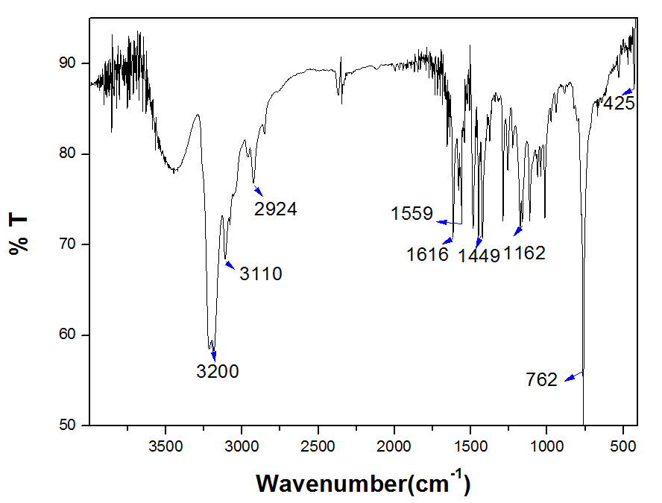

**Figure S1**.FTIR spectra of complex **1** in KBr disk (400-4000 cm-1).

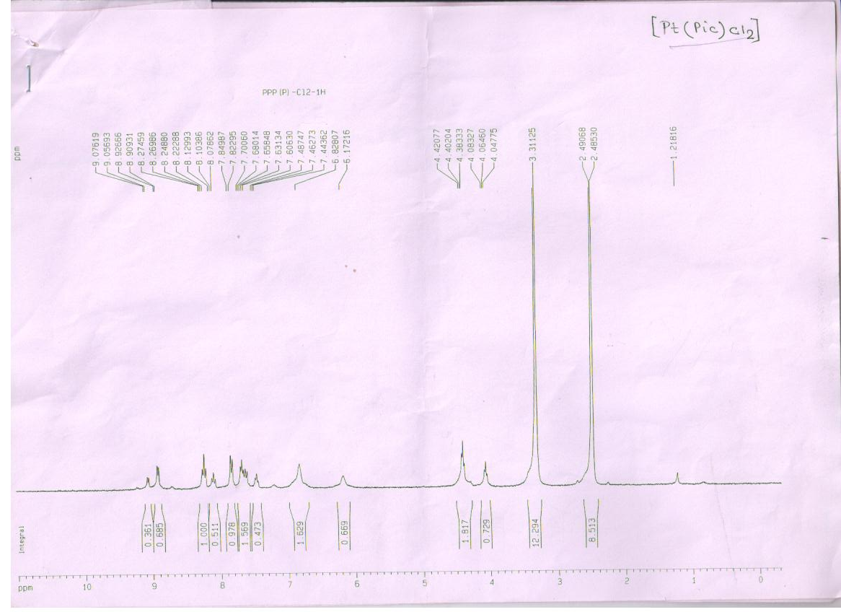

**Figure S2.** 1H NMR spectra of [Pt(pic)Cl2] in DMSO-d6 as solvent.

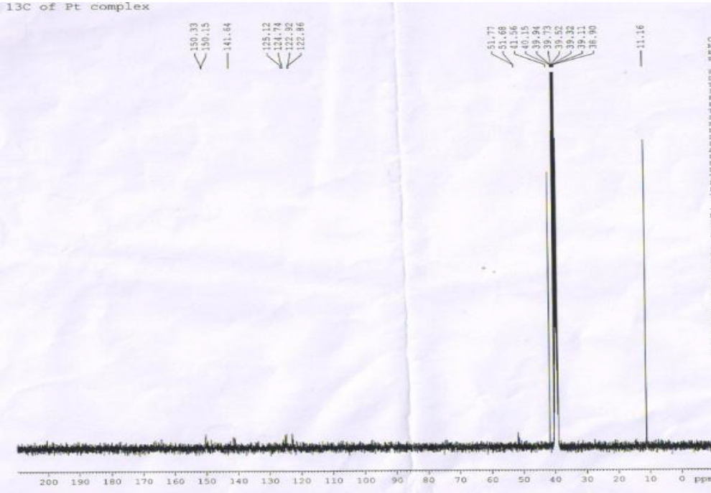

**Figure S3.** 13C NMR of complex **1** in DMSO-d6 as solvent.



**Figure S4**. IR spectrum of [Pt(pic)(OH2)2]2+, complex **2**.

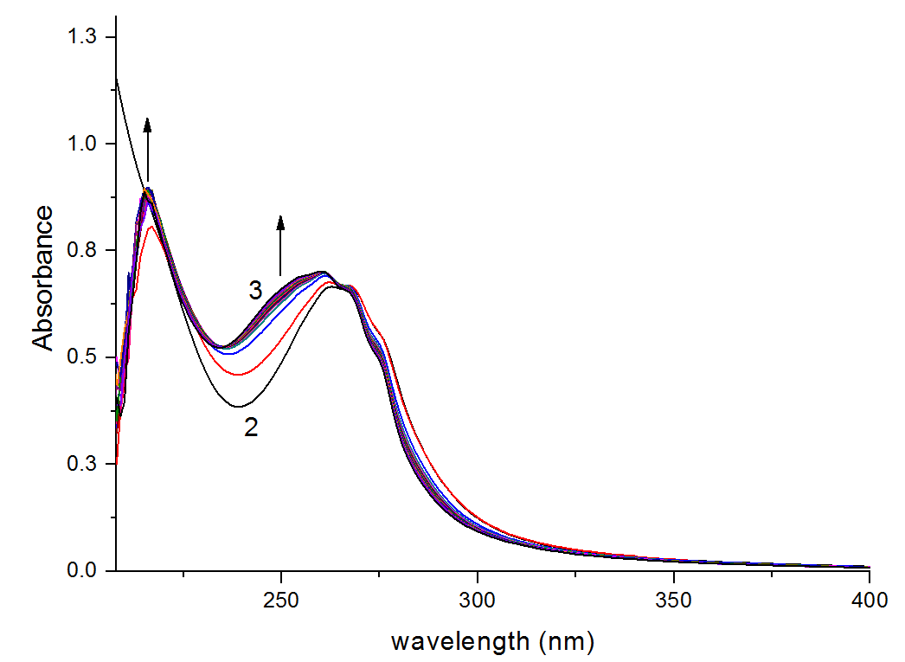

**Figure S5**. Spectral difference between reactant complex **2**, [Pt(pic)(OH2)2](ClO4)2+ (represented by the spectrum 2) and product complex **3** [Pt(pic)(DL-meth)]+ (spectra 3) at pH 4.0. Quartz Cell used was of 1 cm pathlength.

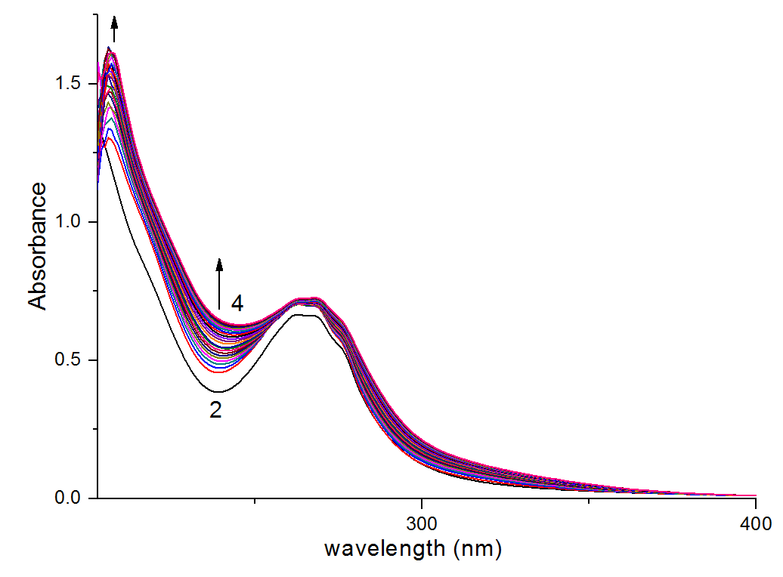

**Figure S6**. Spectral difference between reactant complex **2**, [Pt(pic)(OH2)2](ClO4)2+ (represented by the spectra 1) and product complex **4**, [Pt(pic)(DL-pen)]( represented by the group of spectrum 2) at pH 4.0. Quartz Cell used was of 1 cm pathlength.

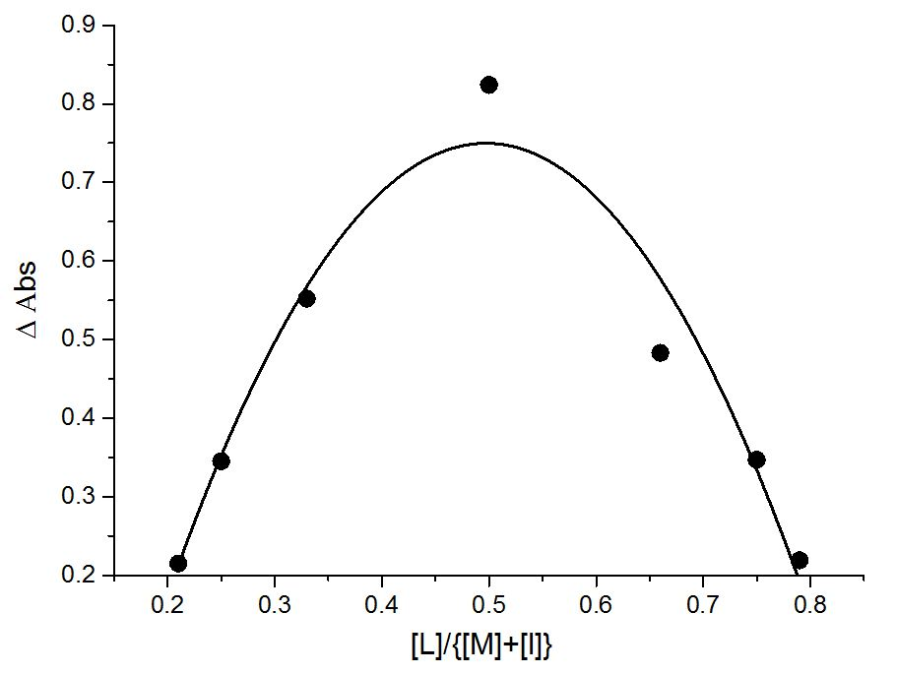

**Figure S7**. Job’s plot of Abs versus [L]/{[L]+[M]} for [DL-methionine].

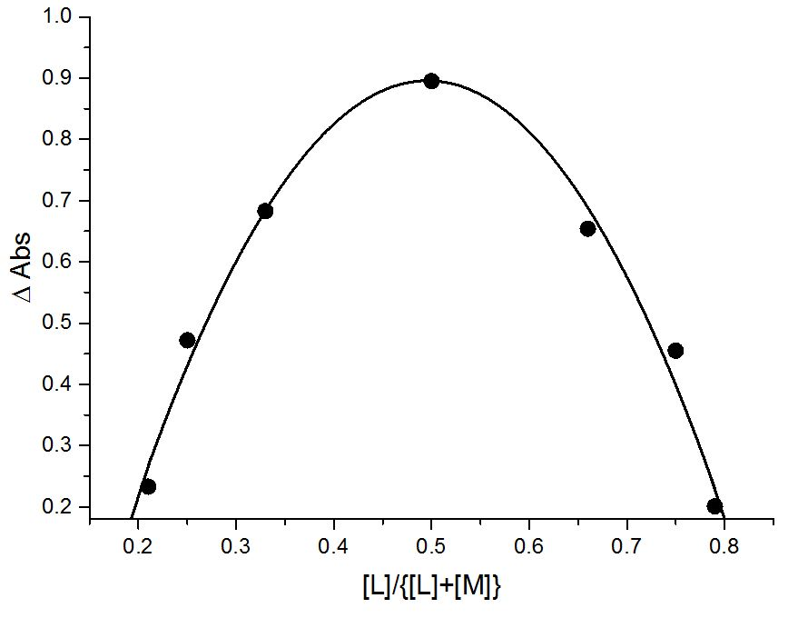

**Figure S8**. Job’s plot of Abs versus [L]/{[L]+[M]} for DL-penicillamine.

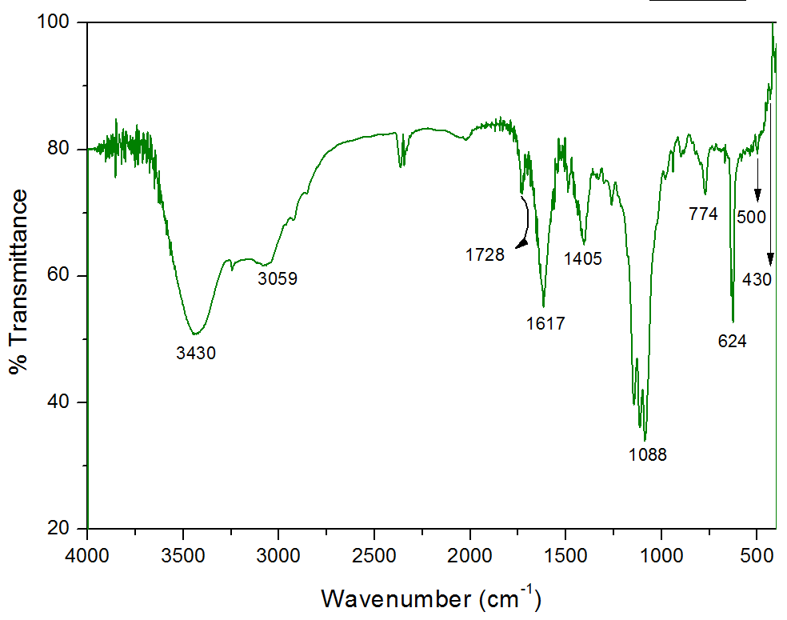

**Figure S9a**. FT-IR spectrum of [Pt(pic)(DL-meth)]ClO4 (complex **3**).

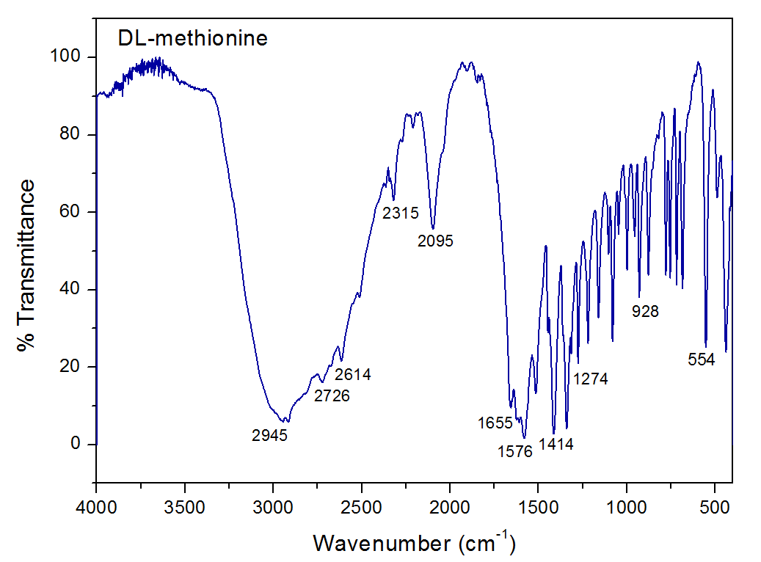

**Figure S9b**. FT-IR spectrum of DL-methionine.

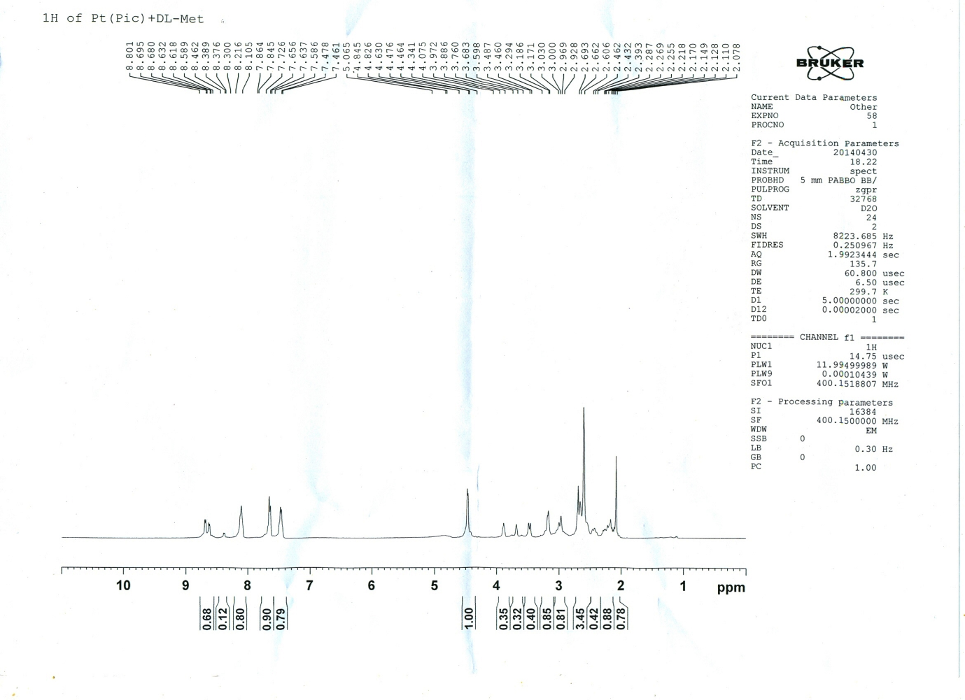**Figure S10**. 1H NMR spectrum of [Pt(pic)(DL-meth)].

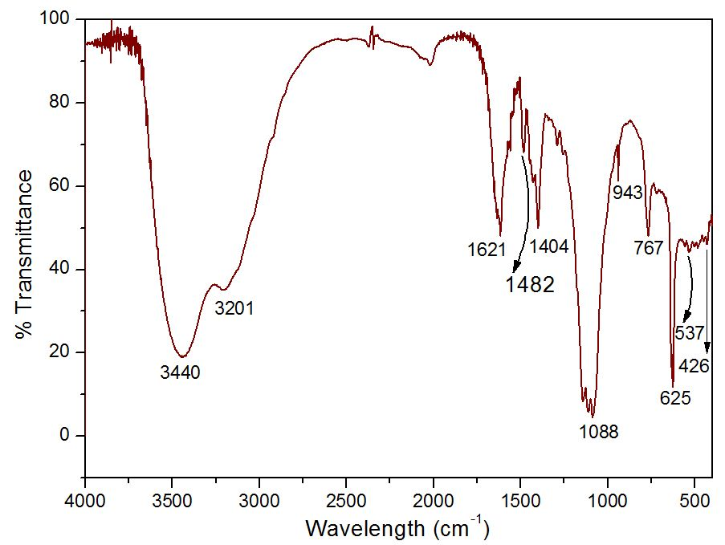

**Figure S11a**. FT-IR spectrum of [Pt(pic)(DL-pen)] (complex **4**).

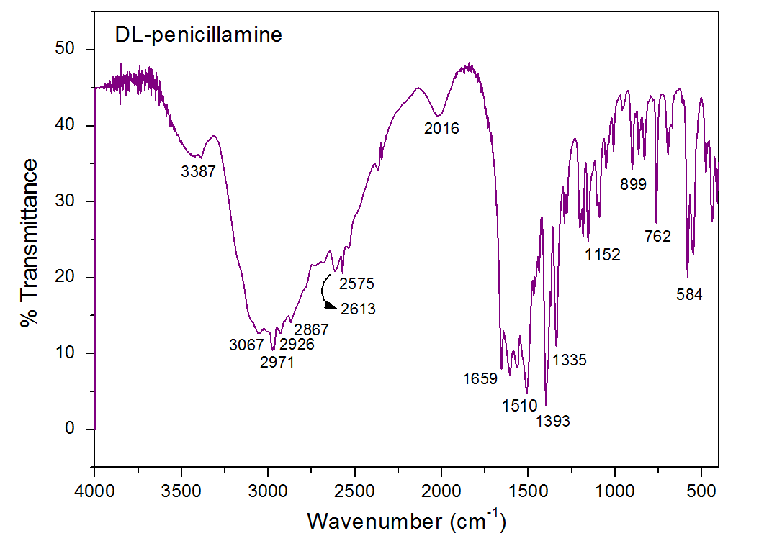

**Figure S11b**. FT-IR spectrum of DL-pen.

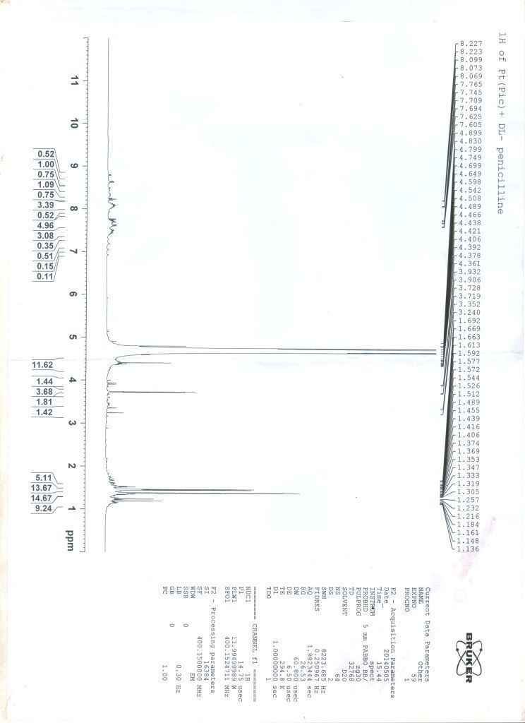**Figure S12**. 1H NMR spectrum of [Pt(pic)(DL-pen)] (complex **4**).

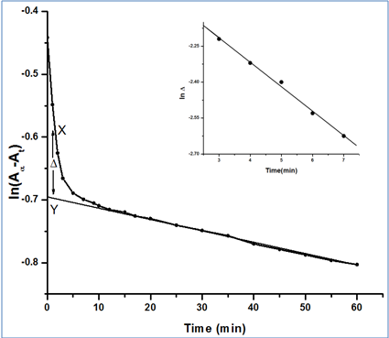

**Figure S13**. A typical plot of ln(Aα–At) versus time (min), [Pt(pic)(OH2)2]2+ = 2.43×10−4 mol.dm−3, [DL-pen] = 4.86×10−3 mol.dm−3, pH = 4.0, t = 25 oC.

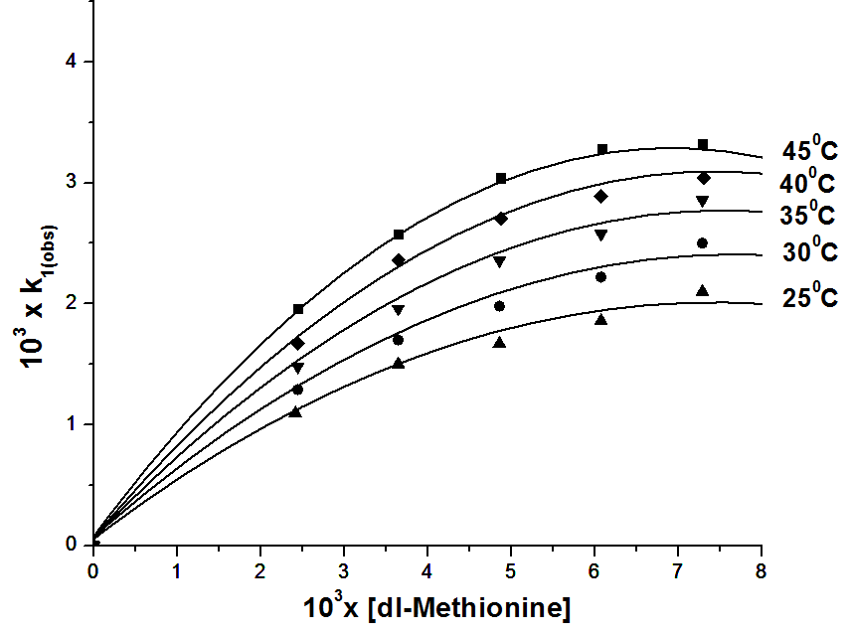

**Figure S14**. Plot of 103 k1(obs) versus 103[DL-meth] at different temperatures.

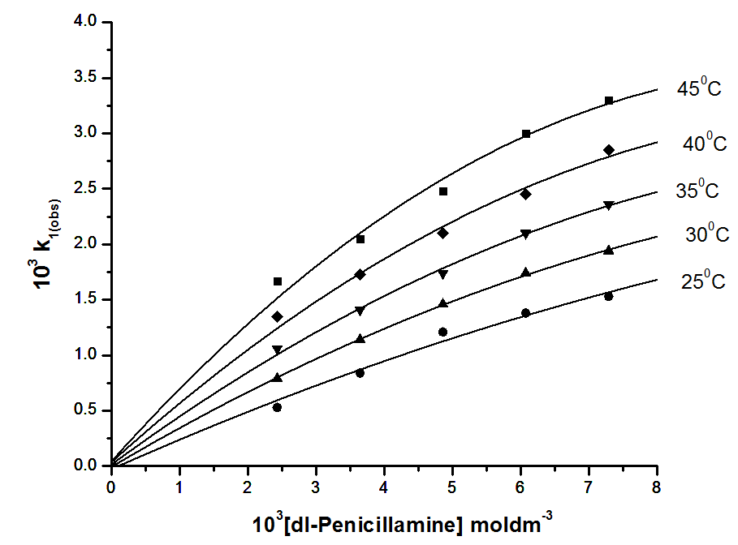

**Figure S15**. Plot of 103 k1(obs) versus 103[DL-Pen] at different temperatures.

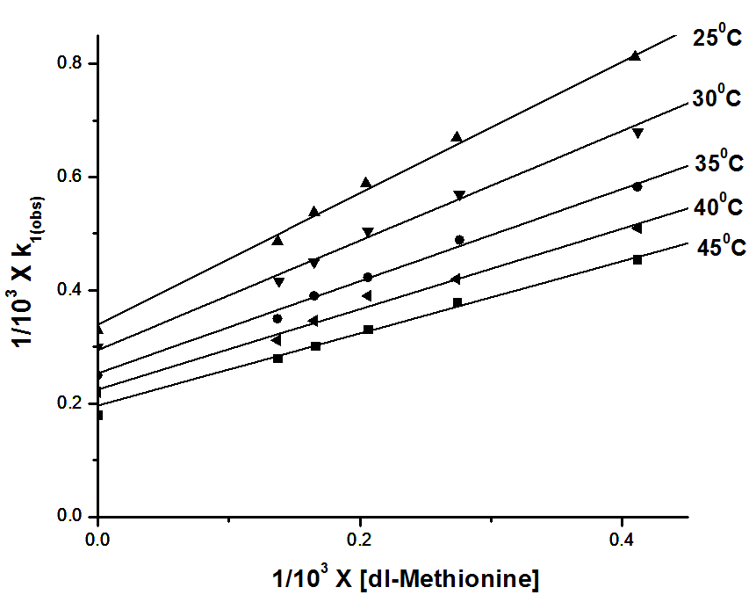

**Figure S16**. Plot of 1/103 k1(obs) versus 1/103[DL-meth] at different temperatures.

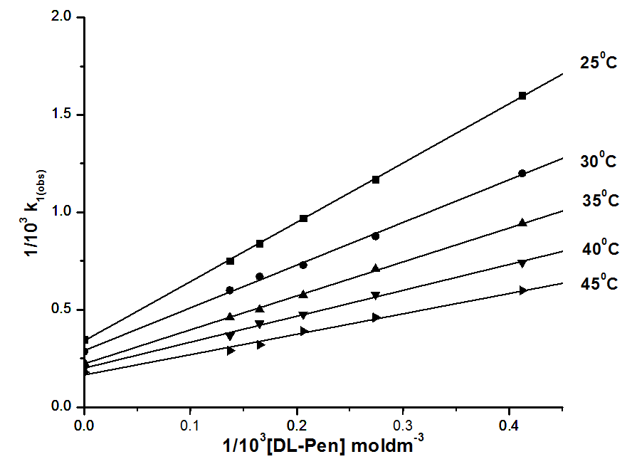

**Figure S17**. Plot of 1/103k1(obs) versus 1/103[DL-Pen] at different temperatures.

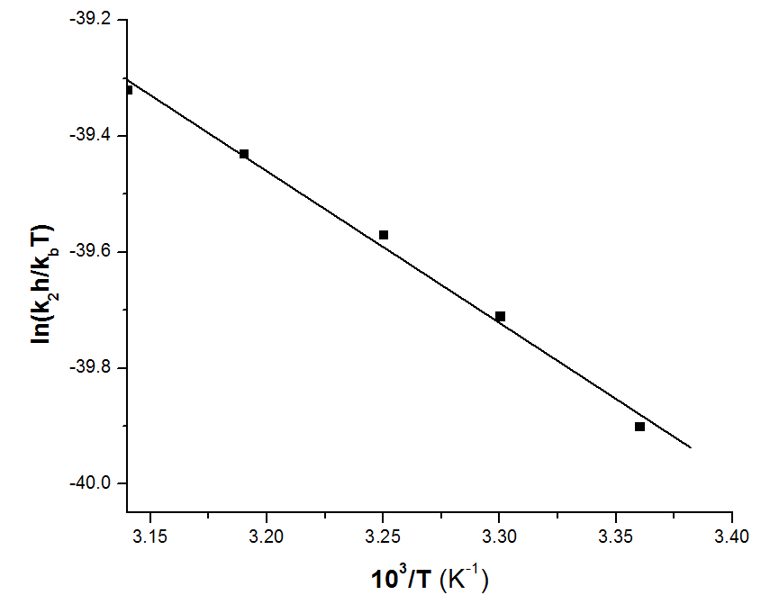

**Figure S18**. Eyring plot of (lnk2h/kbT vs. 103/T) of DL-meth.

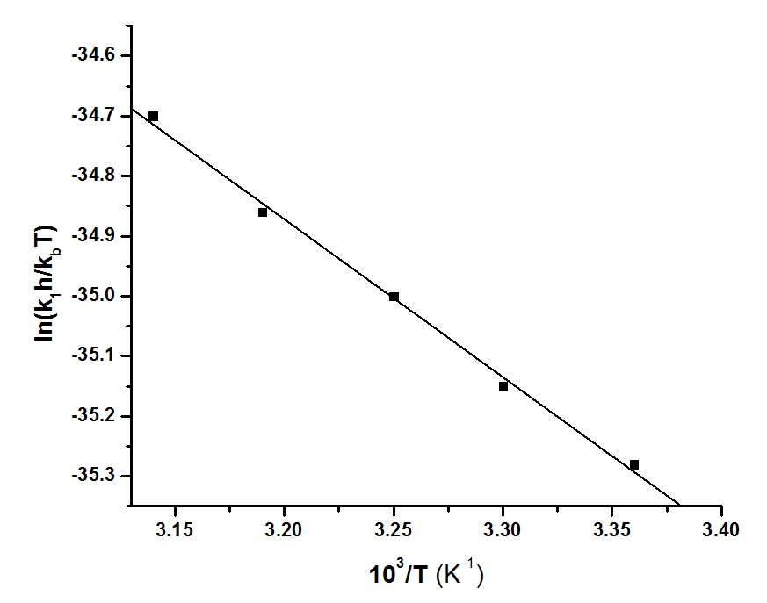

**Figure S19**. Eyring plot of (lnk1h/kbT vs. 103/T) of DL-pen.

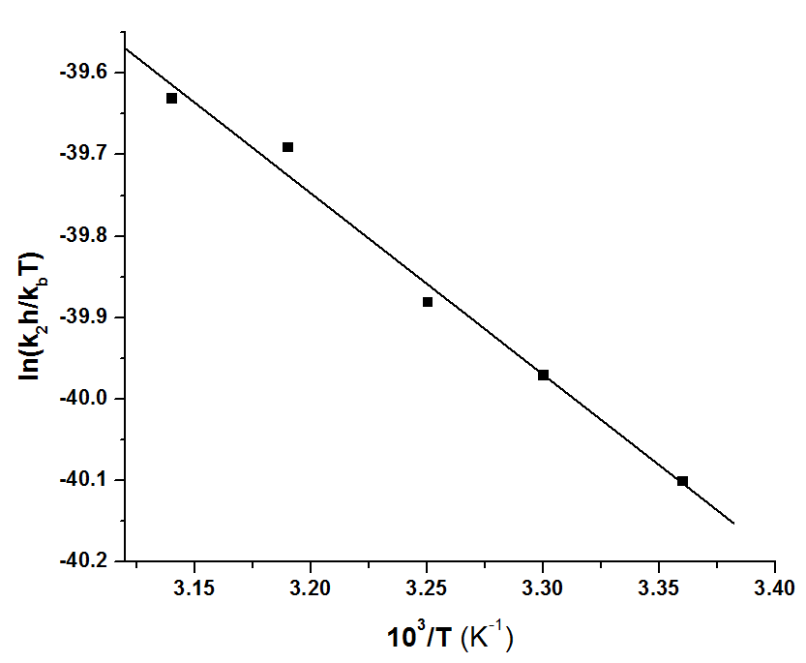

**Figure S20**. Eyring plot of (lnk2h/kbT vs. 103/T) of DL-pen.

pK'1 =1.90

SH-CMe2CH(NH3)-COOH SH-CMe2CH(NH3)-COO- + H+ (2)

pK'2 =7.88

SH-CMe2CH(NH3)-COO-  H-S-CMe2CH(NH3)-COO- + H+ (3)

pK'3 =10.58

-S-CMe2CH(NH3)-COOKa3'  -S-CMe2CH(NH2)-COO- + H+ (4)

**Scheme S1**. Dissociation equilibria of DL-pen.

**Table TS1.** 103 k1(obs) (s-1) values at different [DL-meth] and [DL-pen] at different temperatures. [Complex **2**] = 2.43×10-4 mol.dm-3, pH = 4.0, ionic strength = 0.1 mol.dm-3 NaClO4.

|  |  |  |  |  |  |  |  |  |  |  |  |
| --- | --- | --- | --- | --- | --- | --- | --- | --- | --- | --- | --- |
| 103[L] | Temp (0C) | | | | | | | | | | |
| DL-methionine | | | | | DL-penicillamine | | | | | |
| mol.dm-3 | 25 | 30 | 35 | 40 | 45 | 25 | 30 | 35 | 40 | 45 | |
| 2.43 | 1.29±0.04 | 1.55±0.02 | 1.75±0.05 | 1.90±0.01 | 2.16±0.01 | 0.53±0.05 | 0.789±0.03 | 1.06±0.03 | 1.35±0.04 | 1.67±0.01 | |
| 3.64 | 1.50±0.03 | 1.70±0.01 | 1.96±0.02 | 2.36±0.03 | 2.58±0.02 | 0.84±0.03 | 1.14±0.04 | 1.41±0.05 | 1.73±0.03 | 2.05±0.02 | |
| 4.86 | 1.67±0.06 | 1.98±0.04 | 2.36±0.04 | 2.56±0.04 | 2.82±0.03 | 1.21±0.06 | 1.46±0.06 | 1.74±0.02 | 2.1±0.02 | 2.48±0.01 | |
| 6.07 | 1.86±0.05 | 2.22±0.06 | 2.58±0.06 | 2.89±0.05 | 3.16±0.04 | 1.38±0.07 | 1.74±0.07 | 2.1±0.01 | 2.45±0.03 | 3.00±0.04 | |
| 7.29 | 2.10±0.03 | 2.50±0.07 | 2.86±0.07 | 3.21±0.07 | 3.39±0.06 | 1.53±0.04 | 1.94±0.02 | 2.36±0.02 | 2.85±0.02 | 3.30±0.03 | |
| R2 | 0.98 | 0.98 | 0.98 | 0.98 | 0.99 | 0.99 | 0.99 | 0.99 | 0.98 | 0.99 | |
|  | | | | | | | | | | |

**Table TS2.** 105×k2(obs) (s-1) values at different [DL-meth] and [DL-pen] at different temperatures; [Complex **2**] = 2.43×10-4 mol.dm-3, pH = 4.0, ionic strength = 0.1 mol.dm-3 NaClO4.

|  |  |  |  |  |  |  |  |  |  |  |
| --- | --- | --- | --- | --- | --- | --- | --- | --- | --- | --- |
| 105[L] | DL-methionine | | | | | DL-penicillamine | | | | |
|  | Temp (oC) | | | | | Temp (oC) | | | | |
| mol.dm-3 | 25 | 30 | 35 | 40 | 45 | 25 | 30 | 35 | 40 | 45 |
| 2.43 | 2.12±0.16 | 2.40±0.22 | 2.65±0.16 | 2.77±0.18 | 3.26±0.12 | 2.19±0.14 | 2.65±0.19 | 3.26±0.13 | 3.55±0.13 | 3.91±0.14 |
| 3.64 | 2.07±0.14 | 2.39±0.28 | 2.55±0.19 | 2.70±0.14 | 3.29±0.19 | 2.24±0.13 | 2.61±0.16 | 3.22±0.11 | 3.60±0.14 | 3.90±0.11 |
| 4.86 | 2.05±0.26 | 2.44±0.32 | 2.61±0.26 | 2.78±0.26 | 2.30±0.22 | 2.21±0.16 | 2.66±0.13 | 3.24±0.15 | 3.57±0.18 | 3.93±0.18 |
| 6.07 | 2.13±0.28 | 2.36±0.38 | 2.56±0.32 | 2.72±0.32 | 2.28±0.28 | 2.31±0.18 | 2.62±0.14 | 3.28±0.17 | 3.54±0.11 | 3.95±0.19 |
| 7.29 | 2.11±0.32 | 2.41±0.42 | 2.59±0.42 | 2.75±0.22 | 2.26±0.18 | 2.28±0.22 | 2.61±0.18 | 3.23±0.16 | 3.59±0.21 | 3.92±0.20 |
| R2 | 0.97 | 0.98 | 0.96 | 0.98 | 0.997 | 0.99 | 0.98 | 0.96 | 0.998 | 0.98 |

**Table TS3.** Activation parameters of analogous systems.

|  |  |  |  |  |  |
| --- | --- | --- | --- | --- | --- |
| Systems | ΔH1‡ (kJmol-1) | ΔS1‡ (JKmol-1) | ΔH2‡ (kJmol-1) | ΔS2‡ (JKmol-1) | Ref. |
| [Pt(pic)(H2O)2]2+/  DL-methionine | 25.36±1.94 | -207.6±3.34 | 21.78±1.56 | -258.61±4.41 | This work |
| [Pt(pic)(H2O)2]2+/  DL-penicillamine | 21.86±1.90 | -220.36±3.40 | 18.46±1.67 | -271.39±3.86 |
| [Pt(terpy)(H2O)]2+/  Glutathione | 23 ± 1 | -116 ± 3 | ---- | ---- | [1] |
| *cis*-[Pt(pic)(H2O)2]2+/  Glutathione | 52.37±2.10 | -112.35±2.98 | 37.29±1.84 | -130.12±3.16 | [2] |
| [*cis*-Pt(en)(H2O)2]2+/  L-aspargine | 45.39±0.96 | -116.98±2.9 | 33.78±0.51 | -221.43±1.57 | [3] |
| [*cis*-Pt(en)(H2O)2]2+/  thiourea | 61.90±1.6 | -71±6 | 26.70±0.8 | -186.80±2.7 | [4] |
| [*cis*-Pt(en)(H2O)2]2+/  L-thiosamecarbazide | 35.60±0.8 | -166±3 | 44.50±1.3 | -182±4.0 | [5] |
| [*cis*-Pt(dach)(H2O)2]2+/  Glutathione | 32.9±1.3 | -187.20±4.2 | 30.50±0.1 | -223.1±4.3 | [6] |
| [Pt(pic)(H2O)2]2+/  L-cys  [Pt(pic)(H2O)2]2+/  N-ace-L-cys | 36.10±4.1  34.91±0.97  21..12±0.35 | -175±12  -174.68±2.18  -294.25±1.05 | 44.4±1.1  29.11±0.72  19.45±0.47 | -189±3.0  -233±2.4  -267.68±1.6 | [7]  [8]  " |

**Table TS4.**

|  |
| --- |
| **Complex 3** |
|  |
|  |
|  |
|  |
|  |
|  |
|  |
|  |
|  |
|  |
|  |
|  |

**Table TS5.** Charges (a.u.) and electron configurations for complexes **4**(S,N) and **4**′(S,O).

|  |  |  |  |  |  |
| --- | --- | --- | --- | --- | --- |
| Complex **4**(S,N) | | | Complex **4′**(S,O) | | |
| Atom | Charge | Natural electronic configuration | Atom | Charge | Natural electronic configuration |
| Pt | 0.31869 | [core]6S(0.58)5d(8.79)6p(0.30)6d(0.01) | Pt | 0.35182 | [core]6S(0.58)5d(8.74)6p(0.32)6d(0.01)7p(0.01) |
| N6 | -0.44800 | [core]2S(1.28)2p(4.15)3p(0.01) | N6 | -0.44247 | [core]2S(1.28)2p(4.15)3p(0.01) |
| N8 | -0.83078 | [core]2S(1.40)2p(4.41)3p(0.01) | N8 | -0.83131 | [core]2S(1.40)2p(4.41)3p(0.01) |
| S18 | -0.21402 | [core]3S(1.73)3p(4.46)3d(0.01)4p(0.01) | S18 | -0.22395 | [core]3S(1.72)3p(4.48)3d(0.01)4p(0.01) |
| O33 | -0.79631 | [core]2S(1.72)2p(5.06)3d(0.01) | O30 | -0.69370 | [core]2S(1.71)2p(4.97)3d(0.01) |
| O34 | -0.77589 | [core]2S(1.72)2p(5.04)3d(0.01) | O31 | -0.67632 | [core]2S(1.67)2p(5.00)3p(0.01) |
| N21 | -0.80017 | [core]2S(1.39)2p(4.39)3p(0.01) | N32 | -0.90732 | [core]2S(1.41)2p(4.48)3p(0.01) |

**Table TS6.** MTT assay results.

|  |  |  |  |  |  |  |  |  |  |  |
| --- | --- | --- | --- | --- | --- | --- | --- | --- | --- | --- |
| 10 μM |  | STDEV | 20 μM | STDEV | 30 μM | STDEV | 40 μM | STDEV | 50 μM | STDEV |
| 44.74778 |  | 2.305555 | 55.06944 | 5.104521 | 60.53541 | 4.651203 | 76.0181 | 6.032711 | 83.50168 | 2.750246 |
| 27.54348 |  | 5.335469 | 38.40278 | 1.478041 | 46.20035 | 7.392882 | 52.18703 | 3.514685 | 63.56902 | 2.9229 |
| 23.98682 |  | 3.008487 | 37.22222 | 1.027684 | 40.67358 | 4.605282 | 50.82956 | 2.502362 | 57.44108 | 2.43544 |
| 10.09104 |  | 4.326432 | 28.75 | 3.234203 | 37.91019 | 1.819629 | 44.19306 | 3.536463 | 51.44781 | 2.558036 |

**Supporting references**

[1] D.Ž. Bugarčić, T. Soldatovic, R. Jelic, B. Algues, A. Grandas. *Dalton Trans.*, 3869 (2004).

[2] G.K. Ghosh, K. Misra, W. Linert, S.C. Moi. *Synth.* *React.* *Inorg. Met.-Org. Chem.*, **43**, 714 (2013).

[3] S.K. Bera, S.K. Chandra, G.S. De. *Int J. Chem. Kinet.*, **35**, 252 (2003).

[4] P.S. Sengupta, S. Ghosh, G.S. De. *Transition Met. Chem.*, **25**, 279 (2000).

[5] S. Ghosh, P.S. Sengupta, G.S. De. *Indian J. Chem.*, **38A**, 453 (2000).

[6] R. Sinha, A.K. Choudhary, G.S. De. *Indian J. Chem.*, **42A**, 473 (2003).

[7] P. Karmakar, B.K. Bera, K.L. Barik, S. Mukhopadhay, A.K. Ghosh. *J. Coord. Chem.*, **63**, 2158 (2010).

[8] A. Samanta, G.Kr. Ghosh, I. Mitra, S. Mukherjee, J.C. Bose K, S. Mukhopadhyay, W. Linert, S.Ch. Moi. *RSC Adv.*, **4**, 43516 (2014).