**ELECTRONIC SUPPLEMENTARY MATERIAL**

**Palaeozoic-Recent geological development and uplift of the Amanos Mountains (S Turkey) in the critically located northwesternmost corner of the Arabian continent**

Tamer Y. Dumana, *, Alastair H.F. Robertsonb, Hasan Elmacıc, Meryem Karac

*a FUGRO-SIAL Farabi Sok. 40/4, Çankaya/Ankara, Turkey*

*b Grant Institute (Room 213), School of GeoSciences The King's Buildings, Edinburgh EH9 3FE, UK*

*c General Directorate of Mineral Research and Exploration (MTA), Ankara TR-06800, Turkey*

[duman.tamer@gmail.com](mailto:duman.tamer@gmail.com)

[alastair.robertson@ed.ac.uk](mailto:alastair.robertson@ed.ac.uk)

[hasan.elmaci@mta.gov.tr](mailto:hasan.elmaci@mta.gov.tr)

[meryem.kara@mta.gov.tr](mailto:meryem.kara@mta.gov.tr)

* Corresponding author

This electronic supplement is made up of 6 figures and 2 tables. The figures include annotated field photographs (51).

The figures of field photographs are;

**Electronic Supplementary Publication (ESP), Figure 1.** Field photographs of Palaeozoic and Mesozoic sedimentary features

**ESP, Figure 2.** Field photographs of Eocene and Miocene sedimentary features.

**ESP, Figure 3.** Field photographs showing sedimentary features of the Pliocene and Quaternary deposits

**ESP, Figure 4.** Field photographs of outcrop-scale structural features in the Amanos Mountains

**ESP, Figure 5.** Field photographs of outcrop-scale faults

**ESP, Figure 6.** Field photographs showing lithological and structural influences on geomorphology.

Tables are related with the palaeontological results and structural database.

Palaeontological results obtained by Aslı ELMACI, Palaeontologist, TPAO, Ankara. Seven thin sections of limestones containing microfossils were studied using a using Zeiss Axio Imager.M1 microscope. The samples were collected from key localities to check the accuracy of ages shown on MTA maps used. İn addition, one sample was taken from a previously unmapped outcrop of assumed Eocene limestone.

Map sheet reference is Ulu, Ü., 2002. 1:500,000 scale Geological map of Turkey, No: 16 (Hatay), M. Şenel, (Eds.), General Directorate of Mineral Research and Exploration, Ankara. Turkey

The structural database includes 327 kinematic measurements, which are bedding (168) and schistosity (47) attitudes, fold axes (88) and fault orientation (240).

These are; **ESP, Table 1.** Results and inferred age of palaeontological studies.

**ESP, Table 2.** Structural database of Amanos field survey.

**Reference**.

Ulu, Ü., 2002. 1:500,000 scale Geological map of Turkey, No: 16 (Hatay), M. Şenel, (Eds.), General Directorate of Mineral Research and Exploration, Ankara. Turkey

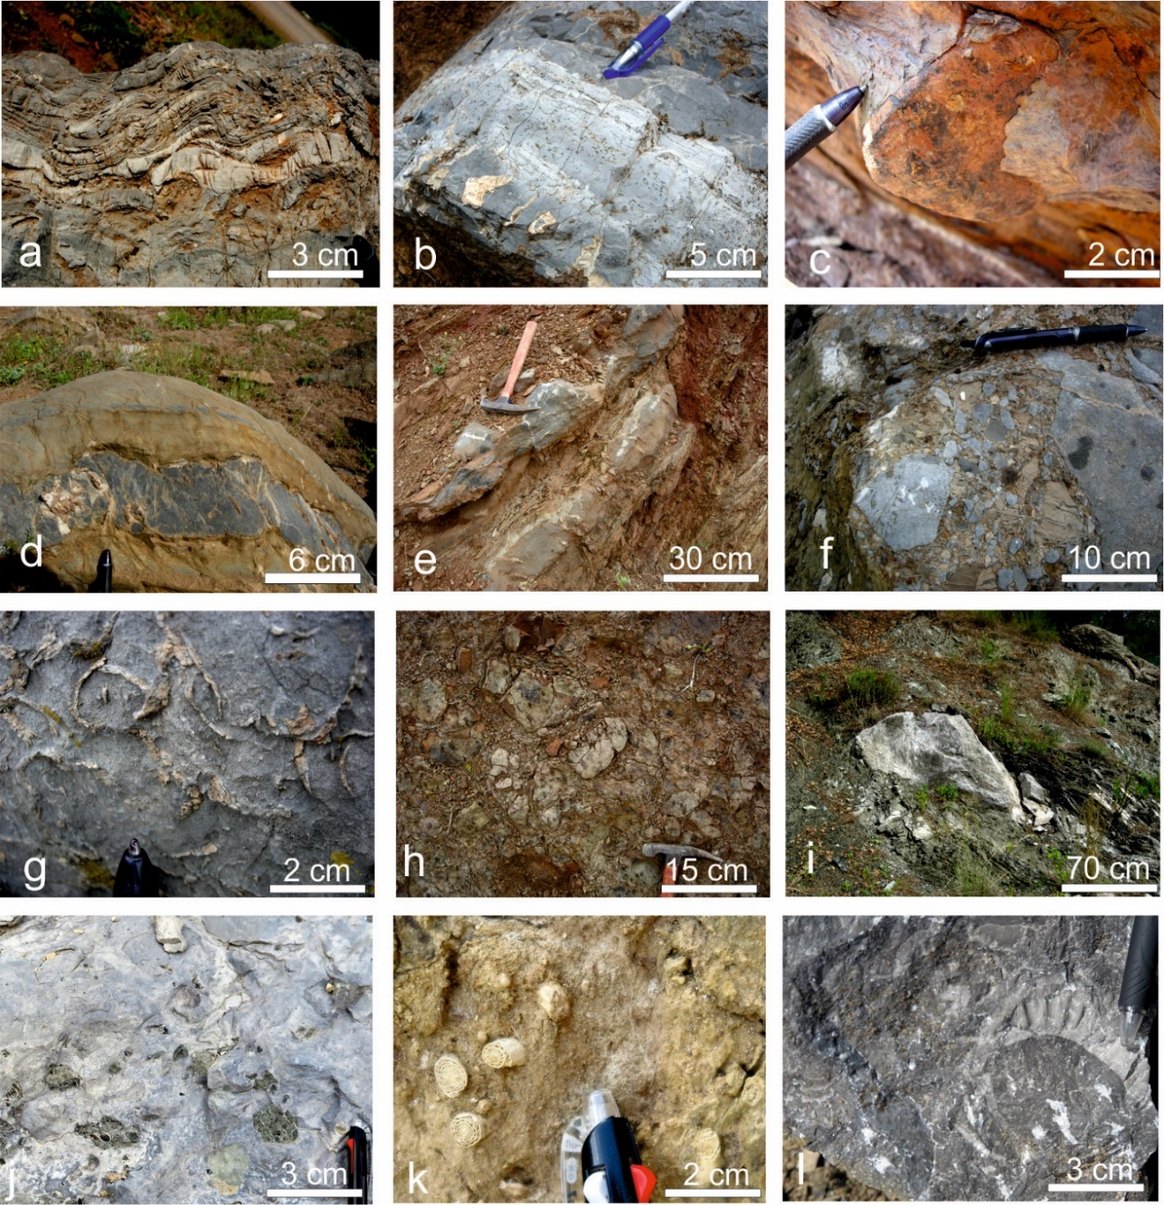**ESP, Fig. 1** Field photographs of Palaeozoic and Mesozoic sedimentary features. **a**, Late Triassic thin-bedded dolomitic carbonates, near Önsen, northern Amanos Mountains (4 km S of Sır); **b**, Late Triassic thin-bedded stromatolitic carbonate; near Hopurlu (ca. 6 km NW of Türkoğlu); **c**, Iron-rich layer between Cretaceous shallow -water carbonate succession and the overlying deepening-upward succession that preceded ophiolite emplacement; near Imali (ca. 10 SW of Türkoğlu); **d**, Redeposited limestones (calcarenites) recording redeposition in the lower part of the Late Cretaceous foredeep sequence (above the ferruginous layer shown in f); same locality as d; e, Interbedded marl (calc-phyllite) and calcarenite, recording deepening-upwards in the lower part of the Late Cretaceous foredeep (stratigraphically above d); **f**, Carbonate debris-flow units recording break-up and collapse of the Mesozoic carbonate platform to form a foredeep related to ophiolite emplacement; same locality as e; **g**. Reworked shelly limestone from the highest levels of the Late Cretaceous carbonate platform sequence; Kızıleniş, 4.8 km SW of Türkoğlu, northeastern area; **h**, Serpentinite-dominated debris-flow unit within ophiolitic melange; 1 km SE of Imali area; NE Amanos Mountain area; **i**, Block of marble in sheared serpentinite of the ophiolitic melange, 5 km SW of Imali; Mountain area; **j**, Late Cretaceous carbonate, Yarpuz road, 5 km NE Osmaniye, containing detritus from the ophiolite beneath; **k**, Late Cretaceous large foraminifera within transgressive Maastrichtian limestone, Yarpuz road, 5.5 km NE Osmaniye. **l**, Late Cretaceous transgressive neritic limestone with rudist bivalves; Yarpuz road, 5.5 km NE Osmaniye.

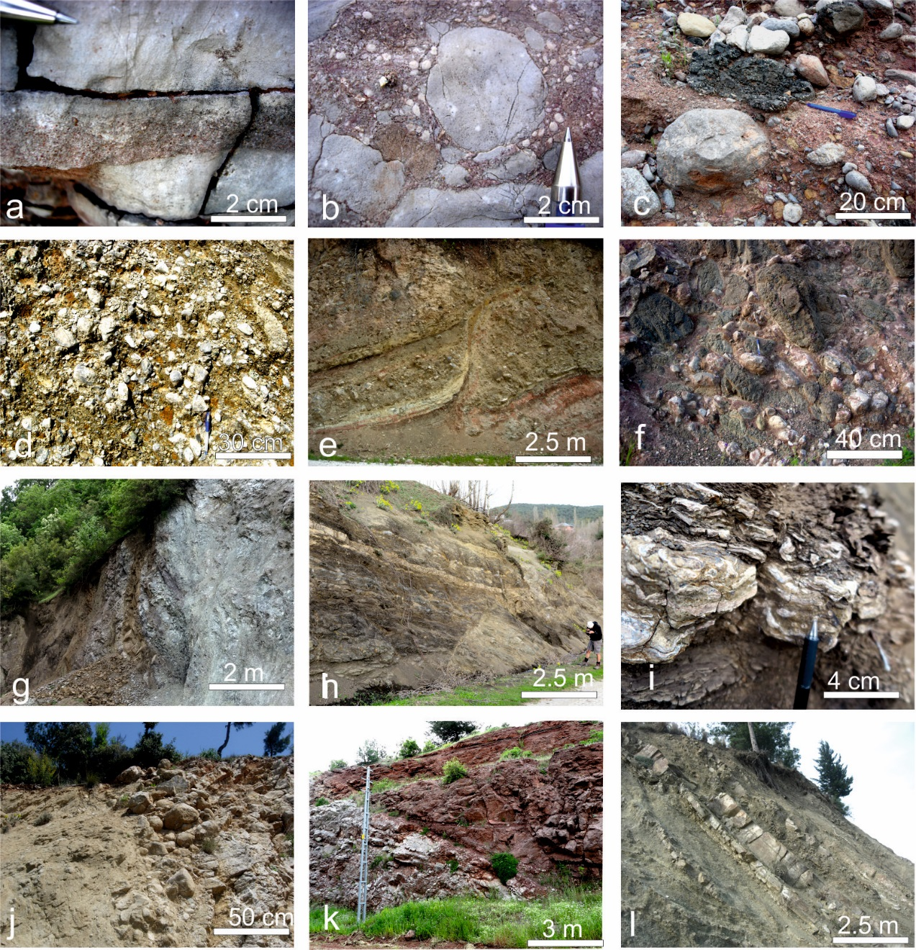

**ESP, Fig. 2** Field photographs of Eocene and Miocene sedimentary features. **a**, Graded calcarenite within hemipelagic calcilutite; Paleogene succession; near Burgaçlı area, 5 S of Düziçi *Nummulites*-bearing, central western Amanos Mountain area; **b**, Debris-flow intercalation within pinkish grey calcilutite; rich in *Nummulites* sp.; same section as a; **c**, Early Miocene texturally immature non-marine conglomerate dominated by clasts of recrystallized Mesozoic limestone, together with some clasts of vesicular basalt (also Early Miocene); near Örencik (ca. 3 km NW of Bahçe); **d**, Nearly monomict conglomerate dominated by clasts of recrystallized Mesozoic limestone, 2 km NE of Burgaçlı (ca. 7 km WSW of Bahçe); **e**. Strongly channelized Early Miocene non-marine conglomerate; Örencik (2.5 km NW of Bahçe); **f**, Polymict conglomerate dominated by poorly sorted clasts of recrystallized Mesozoic limestone and basalt; Early Miocene non-marine succession; near Nohut (3 km WSW of Bahçe); **g**, Miocene basaltic dykes cutting sheared serpentine basements (near Hasanbeyli); **h**, Well-sorted conglomeratic lens in buff-coloured, poorly consolidated sandstone with basaltic sills; base of the Early Miocene succession that unconformably overlies sheared serpentinite; Yarpuz area, central Amanos Mountains; **i**, Early Miocene oyster-bearing mudrock (Yarpuz area); **j**, Unconformity between Palaeocene limestone and Miocene transgressive marine siliciclastic sediments. A thin lenticular basal conglomerate passes directly into shallow-marine coarse sandstone and pebblestone (road cutting, 4.2 km W of Belen, southern Amanos area); **k**, Palaeocene limestones unconformably overlain by non-marine Early Miocene sequence of paleosols with caliche (basal red layer), overlain by fluvial sandstones and conglomerates. A low-angle discordance is present between Eocene and Miocene sequences (Kalecik; central Amanos Mountain area). **l**, Mid-Miocene siliciclastic sandstone turbidites, siltstones and mudrocks (road section 3.5 km E of Kalecik, NE of Osmaniye, central western area).

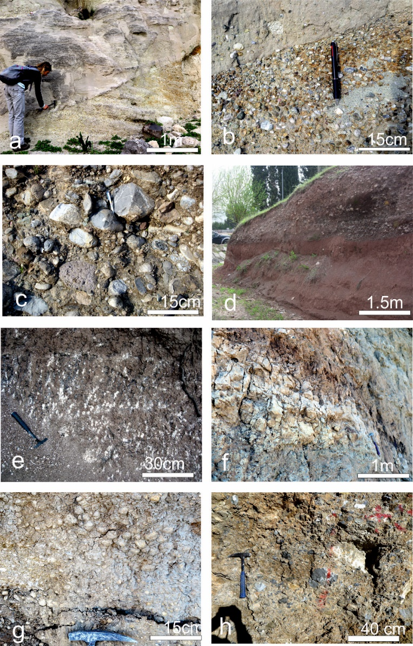

**ESP, Fig. 3** Field photographs showing sedimentary features of the Pliocene and Quaternary deposits. **a**, Pliocene deltaic sediments, Toprakkale; **b**, Polymict conglomerate dominated by clasts of Palaeozoic and Mesozoic lithologies derived from the Amanos Mountains, Toprakkale; **c**, Polymict alluvial fan conglomerate dominated by variably rounded, poorly sorted clasts of Palaeozoic and Mesozoic Amanos Mountain lithologies and also Miocene basalt, Toprakkale*;* **d**, red-coloured sandstone and overlying channelized conglomerate, 3.2 km W of Osmaniye; central Amanos Mountain area; **e**, Paleosols with caliche formed above d; **f** Alluvial fan deposits intercalated with lacustrine facies (exposed on a synclinal limb), Fevzipaşa; g, Sandy pebblestone rich in carbonate clasts, within lacustrine facies**; h**, Conglomerate dominated by recrystallized Mesozoic limestone clasts.

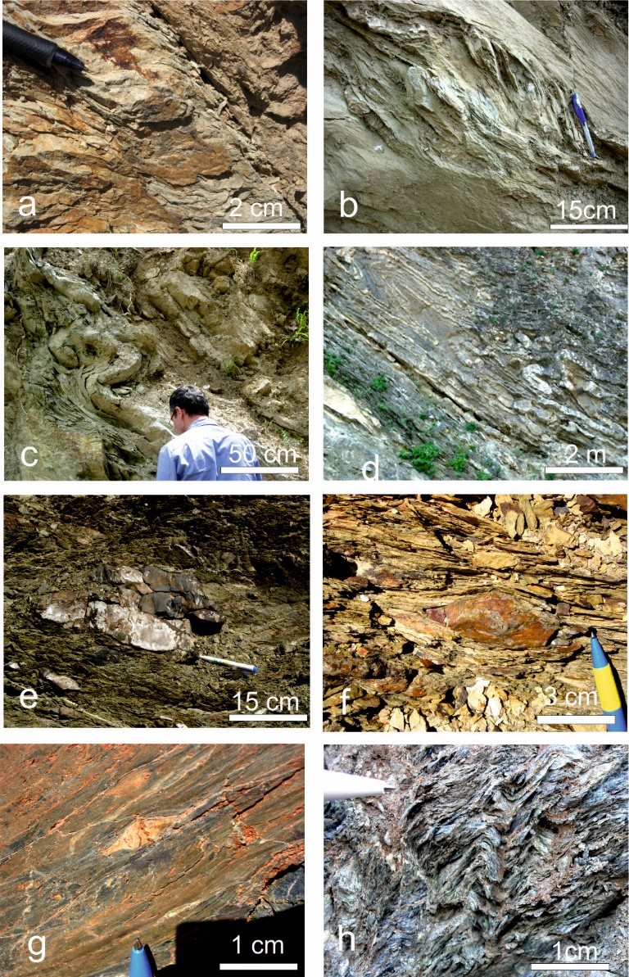

**ESP, Fig. 4.** Field photographs of outcrop-scale structural features in the Amanos Mountains. **a**, Shear bands in Palaeozoic quartzose sandstone-shale, 1 km SW of Sır, northwestern Amanos Mountains (Late Cretaceous deformation?); **b**, Asymmetrical S-type fold (top- to-the left (SE)), Sir area, top-to-the-right displacement (Late Cretaceous deformation?); **c**, Isoclinally folded late Mesozoic limestone-marl sequence below ophiolite thrust sheet; SW-vergent, Çatak village within Sabunsuyu valley, 4.9 km NE of Düziçi; **d**, Isoclinally folded late Mesozoic limestone-marl sequence below ophiolite thrust sheet, SW-vergent, 4 km N of Düziçi, Sabunsuyu valley, NW Amanos Mountains; Late Cretaceous deformation?; **e**, Small blocks thin-bedded pelagic limestone that has undergone layer-parallel extension to form a classic phacoidal fabric within a sheared phyllitic melange matrix, E of İskenderun; **f**, Sheared pebble in debris-flow unit (olistostrome), Ceceli (5.7 km SW of Türkoğlu); **g**, Ductilely-deformed, isoclinally folded phyllite, 2.5 km N of Kaledibi area, N central Amanos Mountains; **h**, Foliation in sheared serpentinite, asymmetrically folded; SE-vergent, from serpentinite melange in quarry E of İskenderun.

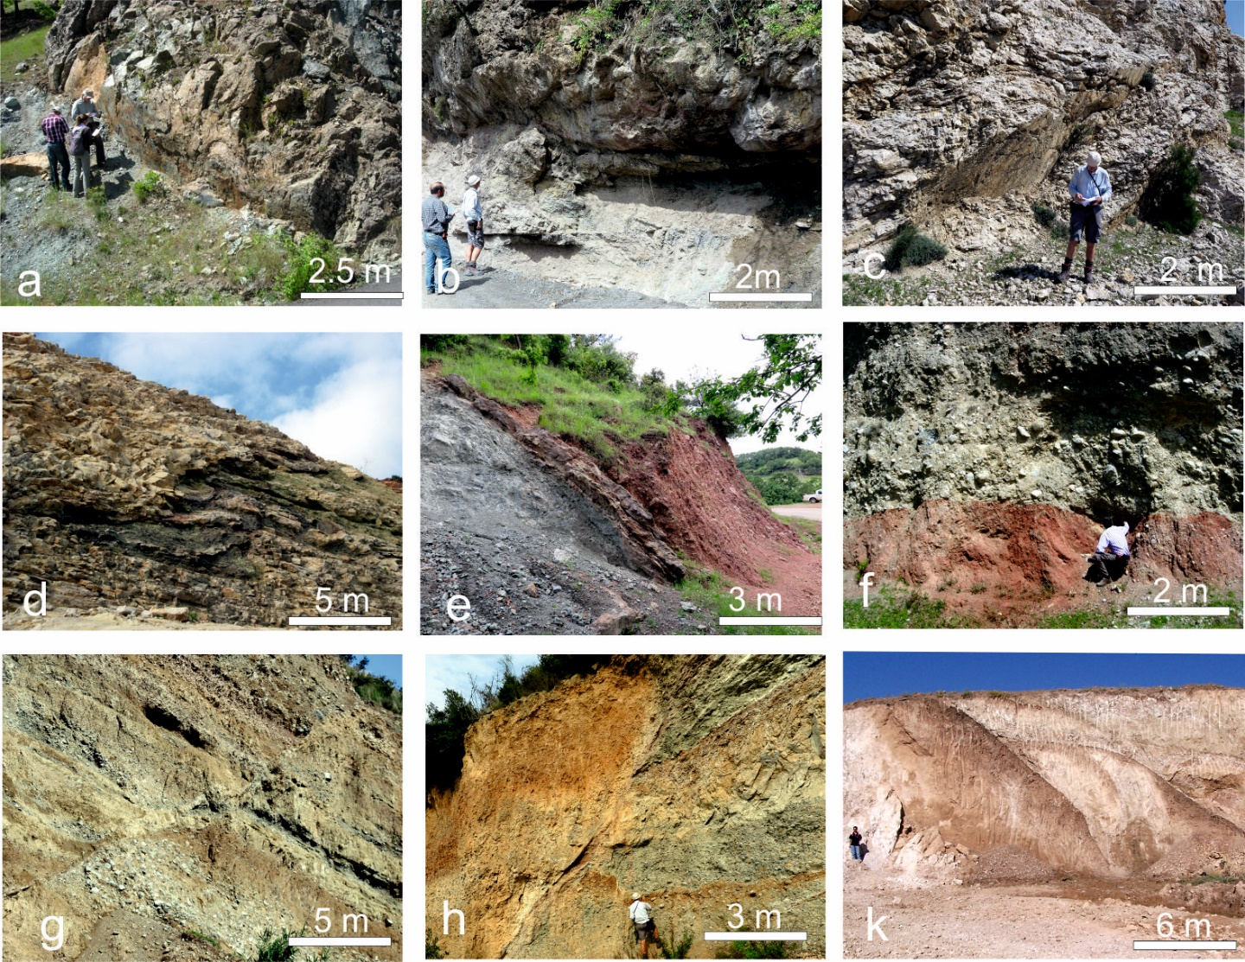

**ESP, Fig. 5** Field photographs of outcrop-scale faults; **a**, Transfer fault, 2 -3 km SE of İmalı; **b**, Detached blocks including Mesozoic recrystallised limestone and serpentinite, İskenderun; **c**, Normal faults cutting Palaeocene limestone, road cutting c. 1.5 km SE of Belen; **d**, Duplex within Palaeocene limestone, road cutting ca. 2 km SE of Belen; **e**, Strike-slip fault zone between sheared serpentine and Early Miocene limestone, Burgaçlı; **f**, Basal red iron-rich deposit (Early Miocene?) in fault contact with Early Miocene poorly sorted, matrix- supported alluvial debris-flow deposit, near Nohut (3 km WSW of Bahçe); **g**, Normal faults cutting Pliocene deposits, 8 km SW of İskenderun; **h,** transpressional dextral-reverse strike slip (transpression) in Pliocene fluvial sediments, 6.6 km SW of Erzin; **k**, Reverse fault zone in Late Miocene sediments, S of K. Maraş.

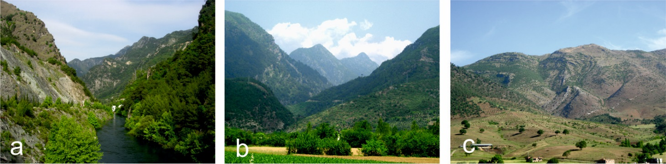

**ESP, Fig. 6** Field photographs showing lithological and structural influences on geomorphology. **a**, View northeastwards up Ceyhan River valley; Palaeozoic succession (upper left) truncated by ca. N-S strike-slip fault (cutting the valley); field of view ca. 1.5 km; **b**, View northeastwards showing Mesozoic carbonate rocks (northeast side of steep Sabunsuyu valley), overlain by Late Triassic carbonate rocks that dip southwestwards beneath ophiolitic melange (exposed on southeastward side of the valley). Note the very immature topography; field of view ca. 1 km; **c**, SE verging, large-scale folds in Mesozoic shelf carbonates and overlying melange; northeastern Amanos Mountains; W of Türkoğlu; field of view ca. 3 km.

**ESP, Table 1**. Results and inferred age of palaeontological studies.

| **Sample No** | **Location** | **GPS** | **Interpretation** | **Remarks** |
| --- | --- | --- | --- | --- |
| **Sample 1** | AM/16-1: Yarpuz Road (Osmaniye Area) | 263398 E 4108227 N | A Late Campanian-Maastrichtian age is assigned based on the following planktic foraminifera: *Gansserina gansseri*, *Globotruncana* cf. *Bulloides*, *Globotruncana* sp., *Globotruncanita* cf*. Pettersi*, *Globotruncanita* spp., *Heterohelix* spp., Hedbergellidae | The determined age is consistent with the previously assigned age by Ulu (2002) |
| **Sample 2** | AM/16-2: Yarpuz Road (Osmaniye Area) | 263398 E 4108227 N | A Late Campanian-Maastrichtian age is assigned based on the following planktic foraminifera: *Gansserina gansseri, Globotruncana ventricosa,* *Globotruncana* cf. *Falsostuarti,*  *Globotruncana* cf. *Orientalis*, *Globotruncana* sp., *Globotruncanita stuartiformis*, *Heterohelix* spp., *Macroglobigerinelloides* spp., Hedbergellidae | The determined age is consistent with the previously assigned age by Ulu (2002) |
| **Sample 3** | AM/16-3: Yarpuz Road (Osmaniye Area) | 263398 E 4108227 N | A Maastrichtian age is assigned based on the benthic foraminifera: *Omphalacyclus macroporus*, *Siderolites calcitrapoides*, *Loftusia* sp., Miliolidae, Rotaliidae. | The determined age is consistent with the previously assigned age by Ulu (2002) |
| **Sample 4** | AM/16-4: Yarpuz Road (Osmaniye Area) | 263398 E 4108227 N | A Maastrichtian age is again assigned based on the benthic foraminiferal assemblage: *Omphalacyclus macroporus, Siderolites calcitrapoides, Loftusia* sp.*,* Miliolidae*,* Rotaliidae*,* Textulariidae | The determined age is consistent with the previously assigned age by Ulu (2002) |
| **Sample 5** | **AM/16-5:** Yarpuz Raod (Osmaniye Area) | 266394 E 4107203 N | A ?Late Campanian-Maastrichtian age is assigned based on the following planktic foraminifera:*Globotruncana mariei*, *Globotruncana* cf. *Falsostuarti*, *Globotruncanita* cf. *Angulata*, *Globotruncanita* cf. *Stuartiformis*, *Globotruncanita* spp.*, Heterohelix* spp., Hedbergellidae | The determined age is consistent with the previously assigned age by Ulu (2002 |
| **Sample 6** | **AM/16-6:** Kalecik Dam (Bahçe) | 274441 E 4114621 N | A Late Paleocene-Eocene age is assigned to the studied Sample 7 based on the following benthic foraminifera: Assilina sp., Discocyclina spp., Nummulites sp., Alveolinidae, Melobesoideae | The determined age is consistent with the previously assigned age by Ulu (2002) |
| **Sample 7** | **AM/16-7:** Burgaçlı Village (Düziçi) | 274149 E 4119643 N | An Eocene (?Middle Eocene) age is assigned based on plankic and benthic foraminifera based on the following taxa: ?*Globigerinathela* sp., Globigerinidae, *Discocyclina* sp., *Gyrodinella* sp., Alveolinidae, Miliolidae, Rotaliidae, | This sample is from a previously unmapped outcrop |

**ESP, Table.2.** Structural database of Amanos field survey. Abbreviations: Loc., Location; Mech., Mechanism; B, Bedding; S, Schistosity; F, Fault; FA, Fold axes; P, Plunge; R, rake; Group number corresponds with Fig. 8 in the main text.

| **LOC.** | **GPS** | | **RHR** | | | **STRUCTURES** | | | | | | | | **GROUP** |
| --- | --- | --- | --- | --- | --- | --- | --- | --- | --- | --- | --- | --- | --- | --- |
| **E** | **N** | **STRIKE/ DIP** | | | **TYPE** | **MECH.** | **ATTITUDE OF FOLD AXES** | | | | | |  |
| 1/6 | 307798 | 4137681 | 90 | / | 45 | FA |  |  |  |  |  |  |  | 3.GROUP |
| 1/8 | 303764 | 4136248 | 280 | / | 68 | FA |  | 18 | N |  | P |  |  | 2.GROUP |
| 318 | / | 79 | F |  | 31 | SW | 220 | R |  |  | 2.GROUP |
| 1/10 | 304218 | 4133319 | 260 | / | 59 | B |  |  |  |  |  |  |  | 1.GROUP |
| 2/1 | 312894 | 4153287 | 40 | / | 40 | B |  |  |  |  |  |  |  | 1.GROUP |
| 250 | / | 35 | S |  |  |  |  |  |  |  | 1.GROUP |
| 2/2 | 311755 | 4152830 | 30 | / | 35 | B |  |  |  |  |  |  |  | 1.GROUP |
| 2/3 | 310682 | 4152128 | 50 | / | 22 | B |  |  |  |  |  |  |  | 1.GROUP |
| 2/4 | 305774 | 4150536 | 75 | / | 65 | B |  |  |  |  |  |  |  | 1.GROUP |
| 2/6 | 303533 | 4146983 | 230 | / | 53 | FA |  | 15 | SW | 220 | P |  |  | 1.GROUP |
| 2/8 | 301428 | 4144604 | 260 | / | 75 | B |  |  |  |  |  |  |  | 1.GROUP |
| 290 | / | 25 | S |  |  |  |  |  |  |  | 1.GROUP |
| 235 | / | 45 | FA |  | 25 | NE |  | P |  |  | 1.GROUP |
| 2/10 | 301124 | 4136386 | 240 | / | 28 | FA |  | 20 | SW |  | P | 220 | T | 2.GROUP |
| 2/13 | 299771 | 4136554 | 60 | / | 65 | B |  |  |  |  |  |  |  | 2.GROUP |
| 245 | / | 63 | S |  |  |  |  |  |  |  | 2.GROUP |
| 240 | / | 65 | FA |  | 20 | NE |  | P | 60 | T | 2.GROUP |
| 2/15 | 298865 | 4135874 | 240 | / | 90 | B |  |  |  |  |  |  |  | 2.GROUP |
| 2/16 | 298347 | 4135187 | 60 | / | 68 | S |  |  |  |  |  |  |  | 2.GROUP |
| 3/4 | 296596 | 4133655 |  |  |  | F |  | 35 | N |  | R | 170 | T | 2.GROUP |
| 3/6 | 295399 | 4134202 | 303 | / | 33 | FA |  | 30 | SE |  | P | 120 | T | 2.GROUP |
| 3/7 | 295318 | 4134258 | 155 | / | 70 | F | OLL | 30 | SW |  | R |  |  | 2.GROUP |
| 135 | / | 70 | F | OLL | 70 | SW |  | R |  |  | 2.GROUP |
| 110 | / | 40 | F | ON | 85 | SW |  | R |  |  | 2.GROUP |
| 3/8 | 295117 | 4134374 | 265 | / | 58 | S |  |  |  |  |  |  |  | 2.GROUP |
| 265 | / | 68 | FA | ISOC. | 22 | NE |  | P | 65 | T | 2.GROUP |
| 3/9 | 295209 | 4134568 | 265 | / | 35 | B |  |  |  |  |  |  |  | 2.GROUP |
| 3/10 | 296353 | 4133154 | 70 | / | 38 | S |  |  |  |  |  |  |  | 2.GROUP |
| 3/11 | 296446 | 4132929 | 250 | / | 38 | F | REV |  |  |  |  |  |  | 2.GROUP |
| 340 | / | 63 | F | ORL | 48 | SE | 150 | P |  |  | 2.GROUP |
| 3/12 | 296820 | 4132653 | 260 | / | 60 | S |  |  |  |  |  |  |  | 2.GROUP |
| 3/14 | 291449 | 4132417 | 60 | / | 67 | B |  |  |  |  |  |  |  | 2.GROUP |
| 3/19 | 297288 | 4128914 | 230 | / | 65 | B |  |  |  |  |  |  |  | 4.GROUP |
| 190 | / | 40 | FA | SYNC | 23 | NW |  | P | 340 | T | 4.GROUP |
| 3/20 | 297488 | 4129050 | 120 | / | 60 | F | RVR |  |  |  |  |  |  | 4.GROUP |
| 4/1 | 304449 | 4131346 | 110 | / | 80 | FA |  | 20 | NW | 290 | P | 280 | T | 3.GROUP |
| 4/2 | 304571 | 4130579 | 315 | / | 87 | B |  |  |  |  |  |  |  | 3.GROUP |
| 240 | / | 46 | S |  |  |  |  |  |  |  | 3.GROUP |
| 210 | / | 56 | S |  |  |  |  |  |  |  | 3.GROUP |
| 260 | / | 10 | FA |  | 10 | W | 270 | P | 300 | T | 3.GROUP |
| 278 | / | 38 | F | REV |  |  |  |  |  |  | 3.GROUP |
| 4/4 | 303845 | 4130529 | 360 | / | 45 | B |  |  |  |  |  |  |  | 3.GROUP |
| 4/5 | 301974 | 4130418 | 120 | / | 48 | F | ON | 50 | SW |  | R |  |  | 4.GROUP |
| 65 | / | 35 | B |  |  |  |  |  |  |  | 4.GROUP |
| 10 | / | 70 | F | N |  |  |  |  |  |  | 4.GROUP |
| 4/6 | 300724 | 4130750 | 0 | / | 25 | B |  |  |  |  |  |  |  | 4.GROUP |
| 190 |  |  | F | RL | 25 | SE |  | R | 270 | T | 4.GROUP |
| 4/7 | 299522 | 4130368 | 130 | / | 86 | FA |  | 40 | SE | 130 | P | 300 | T | 4.GROUP |
| 300 | / | 80 | FA | SYNC | 30 | SE |  | P | 310 | T | 4.GROUP |
| 4/9 | 298880 | 4130141 | 220 | / | 45 | F |  |  |  |  |  |  |  | 4.GROUP |
| 50 | / | 58 | F | LL | 25 | SW | 140 | R |  |  | 4.GROUP |
| 4/10 | 297713 | 4129055 | 232 | / | 40 | B |  |  |  |  |  |  |  | 4.GROUP |
| 230 | / | 45 | S |  |  |  |  |  |  |  | 4.GROUP |
| 310 | / | 12 | FA |  | 12 | NE | 30 | P | 60 | T | 4.GROUP |
| 75 | / | 58 | F | REV |  |  |  |  |  |  | 4.GROUP |
| 245 | / | 20 | FA | ANTC | 10 | NE | 40 | P | 45 | T | 4.GROUP |
| 4/13 | 300210 | 4121438 | 50 | / | 85 | FA |  | 43 | SW |  | P | 220 | T | 8.GROUP |
| 4/14 | 300337 | 4121024 | 155 | / | 40 | S |  |  |  |  |  |  |  | 8.GROUP |
| 160 | / | 45 | F | REV |  |  |  |  |  |  | 8.GROUP |
| 4/15 | 301799 | 4123918 | 200 | / | 55 | S |  |  |  |  |  |  |  | 8.GROUP |
| 5/1 | 288725 | 4131340 | 45 | / | 45 | S |  |  |  |  |  |  |  | 2.GROUP |
| 70 | / | 65 | S |  |  |  |  |  |  |  | 2.GROUP |
| 5/2 | 288591 | 4131861 | 255 | / | 63 | B |  |  |  |  |  |  |  | 2.GROUP |
| 255 | / | 65 | S |  |  |  |  |  |  |  | 2.GROUP |
| 5/3 | 288870 | 4132961 | 250 | / | 63 | B |  |  |  |  |  |  |  | 2.GROUP |
| 5/4 | 287554 | 4133462 | 30 | / | 45 | B |  |  |  |  |  |  |  | 2.GROUP |
| 30 | / | 45 | S |  |  |  |  |  |  |  | 2.GROUP |
| 40 | / | 65 | F | BD | 20 | NE | 40 | R |  |  | 2.GROUP |
| 5/5 | 287014 | 4133006 | 250 | / | 20 | FA |  | 17 | SW | 235 | P | 50 | T | 2.GROUP |
| 5/6 | 286544 | 4132717 | 80 | / | 87 | B |  |  |  |  |  |  |  | 2.GROUP |
| 275 | / | 35 | FA |  | 30 | SW | 240 | P | 240 | T | 2.GROUP |
| 160 | / | 60 | F | OLL | 20 | NW | 340 | R |  |  | 2.GROUP |
| 150 | / | 45 | B |  |  |  |  |  |  |  | 2.GROUP |
| 110 | / | 80 | FA |  |  |  |  |  | 280 | T | 2.GROUP |
| 5/7 | 285809 | 4132007 | 260 | / | 40 | FA |  | 18 | NE | 40 | P | 230 | T | 2.GROUP |
| 5/8 | 285524 | 4131010 | 225 | / | 21 | FA |  | 15 | SW | 210 | P | 210 | T | 2.GROUP |
| 230 | / | 75 | F |  | 30 | NE | 50 | R |  |  | 2.GROUP |
| 240 | / | 40 | F | PSS |  |  |  |  |  |  | 2.GROUP |
| 250 | / | 74 | F |  | 20 | NE | 40 | R |  |  | 2.GROUP |
| 5/10 | 277706 | 4130117 | 220 | / | 45 | B |  |  |  |  |  |  |  | 10.GROUP |
| 220 | / | 45 | FA |  |  |  |  |  | 220 | T | 10.GROUP |
| 220 | / | 45 | F |  |  |  |  |  |  |  | 10.GROUP |
| 5/11 | 276207 | 4129094 | 350 | / | 42 | S |  |  |  |  |  |  |  | 10.GROUP |
| 170 | / | 82 | FA |  | 35 | NW | 320 | P | 150 | T | 10.GROUP |
| 6/1 | 296589 | 4117396 | 230 | / | 52 | FA |  | 35 | NE | 50 | P | 50 | T | 8.GROUP |
| 250 | / | 45 | FA |  | 45 | NE | 50 | P | 60 | T | 8.GROUP |
| 260 | / | 50 | FA |  | 40 | NE | 50 | P | 15 | T | 8.GROUP |
| 6/2 | 295722 | 4116923 | 240 | / | 35 | B |  |  |  |  |  |  |  | 8.GROUP |
| 6/3 | 294943 | 4116395 | 245 | / | 32 | B |  |  |  |  |  |  |  | 8.GROUP |
| 6/5 | 294738 | 4116344 | 360 | / | 35 | B |  |  |  |  |  |  |  | 8.GROUP |
| 6/6 | 285755 | 4119171 | 120 | / | 74 | S |  |  |  |  |  |  |  | 7.GROUP |
| 240 | / | 60 | FA |  | 40 | NE | 50 | P | 50 | T | 7.GROUP |
| 280 | / | 75 | F | LL | 50 | W |  | R |  |  | 7.GROUP |
| 210 | / | 51 | D |  |  |  |  |  |  |  | 7.GROUP |
| 280 | / | 75 | F | N |  |  |  |  |  |  | 7.GROUP |
| 276 | / | 60 | F |  |  |  |  |  |  |  | 7.GROUP |
| 150 | / | 65 | F |  |  |  |  |  |  |  | 7.GROUP |
| 360 | / | 38 | F |  |  |  |  |  |  |  | 7.GROUP |
| 330 | / | 78 | F |  |  |  |  |  |  |  | 7.GROUP |
| 6/7 | 285272 | 4119279 | 200 | / | 57 | B |  |  |  |  |  |  |  | 7.GROUP |
| 190 | / | 50 | S |  |  |  |  |  |  |  | 7.GROUP |
| 6/8 | 284923 | 4119582 | 200 | / | 72 | S |  |  |  |  |  |  |  | 7.GROUP |
| 170 | / | 50 | F |  |  |  |  |  |  |  | 7.GROUP |
| 200 | / | 50 | F |  |  |  |  |  |  |  | 7.GROUP |
| 170 | / | 41 | F |  |  |  |  |  |  |  | 7.GROUP |
| 6/9 | 284351 | 4122188 | 220 | / | 46 | FA |  | 42 | SW | 210 | P | 310 | T | 6.GROUP |
| 6/10 | 284599 | 4122557 | 20 | / | 50 | B |  |  |  |  |  |  |  | 6.GROUP |
| 210 | / | 50 | B |  |  |  |  |  |  |  | 6.GROUP |
| 6/11 | 285187 | 4123284 | 60 | / | 30 | B |  |  |  |  |  |  |  | 6.GROUP |
| 60 | / | 30 | S |  |  |  |  |  |  |  | 6.GROUP |
| 90 | / | 76 | F |  |  |  |  |  |  |  | 6.GROUP |
| 6/13 | 285080 | 4123546 | 260 | / | 56 | FA |  | 30 | SW | 250 | P | 50 | T | 6.GROUP |
| 130 | / | 42 | F | LL |  |  |  |  |  |  | 6.GROUP |
| 220 | / | 50 | FA |  | 25 | NE | 50 | P | 250 | T | 6.GROUP |
| 6/16 | 286028 | 4124753 | 260 | / | 56 | FA |  | 30 | SW | 250 | P | 50 | T | 6.GROUP |
| 130 | / | 42 | F |  |  |  |  |  |  |  | 6.GROUP |
| 220 | / | 50 | FA |  | 25 | NE | 50 | P | 250 | T | 6.GROUP |
| 6/18 | 289679 | 4128075 | 200 | / | 34 |  |  |  |  |  |  |  |  | 5.GROUP |
| 6/19 | 314007 | 4152696 | 260 | / | 76 | F |  |  |  |  |  |  |  | 1.GROUP |
| 180 | / | 80 | D |  |  |  |  |  |  |  | 1.GROUP |
| 7/1 | 281193 | 4118489 | 60 | / | 18 | B |  |  |  |  |  |  |  | 9.GROUP |
| 7/2 | 280366 | 4119536 | 250 | / | 45 | F |  |  |  |  |  |  |  | 9.GROUP |
| 240 | / | 53 | F |  |  |  |  |  |  |  | 9.GROUP |
| 245 | / | 62 | F |  |  |  |  |  |  |  | 9.GROUP |
| 240 | / | 45 | F |  |  |  |  |  |  |  | 9.GROUP |
| 260 | / | 25 | F | LR |  |  |  |  | 355 | RT | 9.GROUP |
| 220 | / | 32 | F |  |  |  |  |  | 310 | RT | 9.GROUP |
| 7/3 | 279964 | 4119791 | 60 | / | 46 | B |  |  |  |  |  |  |  | 9.GROUP |
| 7/4 | 280036 | 4120185 | 270 |  |  |  |  |  |  |  |  |  |  | 9.GROUP |
| 7/5 | 279924 | 4120352 | 340 | / | 87 | F | RL | 62 | SE | 160 | R |  |  | 9.GROUP |
| 7/6 | 279495 | 4120411 | 5 | / | 87 | F | PLL |  |  |  |  |  |  | 9.GROUP |
| 7/7 | 279622 | 4121085 | 320 | / | 52 | FA |  | 50 | SE | 140 | P | 320 | T | 9.GROUP |
| 275 | / | 75 | F | LL | 16 | SE | 110 | R |  |  | 9.GROUP |
| 300 | / | 46 | FA |  | 20 | SE | 150 | P | 330 | T | 9.GROUP |
| 7/8 | 280536 | 4121413 | 230 | / | 48 | S |  |  |  |  |  |  |  | 9.GROUP |
| 7/9 | 278890 | 4120371 | 60 | / | 40 | B |  |  |  |  |  |  |  | 9.GROUP |
| 190 | / | 60 | F |  | 90 |  |  | P | 15 | T | 9.GROUP |
| 160 | / | 74 | F |  |  |  |  |  |  |  | 9.GROUP |
| 160 | / | 86 | F |  |  |  |  |  |  |  | 9.GROUP |
| 7/10 | 278956 | 4119958 | 160 | / | 45 | F | LL | 60 | NW |  | R |  |  | 9.GROUP |
| 7/11 | 278727 | 4119653 | 5 | / | 87 | FA |  |  |  |  |  |  |  | 9.GROUP |
| 7/12 | 272914 | 4116513 | 300 | / | 85 | F |  |  |  |  |  |  |  | 10.GROUP |
| 7/14 | 273598 | 4119687 | 240 | / | 80 | F |  |  |  |  |  |  |  | 10.GROUP |
| 230 | / | 70 | F |  |  |  |  |  |  |  | 10.GROUP |
| 200 | / | 85 |  |  |  |  |  |  |  |  | 10.GROUP |
| 7/15 | 274149 | 4119639 | 150 | / | 32 | B |  |  |  |  |  |  |  | 10.GROUP |
| 240 | / | 86 | F | LL | 70 | SW |  | R |  |  | 10.GROUP |
| 160 | / | 45 | F |  |  |  |  |  |  |  | 10.GROUP |
| 200 | / | 42 | B |  |  |  |  |  |  |  | 10.GROUP |
| 240 | / | 52 | B |  |  |  |  |  |  |  | 10.GROUP |
| 8/1 | 275380 | 4122290 | 230 | / | 28 | B |  |  |  |  |  |  |  | 10.GROUP |
| 30 | / | 83 | F |  |  |  |  |  |  |  | 10.GROUP |
| 30 | / | 86 | F |  |  |  |  |  |  |  | 10.GROUP |
| 240 | / | 64 | F |  | 45 | SE | 220 | R |  |  | 10.GROUP |
| 8/2 | 274730 | 4123206 | 175 | / | 83 | F | LL | 57 | SE |  | R |  |  | 10.GROUP |
| 8/3 | 271755 | 4133646 | 150 | / | 41 | F |  |  |  |  |  |  |  | 10.GROUP |
| 160 | / | 40 | F |  |  |  |  |  |  |  | 10.GROUP |
| 150 | / | 26 | F |  |  |  |  |  |  |  | 10.GROUP |
| 150 | / | 63 | F |  |  |  |  |  |  |  | 10.GROUP |
| 9/4 | 304811 | 4156883 | 55 | / | 76 | S |  |  |  |  |  |  |  | 13.GROUP |
| 55 | / | 76 | B |  |  |  |  |  |  |  | 13.GROUP |
| 88 | / | 81 | S |  |  |  |  |  |  |  | 13.GROUP |
| 88 | / | 81 | B |  |  |  |  |  |  |  | 13.GROUP |
| 9/5 | 304267 | 4158297 |  | / |  |  |  |  |  |  |  |  |  | 13.GROUP |
| 9/7 | 301832 | 4157467 | 250 | / | 27 | B |  |  |  |  |  |  |  | 13.GROUP |
| 9/8 | 301217 | 4157013 | 230 | / | 74 | FA |  | 10 | NE | 60 |  |  |  | 13.GROUP |
| 9/9 | 295920 | 4157542 |  | / |  |  |  |  |  |  |  |  |  | 13.GROUP |
| 9/10 | 295212 | 4156583 | 230 | / | 35 | B |  |  |  |  |  |  |  | 13.GROUP |
| 40 | / | 30 | B |  |  |  |  |  |  |  | 13.GROUP |
| 9/11 | 293486 | 4155877 | 180 | / | 25 | FA |  |  |  |  |  |  |  | 13.GROUP |
| 40 | / | 90 | F | SS |  |  |  |  |  |  | 13.GROUP |
| 220 | / | 57 | B |  |  |  |  |  |  |  | 13.GROUP |
| 230 | / | 57 | B |  |  |  |  |  |  |  | 13.GROUP |
| 9/13 | 287144 | 4151590 | 220 | / | 56 | S |  |  |  |  |  |  |  | 13.GROUP |
| 9/14 | 287682 | 4152162 | 275 | / | 54 | S |  |  |  |  |  |  |  | 13.GROUP |
| 310 | / | 38 | J |  |  |  |  |  |  |  | 13.GROUP |
| 160 | / | 73 | J |  |  |  |  |  |  |  | 13.GROUP |
| 250 | / | 22 | T |  |  |  |  |  |  |  | 13.GROUP |
| 50 | / | 90 | F | SS |  |  |  |  |  |  | 13.GROUP |
| 9/15 | 291553 | 4154406 | 255 | / | 64 | B |  |  |  |  |  |  |  | 13.GROUP |
| 255 | / | 64 | S |  |  |  |  |  |  |  | 13.GROUP |
| 9/16 | 292506 | 4155239 | 230 | / | 76 | B |  |  |  |  |  |  |  | 13.GROUP |
| 40 | / | 82 | OLL |  | 67 | W | 270 |  |  |  | 13.GROUP |
| 9/17 | 293524 | 4155767 | 50 | / | 70 | F | T |  |  |  |  |  |  | 13.GROUP |
| 205 | / | 45 | B |  |  |  |  |  |  |  | 13.GROUP |
| 220 | / | 30 | F | T |  |  |  |  |  |  | 13.GROUP |
| 50 | / | 72 | Contact |  |  |  |  |  |  |  | 13.GROUP |
| 10/1 | 303011 | 4151327 | 30 | / | 25 | B |  |  |  |  |  |  |  | 13.GROUP |
| 240 | / | 20 | FA |  |  |  |  |  |  |  | 13.GROUP |
| 290 | / | 30 | F | T |  |  |  |  |  |  | 13.GROUP |
| 50 | / | 65 | B |  |  |  |  |  |  |  | 13.GROUP |
| 10/5 | 288193 | 4157391 | 155 | / | 18 | B |  |  |  |  |  |  |  | 14.GROUP |
| 40 | / | 15 | B |  |  |  |  |  |  |  | 14.GROUP |
| 230 | / | 70 | F |  |  |  |  |  |  |  | 14.GROUP |
| 140 | / | 78 | F |  |  |  |  |  |  |  | 14.GROUP |
| 260 | / | 38 | F | OLL |  |  |  |  |  |  | 14.GROUP |
| 20 | / | 90 | SS |  | 35 | SW | 110 | R |  |  | 14.GROUP |
| 10/6 | 287507 | 4157491 | 200 | / | 15 | B |  |  |  |  |  |  |  | 14.GROUP |
| 10/9 | 288522 | 4162837 | 215 | / | 40 | F | T |  |  |  |  |  |  | 14.GROUP |
| 10/10 | 289064 | 4163062 | 270 | / | 68 | F | T |  |  |  |  |  |  | 14.GROUP |
| 11/2 | 275559 | 4156777 | 160 | / | 38 | B |  |  |  |  |  |  |  | 14.GROUP |
| 11/5 | 274028 | 4149687 | 220 | / | 59 | S |  |  |  |  |  |  |  | 11.GROUP |
| 11/6 | 274171 | 4146720 | 5 | / | 90 | SS |  |  |  |  |  |  |  | 11.GROUP |
| 11/7 | 273157 | 4144234 | 115 | / | 72 | SS |  | 45 | W |  |  |  |  | 11.GROUP |
| 10 | / | 54 | F |  |  |  |  |  |  |  | 11.GROUP |
| 10 | / | 90 | F |  |  |  |  |  |  |  | 11.GROUP |
| 11/8 | 273878 | 4140573 | 60 | / | 75 | B |  |  |  |  |  |  |  | 11.GROUP |
| 60 | / | 75 | S |  |  |  |  |  |  |  | 11.GROUP |
| 285 | / | 46 | S |  |  |  |  |  |  |  | 11.GROUP |
| 285 | / | 46 | B |  |  |  |  |  |  |  | 11.GROUP |
| 290 | / | 10 | F | T |  |  |  |  |  |  | 11.GROUP |
| 11/9 | 272847 | 4139074 | 230 | / | 22 | F |  |  |  |  |  |  |  | 11.GROUP |
| 250 | / | 44 | B |  |  |  |  |  |  |  | 11.GROUP |
| 60 | / | 45 | B |  |  |  |  |  |  |  | 11.GROUP |
| 50 | / | 90 | F | SS |  |  |  |  |  |  | 11.GROUP |
| 11/10 | 274588 | 4135006 | 180 | / | 29 | F | SS |  |  |  |  |  |  | 10.GROUP |
| 12/1 | 289680 | 4108938 | 40 | / | 20 | B |  |  |  |  |  |  |  | 12.GROUP |
| 250 | / | 63 | B |  |  |  |  |  |  |  | 12.GROUP |
| 230 | / | 25 | S |  |  |  |  |  |  |  | 12.GROUP |
| 240 | / | 50 | FA |  | 50 | NE | 38 |  |  |  | 12.GROUP |
| 12/2 | 289578 | 4109325 | 350 | / | 42 | B |  |  |  |  |  |  |  | 12.GROUP |
| 12/3 | 288152 | 4110296 | 260 | / | 15 | S |  |  |  |  |  |  |  | 12.GROUP |
| 220 | / | 34 | B |  |  |  |  |  |  |  | 12.GROUP |
| 240 | / | 90 | FA |  |  |  |  |  |  |  | 12.GROUP |
| 12/4 | 287283 | 4109730 | 160 | / | 30 | B |  |  |  |  |  |  |  | 12.GROUP |
| 110 | / | 38 | B |  |  |  |  |  |  |  | 12.GROUP |
| 100 | / | 80 | FA |  |  |  |  |  |  |  | 12.GROUP |
| 70 | / | 40 | B |  |  |  |  |  |  |  | 12.GROUP |
| 340 | / | 90 | F |  |  |  |  |  |  |  | 12.GROUP |
| 12/5 | 284585 | 4111195 | 160 | / | 48 | FA |  | 10 | S |  |  |  |  | 12.GROUP |
| 160 | / | 29 | S |  |  |  |  |  |  |  | 12.GROUP |
| 110 | / | 36 | B |  |  |  |  |  |  |  | 12.GROUP |
| 12/6 | 283929 | 4111672 | 220 | / | 49 | S |  |  |  |  |  |  |  | 12.GROUP |
| 220 | / | 20 | S |  |  |  |  |  |  |  | 12.GROUP |
| 12/7 | 283350 | 4111983 | 150 | / | 35 | B |  |  |  |  |  |  |  | 12.GROUP |
| 150 | / | 45 | B |  |  |  |  |  |  |  | 12.GROUP |
| 12/8 | 284086 | 4112543 | 150 | / | 68 | B |  |  |  |  |  |  |  | 12.GROUP |
| 12/9 | 281737 | 4112836 | 45 | / | 15 | B |  |  |  |  |  |  |  | 12.GROUP |
| 160 | / | 57 | F |  |  |  |  |  |  |  | 12.GROUP |
| 150 | / | 41 | F |  |  |  |  |  |  |  | 12.GROUP |
| 150 | / | 40 | F |  |  |  |  |  |  |  | 12.GROUP |
| 30 | / | 72 | F |  |  |  |  |  |  |  | 12.GROUP |
| 40 | / | 60 | B |  |  |  |  |  |  |  | 12.GROUP |
| 30 | / | 90 | F | SS |  |  |  |  |  |  | 12.GROUP |
| 20 | / | 90 | F | SS |  |  |  |  |  |  | 12.GROUP |
| 12/11 | 282908 | 4117387 | 180 | / | 34 | B |  |  |  |  |  |  |  | 9.GROUP |
| 12/12 | 282275 | 4120336 | 190 | / | 24 | FA |  |  |  |  |  |  |  | 9.GROUP |
| 150 | / | 41 | F |  |  |  |  |  |  |  | 9.GROUP |
| 45 | / | 15 | B |  |  |  |  |  |  |  | 9.GROUP |
| 160 | / | 57 | F | N |  |  |  |  |  |  | 9.GROUP |
| 150 | / | 40 | F |  |  |  |  |  |  |  | 9.GROUP |
| 150 | / | 50 | F |  |  |  |  |  |  |  | 9.GROUP |
| 160 |  | 30 | F |  |  |  |  |  |  |  | 9.GROUP |
| 30 |  | 72 | F |  |  |  |  |  |  |  | 9.GROUP |
| 30 |  | 90 | SZ |  |  |  |  |  |  |  | 9.GROUP |
| 11/10 | 274588 | 4135006 | 180 | / | 29 | F | SS |  |  |  |  |  |  | 10.GROUP |
| 12/13 | 274562 | 4116366 | 20 | / | 30 | B |  |  |  |  |  |  |  | 10.GROUP |
| 12/14 | 274461 | 4114633 | 310 | / | 45 | B |  |  |  |  |  |  |  | 10.GROUP |
| 320 | / | 18 | B |  |  |  |  |  |  |  | 10.GROUP |
| 40 | / | 20 | FA |  | 20 | NE |  |  |  |  | 10.GROUP |
| 290 | / | 60 | F |  |  |  |  |  |  |  | 10.GROUP |
| 13/4 | 280999 | 4091624 | 60 | / | 45 | B |  |  |  |  |  |  |  | 17.GROUP |
| 220 | / | 75 | F |  |  |  |  |  |  |  | 17.GROUP |
| 13/5 | 280119 | 4079926 | 230 | / | 35 | F |  |  |  |  |  |  |  | 17.GROUP |
| 13/6 | 280009 | 4079204 | 200 | / | 25 | B |  |  |  |  |  |  |  | 17.GROUP |
| 13/7 | 273548 | 4063386 | 40 | / | 10 | B |  |  |  |  |  |  |  | 17.GROUP |
| 40 | / | 15 | B |  |  |  |  |  |  |  | 17.GROUP |
| 13/8 | 266032 | 4048512 | 0 | / | 52 | B |  |  |  |  |  |  |  | 17.GROUP |
|  |  |  | 120 | / | 50 | F |  |  |  |  |  |  |  | 17.GROUP |
|  |  |  | 50 | / | 82 | F |  |  |  |  |  |  |  | 17.GROUP |
|  |  |  | 320 | / | 90 | SZ |  |  |  |  |  |  |  | 17.GROUP |
| 14/1 | 330624 | 4161505 | 100 | / | 17 | B |  |  |  |  |  |  |  | 15.GROUP |
| 14/2 | 334850 | 4162278 | 280 | / | 10 | B |  |  |  |  |  |  |  | 15.GROUP |
| 14/5 | 332714 | 4165283 | 300 | / | 39 | B |  |  |  |  |  |  |  | 15.GROUP |
| 75 | / | 35 | FA |  |  |  |  |  |  |  | 15.GROUP |
| 14/6 | 332196 | 4166023 | 300 | / | 40 | B |  |  |  |  |  |  |  | 15.GROUP |
| 14/7 | 333175 | 4163203 | 290 | / | 60 | FA |  |  |  |  |  |  |  | 15.GROUP |
| 14/8 | 350461 | 4159474 | 90 | / | 30 | B |  |  |  |  |  |  |  | 16.GROUP |
| 90 | / | 55 | B |  |  |  |  |  |  |  | 16.GROUP |
| 240 | / | 85 | F | OF |  |  |  |  |  |  | 16.GROUP |
| 310 | / | 72 | F |  |  |  |  |  |  |  | 16.GROUP |
| 290 | / | 50 | F |  |  |  |  |  |  |  | 16.GROUP |
| 285 | / | 55 | F |  |  |  |  |  |  |  | 16.GROUP |
| 190 | / | 46 | F |  |  |  |  |  |  |  | 16.GROUP |
| 160 | / | 65 | F |  |  |  |  |  |  |  | 16.GROUP |
| 295 | / | 72 | F |  |  |  |  |  |  |  | 16.GROUP |
| 14/9 | 352579 | 4162634 | 65 | / | 30 | B |  |  |  |  |  |  |  | 16.GROUP |
| 14/10 | 354818 | 4163370 | 300 | / | 25 | B |  |  |  |  |  |  |  | 16.GROUP |
| 14/11 | 355360 | 4160249 | 340 | / | 15 | B |  |  |  |  |  |  |  | 16.GROUP |
| 15/9 | 278948 | 4119966 | 70 | / | 65 | F |  |  |  |  |  |  |  | 10.GROUP |
| 15/10 | 274746 | 4119758 | 100 | / | 70 | B |  |  |  |  |  |  |  | 10.GROUP |
| 110 | / | 50 | B |  |  |  |  |  |  |  | 10.GROUP |
| 100 | / | 50 | B |  |  |  |  |  |  |  | 10.GROUP |
| 110 | / | 70 | B |  |  |  |  |  |  |  | 10.GROUP |
| 250 | / | 70 | F | SS | 45 | W |  |  |  |  | 10.GROUP |
| 15/11 | 274221 | 4119615 | 90 | / | 25 | FA |  | 10 | SE |  |  |  |  | 10.GROUP |
| 90 | / | 30 | FA |  | 10 | SE |  |  |  |  | 10.GROUP |
| 330 | / | 79 | FA |  |  |  |  |  |  |  | 10.GROUP |
| 340 | / | 79 | FA |  |  |  |  |  |  |  | 10.GROUP |
| 130 | / | 30 | B |  |  |  |  |  |  |  | 10.GROUP |
| 205 | / | 45 | B |  |  |  |  |  |  |  | 10.GROUP |
| 260 | / | 55 | F |  | 45 | B |  | R |  |  | 10.GROUP |
| 250 |  | 70 | F |  | 46 | B |  | R |  |  | 10.GROUP |
| 330 |  | 70 | FA |  | 20 | GD | 190 |  |  |  | 10.GROUP |
| 340 | / | 90 | F |  |  |  |  |  |  |  | 10.GROUP |
| 916/1 | 259939 | 4046396 | 89 | / | 48 | FA |  |  |  |  |  |  |  | 18.GROUP |
| 115 | / | 10 | OB |  |  |  |  |  |  |  | 18.GROUP |
| 10 | / | 27 | FA |  |  |  |  |  |  |  | 18.GROUP |
| 350 | / | 20 | FA |  |  |  |  |  |  |  | 18.GROUP |
| 280 | / | 78 | FA |  |  |  |  |  |  |  | 18.GROUP |
| 90 | / | 40 | F |  |  |  |  |  |  |  | 18.GROUP |
| 105 | / | 13 | FA |  |  |  |  |  |  |  | 18.GROUP |
| 105 | / | 43 | F |  |  |  |  |  |  |  | 18.GROUP |
| 90 | / | 11 | FA |  |  |  |  |  |  |  | 18.GROUP |
| 16/4 | 259881 | 4048127 | 130 | / | 50 | F | T |  |  |  |  |  |  | 18.GROUP |
| 16/5 | 259099 | 4043489 | 25 | / | 49 | B |  |  |  |  |  |  |  | 19.GROUP |
| 16/6 | 258473 | 4043685 | 20 | / | 54 | B |  |  |  |  |  |  |  | 19.GROUP |
| 16/7 | 257662 | 4043682 | 25 | / | 70 | F |  | 65 | NE |  |  |  |  | 19.GROUP |
| 75 | / | 86 | F |  | 17 | SW |  |  |  |  | 19.GROUP |
| 40 | / | 32 | B |  |  |  |  |  |  |  | 19.GROUP |
| 110 | / | 55 | B |  |  |  |  |  |  |  | 19.GROUP |
| 110 | / | 85 | FA |  | 10 | NE |  |  |  |  | 19.GROUP |
| 35 | / | 34 | B |  |  |  |  |  |  |  | 19.GROUP |
| 30 | / | 90 | F |  |  |  |  |  |  |  | 19.GROUP |
| 16/8 | 254382 | 4040622 | 40 | / | 65 | F | N |  |  |  |  |  |  | 20.GROUP |
| 40 | / | 55 | F | N |  |  |  |  |  |  | 20.GROUP |
| 240 | / | 45 | FA |  | 20 | NE |  |  |  |  | 20.GROUP |
| 40 | / | 55 | F | N |  |  |  |  |  |  | 20.GROUP |
| 50 | / | 41 | B |  |  |  |  |  |  |  | 20.GROUP |
| 220 | / | 78 | F | N |  |  |  |  |  |  | 20.GROUP |
| 20 | / | 86 | FA |  |  |  |  |  |  |  | 20.GROUP |
| 345 | / | 80 | F |  |  |  |  |  |  |  | 20.GROUP |
| 260 | / | 69 | FA |  |  |  |  |  |  |  | 20.GROUP |
| 80 | / | 43 | B |  |  |  |  |  |  |  | 20.GROUP |
| 180 | / | 70 | F | N |  |  |  |  |  |  | 20.GROUP |
| 16/9 | 253034 | 4040765 | 110 | / | 30 | F | T |  |  |  |  |  |  | 20.GROUP |
| 205 | / | 60 | F | N |  |  |  |  |  |  | 20.GROUP |
| 60 | / | 72 | F | N |  |  |  |  |  |  | 20.GROUP |
| 50 | / | 55 | F | RL | 45 | SW |  |  |  |  | 20.GROUP |
| 235 | / | 35 | B |  |  |  |  |  |  |  | 20.GROUP |
| 230 | / | 40 | B |  |  |  |  |  |  |  | 20.GROUP |
| 350 | / | 45 | B |  |  |  |  |  |  |  | 20.GROUP |
| 17/1 | 253006 | 4040878 | 125 | / | 32 | B |  |  |  |  |  |  |  | 20.GROUP |
| 40 | / | 67 | B |  |  |  |  |  |  |  | 20.GROUP |
| 80 | / | 60 | F |  |  |  |  |  |  |  | 20.GROUP |
| 350 | / | 25 | FA |  |  |  |  |  |  |  | 20.GROUP |
| 90 | / | 39 | F | N |  |  |  |  |  |  | 20.GROUP |
| 90 | / | 39 | F | N |  |  |  |  |  |  | 20.GROUP |
| 10 | / | 56 | F | N |  |  |  |  |  |  | 20.GROUP |
| 105 | / | 63 | F | N |  |  |  |  |  |  | 20.GROUP |
| 325 | / | 21 | F | N |  |  |  |  |  |  | 20.GROUP |
| 180 | / | 32 | F | N |  |  |  |  |  |  | 20.GROUP |
| 180 | / | 21 | F | N |  |  |  |  |  |  | 20.GROUP |
| 40 | / | 67 | F | N |  |  |  |  |  |  | 20.GROUP |
| 330 | / | 32 | B |  |  |  |  |  |  |  | 20.GROUP |
| 17/2 | 252760 | 4041101 | 170 | / | 70 | FA |  | 22 | SE |  |  |  |  | 20.GROUP |
| 150 | / | 30 | B |  |  |  |  |  |  |  | 20.GROUP |
| 0 | / | 20 | B |  |  |  |  |  |  |  | 20.GROUP |
| 310 | / | 69 | F |  |  |  |  |  |  |  | 20.GROUP |
| 15 | / | 66 | FA |  |  |  |  |  |  |  | 20.GROUP |
| 160 | / | 90 | F |  |  |  |  |  |  |  | 20.GROUP |
| 17/3 | 252499 | 4041098 | 160 | / | 52 | F |  |  |  |  |  |  |  | 20.GROUP |
| 350 | / | 76 | F |  |  |  |  |  |  |  | 20.GROUP |
| 220 | / | 74 | F |  |  |  |  |  |  |  | 20.GROUP |
| 260 | / | 74 | F |  |  |  |  |  |  |  | 20.GROUP |
| 350 | / | 11 | B |  |  |  |  |  |  |  | 20.GROUP |
| 179 | / | 9 | B |  |  |  |  |  |  |  | 20.GROUP |
| 160 | / | 90 | FA |  |  |  |  |  |  |  | 20.GROUP |
| 17/4 | 252035 | 4040891 | 180 | / | 43 | B |  |  |  |  |  |  |  | 20.GROUP |
| 315 | / | 33 | B |  |  |  |  |  |  |  | 20.GROUP |
| 255 | / | 17 | B |  |  |  |  |  |  |  | 20.GROUP |
| 90 | / | 60 | F |  | 45 | NW |  |  |  |  | 20.GROUP |
| 85 | / | 69 | F |  | 32 |  |  |  |  |  | 20.GROUP |
| 70 | / | 69 | F |  |  |  |  |  |  |  | 20.GROUP |
| 110 | / | 35 | F |  |  |  |  |  |  |  | 20.GROUP |
| 195 | / | 64 | F |  |  |  |  |  |  |  | 20.GROUP |
| 60 | / | 52 | F |  |  |  |  |  |  |  | 20.GROUP |
| 190 | / | 15 | F |  |  |  |  |  |  |  | 20.GROUP |
| 180 | / | 81 | F |  |  |  |  |  |  |  | 20.GROUP |
| 240 | / | 46 | F |  |  |  |  |  |  |  | 20.GROUP |
| 35 | / | 66 | F |  |  |  |  |  |  |  | 20.GROUP |
| 355 | / | 42 | F |  |  |  |  |  |  |  | 20.GROUP |
| 30 | / | 49 | F |  |  |  |  |  |  |  | 20.GROUP |
| 280 | / | 55 | F |  |  |  |  |  |  |  | 20.GROUP |
| 25 | / | 85 | F |  |  |  |  |  |  |  | 20.GROUP |
| 20 | / | 90 | F |  |  |  |  |  |  |  | 20.GROUP |
| 17/5 | 251570 | 4041153 | 180 | / | 55 | B |  |  |  |  |  |  |  | 20.GROUP |
| 180 | / | 38 | B |  |  |  |  |  |  |  | 20.GROUP |
| 340 | / | 44 | F |  |  |  |  |  |  |  | 20.GROUP |
| 190 | / | 80 | FA |  |  |  |  |  |  |  | 20.GROUP |
| 180 | / | 53 | B |  |  |  |  |  |  |  | 20.GROUP |
| 55 | / | 25 | F |  |  |  |  |  |  |  | 20.GROUP |
| 350 | / | 15 | F |  |  |  |  |  |  |  | 20.GROUP |
| 17/6 | 250882 | 4042094 | 80 | / | 30 | B |  |  |  |  |  |  |  | 20.GROUP |
| 230 | / | 60 | F |  |  |  |  |  |  |  | 20.GROUP |
| 40 | / | 21 | F |  |  |  |  |  |  |  | 20.GROUP |
| 0 | / | 48 | B |  |  |  |  |  |  |  | 20.GROUP |
| 20 | / | 45 | F |  | 65 |  |  |  |  |  | 20.GROUP |
| 230 | / | 60 | F |  |  |  |  |  |  |  | 20.GROUP |
| 40 | / | 21 | F |  |  |  |  |  |  |  | 20.GROUP |
| 30 | / | 46 | F |  |  |  |  |  |  |  | 20.GROUP |
| 240 | / | 45 | F |  |  |  |  |  |  |  | 20.GROUP |
| 17/7 | 249808 | 4042065 | 120 | / | 30 | B |  |  |  |  |  |  |  | 20.GROUP |
| 30 | / | 85 | F |  |  |  |  |  |  |  | 20.GROUP |
| 340 | / | 90 | F |  |  |  |  |  |  |  | 20.GROUP |
| 170 | / | 84 | F |  |  |  |  |  |  |  | 20.GROUP |
| 10 | / | 68 | F |  |  |  |  |  |  |  | 20.GROUP |
| 20 | / | 80 | F |  |  |  |  |  |  |  | 20.GROUP |
| 60 | / | 22 | F |  |  |  |  |  |  |  | 20.GROUP |
| 17/8 | 248980 | 4042254 | 20 | / | 60 | F |  |  |  |  |  |  |  | 20.GROUP |
| 17/9 | 250856 | 4051514 | 60 | / | 45 | S |  |  |  |  |  |  |  | 22.GROUP |
| 220 | / | 27 | F |  |  |  |  |  |  |  | 22.GROUP |
| 17/10 | 251654 | 4050701 |  |  |  |  |  |  |  |  |  |  |  | 22.GROUP |
| 17/11 | 252967 | 4045906 | 105 | / | 33 | B |  |  |  |  |  |  |  | 21.GROUP |
| 70 | / | 27 | B |  |  |  |  |  |  |  | 21.GROUP |
| 17/12 | 253276 | 4045044 | 63 | / | 61 | F |  |  |  |  |  |  |  | 21.GROUP |
| 0 | / | 50 | F | R |  |  |  |  |  |  | 21.GROUP |
| 0 | / | 36 | B |  |  |  |  |  |  |  | 21.GROUP |
| 17/13 | 252313 | 4045941 | 40 | / | 46 | B |  |  |  |  |  |  |  | 21.GROUP |
| 20 | / | 80 | F | SS |  |  |  |  |  |  | 21.GROUP |
| 310 | / | 40 | F | N |  |  |  |  |  |  | 21.GROUP |
| 160 | / | 43 | S |  |  |  |  |  |  |  | 21.GROUP |
| 17/14 | 252018 | 4046463 |  |  |  |  |  |  |  |  |  |  |  | 21.GROUP |
| 18/1 | 249911 | 4052479 | 230 | / | 54 | F | R |  |  |  |  |  |  | 22.GROUP |
| 225 | / | 50 | FA |  |  |  |  |  |  |  | 22.GROUP |
| 235 | / | 38 | S |  |  |  |  |  |  |  | 22.GROUP |
| 200 | / | 15 | F | R |  |  |  |  |  |  | 22.GROUP |
| 195 | / | 17 | FA |  |  |  |  |  |  |  | 22.GROUP |
| 18/2 | 250543 | 4053839 | 290 |  | 35 | FA |  |  |  |  |  |  |  | 22.GROUP |
| 290 |  | 39 | FA |  |  |  |  |  |  |  | 22.GROUP |
| 260 |  | 70 | FA |  |  |  |  |  |  |  | 22.GROUP |
| 100 |  | 70 | FA |  |  |  |  |  |  |  | 22.GROUP |
| 160 |  | 66 | FA |  |  |  |  |  |  |  | 22.GROUP |
| 210 |  | 66 | FA |  |  |  |  |  |  |  | 22.GROUP |
| 305 |  | 25 | S |  |  |  |  |  |  |  | 22.GROUP |
| 250 |  | 45 | F | R |  |  |  |  |  |  | 22.GROUP |
| 18/3 | 257219 | 4072775 | 220 |  | 11 | F | D | 15 | NW |  |  |  |  | 23.GROUP |
| 310 |  | 42 | S |  |  |  |  |  |  |  | 23.GROUP |
| 18/5 | 258815 | 4073668 | 320 |  | 60 | S |  |  |  |  |  |  |  | 23.GROUP |
| 18/6 | 244164 | 4088772 | 135 |  | 84 | F |  |  |  |  |  |  |  | 24.GROUP |
| 200 |  | 79 | F |  |  |  |  |  |  |  | 24.GROUP |
| 185 |  | 89 | F |  | 90 |  |  |  |  |  | 24.GROUP |
| 245 |  | 51 | F |  | 45 | SW |  |  |  |  | 24.GROUP |
| 80 |  | 10 | B |  |  |  |  |  |  |  | 24.GROUP |
| 130 |  | 10 | B |  |  |  |  |  |  |  | 24.GROUP |
| 18/7 | 245487 | 4102608 | 255 |  | 26 | B |  |  |  |  |  |  |  | 24.GROUP |
| 330 |  | 12 | B |  |  |  |  |  |  |  | 24.GROUP |
| 19/1 | 245510 | 4102940 | 285 |  | 60 | F | R |  |  |  |  |  |  | 24.GROUP |
| 315 |  | 26 | B |  |  |  |  |  |  |  | 24.GROUP |
| 19/2 | 247643 | 4104833 | 170 |  | 55 | F |  | 75 |  |  |  |  |  | 24.GROUP |
| 190 |  | 63 | F |  | 75 |  |  |  |  |  | 24.GROUP |
| 15 |  | 74 | F |  |  |  |  |  |  |  | 24.GROUP |
| 320 |  | 23 | AY |  |  |  |  |  |  |  | 24.GROUP |
| 315 |  | 29 | AY |  |  |  |  |  |  |  | 24.GROUP |
| 318 |  | 26 | AY |  |  |  |  |  |  |  | 24.GROUP |
| 280 |  | 11 | B |  |  |  |  |  |  |  | 24.GROUP |
| 19/3 | 249838 | 4104962 | 320 |  | 5 | B |  |  |  |  |  |  |  | 24.GROUP |
| 350 |  | 33 | AY |  |  |  |  |  |  |  | 24.GROUP |
| 40 |  | 88 | F | SS |  |  |  |  |  |  | 24.GROUP |
| 19/4 | 274569 | 4116369 | 310 |  | 38 | B |  |  |  |  |  |  |  | 10.GROUP |
| 140 |  | 45 | F |  |  |  |  |  |  |  | 10.GROUP |
| 335 |  | 87 | F |  |  |  |  |  |  |  | 10.GROUP |
| 19/5 | 273244 | 4116556 | 90 |  | 30 | B |  |  |  |  |  |  |  | 10.GROUP |
| 230 |  | 50 | J |  |  |  |  |  |  |  | 10.GROUP |
| 50 |  | 60 | J |  |  |  |  |  |  |  | 10.GROUP |
| 240 |  | 75 | J |  |  |  |  |  |  |  | 10.GROUP |
| 19/6 | 270736 | 4116883 | 200 |  | 27 | B |  |  |  |  |  |  |  | 10.GROUP |
| 310 |  | 85 | J |  |  |  |  |  |  |  | 10.GROUP |
| 210 |  | 72 | J |  |  |  |  |  |  |  | 10.GROUP |
| 19/7 | 270337 | 4117940 | 250 |  | 79 | B |  |  |  |  |  |  |  | 25.GROUP |
| 245 |  | 74 | B |  |  |  |  |  |  |  | 25.GROUP |
| 210 |  | 67 | B |  |  |  |  |  |  |  | 25.GROUP |
| 60 |  | 60 | F |  |  |  |  |  |  |  | 25.GROUP |
| 195 |  | 45 | F |  |  |  |  |  |  |  | 25.GROUP |
| 205 |  | 61 | F |  |  |  |  |  |  |  | 25.GROUP |
| 155 |  | 65 | F |  |  |  |  |  |  |  | 25.GROUP |
| 175 |  | 49 | F |  |  |  |  |  |  |  | 25.GROUP |
| 210 |  | 70 | F |  |  |  |  |  |  |  | 25.GROUP |
| 230 |  | 66 | F |  |  |  |  |  |  |  | 25.GROUP |
| 230 |  | 50 | F |  |  |  |  |  |  |  | 25.GROUP |
| 310 |  | 80 | F |  | 45 | SE |  |  |  |  | 25.GROUP |
| 19/8 | 270984 | 4117986 | 10 |  | 45 | B |  |  |  |  |  |  |  | 25.GROUP |
| 55 |  | 17 | B |  |  |  |  |  |  |  | 25.GROUP |
| 0 |  | 13 | B |  |  |  |  |  |  |  | 25.GROUP |
| 50 |  | 22 | B |  |  |  |  |  |  |  | 25.GROUP |
| 20 |  | 26 | B |  |  |  |  |  |  |  | 25.GROUP |
| 220 |  | 60 | F |  |  |  |  |  |  |  | 25.GROUP |
| 160 |  | 85 | F |  |  |  |  |  |  |  | 25.GROUP |
| 200 |  | 72 | F |  |  |  |  |  |  |  | 25.GROUP |
| 250 |  | 88 | F |  |  |  |  |  |  |  | 25.GROUP |
| 150 |  | 90 | F |  |  |  |  |  |  |  | 25.GROUP |
| 250 |  | 74 | F | R |  |  |  |  |  |  | 25.GROUP |
| 19/9 | 270733 | 4118454 | 190 |  | 65 | F |  |  |  |  |  |  |  | 25.GROUP |
| 150 |  | 70 | F |  |  |  |  |  |  |  | 25.GROUP |
| 185 |  | 65 | F |  |  |  |  |  |  |  | 25.GROUP |
| 195 |  | 65 | F |  |  |  |  |  |  |  | 25.GROUP |
| 320 |  | 25 | B |  |  |  |  |  |  |  | 25.GROUP |
| 19/10 | 265688 | 4116645 | 210 |  | 70 | F |  |  |  |  |  |  |  | 25.GROUP |
| 220 |  | 82 | F |  |  |  |  |  |  |  | 25.GROUP |
| 190 |  | 65 | F |  |  |  |  |  |  |  | 25.GROUP |
| 10 |  | 24 | B |  |  |  |  |  |  |  | 25.GROUP |
| 350 |  | 21 | B |  |  |  |  |  |  |  | 25.GROUP |
| 20/1 | 262792 | 4107988 | 230 |  | 40 | B |  |  |  |  |  |  |  | 27.GROUP |
| 260 |  | 32 | B |  |  |  |  |  |  |  | 27.GROUP |
| 50 |  | 66 | J |  |  |  |  |  |  |  | 27.GROUP |
| 130 |  | 76 | J |  |  |  |  |  |  |  | 27.GROUP |
| 110 |  | 76 | J |  |  |  |  |  |  |  | 27.GROUP |
| 170 |  | 71 | J |  |  |  |  |  |  |  | 27.GROUP |
| 125 |  | 74 | J |  |  |  |  |  |  |  | 27.GROUP |
| 220 |  | 55 | B |  |  |  |  |  |  |  | 27.GROUP |
| 210 |  | 84 | J |  |  |  |  |  |  |  | 27.GROUP |
| 230 |  | 40 | S |  |  |  |  |  |  |  | 27.GROUP |
| 220 |  | 40 | S |  |  |  |  |  |  |  | 27.GROUP |
| 225 |  | 55 | S |  |  |  |  |  |  |  | 27.GROUP |
| 10 |  | 80 | FA |  | 55 | NW |  |  |  |  | 27.GROUP |
| 60 |  | 30 | FA |  |  |  |  |  |  |  | 27.GROUP |
| 10 |  | 75 | FA |  | 45 | NE |  |  |  |  | 27.GROUP |
| 255 |  | 30 | F |  |  |  |  |  |  |  | 27.GROUP |
| 250 |  | 45 | F |  |  |  |  |  |  |  | 27.GROUP |
| 225 |  | 28 | F |  |  |  |  |  |  |  | 27.GROUP |
| 330 |  | 75 | F |  | 25 |  |  |  |  |  | 27.GROUP |
| 20/2 | 263398 | 4108227 | 290 |  | 55 | B |  |  |  |  |  |  |  | 27.GROUP |
| 260 |  | 55 | FA |  |  |  |  |  |  |  | 27.GROUP |
| 20/3 | 263759 | 4108290 | 310 |  | 87 | F |  |  |  |  |  |  |  | 27.GROUP |
| 20/4 | 263127 | 4107847 | 0 |  | 70 | FA |  | 30 | NW |  |  |  |  | 27.GROUP |
| 300 |  | 40 | B |  |  |  |  |  |  |  | 27.GROUP |
| 230 |  | 40 | B |  |  |  |  |  |  |  | 27.GROUP |
| 0 |  | 67 | F |  |  |  |  |  |  |  | 27.GROUP |
| 20/5 | 263946 | 4107684 | 300 |  | 52 | B |  |  |  |  |  |  |  | 27.GROUP |
| 70 |  | 55 | B |  |  |  |  |  |  |  | 27.GROUP |
| 240 |  | 70 | J |  |  |  |  |  |  |  | 27.GROUP |
| 250 |  | 84 | J |  |  |  |  |  |  |  | 27.GROUP |
| 200 |  | 73 | FA |  |  |  |  |  |  |  | 27.GROUP |
| 240 |  | 84 | F |  |  |  |  |  |  |  | 27.GROUP |
| 340 |  | 82 | F |  |  |  |  |  |  |  | 27.GROUP |
| 5 |  | 70 | F |  |  |  |  |  |  |  | 27.GROUP |
| 20/6 | 266394 | 4107203 | 40 |  | 42 | B |  |  |  |  |  |  |  | 27.GROUP |
| 190 |  | 58 | B |  |  |  |  |  |  |  | 27.GROUP |
| 70 |  | 83 | FA |  |  |  |  |  |  |  | 27.GROUP |
| 200 |  | 22 | FA * |  |  |  |  |  |  |  | 27.GROUP |
| 10 |  | 57 | FA |  |  |  |  |  |  |  | 27.GROUP |
| 60 |  | 82 | FA |  |  |  |  |  |  |  | 27.GROUP |
| 180 |  | 80 | F |  |  |  |  |  |  |  | 27.GROUP |
| 30 |  | 50 | F |  |  |  |  |  |  |  | 27.GROUP |
| 20/7 | 270365 | 4105097 | 140 |  | 30 | F |  |  |  |  |  |  |  | 2.GROUP |
| 40 |  | 88 | F |  |  |  |  |  |  |  | 2.GROUP |
| 210 |  | 64 | FA |  |  |  |  |  |  |  | 2.GROUP |
| 240 |  | 83 | F* | SS |  |  |  |  |  |  | 2.GROUP |
| 180 |  | 70 | F |  |  |  |  |  |  |  | 2.GROUP |
| 180 |  | 58 | F |  |  |  |  |  |  |  | 2.GROUP |
| 20/8 | 270606 | 4104581 | 40 |  | 30 | B |  |  |  |  |  |  |  | 2.GROUP |
| 20/9 | 271037 | 4104245 | 350 |  | 40 | B |  |  |  |  |  |  |  | 2.GROUP |
| 20/10 | 273633 | 4101399 |  |  |  |  |  |  |  |  |  |  |  | 17.GROUP |
| 20/11 | 274757 | 4099410 | 60 |  | 25 | B |  |  |  |  |  |  |  | 17.GROUP |
| 20/12 | 274198 | 4099756 | 200 |  | 82 | B |  |  |  |  |  |  |  | 17.GROUP |
| 20/13 | 272194 | 4103022 | 0 |  | 25 | B |  |  |  |  |  |  |  | 26.GROUP |
| 335 |  | 75 | F |  |  |  |  |  |  |  | 26.GROUP |
| 260 |  | 88 | F |  |  |  |  |  |  |  | 26.GROUP |
| 10 |  | 75 | F |  |  |  |  |  |  |  | 26.GROUP |
| 10 |  | 10 | FA |  |  |  |  |  |  |  | 26.GROUP |
| 350 |  | 40 | F |  |  |  |  |  |  |  | 26.GROUP |
| 20/14 | 272107 | 4103796 | 50 |  | 32 | B |  |  |  |  |  |  |  | 26.GROUP |
| 21/1 | 262600 | 4053562 | 160 |  | 44 | F | T |  |  |  |  |  |  | 28.GROUP |
| 210 |  | 19 | B |  |  |  |  |  |  |  | 28.GROUP |
| 170 |  | 74 | FA |  |  |  |  |  |  |  | 28.GROUP |
| 165 |  | 21 | FA |  |  |  |  |  |  |  | 28.GROUP |
| 21/2 | 291097 | 4107638 | 200 |  | 55 | B |  |  |  |  |  |  |  | 12.GROUP |
| 21/3 | 291353 | 4108420 | 70 |  | 25 | B |  |  |  |  |  |  |  | 12.GROUP |
| 21/5 | 274149 | 4119643 | 140 |  | 88 | F | SS |  |  |  |  |  |  | 10.GROUP |
| 21/6 | 238844 | 4047103 | 250 |  | 43 | F | N |  |  |  |  |  |  | 29.GROUP |
| 170 |  | 32 | F | N |  |  |  |  |  |  | 29.GROUP |
| 315 |  | 25 | B |  |  |  |  |  |  |  | 29.GROUP |
| 330 |  | 30 | B |  |  |  |  |  |  |  | 29.GROUP |
| 21/7 | 247109 | 4046396 | 70 |  | 12 | B |  |  |  |  |  |  |  | 29.GROUP |