Experimental and thermomechanical analysis of friction stir welding of poly(methyl methacrylate) sheets
Hamed Aghajani Derazkola^{a*} and Abdolreza Simchi^{b,c*}
ªYoung Researchers and Elites Club, Science and Research Branch, Islamic Azad University, Tehran, Iran.
^{b}Department of Materials Science and Engineering, Sharif University of Technology, P.O. Box 11365-9466, Azadi Avenue, 14588 Tehran, Iran
^{c}Institute for Nanoscience and Nanotechnology, Sharif University of Technology, P.O. Box 11365-9466, Azadi Avenue, 14588 Tehran, Iran
*Corresponding authors: hamed.aghajani@srbiau.ac.ir; simchi@sharif.edu
Tel: +98 (21) 6616 5226; Fax: +98 (21) 6600 5717

S1. Properties of PMMA. (a) Viscosity as a function of shear rate. (b) Heat capacity. (c) Thermal conductivity [1-5]. The emissivity coefficient of the PMMA was selected 0.97 from literature [6].
S2. Thermal properties of the steel tool are deduced from Ref. [7] and used:
(1)
(2)

S3. Properties of the commercial PMMA sheet used in this study. For comparison, the reported values in literatures [1-5] are shown.
Property | Measured values | Reported values
Density (g/cm³) | 2.57 | 2.58
Tensile Strength (MPa) | 69.8 | 70
Young Modulus (GPa) | 72 | 72.3
Elongation (%) | 4.73 | 4.8
Poison’s Ratio | 0.2 | 0.2

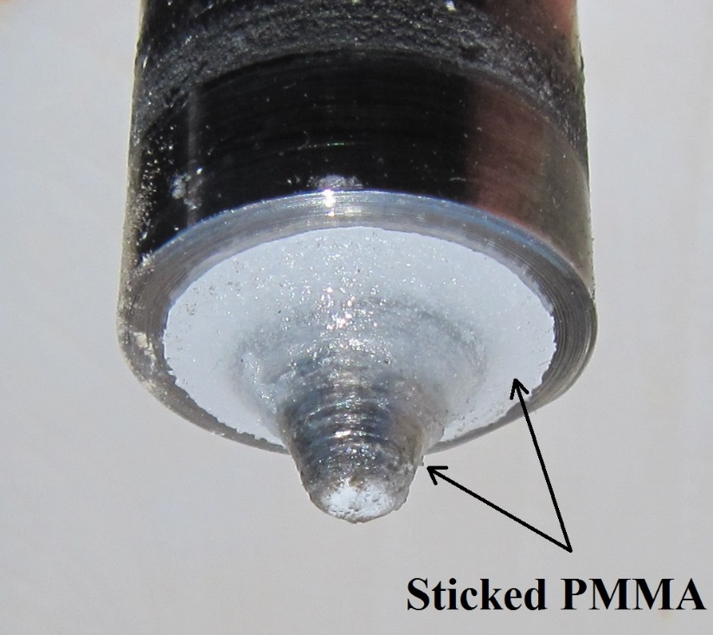
Fig. S2. Electronic image showing sticking of PMMA to the tool.
References
[1] Plastics Processing Data Handbook, 2nd ed. Rosato V D, NewYork: Springer-Verlag.; 1997.
[2] The Physics of Polymers: Concepts for Understanding Their Structures and Behavior, Gert Strobl G, editor. Berlin: Springer-Verlag.; 2007.
[3] Polymer Blends Handbook, Vol. 1, Utracki L A. NewYork: Kluwer Academic Publishers.; 2002.
[4] Polymer Data handbook, Mark J E. London: Oxford University Press.; 1999.
[5] Handbook of Polymers, Wypych G. Ontario: ChemTec Publishing.; 2012.
[6] Urbas J, Parker WJ, Gerald E. Luebbers GE. Surface temperature measurements on burning materials using an infrared pyrometer: accounting for emissivity and reflection of external radiation. Fire Mater. 2004; 28:33–53.
[7] Nandan R, Roy GG, Lienert TJ, et al. Three-dimensional heat and material flow during friction stir welding of mild steel. Acta Mater. 2007;55:883–895.

