### Supplemental Material

### For

Schiff-base Appended Polymers for Phosphate Removal

Murat K. Deliomeroglu, Vincent M. Lynch, Jonathan L. Sessler*

Department of Chemistry, 105 E. 24th Street – A5300, The University of Texas at Austin, Austin TX, 78712-1224 USA

E-mail: sessler@cm.utexas.edu

### general

All solvents and chemicals were purchased from Aldrich, TCI, Acros, or Alfa Aesar unless otherwise noted. Pyrrole was distilled at 80 °C under reduced pressure (100 mbar) prior to use. Other solvents and reagents were used without further purification. NMR spectra were referenced to residual solvent proton peaks. The NMR solvents were purchased from Cambridge Isotope Laboratories. Chemical ionization (CI) and electrospray ionization (ESI) mass spectra were recorded on a VG ZAB-2E instrument and a VG AutoSpec apparatus, respectively. Thin-layer chromatography (TLC) analyses were carried out using silica gel (200 mm) glass-backed sheets obtained from Sorbent Technologies. Column chromatography was performed on Sorbent Technologies silica gel 60 (40–63 mm). All micro-calorimetric titrations were carried out using a MicroCal VP-ITC instrument.

#### Synthesis and Characterization



2,2'-(1-(4-Methoxyphenyl)ethane-1,1-diyl)bis(1*H*-pyrrole) (**12**): This intermediate was prepared using a slight modification of a procedure first reported by Lindsey *et al.*1 Briefly, in a 500 mL round bottom flask, 4’-methoxyacetophenone (**10**) (8.0 g, 53.3 mmol, 1 equiv.) was added to freshly distilled pyrrole (100.0 g, 1490.3 mmol, 25 equiv.). TFA (650 mg, 5.7 mmol, 10 mol%) was then added to the reaction mixture. This caused a color change from colorless to pale yellow. The resulting solution was stirred at 90 °C for 2 h. Unreacted pyrrole[1] and TFA were removed at 80 °C under reduced pressure (100 mbar). The resulting dark green oil was dried *in vacuo* overnight to give a brown solid. This product, **12** (*Rf* = 0.8[2]), was separated from non-reacted starting material **10** (*Rf* = 0.7) by column chromatography (silica gel, CH2Cl2). This gave compound **12** in purified from as a white-solid (6.3 g, 44% yield). 1H NMR (300 MHz, CDCl3) δ 7.76 (bs, 2H, NH), 7.03 (d, 2H), 6.81 (d, 2H), 5.96 (m, 2H), 6.64 (m, 2H), 6.17 (m, 2H, pyrrole CH), 3.78 (s, 3H), 2.02 (s, 3H) ppm. 13C NMR (125 MHz, CDCl3) δ 158.1, 139.4, 137.7, 128.4, 116.8, 113.3, 108.1, 106.1, 55.2, 44.0, 28.9 ppm. HRMS (CI+) *m*/*z* for C17H18N2O [M]+ calcd 266.1419, found 266.1418.



5,5'-(1-(4-Methoxyphenyl)ethane-1,1-diyl)bis(1*H*-pyrrole-2-carbaldehyde) (**14**): A slight modification of a literature procedure2 was employed. Briefly, a solution of **12** (6.3 g, 23.7 mmol, 1 equiv.) in DMF (25 ml, 350 mmol, 15 equiv.) was cooled to 0 °C in an external ice bath. To the solution, phosphoryl chloride (POCl3) (21.7 g, 142 mmol, 6 equiv.) was added dropwise *via* an addition funnel. A color change from colorless to orange was observed during the addition. The mixture was stirred at 0 °C for 1 h. The solution was then heated to 60 °C and stirred for 3 h. The solution was allowed to cool to room temperature and then to 0 °C in an ice bath. Aqueous Na2CO3 (52 g in 100 ml) was added slowly until a pH of 10 was reached. The solution was then stirred at 80 °C for 2 h. The solution was allowed to cool to room temperature. This gave a mixture containing insoluble solid material. This reaction mixture was extracted with EtOAc. The resulting organic phase was dried over anhydrous sodium sulfate (Na2SO4) before being subjected to column chromatography (silica gel, CH2Cl2:EtOAc (5:4)). Product **14** (*Rf* = 0.8) was obtained as a white solid (6.3 g, 82%) after collecting the appropriate fractions and precipitating by treating with hexanes. 1H NMR (400 MHz, CDCl3) δ 10.46 (bs, 2H), 9.26 (s, 2H), 7.00 (d, 2H), 6.89 (m, 2H), 6.82 (d, 2H), 6.14 (m, 2H), 3.81 (s, 3H), 2.11 (s, 3H) ppm. 13C NMR (125 MHz, CDCl3) δ 178.8, 158.5, 146.5, 136.9, 132.6, 128.2, 121.8, 113.7, 110.3, 55.1, 44.9, 28.5 ppm. FTIR: 3268, 1667, 1651, 1614, 1481, 1434, 1410, 1266, 1216, 1200, 1177, 1045, 1021, 788, 760 cm-1. HRMS (ESI+) *m*/*z* for C19H18N2O3 [M+H]+ calcd 323.13170, found 323.13902.



In a 500 ml Shlenck flask flushed with argon, formyl-methoxy-dipyrromethaned (1.53 g, 4.75 mmol, 1 equiv.) was dissolved in dry, degassed, CH2Cl2 (60 ml). The solution was cooled to 0 °C using an ice bath, and a 1 M boron tribromide (BBr3) solution in CH2Cl2 (2.97 g, 12.0 mmol) was added slowly *via* syringe. The resulting solution was stirred at 0 °C for 2 h. The solution was then warmed to room temperature and stirred for an additional 2 h. The precipitation of an orange solid was observed immediately upon BBr3 addition. To this mixture, 100 ml of water was added. Stirring was then continued for another 2 h. The mixture was extracted with EtOAc, giving a dark red solution. This red solution was dried over Na2SO4 and the volatiles removed by means of a rotary evaporation. The product was purified by column chromatography over silica gel using a mixture of CH2Cl2 and EtOAc (3:1) as the eluent. Due to the poor solubility of the crude product, the column was loaded using silica gel onto which the crude product had been placed. Product **15** was isolated as an off-white solid (1.2 g, 82.1%). 1H NMR (400 MHz, 1% CD3OD in CDCl3) 2.04 (s, 3H, meso-CH3), 6.12 (m, 2H, pyrrole CH), 6.73 (d, 2H, Ar H), 6.85 (d, 2H, Ar H), 6.90 (m, 2H, Ar H), 9.30 (s, 2H, formyl protons), 10.23 (br s, 2H, pyrrole NH). 13C NMR (100 MHz, CD3OD) δ 179.5, 156.4, 147.3, 136.4, 133.2, 133.2, 128.4, 115.0, 110.7, 45.2, 27.3 ppm. FTIR: 3284, 3208, 1630, 1482, 1435, 1318, 1295, 1201, 1172, 1052, 785, 771, 698.

Alternatively, **15** could be prepared by the following reaction sequence:



For the synthesis of **13**, a procedure identical to that used to prepare **12** (*vide supra*) was used, albeit starting with **11**. For the synthesis of **15**, a procedure identical to that used to prepare **14** (*vide supra*) was used, albeit starting with **13**.



The mono-protected form (**17**) of *o*-phenylenediamine (**16**) is a known compound.3 It was prepared for use in this study as follows:*o*-Phenylenediamine (5 g, 46.3mmol) was dissolved in 200 ml CHCl3. A 100 ml aqueous solution containing 2.33 g of sodium bicarbonate (27.78 mmol) and 2.77 g of sodium chloride (47.4 mmol) was made up separately. These solutions were combined in a 500 ml round bottom flask and cooled in an ice-bath. Di-*tert*-butylpyrocarbonate (10.33 g, 47.4 mmol) was dissolved in 100 ml CHCl3 and added slowly to the reaction mixture cooled in an external ice-bath. The resulting mixture was stirred in an ice-bath for 30 minutes. The reaction vessel was first heated to room temperature and then heated at reflux (73.6 ºC) for 12 h. The reaction mixture was left standing and phase separation was observed. The aqueous phase was extracted with CHCl3 (2x 50 ml). The combined organic extracts were dried over anhydrous sodium sulfate. The volatiles were removed under reduced pressure. The solids were re-dissolved in a 3:1 mixture of CH2Cl2 and EtOAc. The resulting solution was subjected to column chromatography (silica gel) using a 3:1 mixture of CH2Cl2 and EtOAc as the eluent. The doubly protected side product elutes first with (*Rf* = 0.92), followed by mono-protected, desired product (**17**) (*Rf* = 0.8). After removal of the solvent, this desired product was obtained as a white solid (6.64 g, 67%).

Bis(2-aminophenyl)pyridine-2,6-dicarboxamide (**19**) was synthesized using the procedure reported by the Sessler group.4 Compound **17** (6.64 g, 32 mmol) was dissolved in 30 ml dry tetrahydrofuran (THF). To this solution, 4.45 ml of dry triethylamine (TEA) was added under Ar. The resulting solution was placed in a water-bath and 2,6-pyridine-dicarboxylic acid chloride (**18**) (3.26 g, 16 mmol, 0.5 equiv.) in dry THF (40 ml) was added. The ensuing mixture was stirred for 4 h. It was then filtered to remove insoluble by products. After removal of solvent under reduced pressure, the reaction product was passed through a very short column eluting with CH2Cl2. This procedure was used to remove a material that did not migrate under conditions of TLC analysis.

*N2,N6*-Bis(2-aminophenyl)pyridine-2,6-dicarboxamide (**20**): Compound **19** (6.37 g, 12 mmol) in CH2Cl2 (100 ml) was placed in a water-bath. TFA (19 ml) was added slowly to this solution. The resulting mixture was stirred for 3.5 h. TLC analysis (CH2Cl2:EtOAc 3:1) revealed conversion of material that moved at the solvent front spot to one that did not move. To neutralize the TFA, an aqueous solution of NaOH (10.77 g, 300 mL DI water) was added slowly to the reaction mixture with vigorous stirring in an external ice-bath. In order to ensure that all TFA was neutralized, the pH of the aqueous solution checked. The desired pH value of 10 was reached. After separating the phases, organic phase was dried over anhydrous Na2SO4. Volatiles were removed *in vacuo* to give a yellow crystalline product (**20**) (2.7 g, 60%).



(4*E*,13*E*)-2-(4-Methoxyphenyl)-2-methyl-11*H*,31*H*-5,7,11,13-tetraaza-9(2,6)-pyridina-1,3(2,5)-dipyrrola-6,12(1,2)-dibenzenacyclotetradecaphane-4,13-diene-8,10-dione (**21**): The synthetic procedure and spectral data are provided in the main text.



(4E,13E)-2-(4-Hydroxyphenyl)-2-methyl-11H,31H-5,7,11,13-tetraaza-9(2,6)-pyridina-1,3(2,5)-dipyrrola-6,12(1,2)-dibenzenacyclotetradecaphane-4,13-diene-8,10-dione (**22**): The synthetic procedure and spectral data are provided in the main text.



Co-polymer **24**: The synthetic procedure and spectral data are provided in the main text.



The synthetic procedure and spectral data for the compound **27** are provided in the main text.



### Supplemental Figures

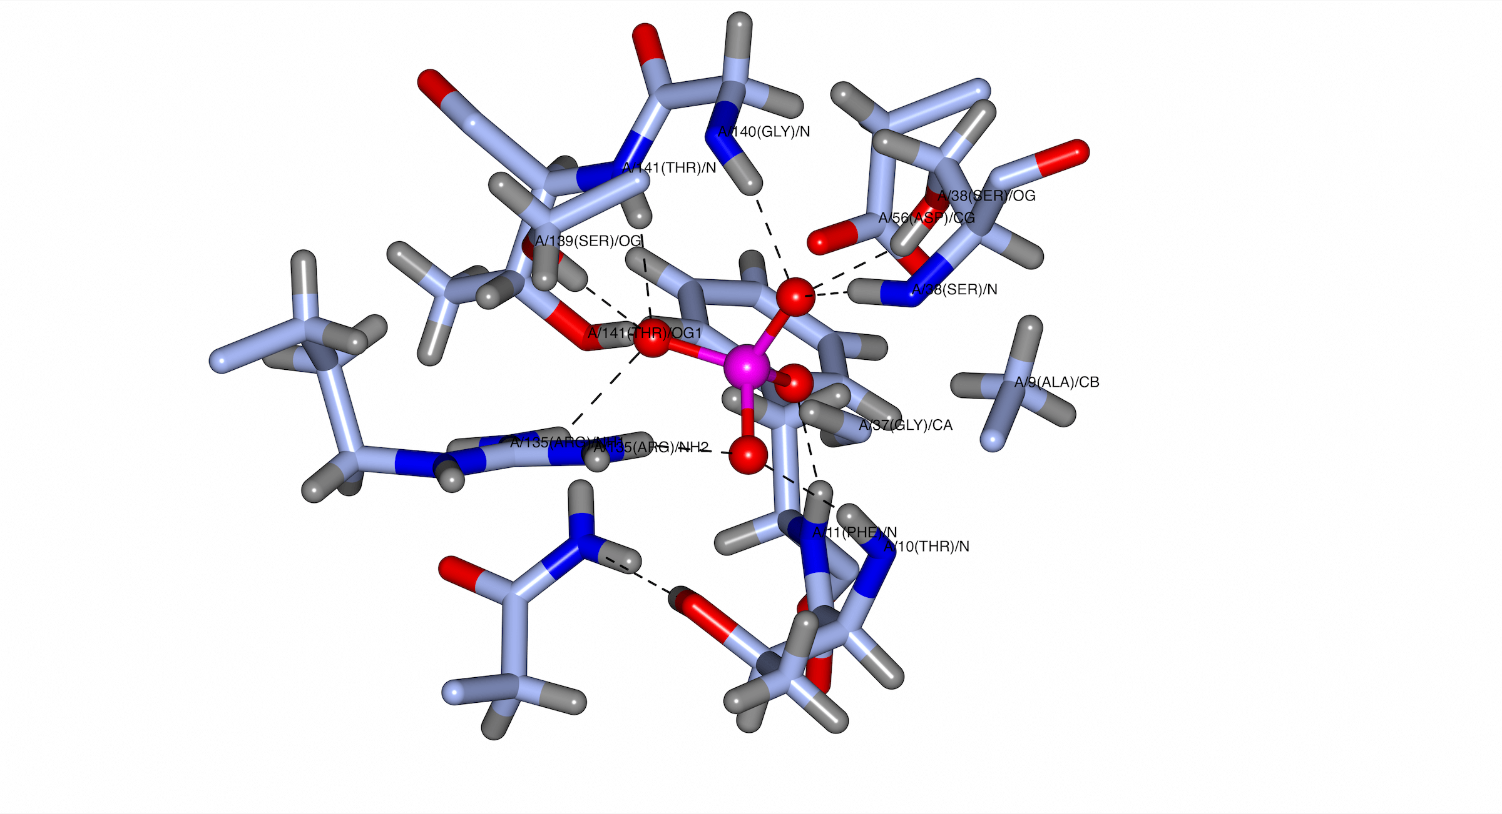

Figure S.1. X-ray crystal structure of *E. Coli* phosphate-binding protein (PBP) (left) and the binding site of the PBP (right). This structure was originally reported by Quiocho and coworkers6 and was redrawn using the program QtMG using data from the protein data bank (PDB) (PDB code: 1IXH, 0.98 Å resolution).



Scheme S.1. Basic concept of the anaerobic-aerobic process known as enhanced biological phosphate removal (EBPR).

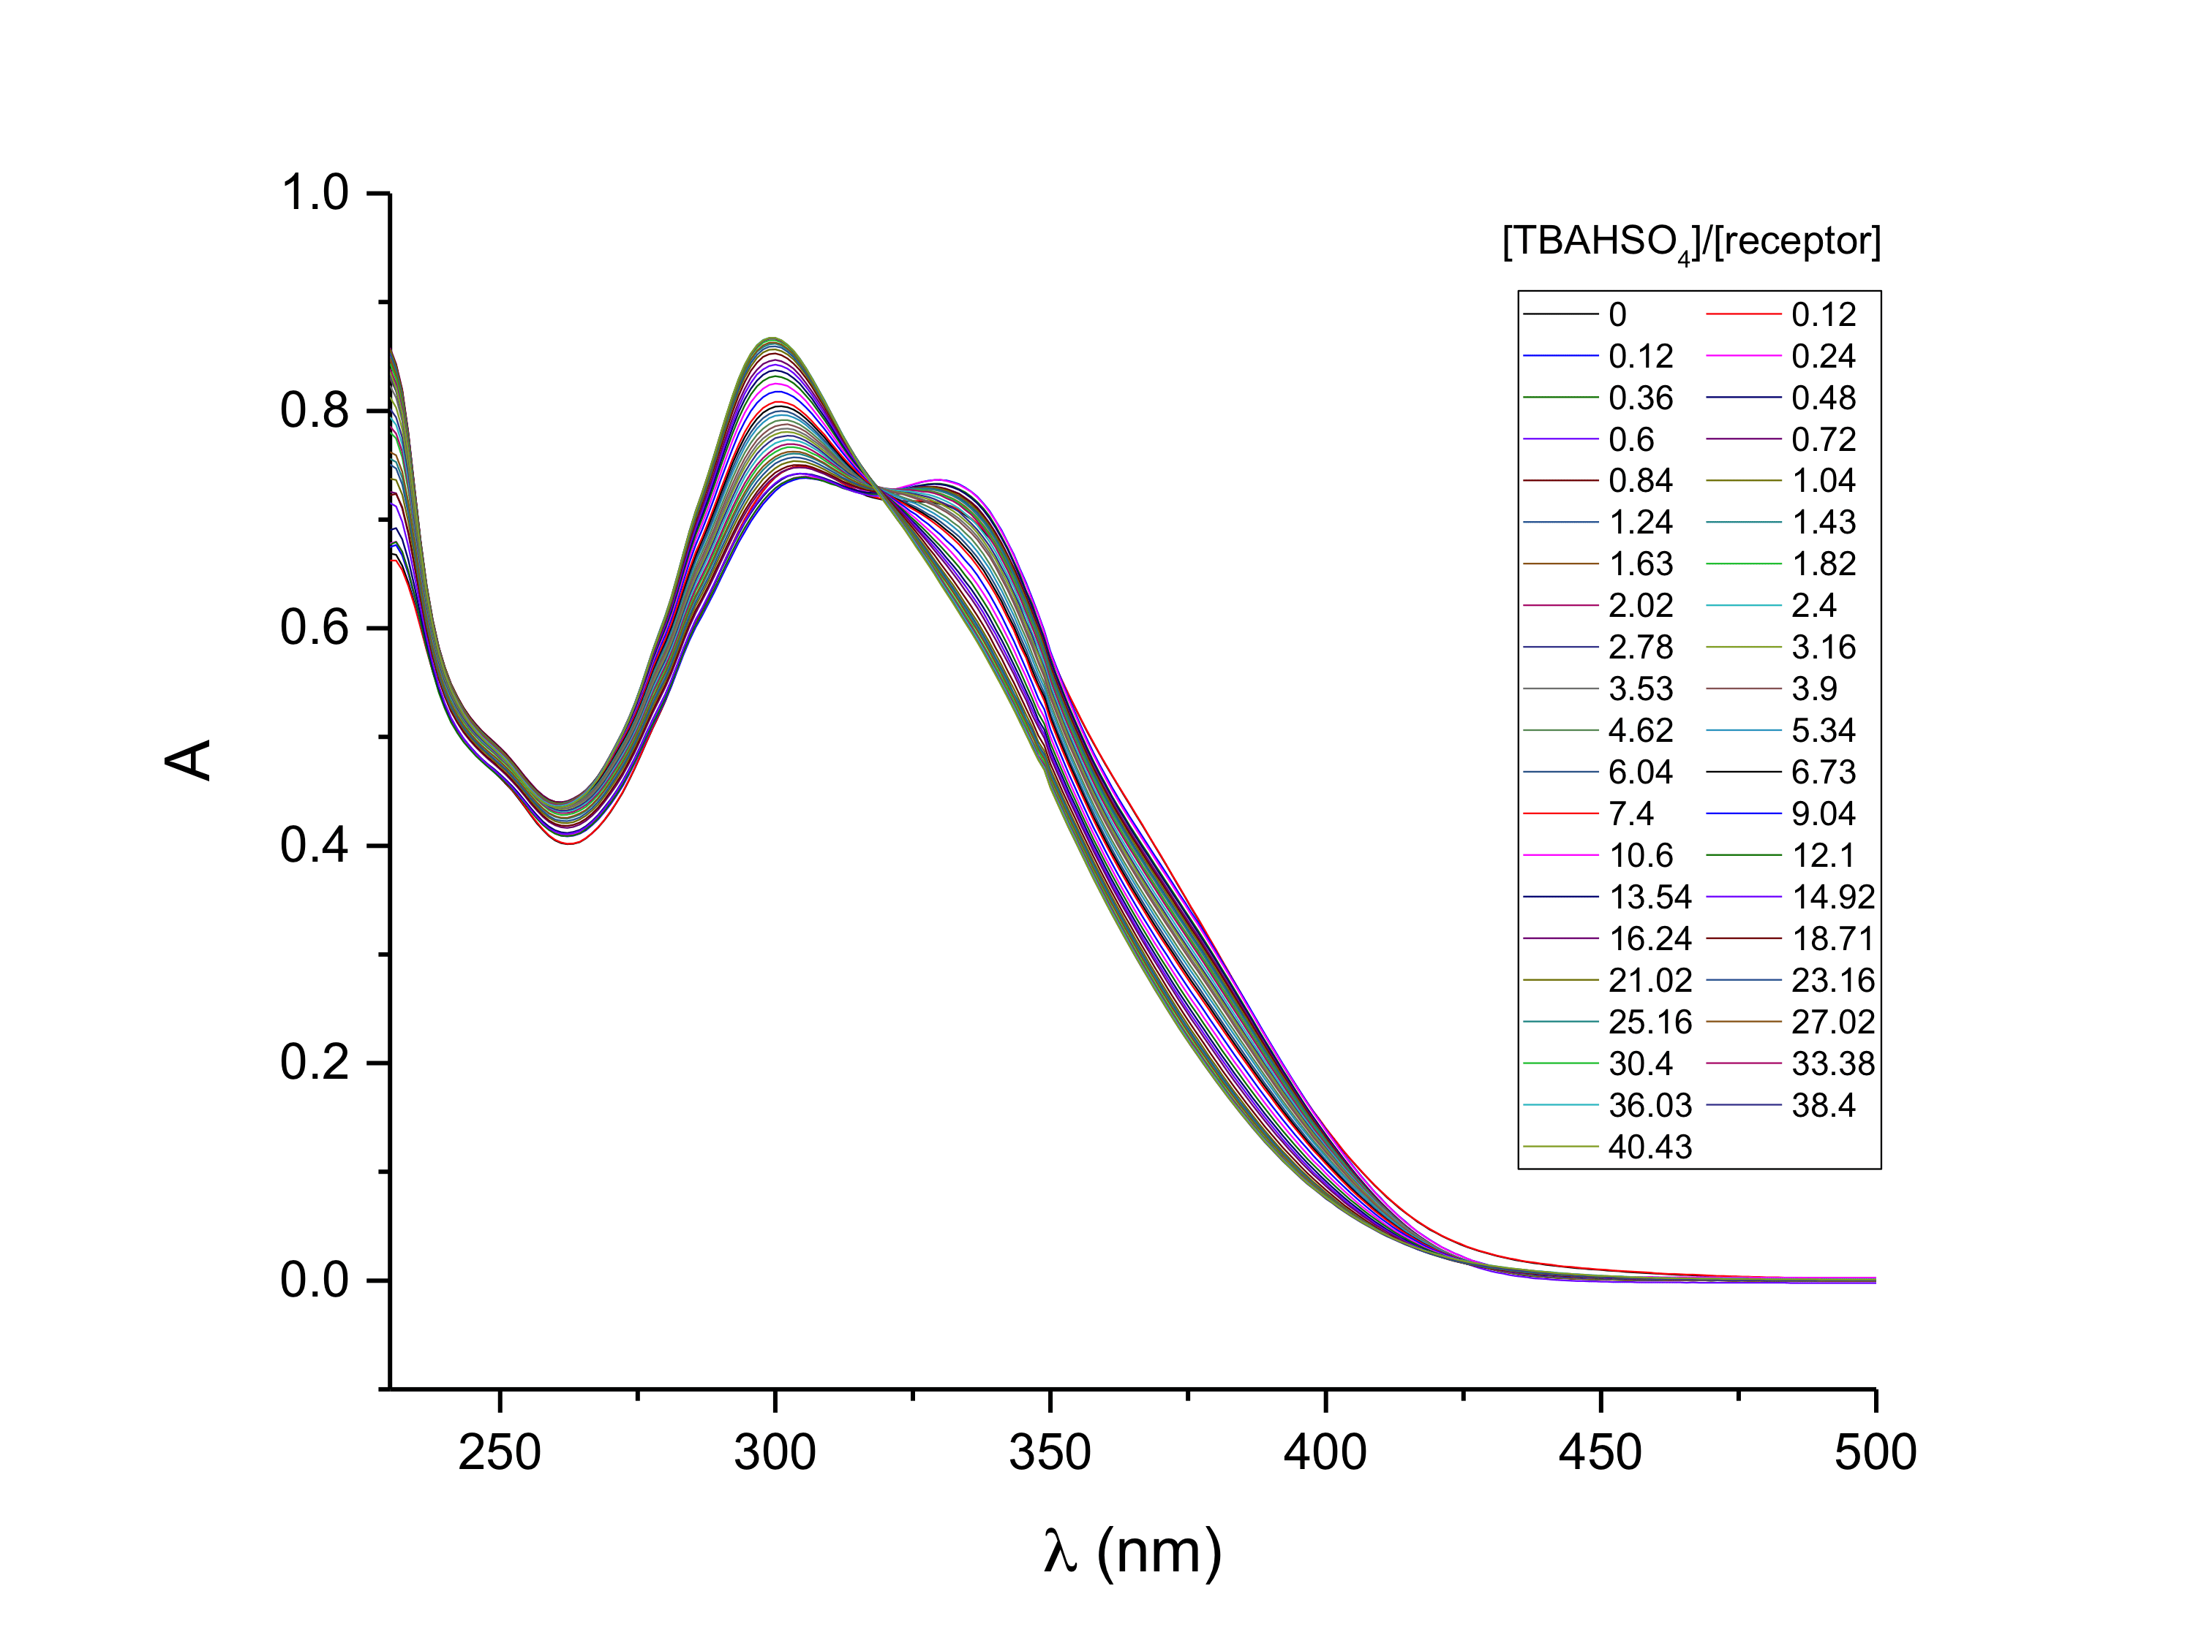

Figure S.2. Stacked UV-Vis spectra corresponding to the titration of **21** (2.43 x 10-5 M) with TBAHSO4 (1.97 x 10-3 M) in CH2Cl2.

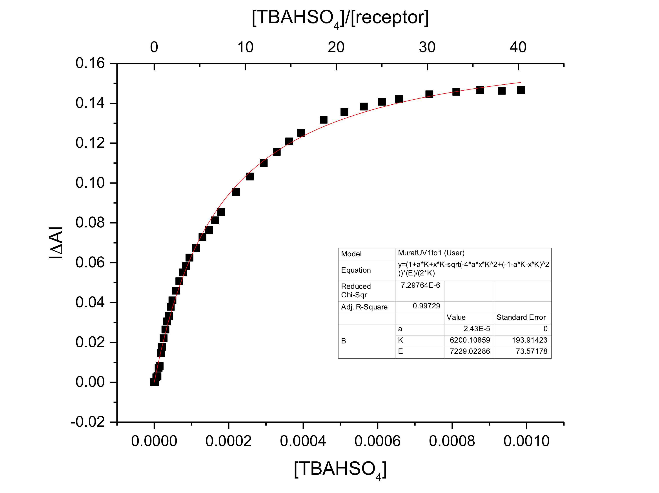

Figure S.3. Binding curve and 1:1 fit generated from the titration data shown in Figure S.2 using the spectral changes at 300 nm. *K*a = (1.2 ± 0.2) x 104 M-1.

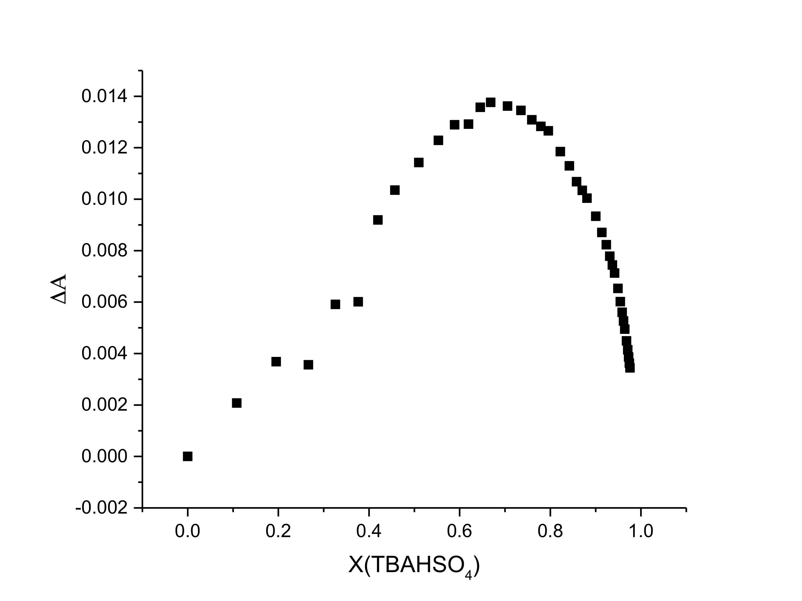

Figure S.4. Job plot for **21** binding with TBAHSO4 derived from the spectral data shown in Figure S.2 at 300 nm. The maximum at a mole fraction of about 0.67 is consistent with a 1:2 (**21**:TBAHSO4) binding stoichiometry.

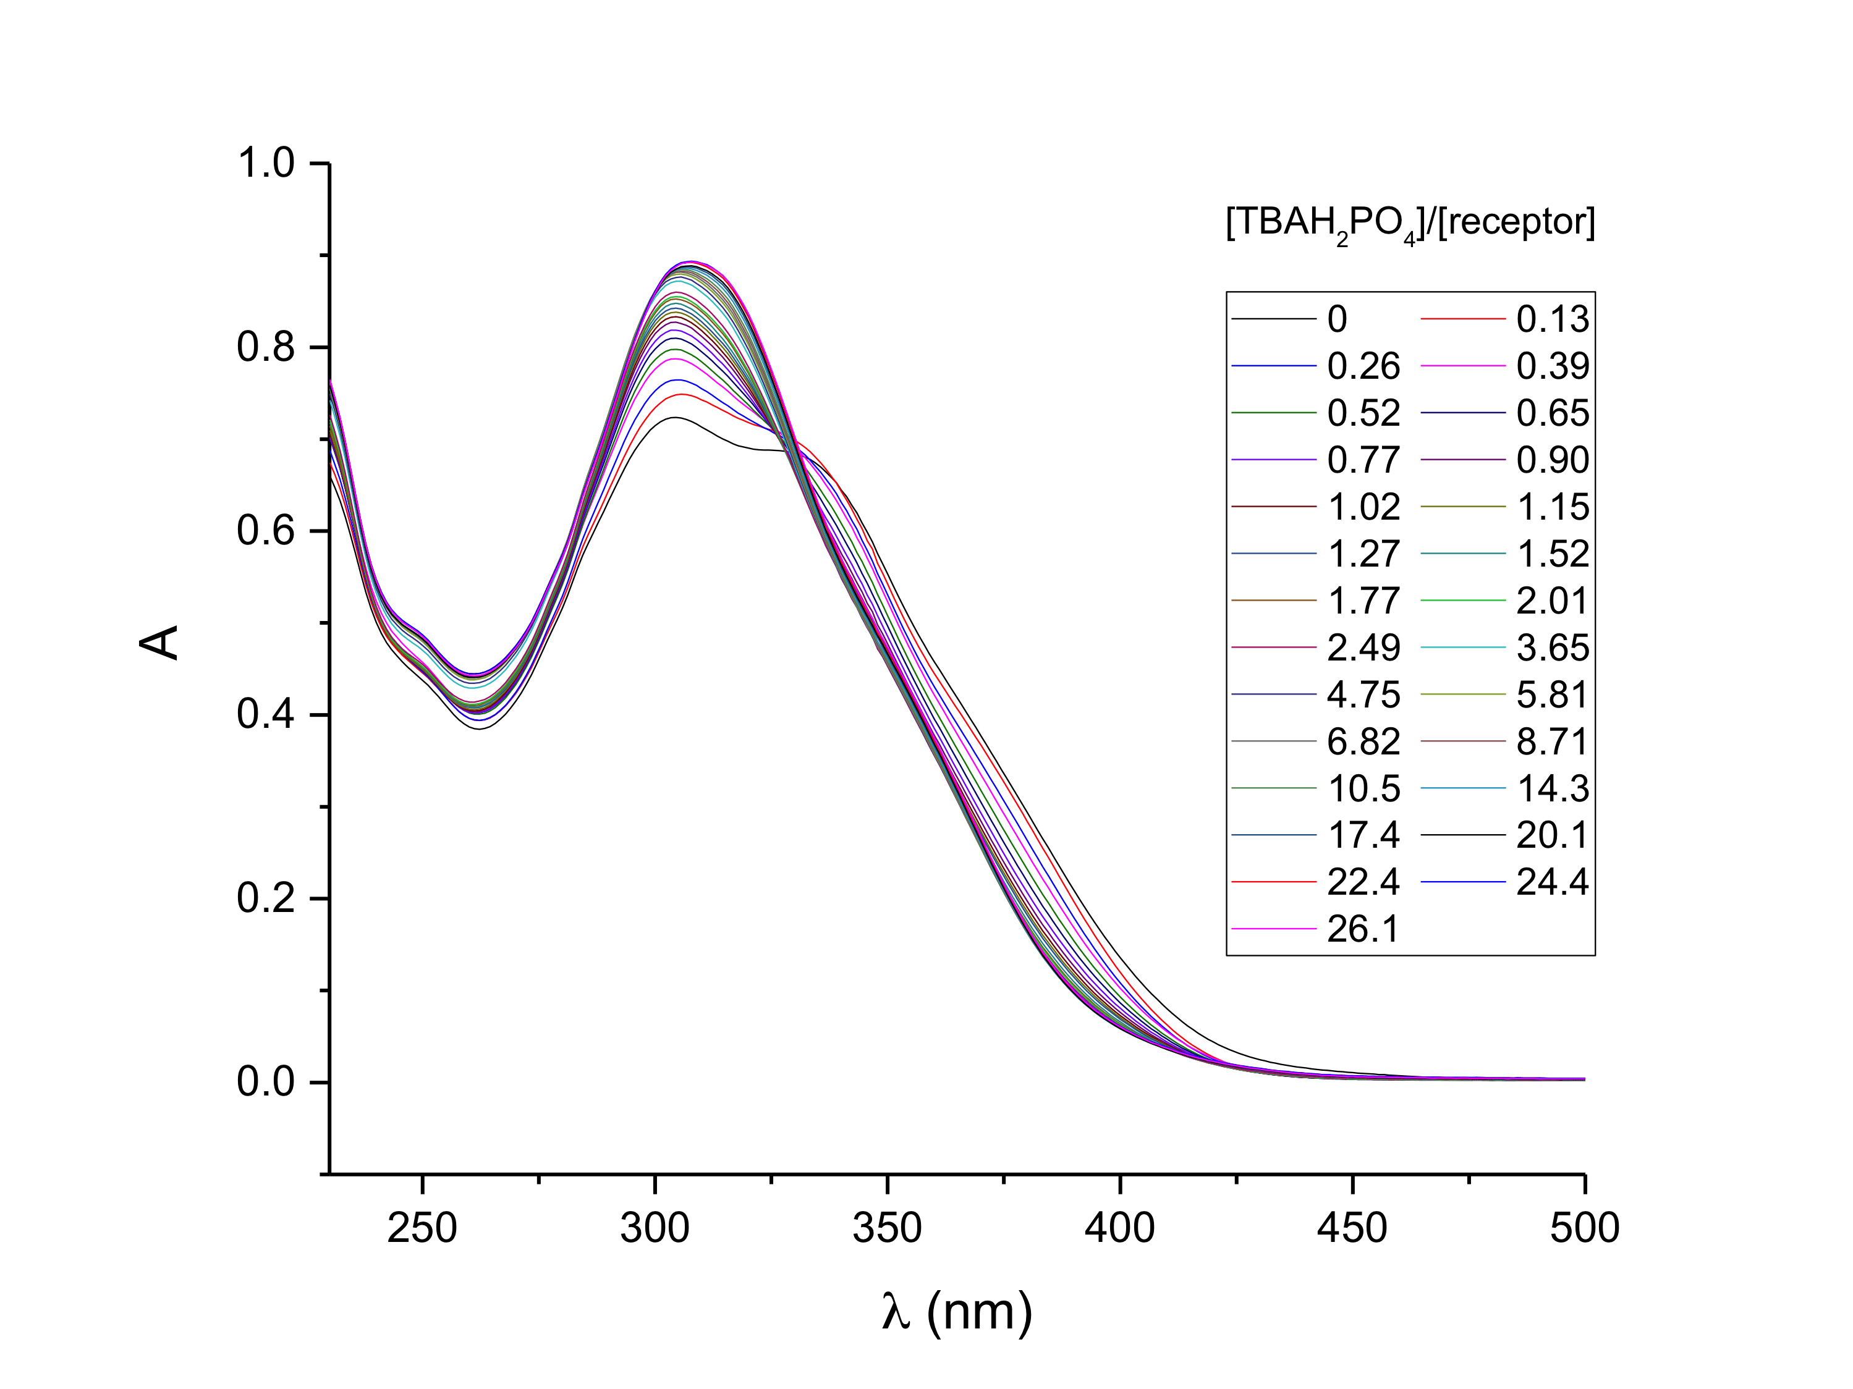

Figure S.5. Stacked UV-Vis spectra corresponding to the titration of **21** (2.43 x 10-5 M) with TBAH2PO4 (1.27 x 10-3 M) in CH2Cl2.

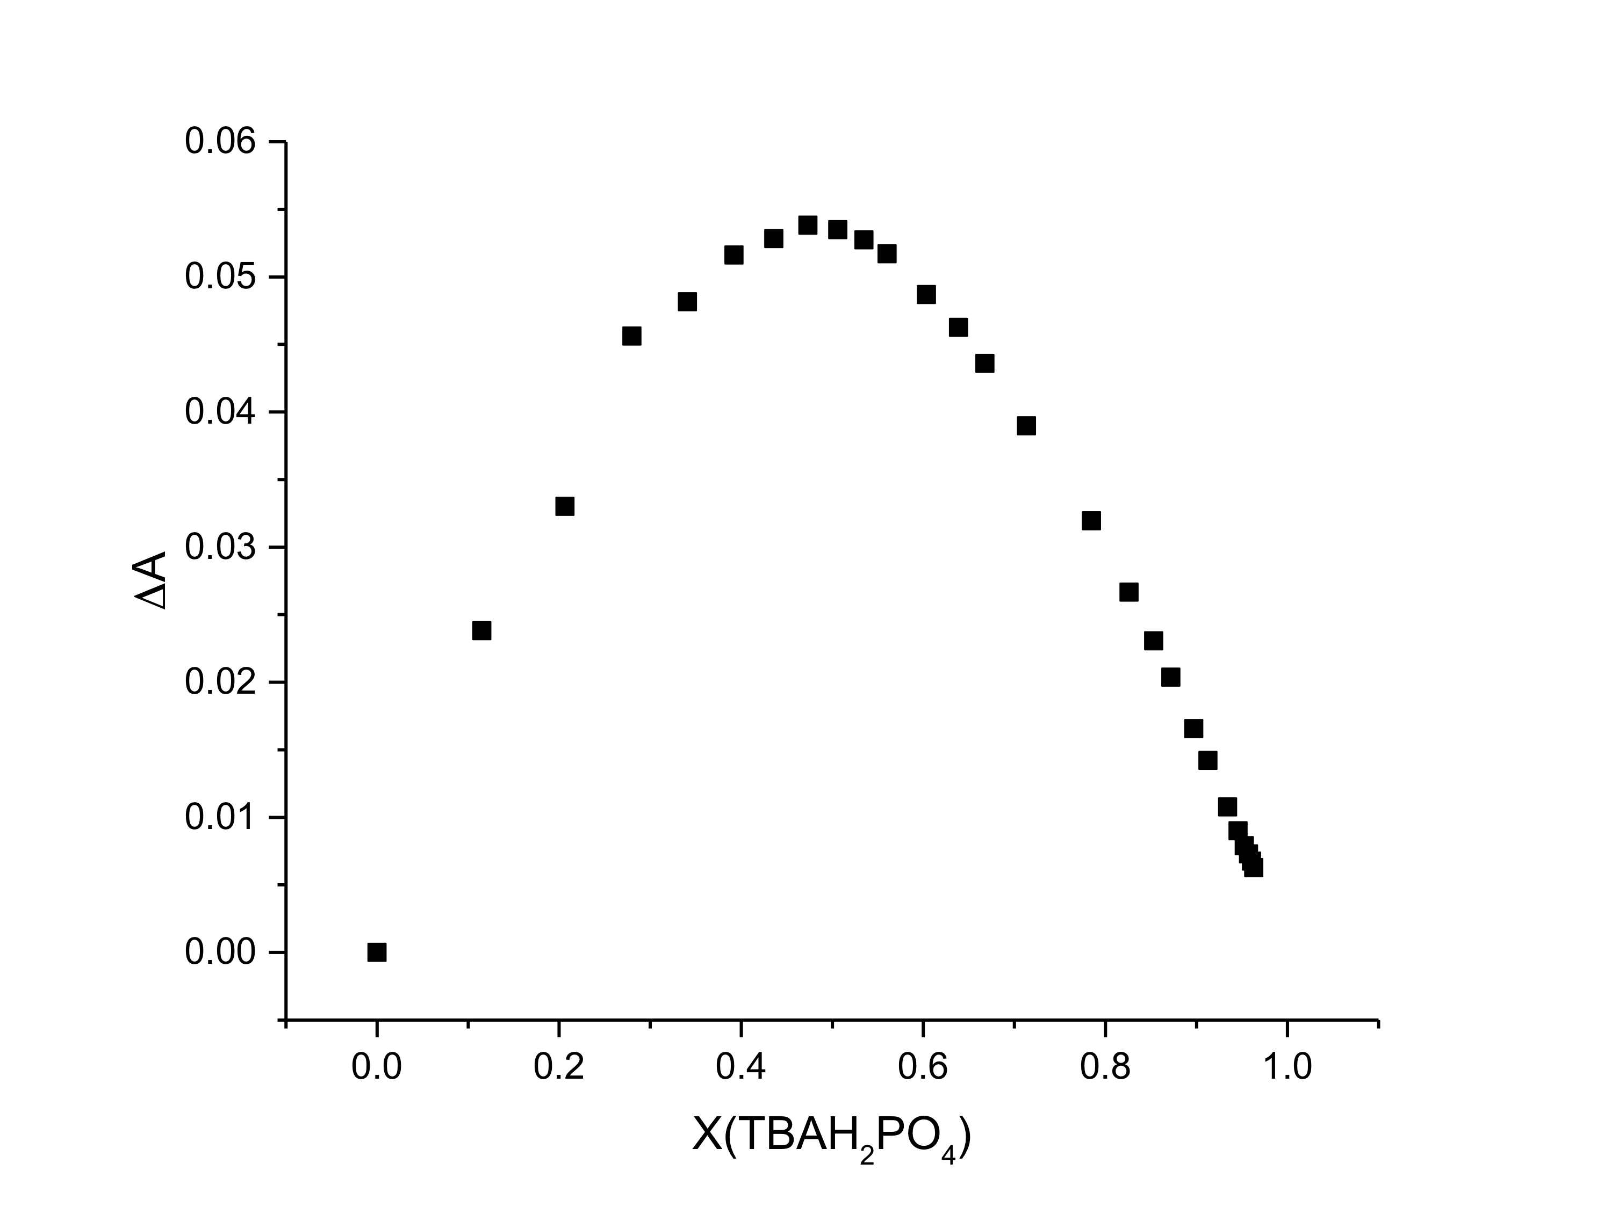

Figure S.6. Job plot for **21** binding with TBAH2PO4 derived using the spectra shown in Figure S.5 at 306.7 nm. The observed maximum near a 0.5 mole fraction is consistent with a 1:1 binding stoichiometry.

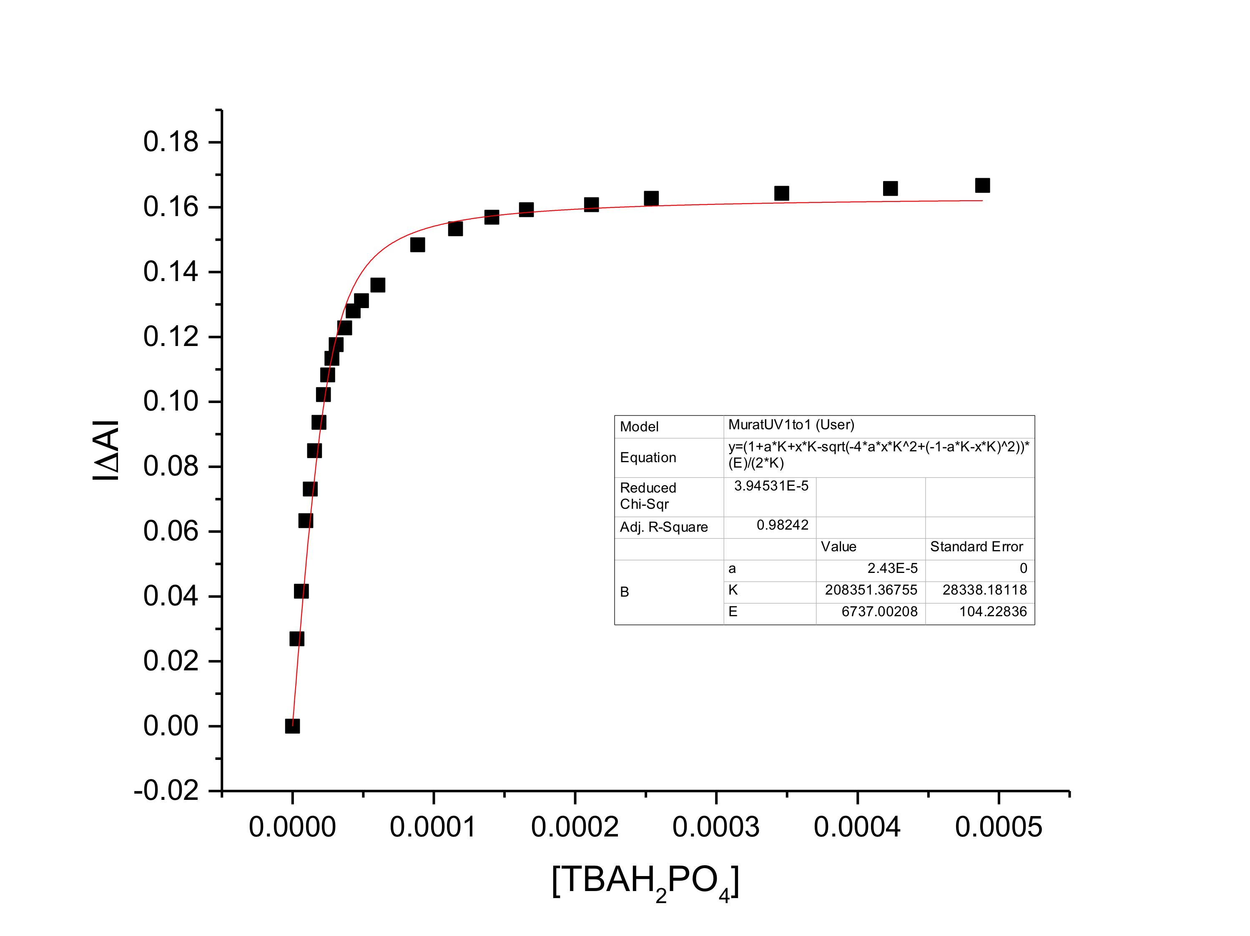

Figure S.7. Binding curve and 1:1 fit generated from the titration data shown in Figure S.5 using the spectral changes at 306.7 nm. *K*a = (2.1 ± 0.3) x 105 M-1.

a)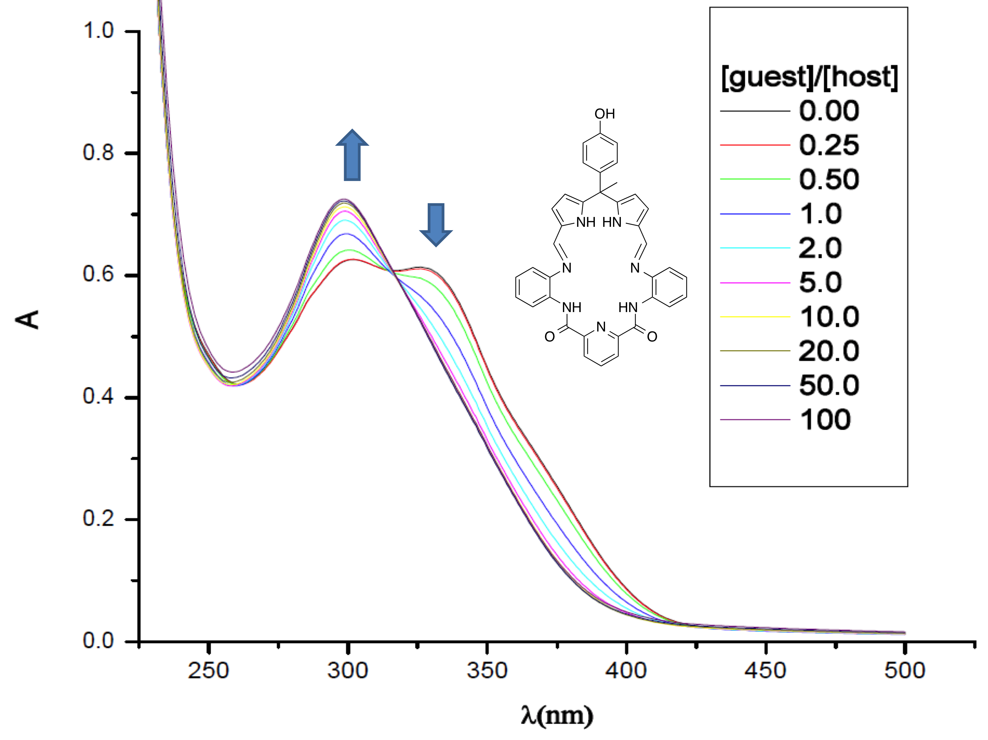

b)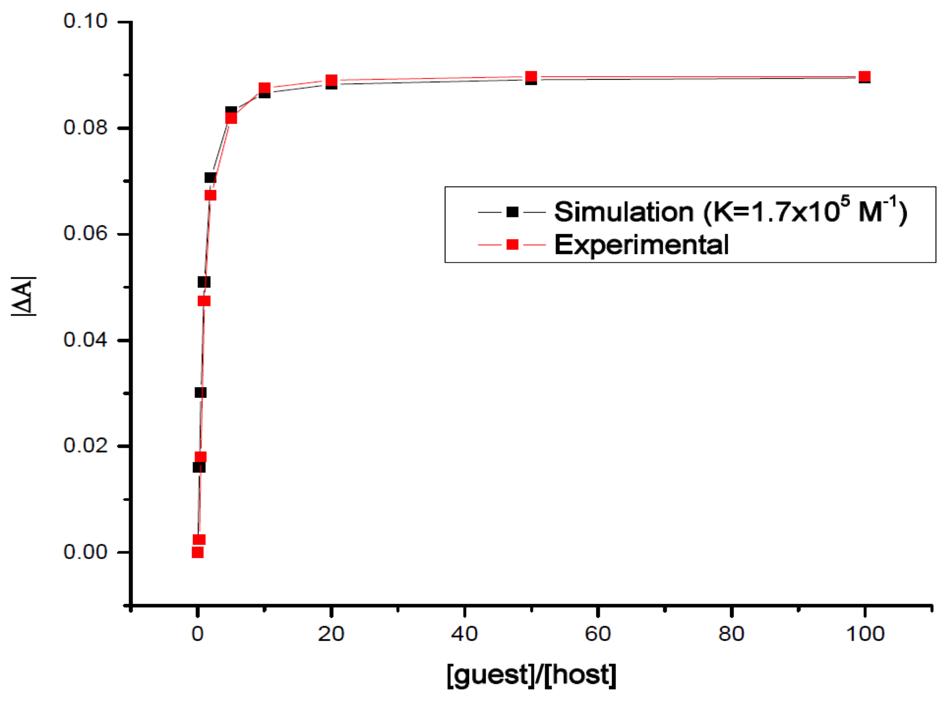

Figure S.8. a) Stacked UV-Vis spectra for the titration of **22** (1.8 x10-5 M) with TBAH2PO4 in CH3CN. Binding curve derived from the spectral changes observed in (a) at 326 nm. b) Also shown is a 1:1 (**22**: TBAH2PO4) simulation with an association constant *K*a = 1.7 x 105 M-1.

a)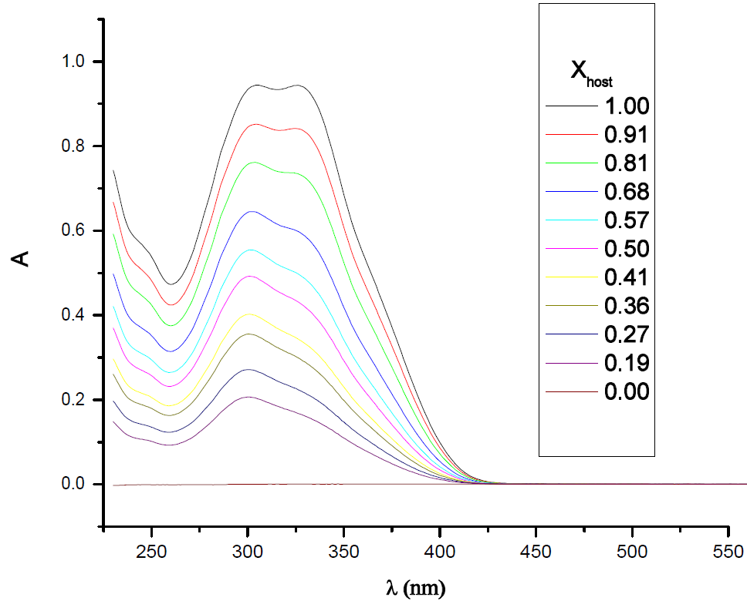

b)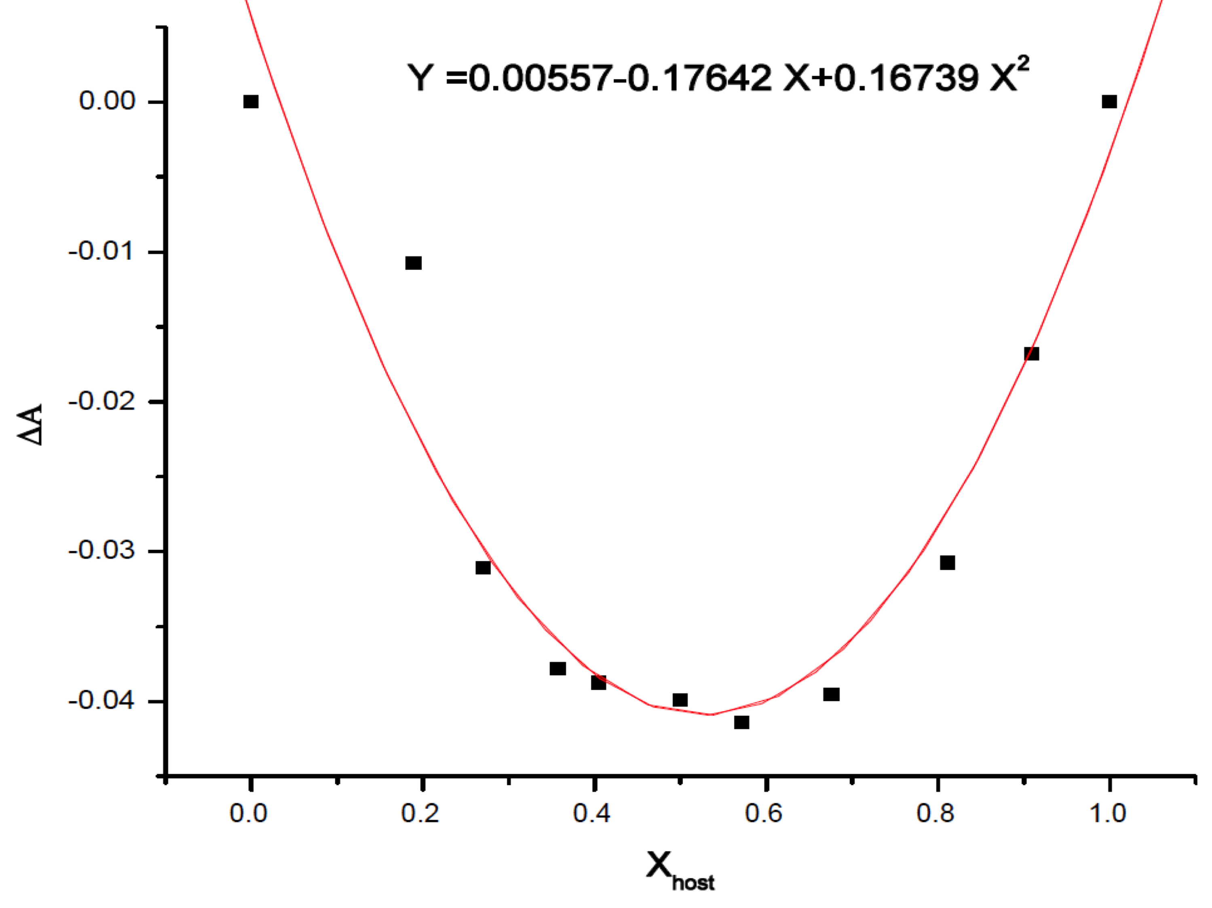

Figure S.9. a) Stacked UV-Vis spectra corresponding to Job plot of **22** with TBAH2PO4 in CH3CN. The decrease in absorbance at 326 nm is plotted against [**22**]+[TBAH2PO4] = 2.28 x 10-5 M at each point and Xhost = [**22**]/( [**22**]+[TBAH2PO4]). The minimum, dy/dx = 0 was seen when Xhost = 0.53, as would be expected for 1:1 binding.



Figure S.10. ITC titration of **22** (1 x 10-4 M) with TBAH2PO4 (2 x 10-3 M) in dry CH3CN. The calculated binding constant for a 1:1 binding is *K*a = (1.63 ± 0.08) x 105 M-1.



Figure S.11. ITC titration of **22** (3 x 10-4 M) with TBAH2PO4 (6 x 10-3 M) in dry CH3CN. The calculated binding constant for a 1:1 binding is *K*a = (1.16 ± 0.05) x 105 M-1.

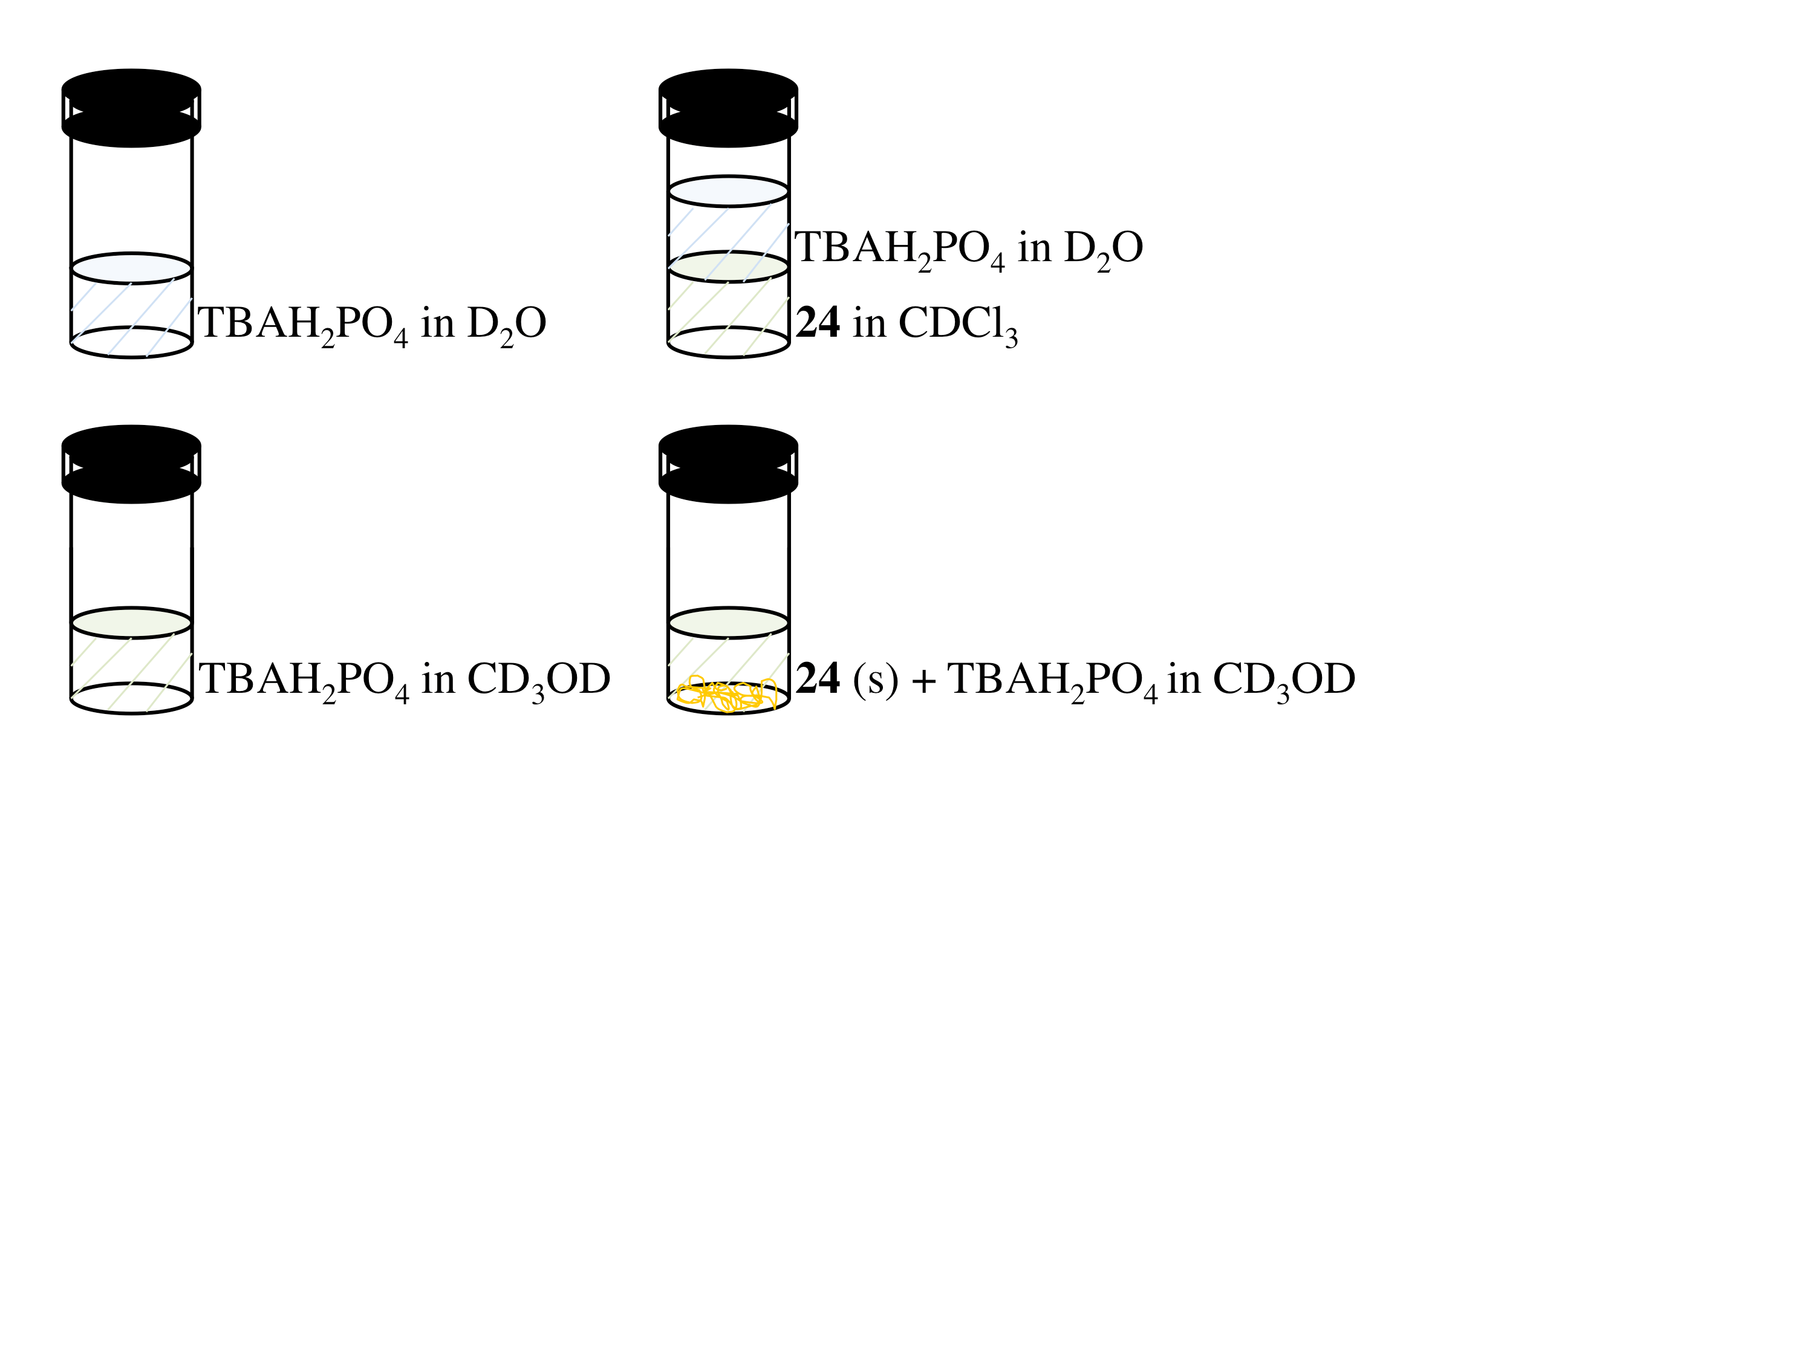

Figure S.12. Graphical presentation of the solid-liquid extraction approach used to test co-polymer **24** as a possible phosphate anion extractant (using TBA+ salts as the anion source). Left: H2PO4– solution in CD3OD, Right: Biphasic mixture obtained by adding solid co-polymer **24** into the solution on the left.

#### 1H & 13C NMR Spectra

All nuclear magnetic resonance (NMR) spectra were recorded at the University of Texas at Austin Department of Chemistry NMR Facility. Instruments used include:

Varian Unity 300 (300 MHz),

Agilent MR 400 MHz,

Varian MR 400 MHz,

Varian Inova 500 MHz,

and Brüker AC 300 MHz spectrometer.

Chemical shifts (δ) are reported in ppm and referenced to the solvent. All deuterated NMR solvents were purchased from Cambridge Isotope Laboratories and used as received. Solvent reference chemical shifts were set for values reported in the literature.5

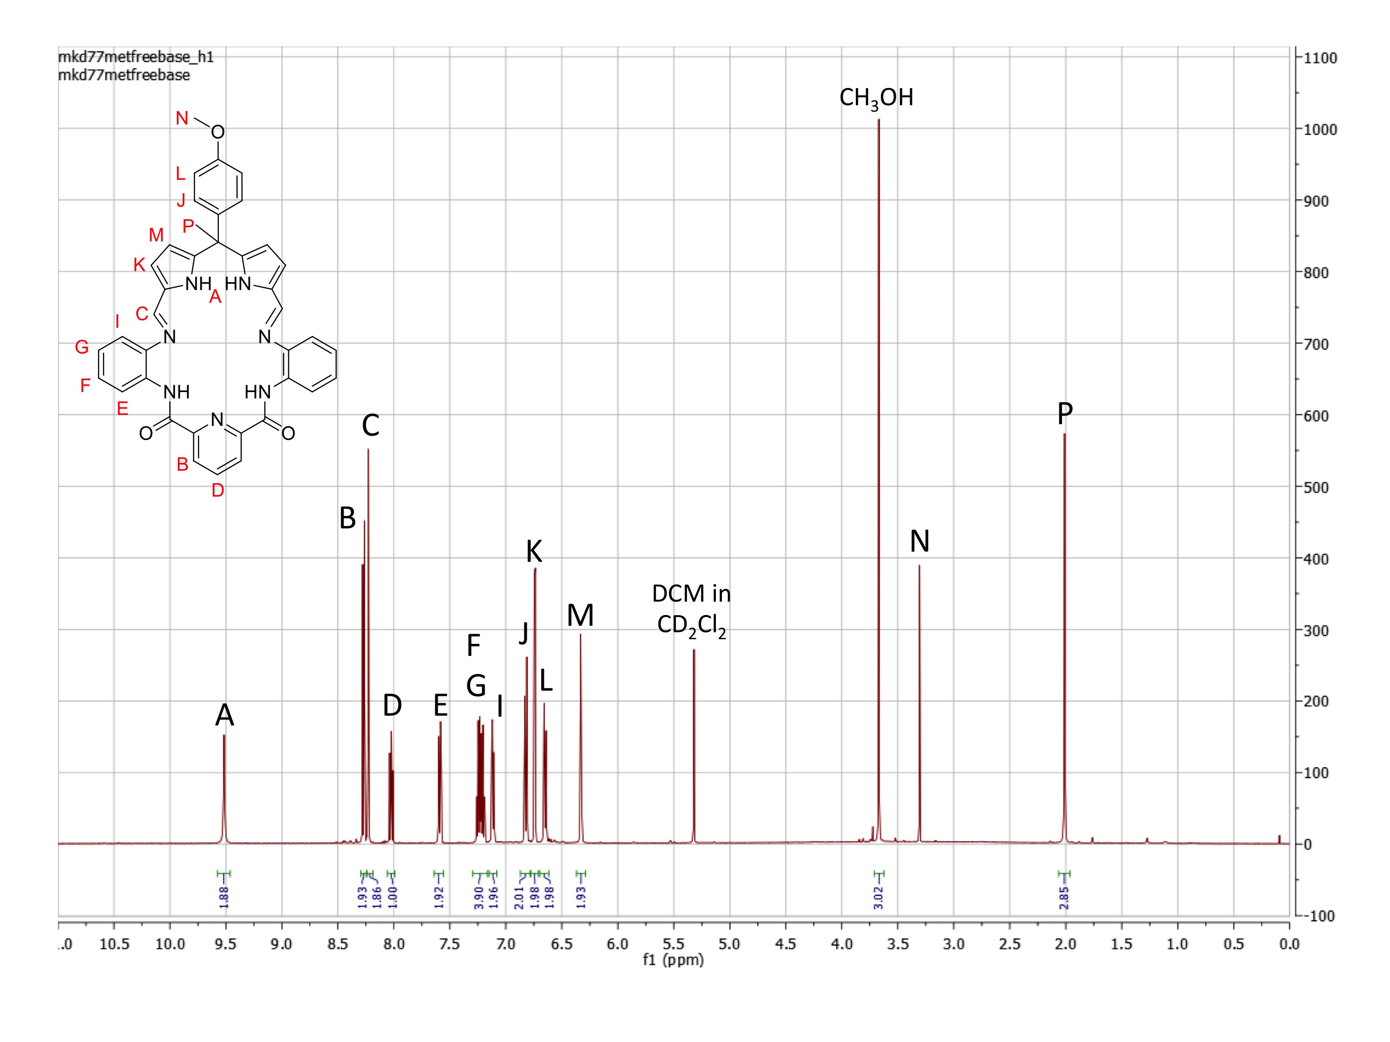

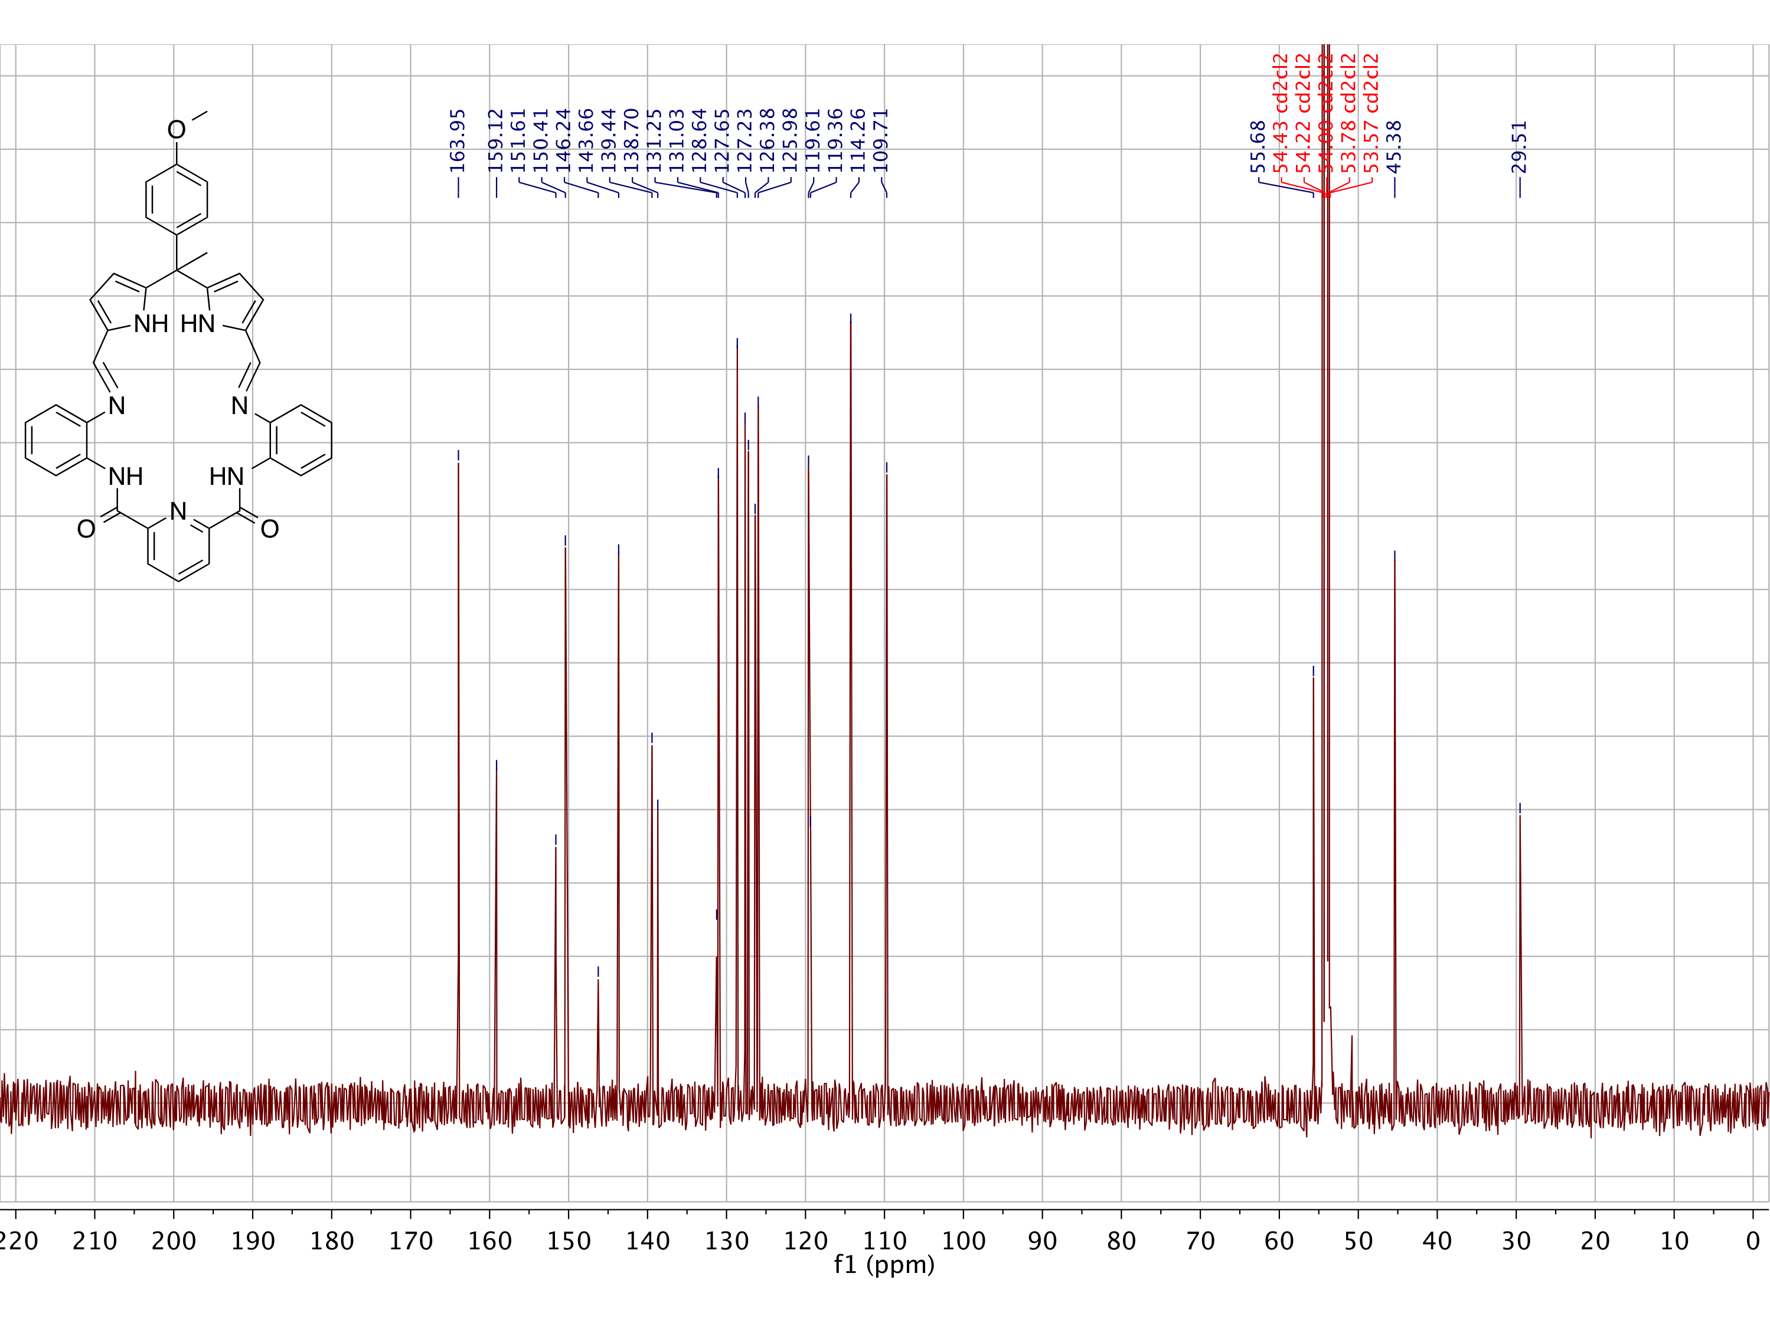

Figure S.13: Top: 1H NMR (500 MHz), Bottom: 13C NMR (126 MHz) spectra of **21** in CD2Cl2.

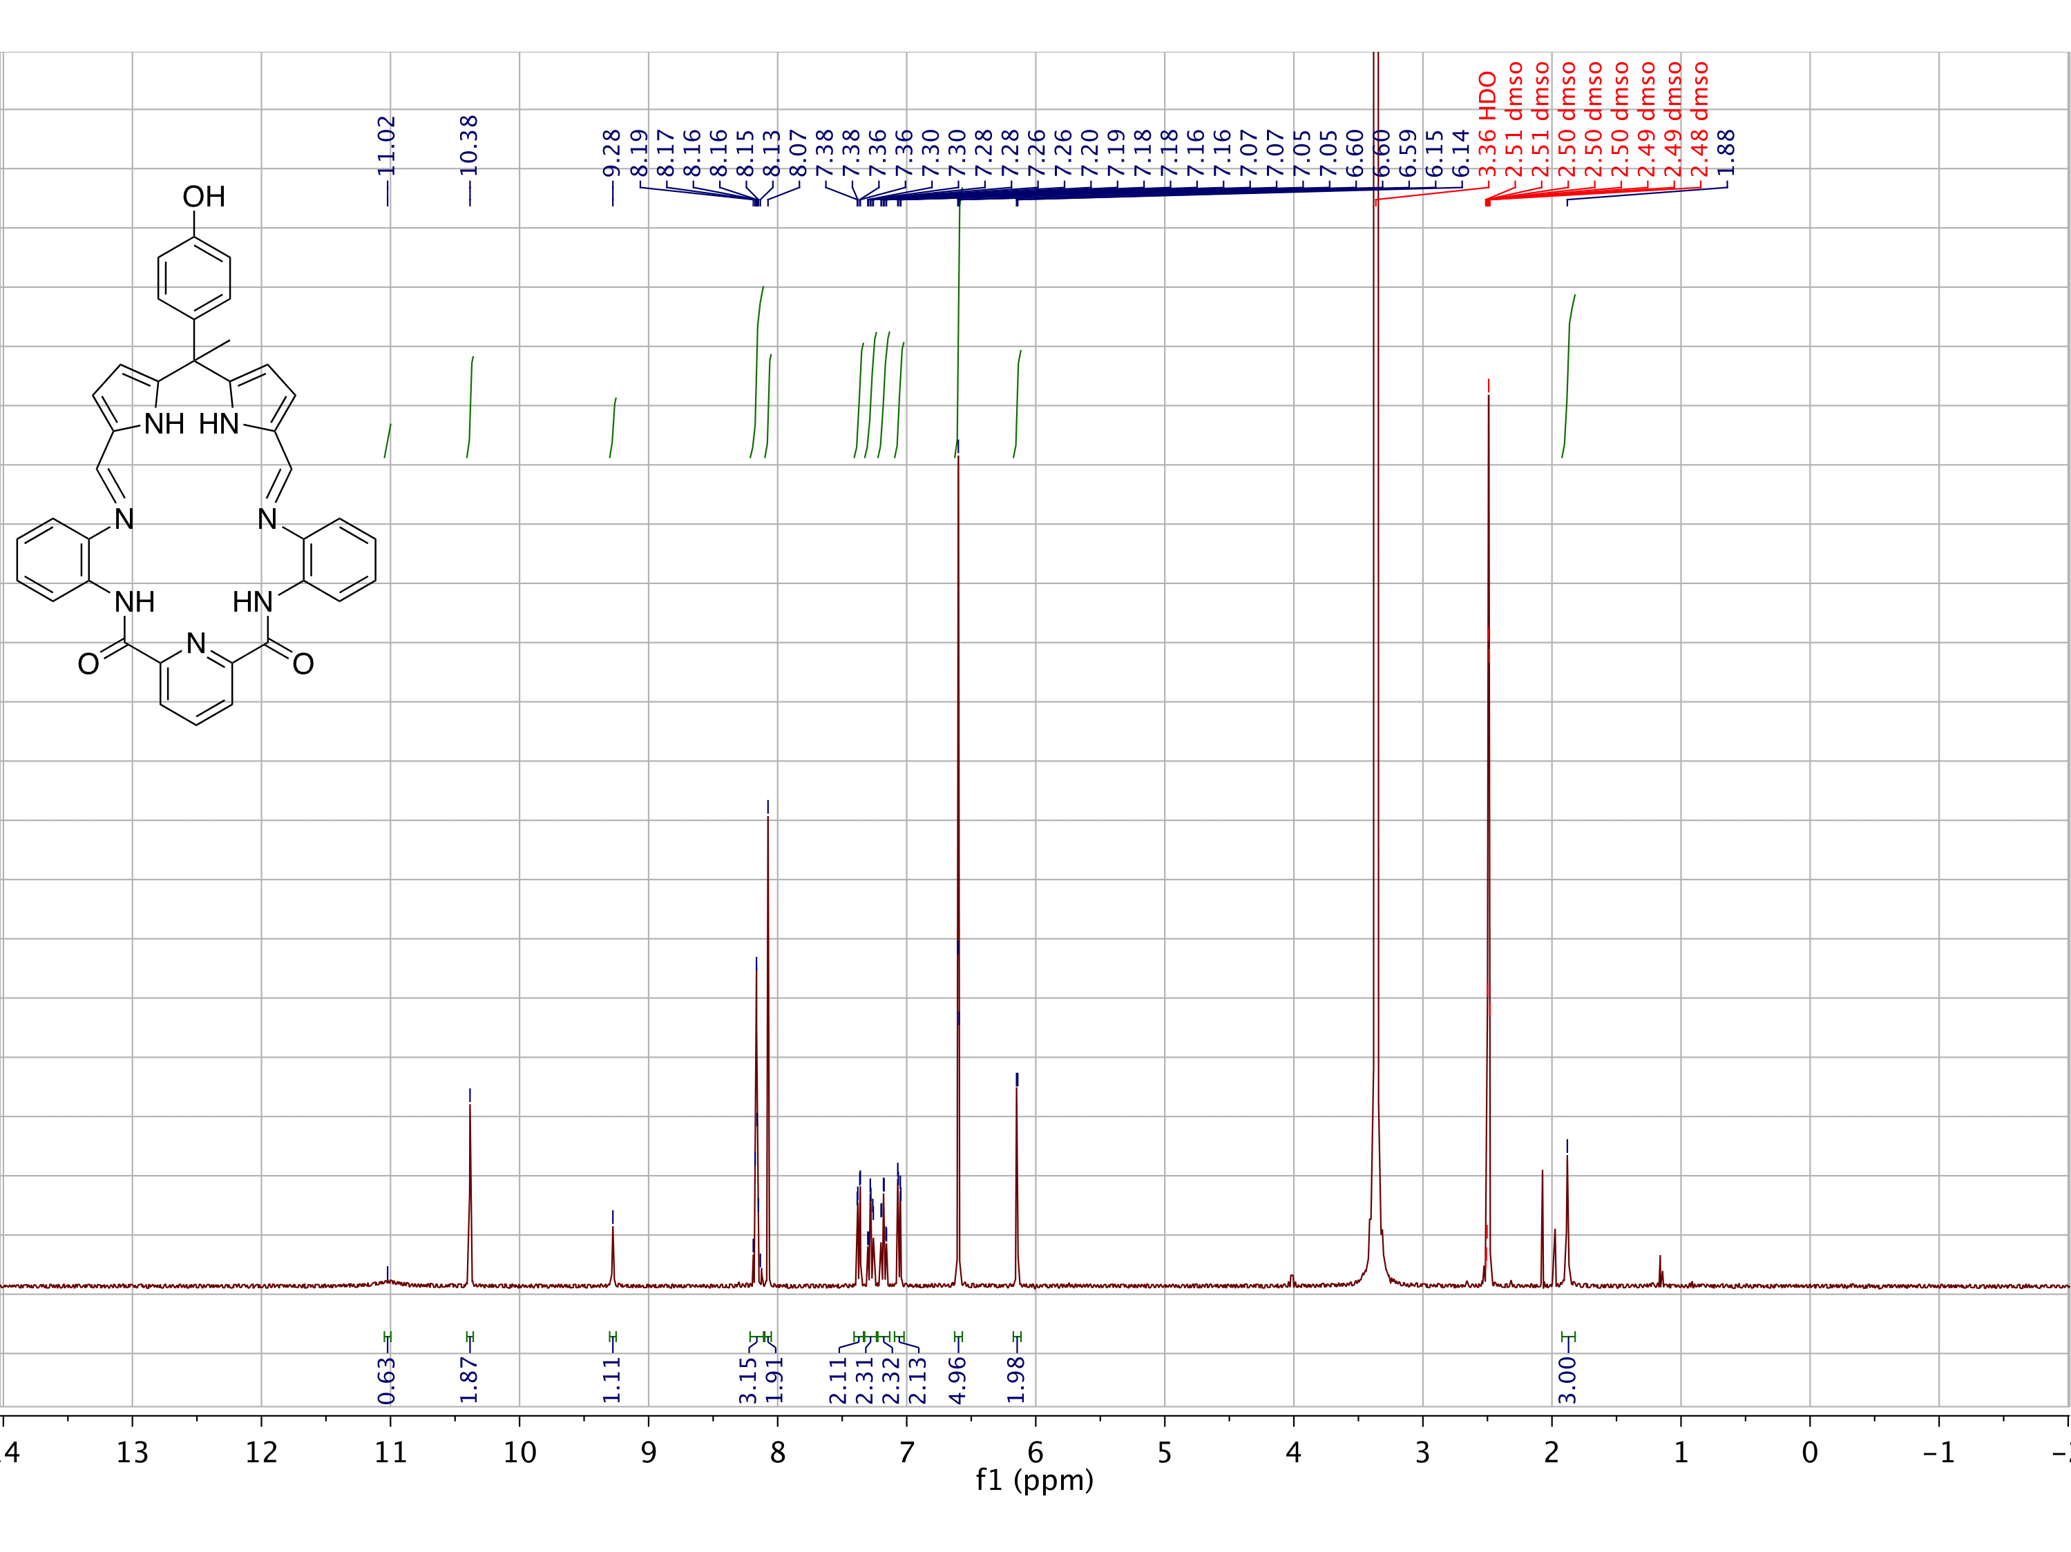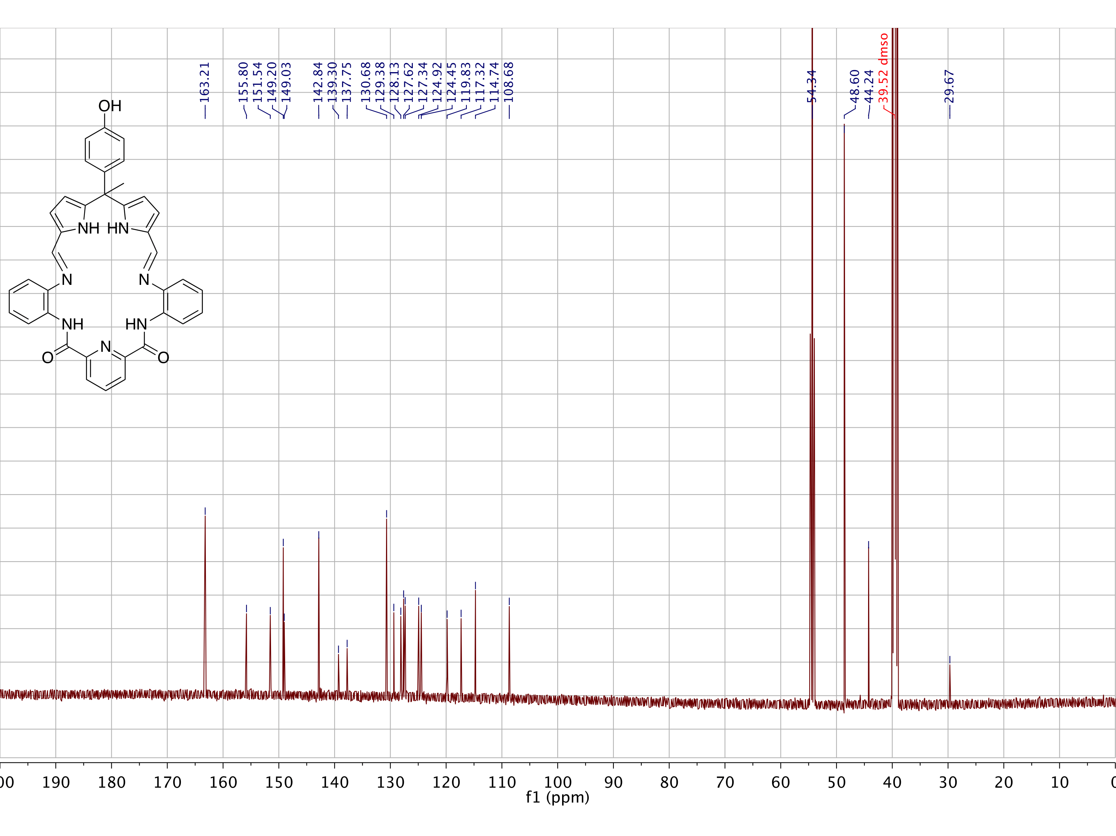

Figure S.14: Top: 1H NMR (400 MHz), Bottom: 13C NMR (150 MHz) spectra of **22** in DMSO-*d6*.

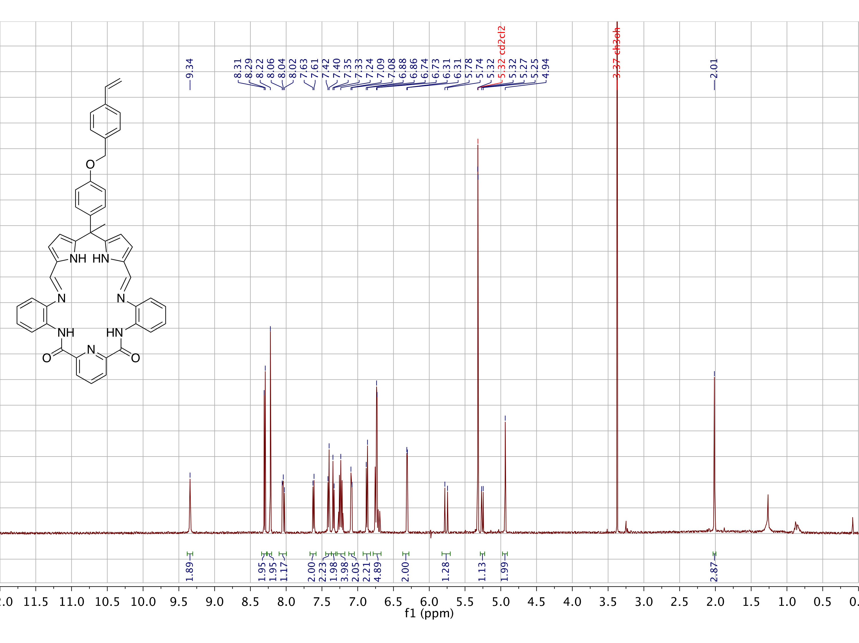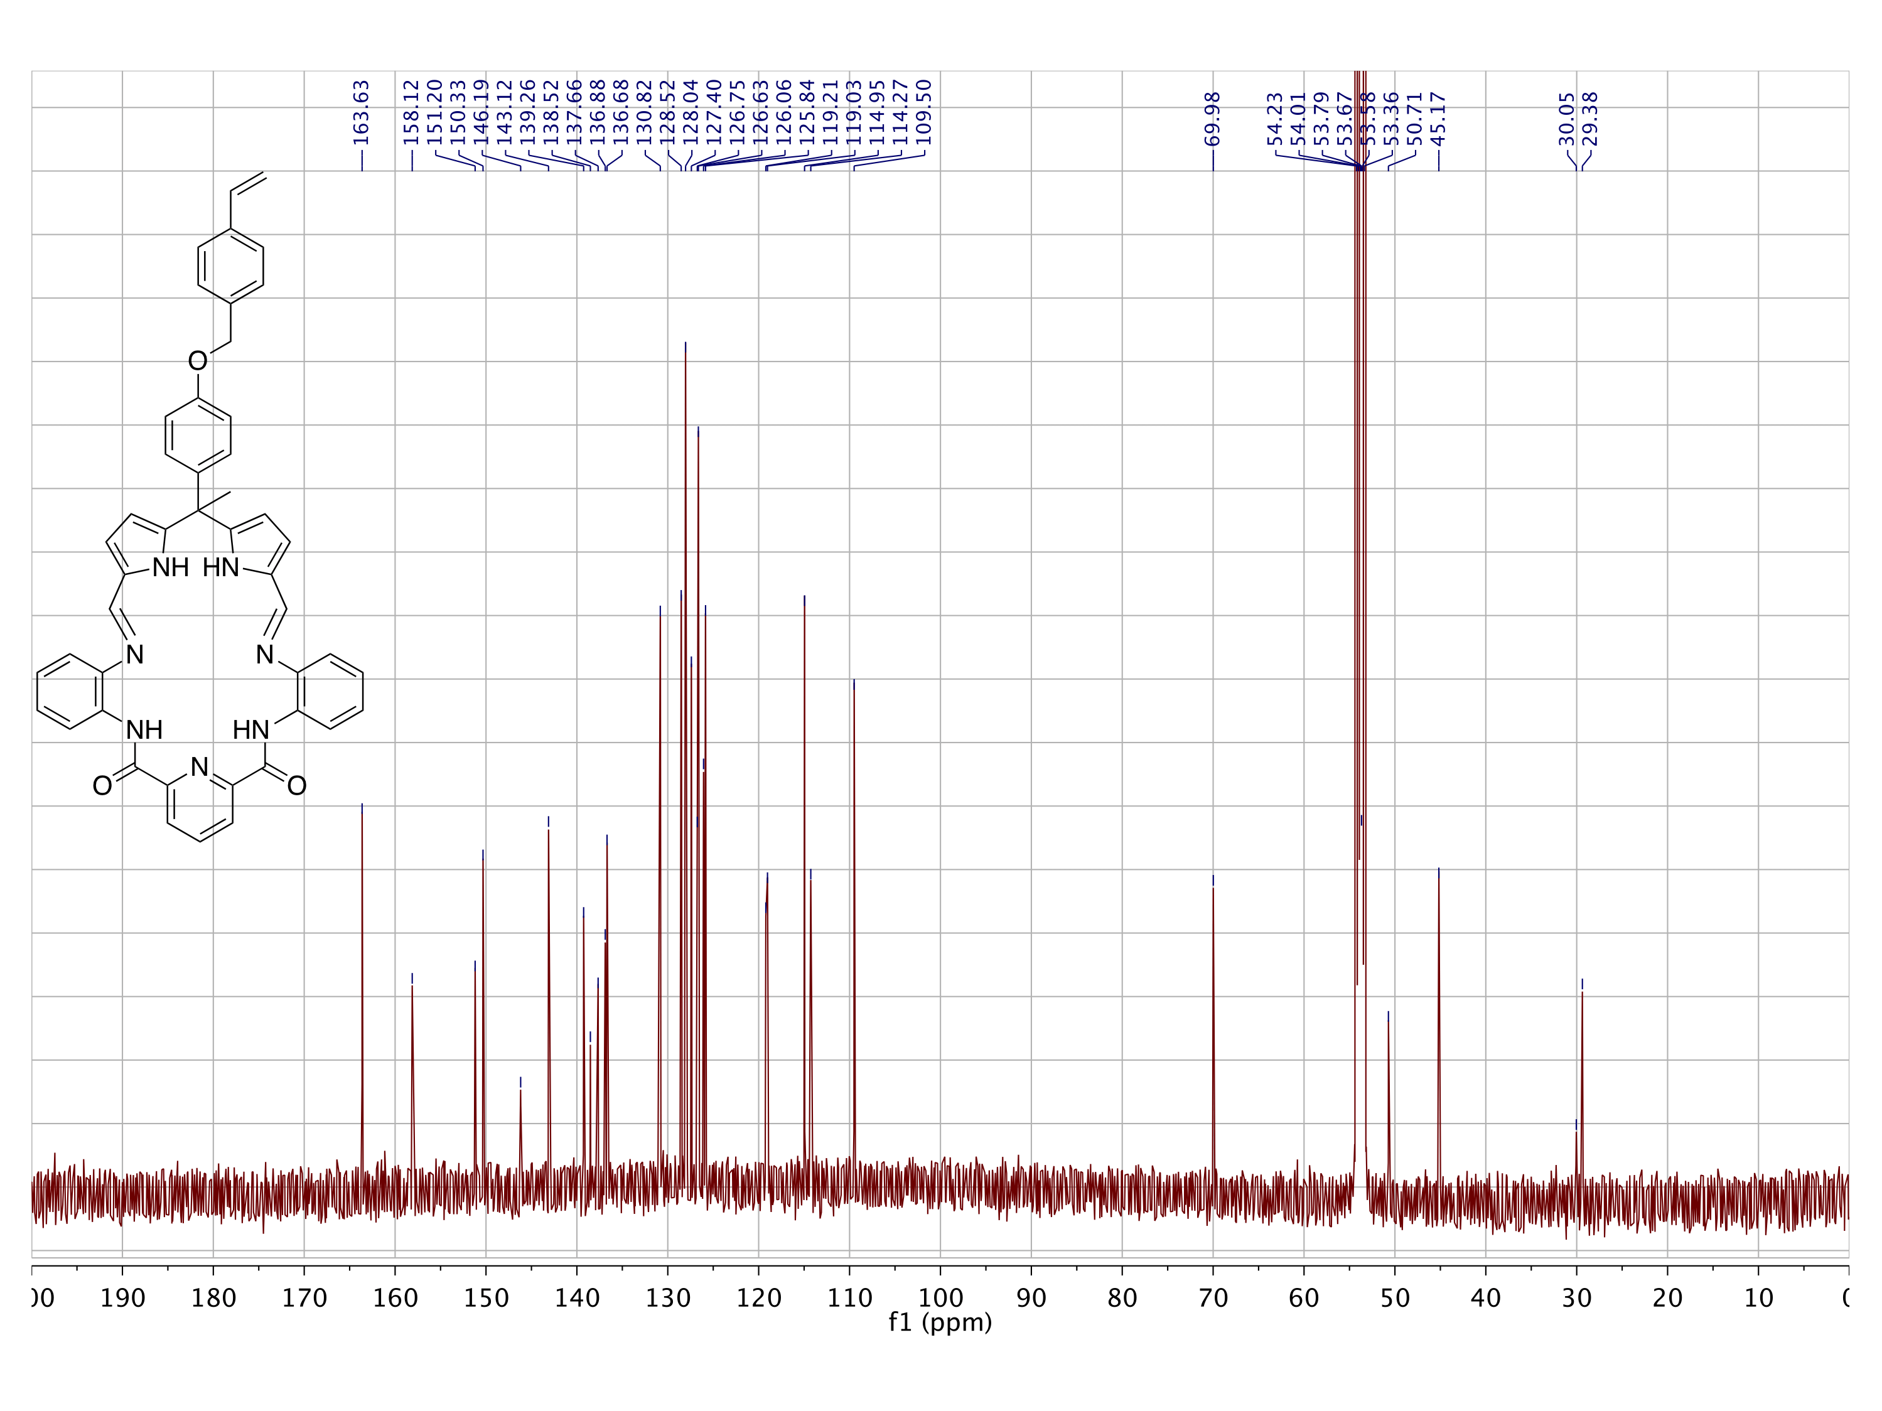

Figure S.15: Top: 1H NMR (500 MHz), Bottom: 13C NMR (126 MHz) spectra of **25** in CD2Cl2.

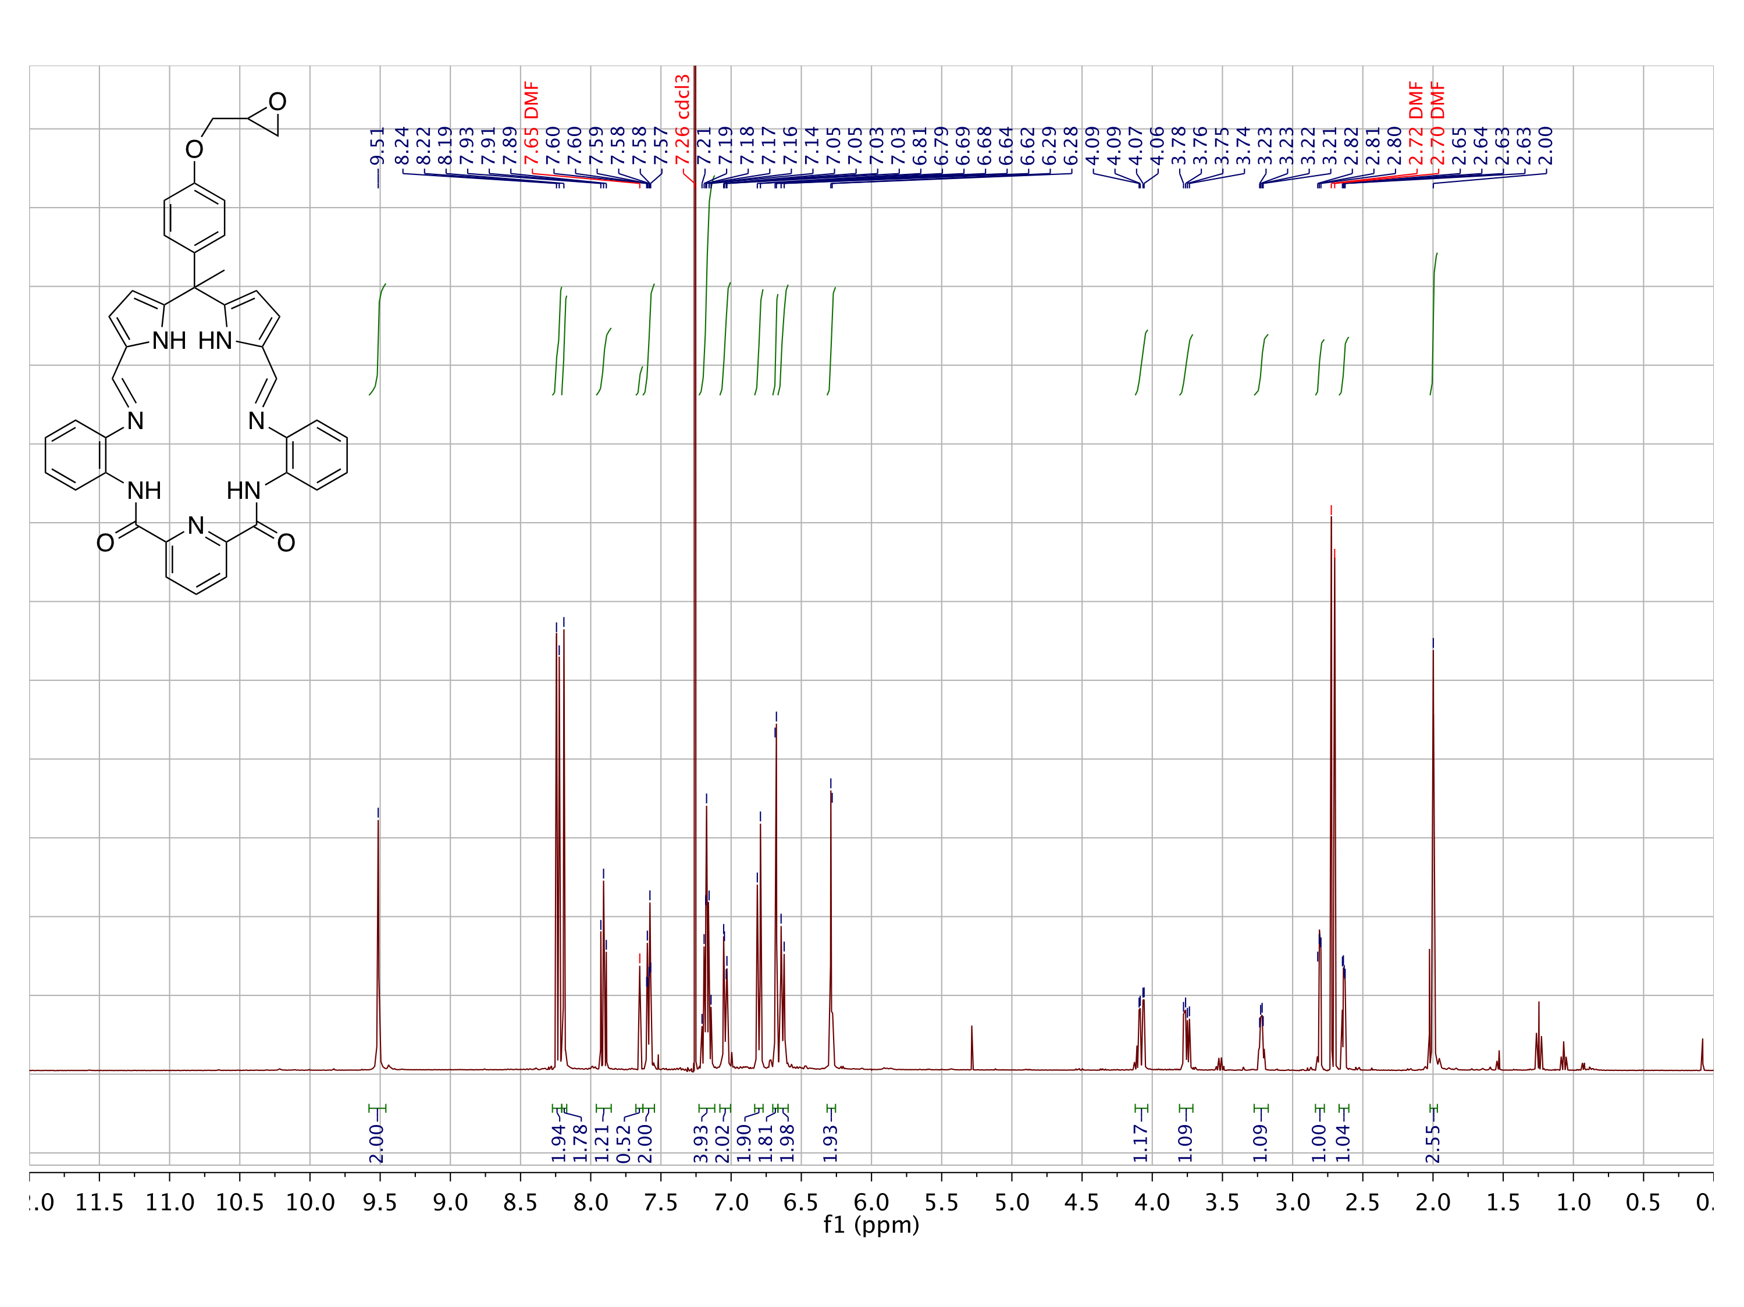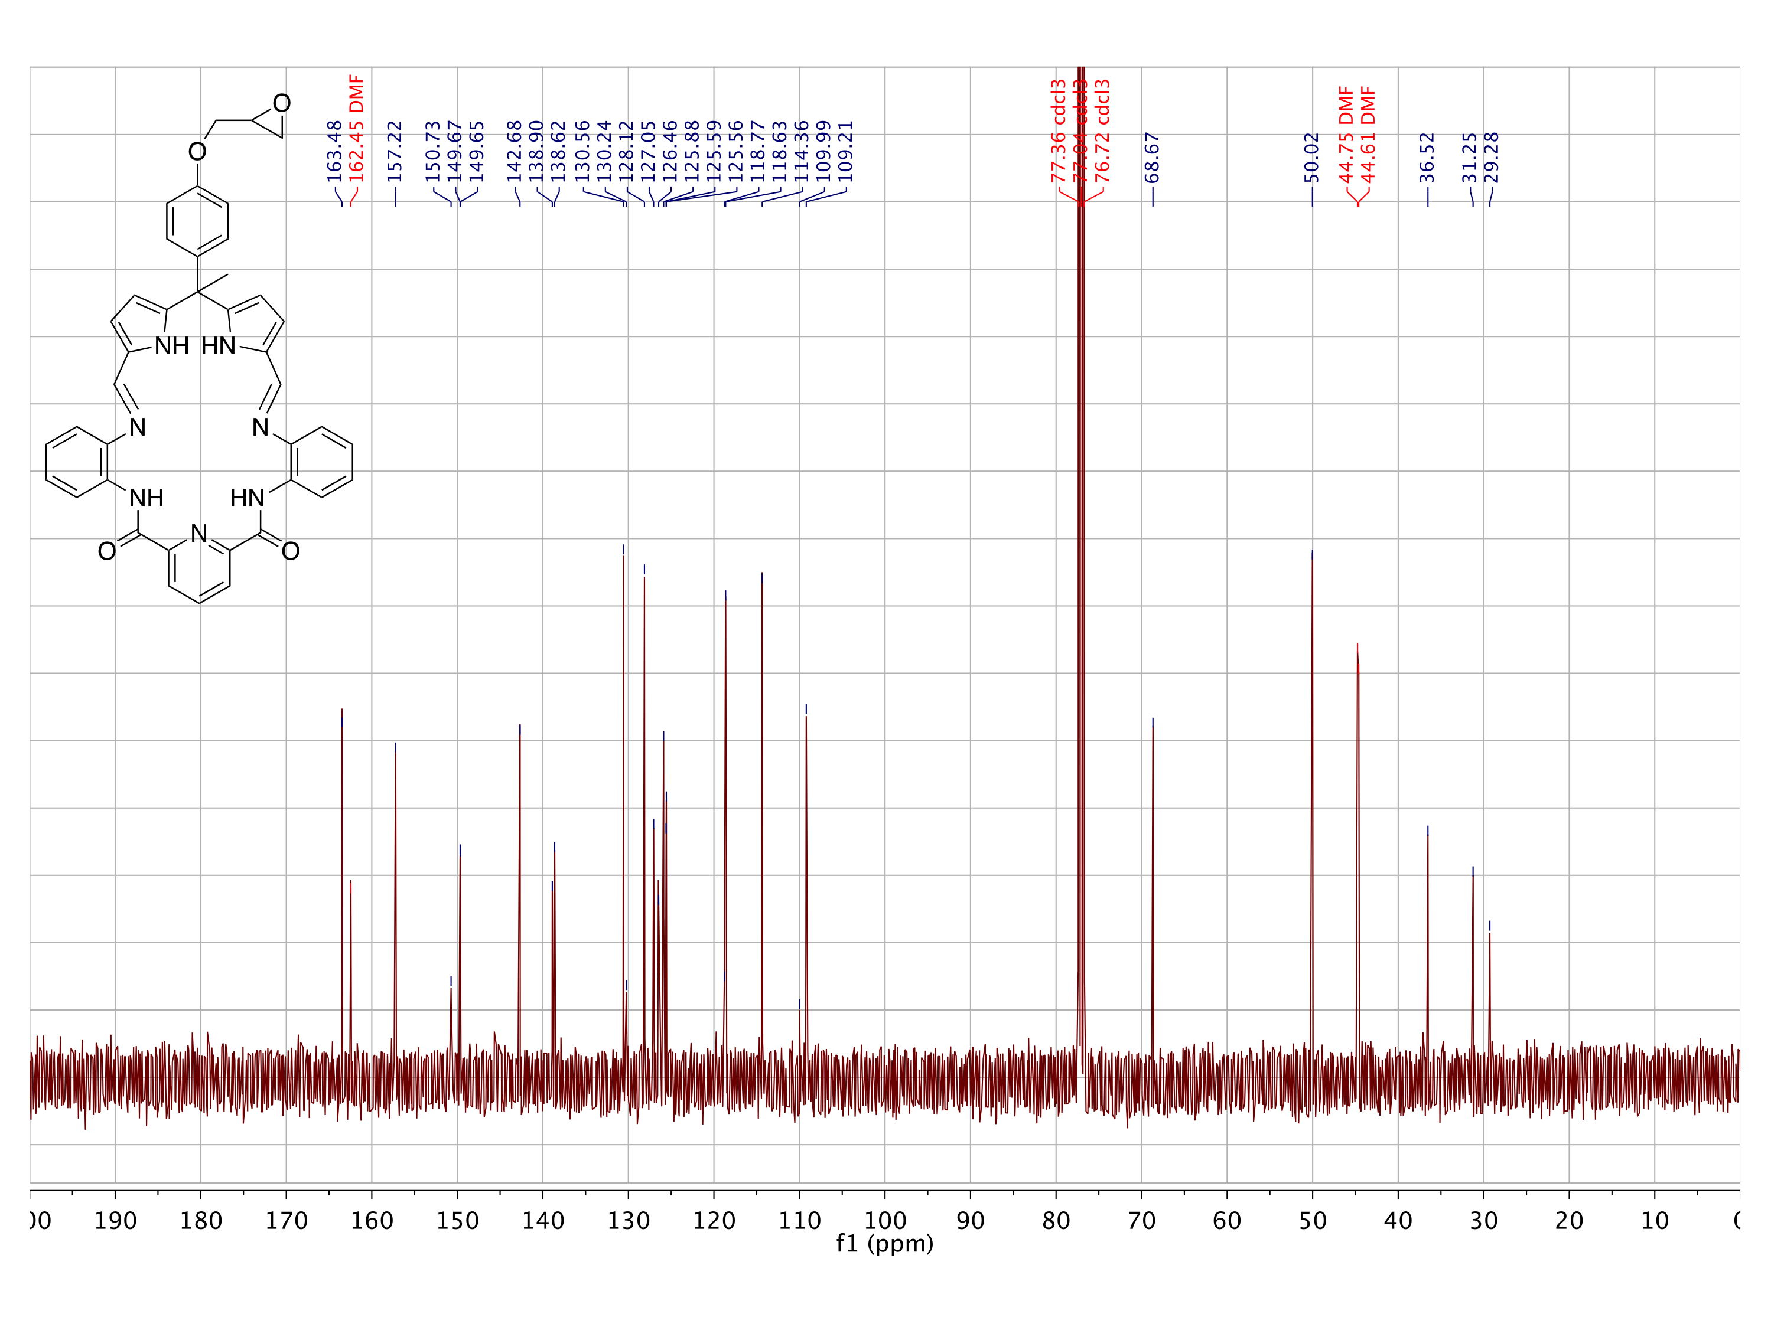

Figure S.16: Top: 1H NMR (400 MHz), Bottom: 13C NMR (100 MHz) spectra of **27** in CDCl3.

### Crystallographic Experimental Methods

The X-ray diffraction data collection and refinements for the crystal structures of **15**, **20**, **21**, and **22** may be obtained from the Cambridge Crystallographic Data Centre (CCDC) by reference to CCDC numbers 1562539-1562542. Some experimental details and relevant data tables for the refinements in question are given below.

view1.eps

X-ray experimental for **15** (C18H16N2O3): Crystals grew as clusters of large, colorless prisms by slow evaporation from methanol. The data crystal was cut from a larger crystal and had approximate dimensions; 0.48 x 0.32 x 0.11 mm. The data were collected at room temperature on a Rigaku SCX-Mini diffractometer with a Mercury 2 CCD using a graphite monochromator with MoK radiation ( = 0.71073 Å). A total of 311 frames of data were collected using -scans with a scan range of 1° and a counting time of 35 seconds per frame. Details of crystal data, data collection and structure refinement are listed in Table S.1. Data reduction were performed using the Rigaku Americas Corporation’s Crystal Clear version 1.40.7 The structure was solved by direct methods using SIR20048 and refined by full-matrix least-squares on F2 with anisotropic displacement parameters for the non-H atoms using SHELXL-2014/7.9 Structure analysis was aided by use of the programs PLATON9810 and WinGX.11 The hydrogen atoms on carbon were calculated in ideal positions with isotropic displacement parameters set to 1.2xUeq of the attached atom (1.5xUeq for methyl hydrogen atoms). The H atoms bond to the pyrrole nitrogen atoms and to the hydroxyl oxygen atom were located in a ∆F map and refined with isotropic displacement parameters.

The function, Σw(|Fo|2 - |Fc|2)2, was minimized, where w = 1/[((Fo))2 + (0.0558*P)2 + (0.2999*P)] and P = (|Fo|2 + 2|Fc|2)/3. Rw(F2) refined to 0**.**121, with R(F) equal to 0.0447 and a goodness of fit, S, = 1.02. Definitions used for calculating R(F), Rw(F2) and the goodness of fit, S, are given below.12 The data were checked for secondary extinction but no correction was necessary. Neutral atom scattering factors and values used to calculate the linear absorption coefficient are from the International Tables for X-ray Crystallography (1992).13 All figures were generated using SHELXTL/PC.14 Tables of positional and thermal parameters, bond lengths and angles, torsion angles and figures may be obtained from the CCDC by referencing CCDC number 1562539.

mol1.eps

X-ray experimental for **20** (C19H17N5O2): Crystals grew as yellow prisms by slow evaporation from CHCl3. The data crystal was cut from a larger crystal and had approximate dimensions; 0.30 x 0.20 x 0.10 mm. The data were collected on a Rigaku R-Axis Spider diffractometer with an image plate detector using a graphite monochromator with CuK radiation ( = 1.5418 Å). A total of 180 images of data were collected using -scans with a scan range of 5° and a counting time of 240 seconds per image. The data were collected at 100 K using a Rigaku XStream low temperature device. Details of crystal data, data collection and structure refinement are listed in Table S.2. Data reduction was performed using the Rigaku Americas Corporation’s Crystal Clear version 1.40.0 The structure was solved by direct methods using SIR9715 and refined by full-matrix least-squares on F2 with anisotropic displacement parameters for the non-H atoms using SHELXL-97.16 Structure analysis was aided by use of the programs PLATON9810 and WinGX.11 The hydrogen atoms on carbon were calculated in ideal positions with isotropic displacement parameters set to 1.2xUeq of the attached atom. The hydrogen atoms bound to nitrogen were observed in a ∆F map and refined with isotropic displacement parameters.

The function, Σw(|Fo|2 - |Fc|2)2, was minimized, where w = 1/[((Fo))2 + (0.054*P)2] and P = (|Fo|2 + 2|Fc|2)/3. Rw(F2) refined to 0**.**130, with R(F) equal to 0.0477 and a goodness of fit, S, = 1.29. Definitions used for calculating R(F), Rw(F2) and the goodness of fit, S, are given below.12 The data were checked for secondary extinction effects but no correction was necessary. Neutral atom scattering factors and values used to calculate the linear absorption coefficient are from the International Tables for X-ray Crystallography (1992).13 All figures were generated using SHELXTL/PC.14 Tables of positional and thermal parameters, bond lengths and angles, torsion angles and figures may be obtained from the CCDC by referencing CCDC number 1562540.

C:\x-ray\sessler\murat\murat3\murat3v1.hgl

X-ray Experimental for **21** (C38H31N7O3 – 2.5 CH3OH): Crystals grew as long, yellow laths by slow evaporation from methanol. The data crystal had approximate dimensions; 0.30 x 0.15 x 0.08 mm. The data were collected on a Nonius Kappa CCD diffractometer using a graphite monochromator with MoK radiation ( = 0.71073 Å). A total of 356 frames of data were collected using -scans with a scan range of 0.8° and a counting time of 174 seconds per frame. The data were collected at 153 K using an Oxford Cryostream low temperature device. Details of crystal data, data collection and structure refinement are listed in Table S.3. Data reduction were performed using DENZO-SMN.17 The structure was solved by direct methods using SIR9715 and refined by full-matrix least-squares on F2 with anisotropic displacement parameters for the non-H atoms using SHELXL-97.16 The hydrogen atoms were calculated in ideal positions with isotropic displacement parameters set to 1.2xUeq of the attached atom (1.5xUeq for methyl hydrogen atoms).

One molecule of methanol was disordered about a crystallographic inversion center at 0, 0, ½. It was assigned an occupancy of ½ because of the low electron density associated with this molecule. No H atoms for this molecule were included in the refinement model. One of the methanol molecules H-bound to the macrocycle appeared to have a disordered hydroxyl group H atom. This molecule composed of atoms O1b and C1b, was H-bound via the Schiff base amines, N3 and N5. The hydroxyl hydrogen appeared to be H-bound to the imine nitrogen atoms, N2 and N6, resulting in the disordered hydroxyl hydrogen bound to O1b.

The function, Σw(|Fo|2 - |Fc|2)2, was minimized, where w = 1/[((Fo))2 + (0.0399*P)2 + (1.2999*P)] and P = (|Fo|2 + 2|Fc|2)/3. Rw(F2) refined to 0**.**169, with R(F) equal to 0.0794 and a goodness of fit, S, = 1.07. Definitions used for calculating R(F),Rw(F2) and the goodness of fit, S, are given below.12 The data were checked for secondary extinction effects but no correction was needed. Neutral atom scattering factors and values used to calculate the linear absorption coefficient are from the International Tables for X-ray Crystallography (1992).13 All figures were generated using SHELXTL/PC.14 Tables of positional and thermal parameters, bond lengths and angles, torsion angles and figures may be obtained from the CCDC by referencing CCDC number 1562541.

murat613v1.eps

X-ray experimental for **22** (C37H36N7O3 – 4 C3H7NO): Crystals grew as yellow plates by slow evaporation from N,N-dimethylformamide. The data crystal was cut from a larger crystal and had approximate dimensions; 0.34 x 0.24 x 0.09 mm. The data were collected on a Rigaku SCX-Mini diffractometer with a Mercury 2 CCD using a graphite monochromator with MoK radiation ( = 0.71075 Å). A total of 1440 frames of data were collected using -scans with a scan range of 0.5° and a counting time of 21 seconds per frame. The data were collected at 100 K using a Rigaku XStream low temperature device. Details of crystal data, data collection and structure refinement are listed in Table S.4. Data reduction was performed using the Rigaku Americas Corporation’s Crystal Clear version 1.40.0 The structure was solved by direct methods using SIR9715 and refined by full-matrix least-squares on F2 with anisotropic displacement parameters for the non-H atoms using SHELXL-97.16 Structure analysis was aided by use of the programs PLATON9810 and WinGX.11 The hydrogen atoms on carbon were calculated in ideal positions with isotropic displacement parameters set to 1.2xUeq of the attached atom (1.5xUeq for methyl hydrogen atoms). The hydrogen atoms on nitrogen and oxygen were observed in a ∆F map and refined with isotropic displacement parameters.

The function, Σw(|Fo|2 - |Fc|2)2, was minimized, where w = 1/[((Fo))2 + (0.0484*P)2 + (4.0684*P)] and P = (|Fo|2 + 2|Fc|2)/3. Rw(F2) refined to 0**.**154, with R(F) equal to 0.0642 and a goodness of fit, S, = 1.06. Definitions used for calculating R(F), Rw(F2) and the goodness of fit, S, are given below.12 The data were checked for secondary extinction but no correction was necessary. Neutral atom scattering factors and values used to calculate the linear absorption coefficient are from the International Tables for X-ray Crystallography (1992).13 All figures were generated using SHELXTL/PC.14 Tables of positional and thermal parameters, bond lengths and angles, torsion angles and figures may be obtained from the CCDC by referencing CCDC number 1562542.

### Structure Refinement Parameters

Table S.1: Crystal data and structure refinement parameters for **15**.

CCDC number 1562539

Empirical formula C18 H16 N2 O3

Formula weight 308.33

Temperature 298(2) K

Wavelength 0.71073 Å

Crystal system monoclinic

Space group P 21/n

Unit cell dimensions a = 8.9152(10) Å  = 90°.

b = 16.056(2) Å  = 107.031(3)°.

c = 11.6016(15) Å  = 90°.

Volume 1587.9(3) Å3

Z 4

Density (calculated) 1.290 Mg/m3

Absorption coefficient 0.089 mm-1

F(000) 648

Crystal size 0.480 x 0.320 x 0.110 mm3

Theta range for data collection 3.132 to 27.480°.

Index ranges -11<=h<=11, -20<=k<=20, -15<=l<=10

Reflections collected 9559

Independent reflections 3600 [R(int) = 0.0263]

Completeness to theta = 25.242° 99.8 %

Absorption correction Semi-empirical from equivalents

Max. and min. transmission 1.00 and 0.717

Refinement method Full-matrix least-squares on F2

Data / restraints / parameters 3600 / 0 / 221

Goodness-of-fit on F2 1.024

Final R indices [I>2sigma(I)] R1 = 0.0447, wR2 = 0.1099

R indices (all data) R1 = 0.0595, wR2 = 0.1206

Extinction coefficient n/a

Largest diff. peak and hole 0.163 and -0.212 e.Å-3

Table S.2: Crystal data and structure refinement parameters for **20**.

CCDC number 1562540

Empirical formula C19 H17 N5 O2

Formula weight 347.38

Temperature 100(2) K

Wavelength 1.54180 Å

Crystal system Monoclinic

Space group P21/n

Unit cell dimensions a = 15.9252(14) Å  = 90°.

b = 13.253(2) Å  = 116.594(9)°.

c = 17.3380(15) Å  = 90°.

Volume 3272.1(6) Å3

Z 8

Density (calculated) 1.410 Mg/m3

Absorption coefficient 0.780 mm-1

F(000) 1456

Crystal size 0.30 x 0.20 x 0.10 mm

Theta range for data collection 6.62 to 66.58°.

Index ranges -18<=h<=16, -15<=k<=15, -19<=l<=20

Reflections collected 37427

Independent reflections 5740 [R(int) = 0.0431]

Completeness to theta = 66.58° 99.5 %

Absorption correction Semi-empirical from equivalents

Max. and min. transmission 0.930 and 0.786

Refinement method Full-matrix least-squares on F2

Data / restraints / parameters 5740 / 0 / 517

Goodness-of-fit on F2 1.290

Final R indices [I>2sigma(I)] R1 = 0.0477, wR2 = 0.1133

R indices (all data) R1 = 0.0677, wR2 = 0.1298

Largest diff. peak and hole 0.211 and -0.290 e.Å-3

Table S.3: Crystal data and structure refinement parameters for **21**.

CCDC number 1562541

Empirical formula C40.50 H41 N7 O5.50

Formula weight 713.80

Temperature 153(2) K

Wavelength 0.71070 Å

Crystal system Triclinic

Space group P-1

Unit cell dimensions a = 10.5529(4) Å  = 93.079(3)°.

b = 11.5600(5) Å  = 98.706(2)°.

c = 16.4194(9) Å  = 113.756(2)°.

Volume 1797.57(14) Å3

Z 2

Density (calculated) 1.319 Mg/m3

Absorption coefficient 0.090 mm-1

F(000) 754

Crystal size 0.30 x 0.15 x 0.08 mm

Theta range for data collection 1.94 to 25.00°.

Index ranges -12<=h<=11, -13<=k<=13, -18<=l<=19

Reflections collected 10189

Independent reflections 6195 [R(int) = 0.0633]

Completeness to theta = 25.00° 97.7 %

Absorption correction None

Refinement method Full-matrix least-squares on F2

Data / restraints / parameters 6195 / 16 / 516

Goodness-of-fit on F2 1.073

Final R indices [I>2sigma(I)] R1 = 0.0794, wR2 = 0.1351

R indices (all data) R1 = 0.1768, wR2 = 0.1686

Largest diff. peak and hole 0.378 and -0.266 e.Å-3

Table S.4: Crystal data and structure refinement parameters for **22**.

CCDC number 1562542

Empirical formula C49 H57 N11 O7

Formula weight 912.06

Temperature 100(2) K

Wavelength 0.71073 Å

Crystal system Monoclinic

Space group P21/c

Unit cell dimensions a = 21.787(3) Å  = 90°.

b = 10.6512(15) Å  = 114.832(3)°.

c = 22.247(3) Å  = 90°.

Volume 4685.3(12) Å3

Z 4

Density (calculated) 1.293 Mg/m3

Absorption coefficient 0.089 mm-1

F(000) 1936

Crystal size 0.34 x 0.24 x 0.09 mm3

Theta range for data collection 3.09 to 27.48°.

Index ranges -28<=h<=28, -13<=k<=13, -28<=l<=28

Reflections collected 62241

Independent reflections 10735 [R(int) = 0.0999]

Completeness to theta = 27.48° 99.8 %

Absorption correction Semi-empirical from equivalents

Max. and min. transmission 1.00 and 0.335

Refinement method Full-matrix least-squares on F2

Data / restraints / parameters 10735 / 0 / 633

Goodness-of-fit on F2 1.058

Final R indices [I>2sigma(I)] R1 = 0.0642, wR2 = 0.1345

R indices (all data) R1 = 0.1078, wR2 = 0.1541

Largest diff. peak and hole 0.529 and -0.299 e. Å-3

### Supplementary References

1. Lee, C.-H.; S. Lindsey, J. One-Flask Synthesis of Meso-Substituted Dipyrromethanes and Their Application in the Synthesis of Trans-Substituted Porphyrin Building Blocks. *Tetrahedron* **1994**, *50* (39), 11427–11440.
2. Sessler, J. L.; Katayev, E.; Pantos, G. D.; Ustynyuk, Y. A. Synthesis and Study of a New Diamidodipyrromethane Macrocycle. An Anion Receptor with a High Sulfate-to-Nitrate Binding Selectivity. *Chem. Commun.* **2004**, 11, 1276–1277.
3. Varghese, S.; Senanayake, T.; Murray-Stewart, T.; Doering, K.; Fraser, A.; Casero, R. A.; Woster, P. M. Polyaminohydroxamic Acids and Polyaminobenzamides as Isoform Selective Histone Deacetylase Inhibitors. *J. Med. Chem.* **2008**, *51* (8), 2447–2456.
4. Sessler, J. L.; Katayev, E.; Dan Pantos, G.; Scherbakov, P.; Reshetova, M. D.; Khrustalev, V. N.; Lynch, V. M.; Ustynyuk, Y. A. Fine Tuning the Anion Binding Properties of 2,6-Diamidopyridine Dipyrromethane Hybrid Macrocycles. *J. Am. Chem. Soc.* **2005**, *127* (32), 11442–11446.
5. Gottlieb, H. E.; Kotlyar, V.; Nudelman, A. NMR Chemical Shifts of Common Laboratory Solvents as Trace Impurities. *J. Org. Chem.* **1997**, *62* (3), 7512–7515.
6. Wang, Z.; Luecke, H.; Yao, N.; Quiocho, F. A. A Low Energy Short Hydrogen Bond in Very High Resolution Structures of Protein Receptor--Phosphate Complexes. *Nat. Struct. Biol.* **1997**, *4* (7), 519–522.
7. Rigaku Americas Corporation, CrystalClear 1.40, The Woodlands, TX, 2008.
8. Altomare A.; Burla M.C.; Camalli M.; Cascarano G.L.; Giacovazzo C.; Guagliardi A.; Moliterni A.G.G.; Polidori G.; Spagna R. SIR2004, A program for crystal structure solution, *J. Appl. Crystallogr.* **2005**, (38), 381–388.
9. Sheldrick, G. M. SHELXL-2014/7. Program for the Refinement of Crystal Structures. *Acta Cryst*. **2015**, C71, 9-18.
10. Spek, A. L.,*PLATON, A Multipurpose Crystallographic Tool*, Utrecht University, The Netherlands, 1998.
11. Farrugia, L. J. WinGX 1.64. An Integrated System of Windows Programs for the Solution, Refinement and Analysis of Single Crystal X-ray Diffraction Data. *J. Appl. Cryst*. **1999**, (32). 837-838.
12. Rw(F2) = {w(|Fo|2 - |Fc|2)2/w(|Fo|)4}1/2 where w is the weight given each reflection.

R(F) = (|Fo| - |Fc|)/|Fo|} for reflections with Fo > 4((Fo)).

S = [w(|Fo|2 - |Fc|2)2/(n - p)]1/2, where n is the number of reflections and p is the number of refined parameters.

1. Wilson, A. J. C. (editor), *International Tables for X-ray Crystallography. Vol. C, Tables 4.2.6.8 and 6.1.1.4*, Boston: Kluwer Academic Press, 1992.
2. Sheldrick, G. M. *SHELXTL/PC (Version 5.03)*, Siemens Analytical X-ray Instruments, Inc., Madison, Wisconsin, USA, 1994.
3. Altomare, A.; Burla, M. C.; Camalli, M.; Cascarano, G. L.; Giacovazzo, C.; Guagliardi, A.; Moliterni, A. G.; Polidori, G.; Spagna, R. SIR97: A New Tool for Crystal Structure Determination and Refinement. *J. Appl. Crystallogr.* **1999**, (32), 115–119.
4. Sheldrick, G. SHELX-97: Programs for Crystal Structure Analysis. *Göttingen, Ger.* 1997.
5. a) Otwinowski, Z.; Minor, W. DENZO-SMN. Methods in Enzymology, *Macromolecular Crystallography, part A*, (276**)**,307–326. b) Carter, Jr. C. W.; Sweets, R. M. Editors, Academic Press, 1997.

1. 86 g of pyrrole was recovered.
2. TLC plates were stained by I2 to aid in visualization.