Description of the supplementary figures
Figure S1 and S2 are the supplementary figure of the manuscript. The detail of the figure S1 and 2 has been mentioned under the heading “Coulomb stress changes and its associated parameters” in the manuscript.
Figure R1, R3 and Table R3a and R3b are the figure related to reply of the Reviewer R1 and Reviewer R3. The detail description about figure R1 is mentioned in S. No 14 of “ Reply of reviewer 1” and Figure R3 and Table R3a &R3b is mentioned S.No 5 of “Reply of Reviewer 3”.

Figure S1: The focal depth below each source zone is plotted using GCMT catalogue covering the time 1975-2010.

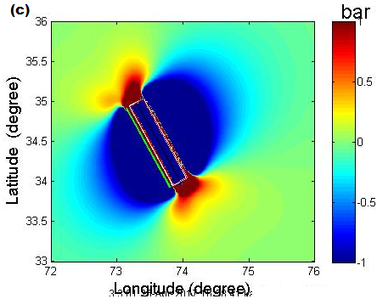
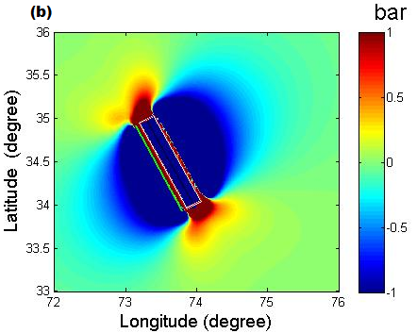
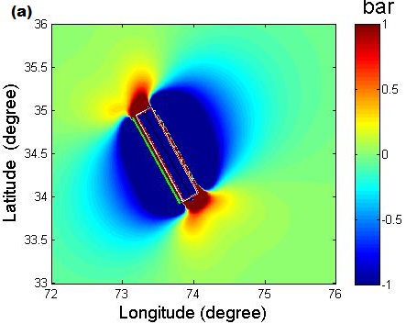

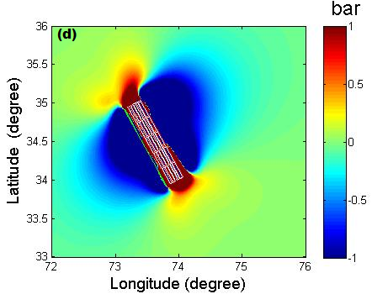
Figure S2: Coulomb stress change (ΔCFF) on receiver fault at 10 km depth from the 8 October, 2005 M =7.6 Kashmir earthquake (a) ΔCFF at 10% slip variation (b) 20% slip variation and (c) 30% slip variation, (d) Coulomb stress computed on variable slip model of Parsons et al., 2006. The outer edges of the source dislocationis shown by the dashed red rectangle. The overall stress pattern is consistent.

Figure R1. Expected number of M_{W} ≥ 5 earthquakes calculated by using spatially variable ΔCFF and b-value.

Figure R3. (a-h): Correlation of different magnitude scales in northwest Himalaya and its adjoining regions.

Table R3a: The values of regression relationships developed by Yadav et al. (2011) for NW Himalaya and the adjoining regions
Correlation X–Y | Regression | Intercept | Slope | N | Magnitude range
m_{b}–M_{W} Total | OR | -1.319 (±0.228) | 1.279 (±0.042) | 463 | m_{b} = 4.7–6.4
 | SR | 0.155 (±0.093) | 1.001 (±0.017)
 | ISR | -2.475 (±0.000) | 1.497 (±0.000)
Shallow (≤70 km) | OR | -1.655 (±0.283) | 1.343 (±0.052) | 309 | m_{b} = 4.7–6.4
 | SR | -0.125 (±0.116) | 1.052 (±0.022)
 | ISR | -2.745 (±0.000) | 1.550 (±0.000)
Intermediate (>70 km) | OR | -0.461 (±0.376) | 1.118 (±0.067) | 154 | m_{b} = 4.7–6.4
 | SR | 0.858 (±0.153) | 0.873 (±0.028)
 | ISR | -1.819 (±0.000) | 1.370 (±0.000)
M_{S}–M_{W} Total | OR | 2.151 (±0.128) | 0.656 (±0.024) | 423 | M_{S} = 3.8–6.1
 | SR | 2.575 (±0.054) | 0.570 (±0.011)
 | ISR | 1.026 (±0.000) | 0.883 (±0.000)
 | OR | -0.127 (±0.240) | 1.011 (±0.036) | 63 | M_{S}= 6.2–8.2
 | SR | 0.225 (±0.147) | 0.959 (±0.022)
 | ISR | -0.494 (±0.216) | 1.065 (±0.032)
Shallow (≤70 km) | OR | 2.253 (±0.086) | 0.616 (±0.016) | 296 | M_{S} = 3.8–6.1
 | SR | 2.417 (±0.041) | 0.583 (±0.008)
 | ISR | 1.812 (±0.000) | 0.704 (±0.000)
 | OR | -0.249 (±0.155) | 1.024 (±0.023) | 43 | M_{S} = 6.2–8.2
 | SR | -0.017 (±0.147) | 0.989 (±0.022)
 | ISR | -0.485 (±0.304) | 1.059 (±0.045)
Intermediate (>70 km) | OR | 2.408 (±0.154) | 0.664 (±0.027) | 123 | M_{S} = 3.3–8.2
 | SR | 2.613 (±0.069) | 0.622 (±0.014)
 | ISR | 1.946 (±0.000) | 0.759 (±0.000)
m_{b}–M_{S} Total | OR | -2.546 (±0.079) | 1.489 (±0.020) | 4,051 | m_{b} = 3.0–6.9
 | SR | -0.567 (±0.032) | 1.038 (±0.007)
 | ISR | -3.826 (±0.023) | 1.780 (±0.005)
Shallow (≤70 km) | OR | -2.615 (±0.089) | 1.515 (±0.022) | 3,228 | m_{b} = 3.0–6.9
 | SR | -0.675 (±0.036) | 1.074 (±0.008)
 | ISR | -3.807 (±0.027) | 1.785 (±0.006)
Intermediate (>70 km) | OR | -1.967 (±0.153) | 1.314 (±0.040) | 823 | m_{b} = 3.0–6.7
 | SR | -0.257 (±0.066) | 0.921 (±0.015)
 | ISR | -3.381 (±0.047) | 1.640 (±0.011)
M_{L}–M_{W} (total data) | OR | 0.356 (±0.714) | 0.934 (±0.135) | 144 | M_{L} = 3.4–7.6
 | SR | 2.734 (±0.197) | 0.482 (±0.037)
 | ISR | -4.919 (±0.147) | 1.936 (±0.027)
M_{L}–m_{b} (total data) | OR | 2.305 (±0.348) | 0.537 (±0.068) | 139 | M_{L} = 3.4–7.6
 | SR | 3.090 (±0.138) | 0.387 (±0.026)
 | ISR | -1.410 (±0.107) | 1.248 (±0.020)
M_{L}-M_{S}(total data) | OR | -3.370 (±1.043) | 1.560 (±0.214) | 141 | M_{L} = 3.7–7.6
 | SR | 1.351 (±0.259) | 0.666 (±0.049)
 | ISR | -7.945 (±0.141) | 2.426 (±0.027)

# N Number of data points, OR Orthogonal regression, SR Standard regression, ISR Inverted standard regression

Table R3b: The values of regression relationships developed for NW Himalaya and the adjoining regions

Correlation X–Y | Regression | Intercept | Slope | N | Magnitude range
m_{b}–M_{W} Total | OR | 1.072 (±0.098) | 1.235 (±0.018) | 206 | m_{b} = 4.5–7.1
 | SR | 0.100 | 1.018
 | ISR | 2.004 | 1.407
M_{S}–M_{W} Total | OR | 2.200(±0.603) | 0.650(±0.121) | 140 | M_{S} = 3.7–6.1
 | SR | 2.647 | 0.560
 | ISR | -0.974 | 0.897
 | OR | -0.915(±0.241) | 1.119(±0.034) | 26 | M_{S}= 6.2–7.8
 | SR | -0.050 | 0.994
 | ISR | 1.692 | 1.231
m_{b}–M_{S} Total | OR | -2.173(±0.032) | 1.392(±0.007) | 5,521 | m_{b} = 3.0–6.6
 | SR | -0.825 | 1.082
 | ISR | 3.068 | 1.598
Shallow (≤70 km) | OR | -2.627(±0.002) | 1.482 (±0.001) | 4,299 | m_{b} = 3.0–6.5
 | SR | 1.398 | 1.204
 | ISR | 3.316 | 1.638
Intermediate (>70 km) | OR | -1.801(±0.073) | 1.269(±0.016) | 1,222 | m_{b} = 3.0–6.6
 | SR | -1.123 | 1.113
 | ISR | 2.281 | 1.380
M_{L}–M_{W} (total data) | OR | 0.121(±0.581) | 1.002(±0.116) | 44 | M_{L} = 2.6–7.0
 | SR | 1.115 | 0.801
 | ISR | 1.115 | 1.253
M_{L}–m_{b} (total data) | OR | 1.294(±0.061) | 0.714(±0.016) | 7,463 | M_{L} = 2.2–6.8
 | SR | 1.873 | 0.559
 | ISR | 0.152 | 1.102
M_{L}-M_{S}(total data) | OR | -0.952(±0.054) | 1.152(±0.013) | 2,609 | M_{L} = 2.9–6.2
 | SR | 0.193 | 0.863
 | ISR | 2.103 | 1.442
# N Number of data points, OR Orthogonal regression, SR Standard regression, ISR Inverted standard regression

