Supporting Information

pH-Sensitive Metal-Phenolic Network Capsules for Targeted Photodynamic Therapy against Cancer Cells
Yuanqing Wei,† Zhenzhen Wei,† Luo Peicheng,*,‡ Wei Wei,† Songqin Liu*,†
†Key Laboratory of Environmental Medicine Engineering, Ministry of Education, Jiangsu Engineering Laboratory of Smart Carbon-Rich Materials and Device, School of Chemistry and Chemical Engineering, Southeast University, Nanjing, 211189, People’s Republic of China

*Corresponding author at: School of Chemistry and Chemical Engineering, Southeast University, Nanjing, 211189, P. R. China. Tel.: 86-25-52090613; Fax: 86-25-52090198.
E-mail addresses: luopeicheng@seu.edu.cn; liusq@seu.edu.cn (S.Q. Liu)

Materials and methods

Materials
8-Arm-poly(ethylene glycol) succinimidyl succinate (8-arm-PEG-NHS, hexaglycerol core, MW 10 kDa) was purchased from JenKem Technology (Beijing, China). (Folic acid)-poly(ethylene glycol)-carboxy succinimidyl ester (FA-PEG-NHS, MW 10 kDa) was obtained from Ponsure Biotechnology (Shanghai, China). Hematoporphyrin monomethyl ether (HMME) was purchased from Yuanye Bio. (Shanghai, China). Dopamine hydrochloride, tris-(hydroxymethyl)aminomethane (Tris), fluorescein isothiocyanate (FITC), 1,3-diphenylisobenzofuran (DPBF), N-hydroxysuccinimide (NHS), 1-(3-dimethylaminopropyl)-3-ethylcarbodiimide hydrochloride (EDC), ethylenediaminetetra-acetic acid (EDTA), dextran (2000 kDa) and triethylamine (TEA) were purchased from Sigma-Aldrich (Shanghai, China). Fetal bovine serum (FBS) , phosphate-buffered saline (PBS), Dulbecco’s modified Eagle’s medium (DMEM), 2′,7′-dichlorfluorescein-diacetate (DCFH-DA), LysoBlue, MTT cell proliferation and cytotoxicity assay kit, Annexin V-FITC/propidium iodide (PI) cell apoptosis kit were purchased from KeyGen Biotech. Co. Ltd. (Nanjing, China). Dialysis Membranes (1000 MWCO and 3500 MWCO) were obtained from Sangon Biotech. (Shanghai, China). All of the chemicals were used as received without further purification. Ultrapure water (18.2 MΩ cm) was got through Thermo purification system. Room temperature denotes 25 °C in all experiments, unless otherwise stated.

Apparatus
The morphology of the nanostructured materials was observed with a reversed biological microscope (ICX40, Sunny optical technology Co., Ltd., China) and a scanning electron microscope (SEM, ProX, Phenom, Netherlands). Capsule suspensions were dropped and air-dried on aqua regia-cleaned silicon wafers for SEM experiments. Zeta potential and the particle size measured by dynamic light scattering (DLS) were both performed at 25 °C on a Malvern Zeta Sizer-Nano Z instrument (Britain). The concentration of capsule was determined by a hemocytometer (Qiujing, Shanghai, China). Confocal laser microscopy images and differential interference contrast (DIC) images were carried out by a confocal laser scanning microscopy (CLSM, FluoViewTM FV1000, Olympus, Japan). MTT assay was measured with microplate reader (Multiskan GO, Thermo Fisher Scientific, China). Cell apoptosis assay and ROS assay were carried on flow cytometry (BD Accuri C6, BD Biosciences, China). The PEG quantity of capsules and the cargo loading capacity were measured by fluorescence spectrophotometry on a FluoroMax-4 spectrofluorometer with Xenon discharge lamp excitation (HORIBA, USA). The fluorescence quantum yields were measured by integrating sphere using HMME (Φ_{F} = 0.026) as the standard (Yu et al. 2008). The fluorescence lifetime was detected on the FluoroMax-4 spectrofluorometer. Singlet oxygen quantum yields (Φ∆) were detected according to a reported procedure through monitoring the oxidation of DPBF using HMME (Φ∆ = 0.6) as the standard (Li et al. 2008, Lei et al. 2012).

Cell Culture
Human cervical carcinoma HeLa cell lines, immortalized human epidermal HaCaT cell lines and adenocarcinomic human alveolar basal epithelial A549 cell lines were obtained from KeyGEN Biotech (Nanjing, China). All cell lines were cultured in Dulbecco's modified Eagle's medium (DMEM) containing 10% fetal bovine serum (FBS), 100 µg mL^{–1} streptomycin and 100 U mL^{–1} penicillin at 37 °C in a humidified incubator containing 5% CO₂ and 95% air. The medium was replenished every other day and the cells were subcultured after reaching confluence.

Statistical Analysis
Data were expressed as means ± SD from at least three experiments. Statistical analyses were carried out using an Origin 85 software. CLSM images were analyzed by Olympus FluoView Ver.3.1a software. Flow cytometer data were analyzed with a FlowJo software.

Scheme S1. Synthesis of PEG-Polyphenol, FA-PEG-phenol and Dextran-HMME. (a) 8-arm-PEG-NHS (100 mg, 10 kDa) and dopamine hydrochloride (76 mg, 4 × 10⁻⁴ mol) were dissolved in 1.5 mL of anhydrous DMF, followed by adding anhydrous TEA (66.5 μL, 4.8 × 10⁻⁴ mol). The mixture was stirred at room temperature under N₂ protection for 12 h. The reaction mixture was purified by dialysis (3500 MWCO) for 3 days against 3 L of ultrapure water (adjusted to pH 3.5), followed by lyophilization to obtain PEG-polyphenol as a white powder; (b) FA-PEG-NHS (20 mg, 0.01 mmol) and dopamine hydrochloride (76 mg, 0.4 mmol) were separately dissolved in 1 mL of anhydrous DMSO and 3 mL of anhydrous DMF. The two solutions were then mixed and degassed by N₂. After stirring at room temperature under N₂ protection for 2 h, the reaction mixture was purified by dialysis (1000 MWCO) for 3 days against 3 L of predegassed ultrapure water, followed by lyophilization to obtain FA-PEG-phenol as a light yellow powder; (c) EDC (3.9 mg, 0.02 mmol) and NHS (2.3 mg, 0.02 mmol) were dissolved in 1 mL of anhydrous DMF, and then mixed with 1 mL of HMME solution (4 mg mL⁻¹, 3.26 mM in DMF). After stirring for 30 min, 2 mL of dextran aqueous solution (2000 kDa, 5 mg mL⁻¹) was added into the reacted bottle and stirred at room temperature for another 3 h to obtain HMME-dextran conjugates.

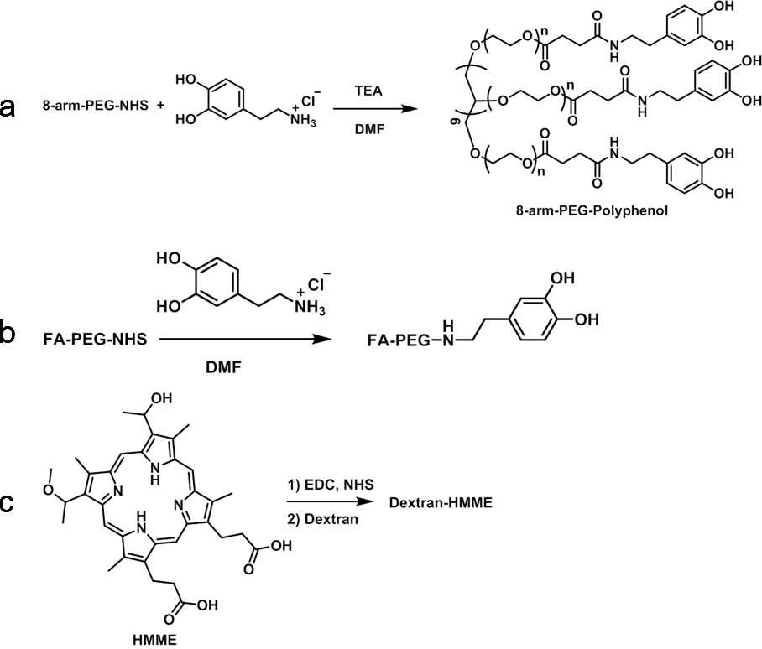

Figure S1. HMME-doped CaCO₃ templates characterized by SEM (a), DIC (b) and fluorescence imaging (c). Scale bars are 1 μm.

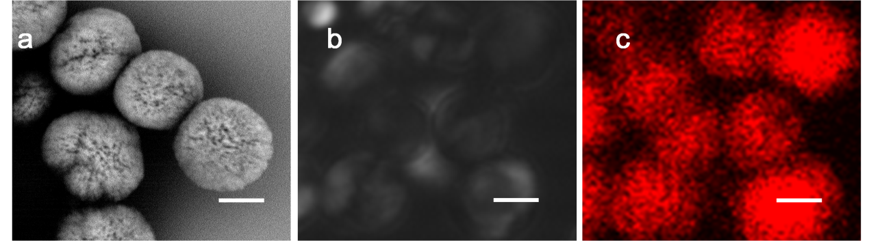

Figure S2. Diameter distribution of HMME-doped CaCO₃ templates.

Figure S3. Standard working curve of HMME in water. (λ_{ex} = 392 nm, λ_{em} = 620 nm)

Figure S4. Drug loading capacity of PEG-MPN capsules synthesized from different initial concentration of HMME.

Figure S5. Dynamic light scattering of the capsules at different pHs.

Figure S6. Zeta potential of CaCO₃ template and PEG-MPN capsules with or without HMME.

Figure S7. Standard working curve of FITC-labeled PEG-polyphenol in water. (λ_{ex} = 438 nm, λ_{em} = 515 nm)

Table S1. The fluorescence quantum yields (Φ_{F}), fluorescence lifetime and singlet oxygen quantum yields (Φ△) at different pHs.

 | Φ_{F} | Φ△ | Lifetime(ns)
cap-7.4 | 0.0135 | 0.40 | 14.4
cap-5.0 | 0.017 | 0.32 | 14.4
HMME | 0.026 | 0.60 | 14.3

Singlet oxygen quantum yields were detected by DPBF oxidizing reaction using HMME (Φ∆ = 0. 6) as the standard (Li et al. 2008, Lei et al. 2012). Briefly an O₂-saturated solution of MPN@HMMEs containing 30 µM DPBF was irradiated with a 638 nm laser at a power of 100 mW cm^{–2} for determined time. DPBF oxidation was monitored by UV-Vis spectrophotometer. The Φ∆ values were calculated with equation S1
$Φ_{△\left(x\right)} = Φ_{△\left(std\right)}\left(\frac{S_{x}}{S_{std}}\right)\left(\frac{F_{std}}{F_{x}}\right)$(S1)
where subscripts x and std stand for the sample and HMME, respectively, S stands for the slope of plot of the change in optical density of DPBF (at 418 nm) vs irradiation time (Figure S8). F stands for the absorption correction factor, which is given by F = 1 – 10^{–OD} (OD represents the optical density of sample and HMME at 638 nm).

Figure S8. Plots of change in optical density of DPBF at 418 nm vs irradiation time at 638 nm in pH 7.4 and 5.0 buffer solutions containing MPN@HMMEs against HMME as the standard.

Figure S9. Fluorescence transient curve of HMME and MPN@HMME capsules in pH 5.0 and 7.4 (λ_{ex} = 392 nm).

Figure S10. (a) The fluorescence intensity of MPN@HMMEs (3 μg mL⁻¹) in different pHs; (b) The fluorescence intensity of MPN@HMMEs at different concentrations.
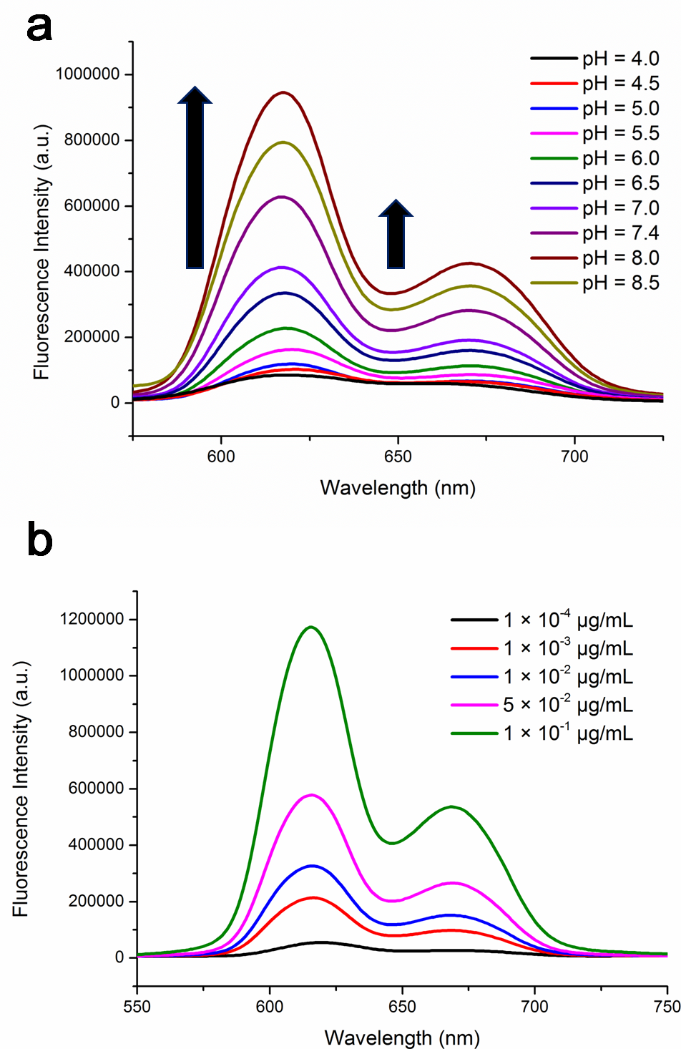

Figure S11. Plots of fluorescence ratio of I_{620nm}/I_{670nm} versus capsules’ incubation time (a) and capsules’ concentration (b), λ_{ex} = 392 nm.
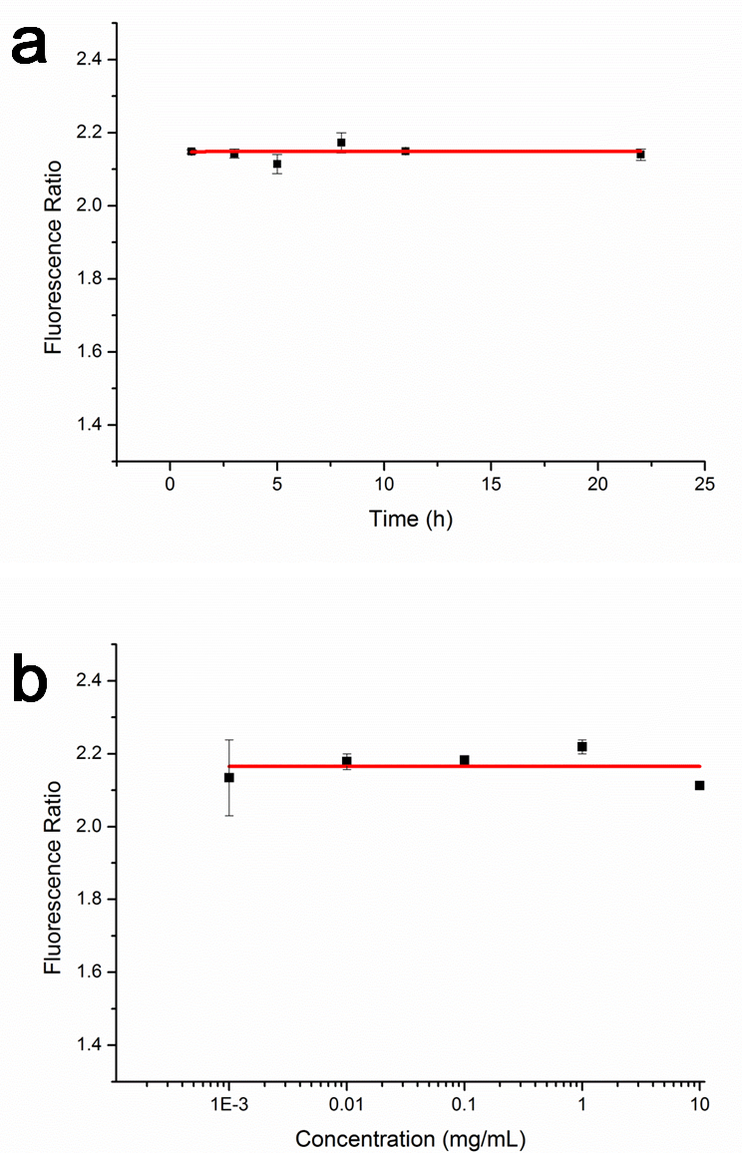

Figure S12 Fluorescence spectrometry of HeLa cells incubated with MPN@HMME capsules for 2 h followed by suspended in buffers with different pHs. HeLa cells were seeded at ∼1 × 10⁵ cells per well into 6-well cell culture cluster and incubated for 24 h. MPN@HMME (300 μL, 30 μg mL⁻¹) were incubated with cells at a capsule-to-cell ratio of 3:1 for 2 h or 12 h.

Figure S13. Viability of HeLa cells treated with capsules without FA-doping (20 μg mL⁻¹) for different time without PDT. HeLa cells were first seeded to three 96-well cell culture clusters at a seeding density of 1 × 10⁴ cells per well in 200 µL complete medium, which was incubated at 37 °C for 24 h. After rinsing with PBS, HeLa cells were incubated with 200 µL culture media containing 20 μg mL⁻¹ MPN@HMMEs for different times.

Figure S14 Confocal fluorescence images for evaluating HeLa cell apoptosis induced by MPN@HMMEs without FA-doping or FA-doped MPN@HMMEs mediated PDT. HeLa cells were incubated with 30 μg mL⁻¹ MPN@HMMEs without FA-doping (b) or FA-doped MPN@HMMEs (c) for 4 h at 37 °C, followed by irradiation with a 638 nm laser at energy density of 40 J cm⁻² and Annexin V-FITC/PI staining. Scale bars are 30 μm.

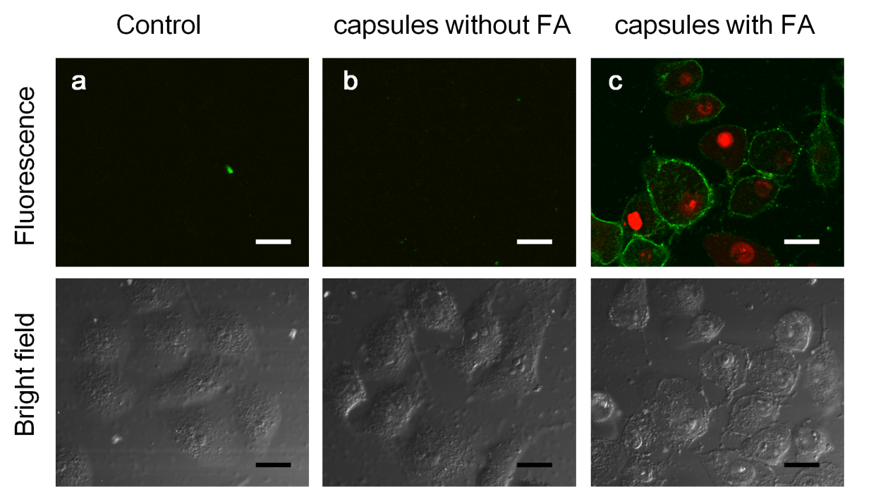

Figure S15 Plot of cellular uptake percentage and uptake quantity against incubated FA-MPN@HMME capsules concentration. HeLa cells were seeded at ∼1 × 10⁵ cells per well into 6-well cell culture cluster and incubated for 24 h. Different concentrations of MPN@HMME were incubated with cells for 12 h. Cellular uptake percentage was investigated by comparing the fluorescence intensity of MPN@HMME capsules before and after incubated with HeLa cells. Uptake quantities were calculated by the product of uptake percentage and capsules concentration which devided by total cells.

References
Lei TC, Glazner GF, Duffy M, Scherrer L, Pendyala S, Li BH, Wang XL, Wang HW, Huang Z. 2012. Optical properties of hematoporphyrin monomethyl ether (HMME), a PDT photosensitizer. Photodiagnosis Photodyn Ther. 9:232-242.
Li BH, Lin LS, Lin HY, Xie SS. 2008. Singlet oxygen quantum yields of porphyrin-based photosensitizers for photodynamic therapy. J Innov Opt Health Sci. 1:141-149.
Yu S, Lin L, Lin H, Li B, Xie S. 2008. Determination of fluorescence quantum yields of porphyrin-based photosensitizers. J Optoelectronics·Laser. 19:1283-1286.

