**Delivering the 2 degree global climate change target using a flexible ratchet framework**

**Supplementary Information**

1. **IPCC RCP scenarios normalised to per capita equity**

Each of the four IPCC 5th Assessment Report (AR5) Relative Concentration Pathways (RCPs) have been normalised into per capita equity/average metrics by using IPCC total GHG annual emissions (GtCO2e), and UN World Prospects historic and projected population data (see Methods). The resultant per capita pathways are shown in Figure S1. As noted, the RCP4.5 scenario results in a stabilisation of per capita emissions at 6.0 tCO2ecapita-1 in approximately 2040 before a steep contraction profile to 2.2 tCO2ecapita-1 in 2080.

1. **Selection of RCP4.5: Comparison of INDCs and RCP temperature targets**

Selected modelling of the RCP4.5 scenario was chosen as the example iteration of the framework as a stepwise increase in ambition from submitted INDCs. It’s estimated that current INDC submissions will fail to produce the level of commitment needed to limit average global temperature rise to 2°C. Best estimates project this action to limit warming to approximately 2.7°C, with a 66% likelihood of limiting below 3°C (<http://climateactiontracker.org/news/224/indcs-lower-projected-warming-to-2.7c-significant-progress-but-still-above-2c-.html>).

Table S1 details the expected average temperature increases for each of the IPCC AR5 RCP scenarios. Temperatures are provided as the level of increase above the reference period 1986-2005. As shown, RCP4.5 projects a mean surface temperature increase of 1.8°C by 2100. Assuming an average pre-industrial temperature increase of 0.6°C prior to the reference period (IPCC, 2014), RCP4.5 will result in an average temperature increase of 2.4°C (likely range 1.7-3.2°C).

The RCP4.5 pathway was therefore selected as a bridging stepwise increase in ambition from current INDC proposals. However, it is acknowledged that such a pathway would be unlikely to limit mean temperature increases to 2°C.

1. **Comparison of framework targets to INDCs of key emitting parties**

Approximately 70% of global GHG emissions are produced by the top 10 emitting parties (WRI figures: <http://www.wri.org/blog/2014/11/6-graphs-explain-world%E2%80%99s-top-10-emitters>), making the inclusion of the major emitters imperative for an effective agreement. To promote the support of major emitters, framework targets were developed and compared to the INDCs (<http://www4.unfccc.int/submissions/INDC/Submission%20Pages/submissions.aspx>)

- most notably the USA due to its omission from Kyoto- and cross-compared for the EU28, China and India.

Table S2 details the comparison of framework targets for the USA with its submitted INDCs. **Despite the lack of a defined 2040 INDC target, this analysis has assumed an approximate reduction goal of 60% (from its 2005 baseline) based on extrapolation of its stated interim target of 28% by 2025 and long-term economy-wide reduction of 80%. As shown, once normalised on a per capita basis using UN population projections, the USA’s pledged reductions result in a 7.7 tCO2ecapita-1 level. This falls closely in line with its targets within the framework of 8.1 tCO2ecapita-1.**

Table S3 similarly details framework and INDC requirements for the EU28. An economy-wide absolute reduction of 60% from 1990 baseline levels has been similarly assumed as an extrapolation of 40% by 2030 (and previously stated reductions of 80% by 2050). As detailed, the EU’s pledged reductions would result in a population-adjusted per capita level of 3.3 **tCO2ecapita-1. This is more ambitious than its framework requirement of 6.4 tCO2ecapita-1, making the EU-28 one of the key outliers in a current (not historical) equity-based framework. We suggest, however, that based on its previous proactive stance within international climate agreement, the EU-28 would still be likely to aim beyond its framework requirements.**

**China’s 2040 framework target of 6.1 tCO2ecapita-1 does not entail a significant reduction from its 2010 baseline level of 6.9 tCO2ecapita-1 –this could be achieve through a largely symmetrical growth-peak-decline trajectory. In order to do so at a constant rate, we calculated it would need to achieve a 2%yr-1 Rate of Growth Return (ROGR). This would result in a 2025 peak year, not largely dissimilar to China’s INDC pledge of a 2030 peak in absolute emissions (with best efforts to do so earlier). China could still achieve its framework target with a delayed 2030 peak with deeper ROGR reductions of greater than 2% post-2030 (especially considering carbon intensity reduction targets of 60-65% from 2005 levels).**

**India’s INDC has been focused on carbon intensity reduction targets rather than absolute reductions, with a stated focus on development and economic growth. Its INDC states a target of 33-35% CO2e/GDP reduction by 2030 (from 2005 levels). The model has therefore applied a carbon intensity reduction assumption of 1.5%yr-1. Within the framework, India has been given no other target than a 2040 peak stabilisation at 6.0 tCO2ecapita-1 (equity). As modelled within the framework, India could sustain a constant economic growth rate of 7%yr-1, and peak at close to 6.0 tCO2ecapita-1 (6.3 tCO2ecapita-1). Analysis on India’s growth trends highlights how sensitive its projections are to its economic or carbon intensity rates: if a constant GDP growth rate of 7% is applied, its per capita emissions in 2040 are calculated to be 7.3 tCO2ecapita-1; at a 6% GDP growth rate, results would be below equity at 5.5 tCO2ecapita-1. India’s challenge would therefore be to balance growth and carbon intensity reduction rates to aim to peak below equity by the target year.**

1. **Assumptions on Pool 2 Growth Rates**

Despite being free to do so, it’s expected that not all Pool 2 nations will reach per capita equity emission levels by 2040 based on realistic growth trends. To account for this within the overall global carbon budget, the model estimated 2040 national emissions for Pool 2 nations based on regional economic growth and carbon intensity assumptions. Table S4 details the regional assumptions which have been applied [India has been allocated an individual grouping based on the sensitivity of its projections on the overall global budget].

Economic growth rates were selected based on regional average current and projected growth rates from the World Bank Global Economic Prospects Database (<http://databank.worldbank.org/data/views/variableselection/selectvariables.aspx?source=world-development-indicators#s_e>). It is acknowledged that regional assumptions will have resulted in a loss in resolution of growth extrapolation and could be improved through better national-level growth estimations through to 2040.

Carbon intensity reduction assumptions of averaging 1.5%yr-1 have been applied based on submitted intensity-based INDCs (such as India, Malaysia, Tunisia).

1. **Baseline and Framework Target Datasets for all Nations**

Table S5 and S6 detail the emissions, population, and 2040 target metadata for Pool 1 and Pool 2 nations respectively.

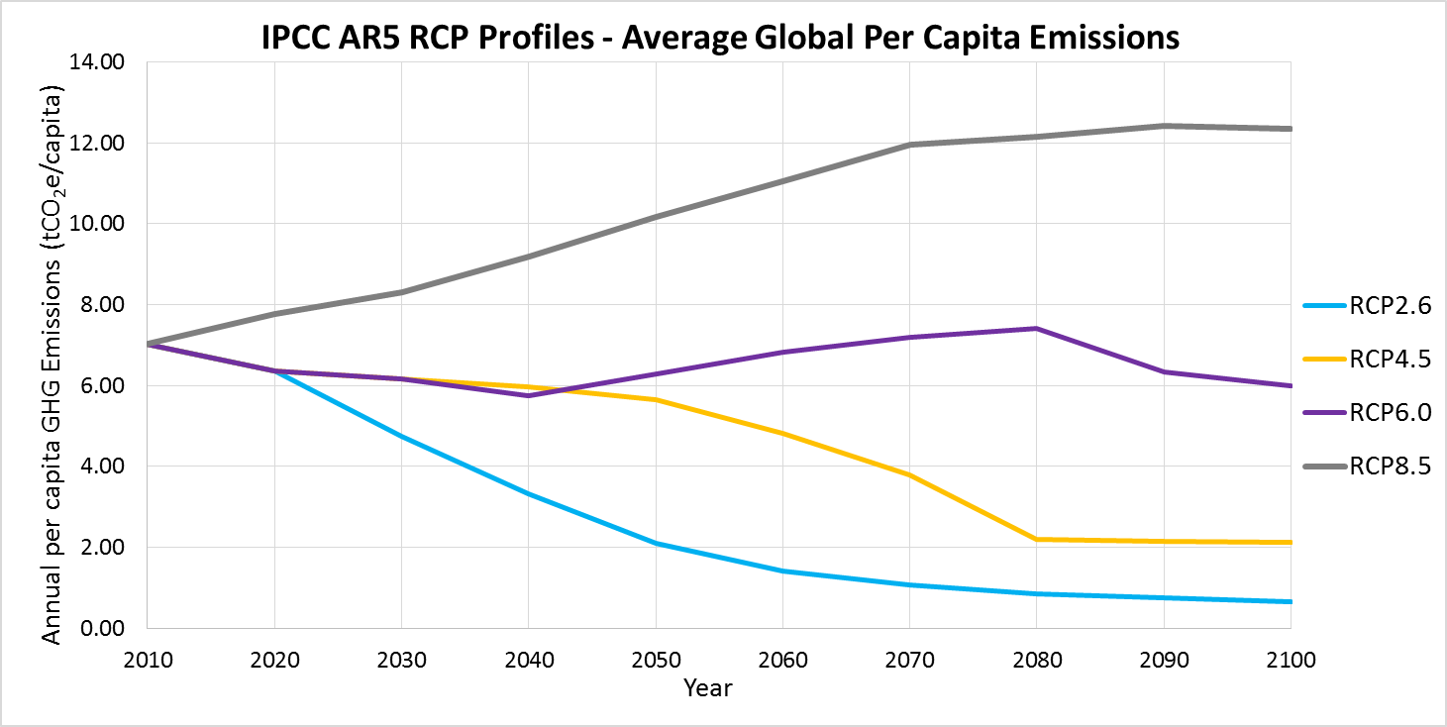**Supplementary Figures**

**Figure S1: IPCC AR5 Relative Concentration Pathways (RCP) scenarios normalised to average per capita emissions based on UN medium fertility projections from 2010-2100.**

**Supplementary Tables**

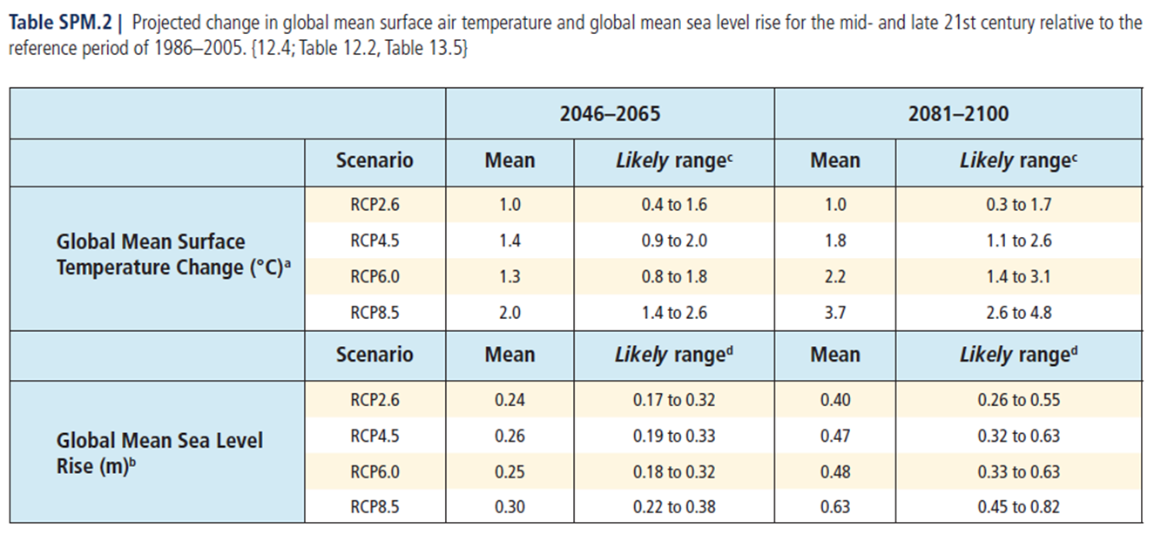

**Table S1: Projected change in global mean surface temperature and global mean sea level rise for the mid- and late 21st century relative to the reference period of 1986-2005.**

Source: IPCC. Climate Change 2014 Synthesis Report Summary Chapter for Policymakers

|  |  |  |  |  |  |  |  |
| --- | --- | --- | --- | --- | --- | --- | --- |
| **USA** | **Baseline Year** | **Baseline Emissions (MtCO2e)** | **Baseline Population (millions)** | **Per Capita Baseline Emissions (tCO2e/capita)** | **2040 Absolute Target (MtCO2e)** | **2040 Population (millions)** | **Per Capita 2040 (tCO2e/capita)** |
| **INDC** | 2005 | 7350 | 296 | 24.8 | 2940 | 383 | **7.7** |
| **Framework** | 2010 | 6254 | 312 | 20.0 | - | 383 | **8.1** |

**Table S2: Comparison of USA extrapolated INDC pledged targets versus requirements within the exemplar convergence framework.**

**Table S3: Comparison of the EU-28 extrapolated INDC pledged targets versus requirements within the exemplar convergence framework.**

|  |  |  |  |  |  |  |  |
| --- | --- | --- | --- | --- | --- | --- | --- |
| **EU-28** | **Baseline Year** | **Baseline Emissions (MtCO2e)** | **Baseline Population (millions)** | **Per Capita Baseline Emissions (tCO2e/capita)** | **2040 Absolute Target (MtCO2e)** | **2040 Population (millions)** | **Per Capita 2040 (tCO2e/capita)** |
| **INDC** | 1990 | 4266 | 470 | 9.1 | 1706 | 523 | **3.3** |
| **Framework** | 2010 | 4413 | 511 | 8.6 | - | 523 | **6.4** |

**Table S4: Regional economic growth, carbon intensity and GHG growth rates applied to Pool 2 nations for 2040 per capita emission estimates.**

|  |  |  |  |  |  |
| --- | --- | --- | --- | --- | --- |
|  | **Africa** | **Asia-Pacific** | **India** | **Latin America and Caribbean** | **Europe** |
| **GDP Growth Rate (%yr-1)** | 5% | 5% | 7% | 5% | 5% |
| **Carbon Intensity Reduction (%yr-1)** | 1.5% | 1.5% | 1.5% | 1.5% | 1.5% |
| **CO2e Growth Rate (%yr-1)** | 3.5% | 3.5% | 5.5% | 3.5% | 3.5% |



**Table S5: Emission, population and target metadata from 2010-2040 for Pool 1 nations.**



**Table S6: Emission, population and projected growth metadata from 2010-2040 for Pool 2 nations.**