SUPPORTING INFORMATION

Facile one-pot synthesis of New [1,2,4]triazolo[1,5-a] pyridine derivatives by ultrasonic irradiation
Lazhar Zribi¹, Fathi Zribi¹ , José Marco-Contelles ², Fakher Chabchoub^{1*}, Lhassane ismaili^{3*}
¹ Laboratory of Applied Chemistry:Heterocycles, Lipids and Polymers, Faculty of Sciences of Sfax, University of Sfax. B. P 802. 3000 Sfax-Tunisia
² Laboratory of Medicinal Chemistry (IQOG, CSIC); Juan de la Cierva, 3, 28006-Madrid, Spain
³ Laboratoire de Chimie Organique et Thérapeutique, Neurosciences intégratives et cliniques EA 481, Univ. Bourgogne Franche-Comté, UFR SMP, 19, rue Ambroise Paré, F-25000 Besançon, France

Experimental part…………………………………………………………………….....S2-S8
1H and 13C NMR spectra of compounds 3a-h…………………………………….S9-S17 1H and 13C NMR spectra of compounds 4a-g………...………………………….S18-S24 1H and 13C NMR spectra of compounds 5a-c………...………………………….S25-S27
Experimental part
Synthesis of 2-(5-phenyl-4H-1,2,4-triazol-3-yl)acetonitrile (2a). A mixture of hydrazine monohydrate (1mmol) and ethyl cyanoacetate (1mmol) was stirred at 0 °C for 5 min; then, the imidate 1 (R₁=H) (1 mmol), dissolved in ethanol (15 cm³), was added to the reaction, and the mixture was refluxed for 4 h. When the reaction was over, the solvent was removed under reduced pressure, and the solid obtained was washed with ether to afford 2-(5-phenyl-4H-1,2,4-triazol-3-yl)acetonitrile (2a) as a white solid, yield: 77%; mp 166 °C ; ¹H NMR (DMSOd6, 400 MHz) δ 0.62 (s, 2H, CH2), 3.82 (m, 3H, Ar), 7.98 (d, 2H, J= 8.0 Hz, Ar), 14.39 (br s, 1H, NH); ¹³C NMR (DMSO-d6, 100 MHz) δ 16.99, 117.09, 126.00, 127.48, 129.03, 130.15, 153.81, 156.32;
Synthesis of 2-(5-(p-tolyl)-4H-1,2,4-triazol-3-yl)acetonitrile (2b) : Following the procedure of 2a but substituting imidate 1 (R₁=CH₃) for imidate 1 (R₁=H) afforded the title compound 2b as white solid; yield: 79%; mp 144 °C ; ¹H NMR (DMSO-d6, 400 MHz) δ 7. 87 (d, 2H, J= 4.0 Hz, Ar), 7.33 (d, 2H, Ar), 4.20 (s, 2H, CH2), 2.36 (s, 3H, CH₃); ¹³C NMR (DMSO-d6, 100 MHz) δ 17.53, 21.40, 117.61, 125.19, 126.47, 130.07, 140.45, 154.30, 156.76.
5-Amino-2,7-diphenyl-[1,2,4]triazolo[1,5-a]pyridine-6,8-dicarbonitrile (3a): White solid; yield: 95%; IR (KBr) υ_{max} 3437, 3291, 2223 cm⁻¹; ¹H NMR (DMSO-d₆, 400 MHz) δ 7.52-8.24 (m, 10H, Ar), 9.24 (br s, 2H, NH₂); ¹³ C NMR (DMSO-d₆, 100 MHz) δ 79.4, 85.1, 115.4, 127.6, 129.1, 129.2, 129.4, 129.6, 130.7, 131.4, 134.9, 149.4, 151.9, 154.0, 164.7; HRMS (ESI-TOF): Calcd. for C₂₀H₁₂N₆: [M+H]⁺ 337.1185. Found: 337.1196. Anal. Calcd: C, 71.42; H, 3.60; N, 24.99. Found: C, 71.53; H, 3.56; N, 24.97.

5-Amino-2-phenyl-7-(p-tolyl)-[1,2,4]triazolo[1,5-a]pyridine-6,8-dicarbonitrile (3b): White solid; yield: 95%; IR (KBr) υ_{max} 3441, 3298, 2221 cm⁻¹; ¹H NMR (DMSO-d₆, 400 MHz) δ 9.26 (br s, 2H, NH₂), 7.58-8.27 (m, 5H, Ar), 7.46 (d, 2H, J= 8.0 Hz, Ar), 7.39 (d, 2H, J= 8.0 Hz, Ar), 2.43 (s, 3H, CH₃); ¹³C NMR (DMSO-d₆, 100 MHz) δ 21.4, 79.4, 84.9, 115.5, 127.7, 129.2, 129.5, 129.7, 129.7, 131.5, 132.1, 140.5, 149.4, 152.1, 154.1, 164.9; HRMS (ESI-TOF): Calcd. for C₂₁H₁₄N₆: [M+H]⁺ 351.1148. Found: 351.1353. Anal. Calcd: C, 71.99; H, 4.03; N, 23.99. Found: C, 71.70; H, 4.09; N, 23.75.
5-Amino-7-(4-methoxyphenyl)-2-phenyl-[1,2,4]triazolo[1,5-a]pyridine-6,8-dicarbo nitrile (3c): Yellow solid; yield: 93%; IR (KBr) υ_{max} 3351, 3307, 2221 cm⁻¹; ¹H NMR (DMSO-d₆, 400 MHz) δ 9.19 (br s, 2H, NH₂), 7.55-8.24 (m, 7H, Ar), 7.14 (d, 2H, J= 8.0 Hz, Ar), 3.84 (s, 3H, OCH₃), ¹³C NMR (DMSO-d₆, 100 MHz) δ 55.8, 79.4, 85.0, 115.6, 114.5, 126.8, 127.6, 129.4, 129.7, 130.9, 131.4, 149.4, 152.5, 153.8, 161.1, 164.6; HRMS (ESI-TOF): Calcd. for C₂₁H₁₄N₆O: [M+H]⁺ 367.1296. Found: 367.1302. Anal. Calcd: C, 68.84; H, 3.85; N, 22.94. Found: C, 68.72; H, 3.85; N, 22.71.
5-Amino-7-(3-methoxyphenyl)-2-phenyl-[1,2,4]triazolo[1,5-a]pyridine-6,8-dicarbo nitrile (3d): White solid; yield: 93%; IR (KBr) υ_{max} 3399, 3289, 2228 cm⁻¹; ¹H NMR (DMSO-d₆, 400 MHz) δ 9.21 (br s, 2H, NH₂), 7.56-8.24 (m, 6H, Ar), 7.41 (d, 1H, J= 4.0 Hz, Ar), 7.27 (d, 1H, J= 8.0 Hz, Ar), 7.18 (d,1H, J= 8.0 Hz, Ar), 3.83 (s, 3H, OCH₃); ¹³C NMR (DMSO-d₆, 100 MHz) δ 56.2, 80.2, 86.1, 115.2, 112.5, 121.1, 123.5, 17.7, 129.4, 129.6, 130.6, 131.4, 132.5, 151.7, 149.1, 151.8, 156.4, 164.7; HRMS (ESI-TOF): Calcd. for C₂₁H₁₄N₆O: [M+H]⁺ 367.1309. Found: 367.1302. Anal. Calcd: C, 68.84; H, 3.85; N, 22.94. Found: C, 68.80; H, 3.87; N, 22.75.

5-Amino-7-(2-methoxyphenyl)-2-phenyl-[1,2,4]triazolo[1,5-a]pyridine-6,8-dicarbo nitrile (3e): White solid; yield: 92%; IR (KBr) υ_{max} 3400, 3288, 2228 cm⁻¹; ¹H NMR (DMSO-d₆, 400 MHz) δ 9.21 (br s, 2H, NH₂), 8.28 (q, 2H, J= 4.0 Hz, Ar), 8.11 (m, 1H, Ar), 7.59 (q, 3H, J= 4.0 Hz, Ar), 7.41 (q, 1H, J= 8.0 Hz, Ar), 7.28 (d, 1H, J= 8.0 Hz, Ar), 7.17 (t, 1H, J= 8.0 Hz, Ar), 3.84 (s, 3H, OCH₃); ¹³C NMR (DMSO-d₆, 100MHz) δ 56.2, 80.2, 86.1, 112.5, 115.2, 121.1, 123.6, 126.8, 127.7, 129.5, 129.7, 130.6, 131.5, 132.4, 149.2, 151.7, 151.9, 156.4, 164.7. Anal. Calcd: for C₂₁H₁₄N₆O: C, 68.84; H, 3.85; N, 22.94. Found: C, 68.96; H, 3.81; N, 23.04.
5-amino-7-(4-nitrophenyl)-2-phenyl-[1,2,4]triazolo[1,5-a]pyridine-6,8-dicarbonitrile (3f) : Yellow solid ; yield : 85%; IR (KBr) υ_{max} 3333, 3277, 2233; ¹H NMR (DMSO-d₆, 400 MHz) δ 9.38 (br s, 2H, NH₂), 8.48 (d, 2H, J=8 Hz, Ar), 8.27 (dd, 2H, J=8Hz, Ar), 7.92 (d, 2H, J=12 Hz, Ar), 7.59 (m, 3H, Ar),; ¹³C NMR (DMSO-d₆, 100 MHz) δ 79.19, 85.27, 115.03, 115.10, 124.39, 127.77, 129.51, 129.58, 131.04, 131.61, 141.31, 149.04, 129.44, 151.80, 151.96, 164.94. Anal. Calcd: for C₂₀H₁₁N₇O₂:C, 62.99; H, 2.91; N, 25.71. Found: C, 62.91; H, 2.94; N, 25.65.
5-amino-7-(4-methoxyphenyl)-2-(p-tolyl)-[1,2,4]triazolo[1,5-a]pyridine-6,8-dicarbonitrile(3g): White solid ; yield : 92%; IR (KBr) υ_{max} 3345, 3286, 2240; ¹H NMR (DMSO-d₆, 400 MHz) δ 9.10 (br s, 2H, NH₂), 8.13 (d, 2H, J=8 Hz, Ar), 7.56 (d, 2H, J=8Hz, Ar), 7,36 (d, 2H, J=8Hz, Ar), 7.16 (d, 2H, J=8Hz, Ar), 3.87(s, 3H,O CH₃), 2,39(s, 3H, CH₃),; ¹³C NMR (DMSO-d₆, 100 MHz) δ 21.56, 55.84, 79.37, 85.04, 114.55, 115.59, 115.62, 126.91, 126.99, 127.66, 129.96, 130.98, 141.32, 149.34, 152.04, 153.71, 161.21, 164.85. Anal. Calcd: for C₂₂H₁₆N₆O: C, 69.46; H, 4.24; N, 22.09. Found: C, 69.51; H, 4.20; N, 21.98.

5-amino-7-(4-nitrophenyl)-2-(p-tolyl)-[1,2,4]triazolo[1,5-a]pyridine-6,8-dicarbonitrile (3h) : Yellow solid ; yield : 83%; IR (KBr) υ_{max} 3329, 3276, 2238; ¹H NMR (DMSO-d₆, 400 MHz) δ 9.30 (br s, 2H, NH₂), 8.47 ( d, 2H, J=8 Hz, Ar), 8.16 (d, 2H, J=8Hz, Ar), 7.92 (d, 2H, J=12Hz, Ar), 7.40 (d, 2H, J=8Hz, Ar), 2.41(s, 3H, CH₃),; ¹³C NMR (DMSO-d₆, 100 MHz) δ 21.57, 79.12, 85.07, 115.07, 115.14, 124.36, 126.87, 127.75, 130.08, 131.03, 141.37, 141.53, 149.04, 149.39, 151.75, 151.87, 165.02. Anal. Calcd: for C₂₁H₁₃N₇O₂: C, 63.79; H, 3.31; N, 24.80. Found: C, 63.84; H, 3.29; N, 24.87.
Ethyl 5-amino-8-cyano-2,7-diphenyl-[1,2,4]triazolo[1,5-a]pyridine-6-carboxylate (4a) :White solid; yield: 83%; IR (KBr) υ_{max} 3475, 3336, 2224, 1673 cm⁻¹; ¹H NMR (DMSO-d₆, 400 MHz) δ 8.72 (br s, 2H, NH₂), 7.45-8.25 (m, 10H, Ar), 3.82 (q, 2H, J= 8.0 Hz CH₂), 0.62 (t, 3H, J= 8.0 Hz, CH₃); ¹³C NMR (DMSO-d₆, 100 MHz) δ 13.3, 61.1, 85.8, 97.1, 115.6, 127.6, 128.2, 128.5, 129.0, 129.3, 129.9, 131.3, 138.4, 147.5, 151.2, 153.0, 164.6, 166.0; HRMS (ESI-TOF): Calcd. for C₂₂H₁₇N₅O₂: [M+H]⁺ 384.1450. Found: 384.1455. Anal. Calcd: C, 68.92; H, 4.47; N, 18.27. Found: C, 69.16; H, 4.48; N, 18.19.
Ethyl 5-amino-8-cyano-2-phenyl-7-(p-tolyl)-[1,2,4]triazolo[1,5-a]pyridine-6-carboxylate (4b): White solid; yield: 81%; IR (KBr) υ_{max} 3382, 3266, 2291, 1679 cm⁻¹; ¹H NMR (DMSO-d₆, 400 MHz) δ 8.68 (br s, 2H, NH₂), 7.57-8.27 (m, 5H, Ar), 7.29 (d, 4H, J= 8.0 Hz, Ar), 3.88 (q, 2H, J= 8.0 Hz, CH₂), 2.40 (s, 3H, CH₃), 0.70 (t, 3H, J= 8.0 Hz, CH₃); ¹³C NMR (DMSO-d₆, 100 MHz) δ 13.4, 21.3, 61.2, 85.4, 97.4, 115.9, 127.7, 128.2, 129.0, 129.4, 129.9, 131.3, 135.4, 138.6, 147.3, 151.3, 153.0, 164.5, 166.0; HRMS (ESI-TOF): Calcd. for C₂₃H₁₉N₅O₂: [M+H]⁺ 398.1621. Found: 398.1621. Anal. Calcd: C, 69.51; H, 4.82; N, 17.62. Found: C, 69.73; H, 4.86; N, 17.53.

Ethyl 5-amino-8-cyano-7-(4-methoxyphenyl)-2-phenyl-[1,2,4]triazolo[1,5-a]pyridine-6-carboxylate (4c): White solid; yield: 80%; IR (KBr) υ_{max} 3473, 3440, 2222, 1686 cm⁻¹; ¹H NMR (DMSO-d₆, 400 MHz) δ 8.64 (br s, 2H, NH₂), 8.27 (m, 2H, Ar), 7.57 (d, J= 4.0 Hz, 3H, Ar), 7.30 (d, 2H, J= 4.0 Hz, Ar), 7.05 (d, 2H, J= 4.0 Hz, Ar), 3.90 (q, 2H, J= 8.0 Hz, CH₂), 3.82 (s, 3H, OCH₃), 0.74 (t, 3H, J= 8.0 Hz, CH₃); ¹³C NMR (DMSO-d₆, 100 MHz) δ 13.5, 55.7, 61.2, 85.6, 97.6, 116.0, 114.0, 127.7, 129.4, 129.8, 130.0, 130.3, 131.3, 147.2, 151.4, 152.7, 160.2, 164.5, 166.1; HRMS (ESI-TOF): Calcd. for C₂₃H₁₉N₅O₃: [M+H]⁺ 414.1555. Found: 414.1561. Anal. Calcd: C, 66.82; H, 4.63; N, 16.94. Found: C, 67.01; H, 4.62; N, 16.79.
Ethyl 5-amino-8-cyano-7-(3-methoxyphenyl)-2-phenyl-[1,2,4]triazolo[1,5-a]pyridine-6-carboxylate (4d): White solid; yield: 79%; IR (KBr) υ_{max} 3470, 3457, 2222, 1689 cm⁻¹; ¹H NMR ( DMSO-d₆, 400 MHz) δ 8.74 (br s, 2H, NH₂), 7.58-8.28 (m, 5H, Ar), 7.42 (t, 1H, J= 6.0 Hz, Ar), 7.07 (d, 1H, J= 6.0 Hz, Ar), 6.93 (m, 2H, Ar), 3.88 (q, 2H, J= 8.0 Hz, CH₂), 3.79 (s, 3H, CH₃), 0.71 (t, 3H, J= 8.0 Hz CH₃); ¹³C NMR (DMSO-d₆, 100 MHz) δ 13.4, 55.7, 61.1, 85.6, 97.1, 115.7, 114.0, 114.5, 120.6, 127.7, 129.4, 129.7, 129.9, 131.4, 139.6, 147.4, 151.2, 152.6, 159.3, 164.6, 165.9; HRMS (ESI-TOF): Calcd. for C₂₃H₁₉N₅O₃: [M+H]⁺ 414,1549. Found: 414.1561. Anal. Calcd: C, 66.82; H, 4.63; N, 16.94; 11.61. Found: C, 67.02; H, 4.64; N, 11.83.
Ethyl 5-amino-8-cyano-7-(2-methoxyphenyl)-2-phenyl-[1,2,4]triazolo[1,5-a]pyridine-6-carboxylate (4e): White solid; yield: 80%; IR (KBr) υ_{max} 3476, 3437, 2221, 1673 cm⁻¹; ¹H NMR (DMSO-d₆, 400 MHz) δ 8.73 (br s, 2H, NH₂), 7.15-8.27 (m, 9H, Ar), 3.86 (q, 2H, J= 8.0 Hz , CH₂), 3.74 (s, 3H, CH₃), 0.69 (t, 3H, J= 8.0 Hz, CH₃), ¹³C NMR (DMSO-d₆, 100 MHz) δ 13.3, 56.0, 61.0, 86.4, 97.1, 115.7, 111.4, 120.7, 127.2, 127.7, 129.4, 129.5, 129.9, 130.7, 131.3, 147.5, 150.3, 151.3, 156.0, 164.5, 165.9; HRMS (ESI-TOF): Calcd. for C₂₃H₁₉N₅O₃: [M+H]⁺ 414.1575. Found: 414.1561. Anal. Calcd: C, 66.82; H, 4.63; N, 16.94. Found: C, 67.06; H, 4.68; N, 16.97.
Ethyl5-amino-8-cyano-7-(4-nitrophenyl)-2-phenyl-[1,2,4]triazolo[1,5-a]pyridine-6-carboxylate (4f) : White solid ; yield : 84%; IR (KBr) υmax 3479, 3424, 2230, 1682 cm⁻¹;¹H NMR (DMSO d₆) , 400 MHz) δ 8.95 (br s, 2H, NH₂), 8.38 (d, 2H, J=8 Hz, Ar), 8.29 (dd, 2H, J=8Hz, Ar), 7.70 (d, 2H, J=8Hz, Ar), 7.59 (m, 3H, Ar), 3.90 (q, 2H, CH₂), 0.68(t, 3H, CH₃),; ¹³C NMR (DMSO-d₆, 100 MHz) δ 13.33, 61.39, 85.94, 95.96, 115.36, 123.71, 127.76, 129.47, 129.79, 129.91, 131.51, 145.73, 147.95, 148.17, 151.03, 151.26, 164.82, 165.51. Anal. Calcd: for C₂₂H₁₆N₆O₄: C, 61.68; H, 3.76; N, 19.62. Found: C, 61.72; H, 3.74; N, 19.73.
Ethyl 5-amino-8-cyano-7-(4-methoxyphenyl)-2-(p-tolyl)-[1,2,4]triazolo[1,5-a]pyridine-6-carboxylate (4g) : White solid ; yield: 91% ;IR (KBr) υmax 3480, 3419, 2238, 1670 cm⁻¹;¹H NMR (DMSO-d₆, 400 MHz) δ 8.58 (br s, 2H, NH₂), 8.15 (d, 2H, J=8 Hz, Ar), 7.36 (d, 2H, J=8Hz, Ar), 7.30 (d, 2H, J=8Hz, Ar), 7.06 (d, 2H, J=8Hz, Ar), 3.90(q, 2H,CH₂), 3.83(s, 3H, OCH ₃), 2.39(s, 3H, CH ₃), 0.74(t, 3H, CH ₃),; ¹³C NMR (DMSO-d₆, 100 MHz) δ 13.54, 21.53, 55.76, 61.20, 85.75, 97.37, 114.01, 115.96, 127.24, 127.65, 129.80, 129.92, 130.46, 141.16, 147.23, 151.28, 152.67, 160.20, 164.70, 166.16. Anal. Calcd: for C₂₄H₂₁N₅O₃: C, 67.44; H, 4.95; N, 16.38. Found: C, 67.49; H, 4.92; N, 16.31.
5-amino-2-phenyl-7-(thiophen-2-yl)-[1,2,4]triazolo[1,5-a]pyridine-6,8-dicarbonitrile (5a) : Yellow solid ; yield: 94%;IR (KBr) υ_{max} 3290, 3256, 2248;¹H NMR (DMSO-d₆, 400 MHz) δ 9.24 (br s, 2H, NH₂), 8.25 (dd, 2H, J=12 Hz,Ar), 7.98 (dd, 1H, J=8Hz, Ar), 7.58 (m, 4H, Ar), 7.33 (dd, 1H, J=8Hz, Ar),; ¹³C NMR (DMSO-d₆, 100 MHz) δ 79.51, 85.53, 115.47, 127.72, 128.32, 129.46, 129.66, 131.02, 131.54, 133.91, 146. 28, 149.58, 152.09, 164.80. Anal. Calcd: for C₁₈H₁₀N₆S: C, 63.15; H, 2.94; N, 24.55. Found: C, 63.22; H, 2.92; N, 24.61.

5-amino-7-(thiophen-2-yl)-2-(p-tolyl)-[1,2,4]triazolo[1,5-a]pyridine-6,8-dicarbonitrile (5b) : White solid ; yield: 93%;IR (KBr) υ_{max} 3288, 3261, 2244;¹H NMR (DMSO-d₆, 400 MHz) δ 9.20 (br s, 2H, NH₂), 8.13 (d, 2H, J=8 Hz, Ar), 7.98 (dd, 1H, J=4Hz, Ar), 7.58 (dd, 1H, J=4Hz, Ar), 7.37 (d, 2H, J=8Hz, Ar), 7.32 (dd, 1H, J=8Hz, Ar), 2.39(s, 3H, CH₃),; ¹³C NMR (DMSO-d₆, 100 MHz) δ 21.59, 79.38, 85.42, 115.45, 115.48, 126.89, 127.67, 128.30, 130.01, 130.99, 131.52, 133.92, 141.40, 146.13, 149.48, 152.01, 164.88 Anal. Calcd: for C₁₉H₁₂N₆S: C, 64.03; H, 3.39; N, 23.58. Found: C, 64.09; H, 3.37; N, 23.48.
Ethyl 5-amino-8-cyano-2-phenyl-7-(thiophen-2-yl)-[1,2,4]triazolo[1,5-a]pyridine-6-carboxylate (5c) : White solid; yield: 93%; IR (KBr) υ_{max} 3278, 3255, 2232, 1681;¹H NMR (DMSO-d₆, 400 MHz) δ 8.47 (br s, 2H, NH₂), 8.06 (d, 2H, J=8 Hz, Ar), 7.98 (d, 1H, J=8 Hz, Ar), 7.88 (d, 1H, J=4 Hz, Ar), 7.53 (m, 3H, Ar), 7.29 (m, 1H, Ar), 2.39(q, 2H, CH₂), 2.39(t, 3H, CH₃); ¹³C NMR (DMSO-d₆, 100 MHz) δ 23.27, 44.58, 85.42, 117.18, 125.28, 125.37, 126.73, 128.08, 128.69, 129.50, 130.64, 133.01, 136.10, 137.41, 156.96, 157.90. Anal. Calcd: for C₂₀H₁₅N₅O₂S: C, 61.68; H, 3.88; N, 17.98. Found: C, 61.61; H, 3.85; N, 17.92.

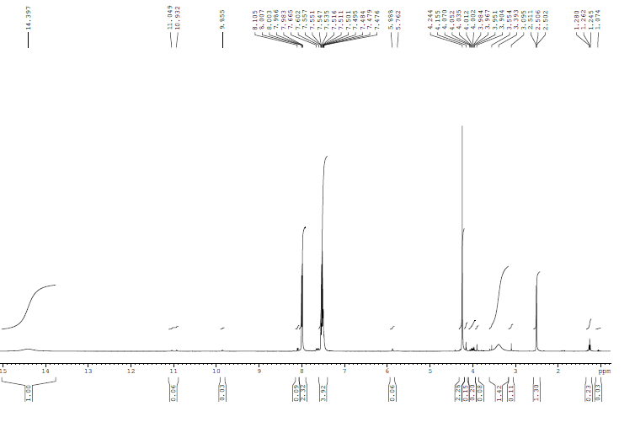
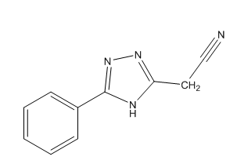

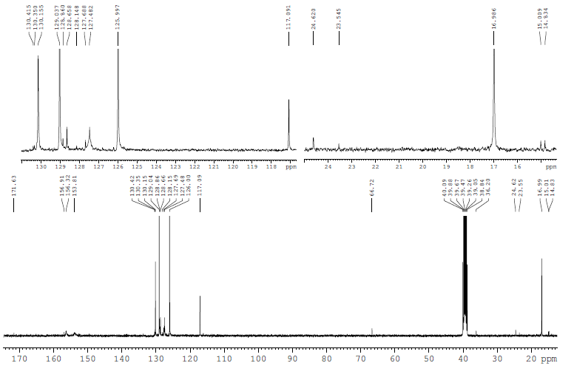

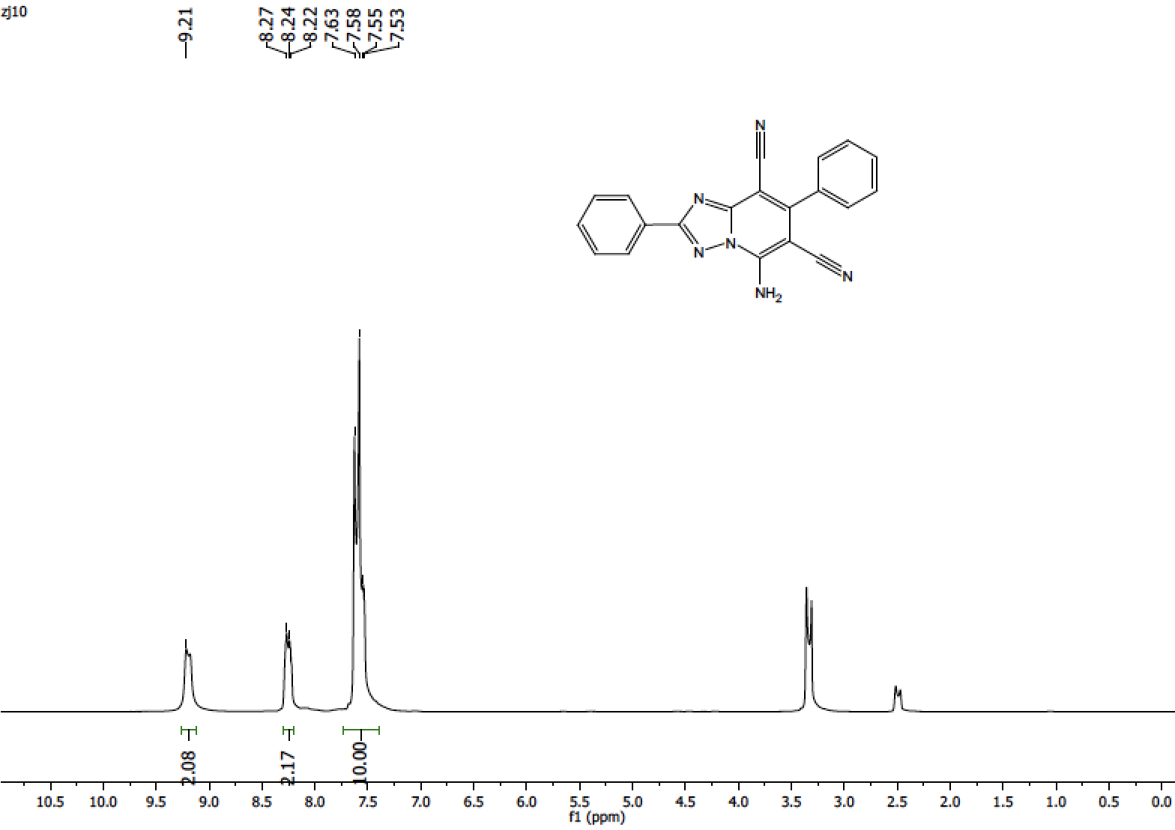
3a
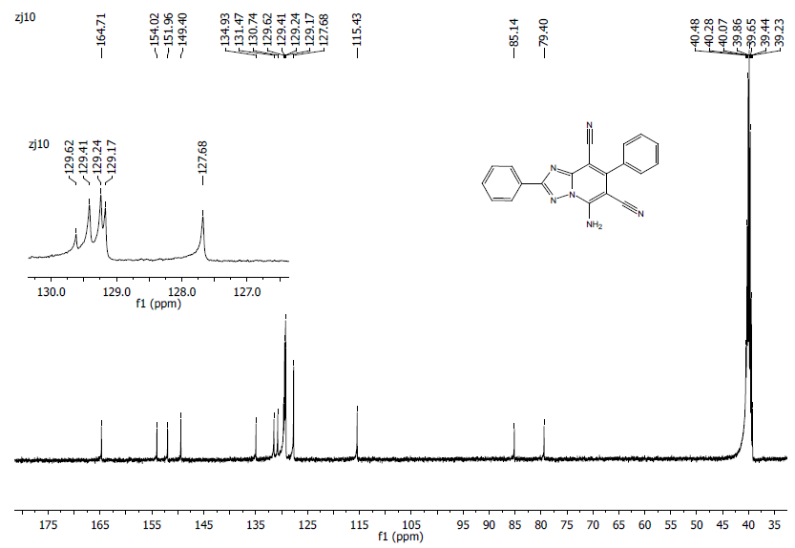
3a

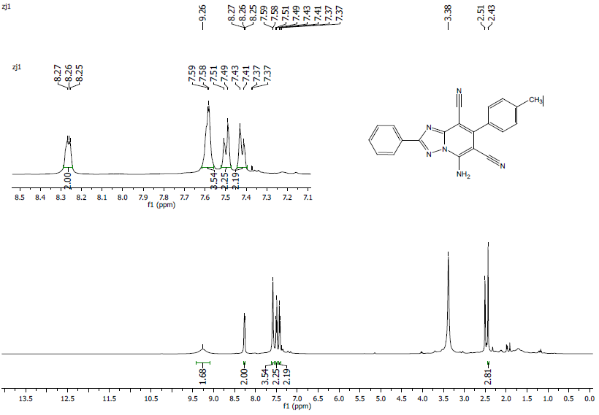
3b

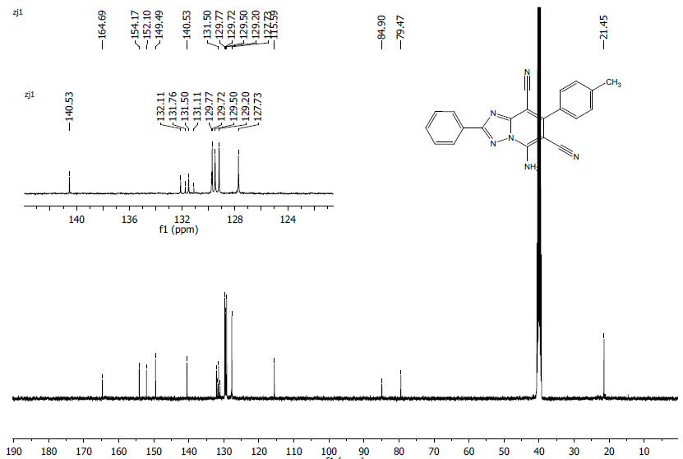
3b

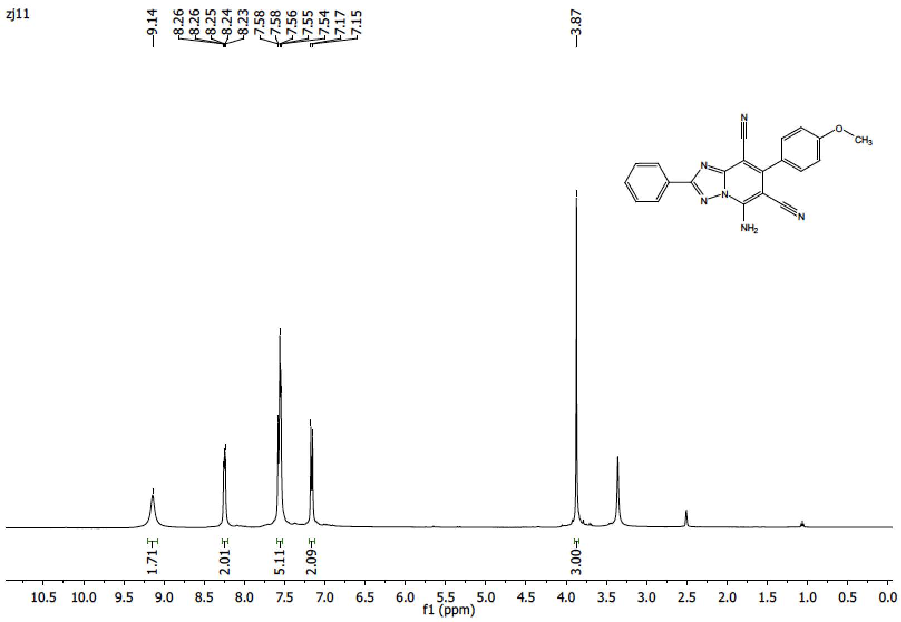
3c
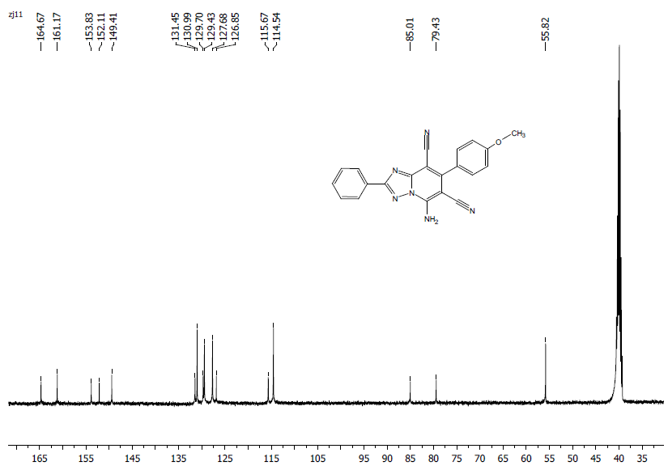
3c

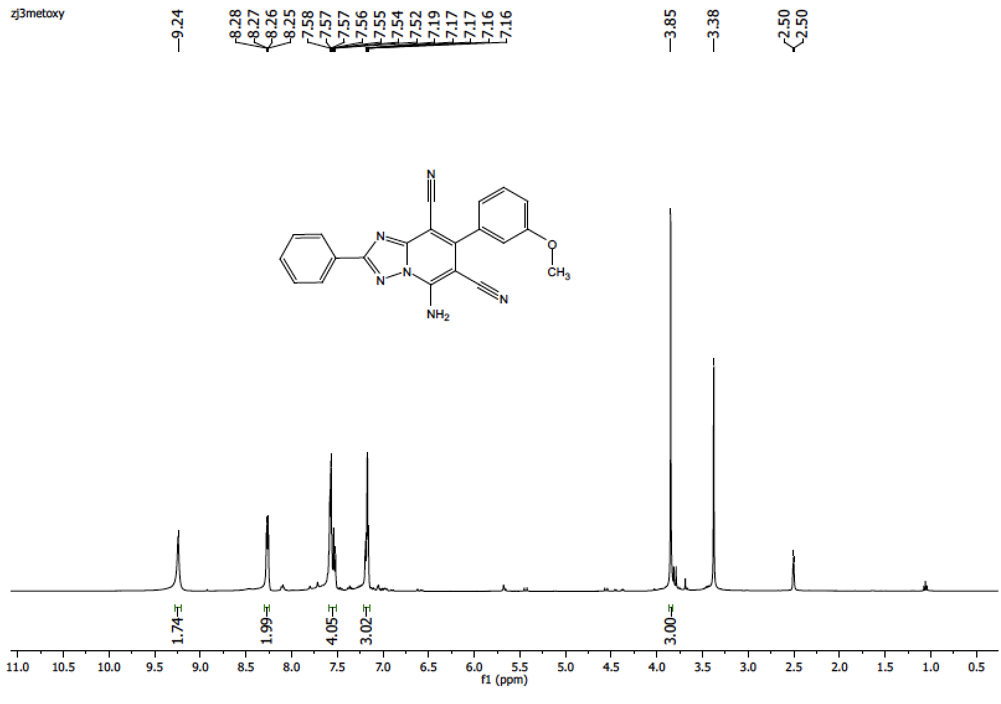
3d
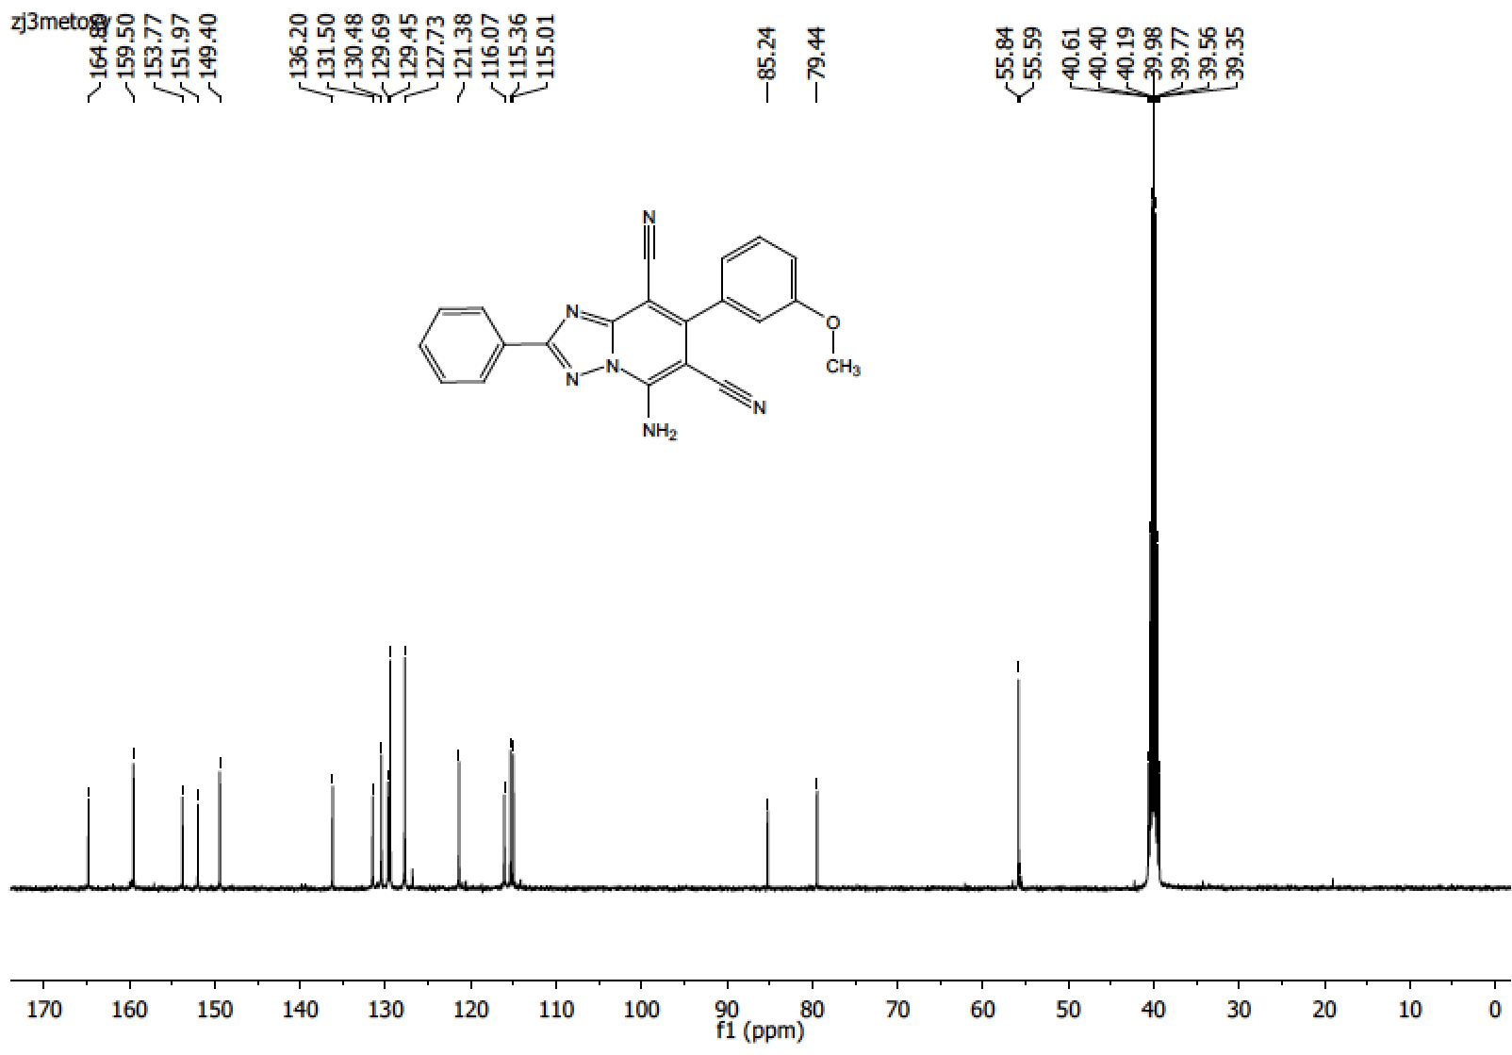
3d
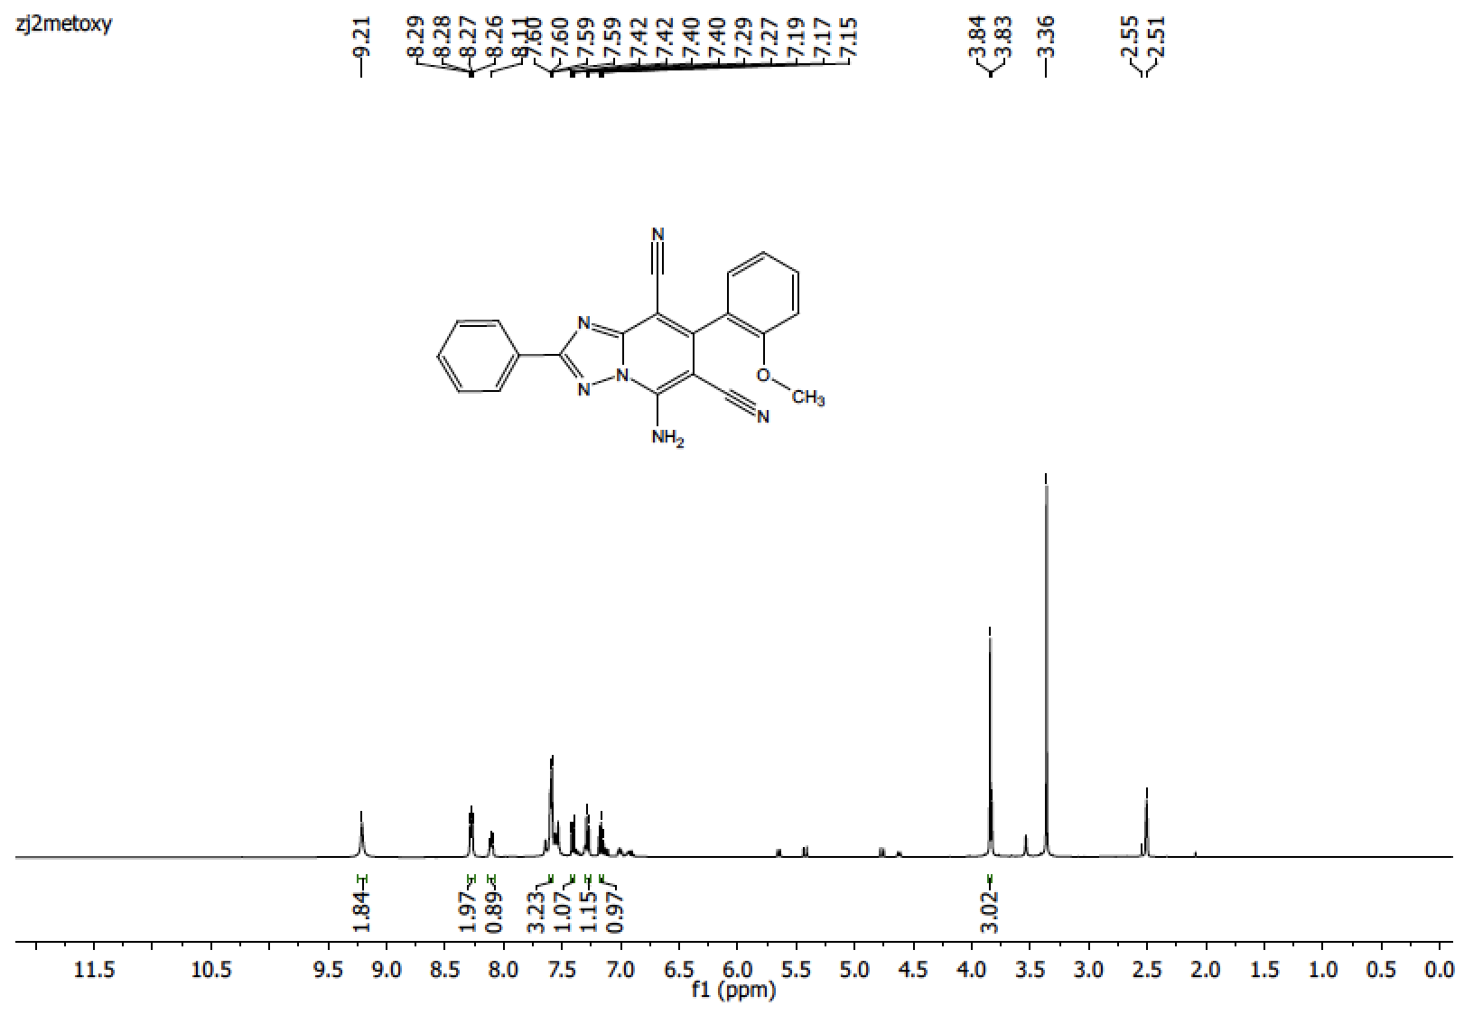
3e

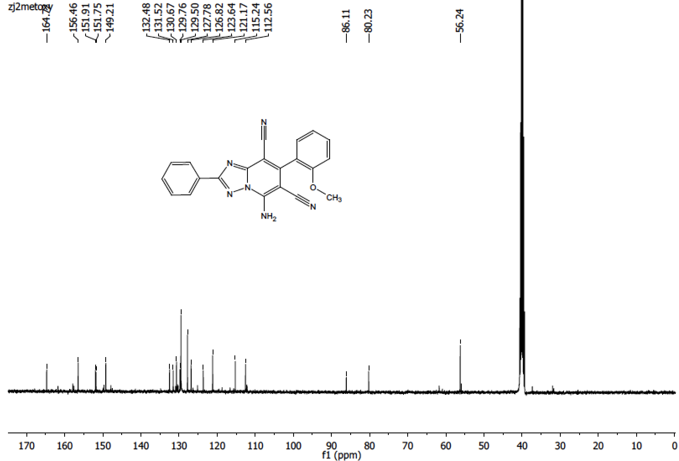
3e
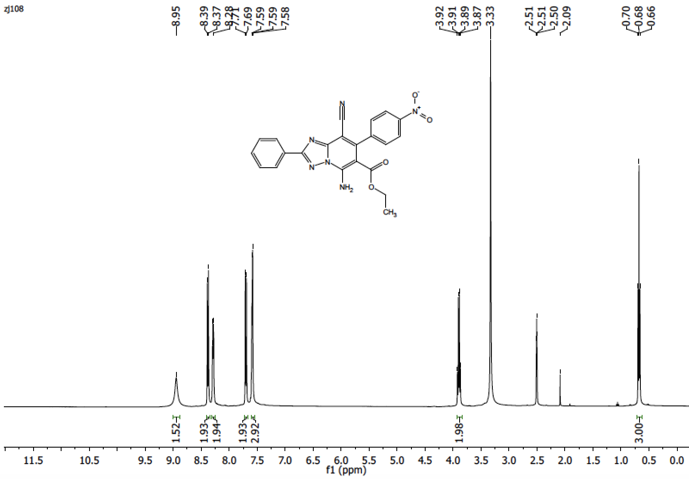
3f
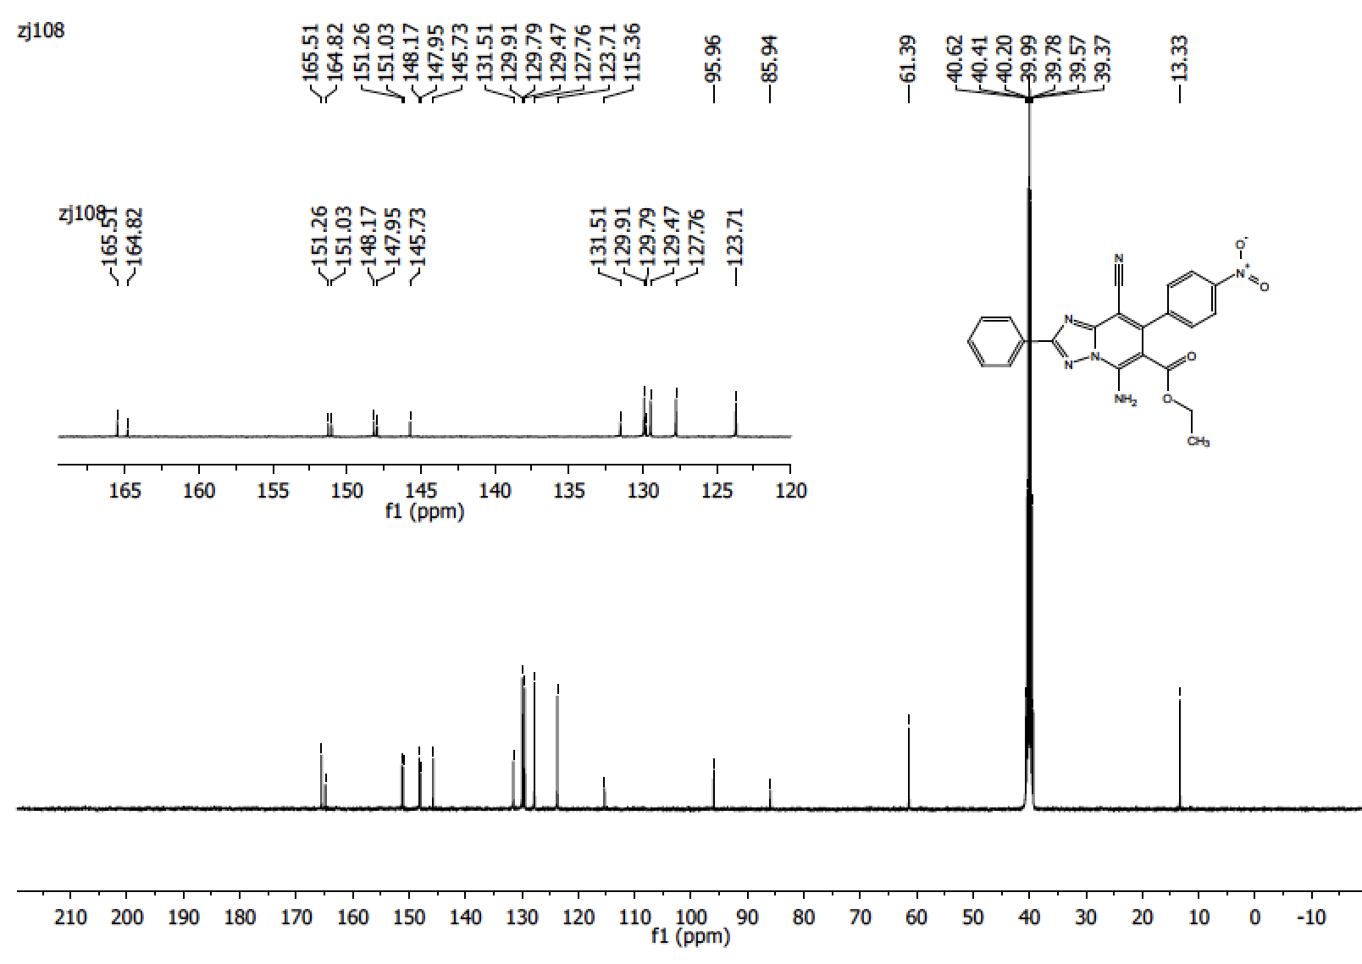

3f

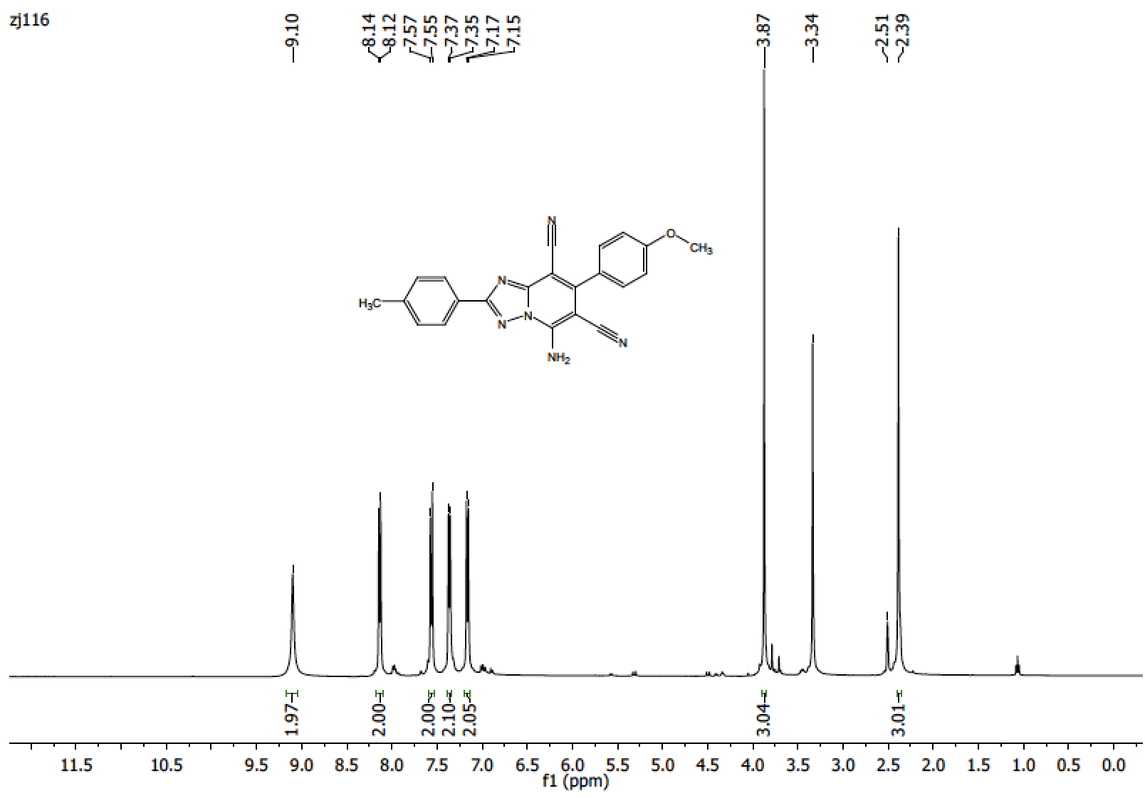

3g

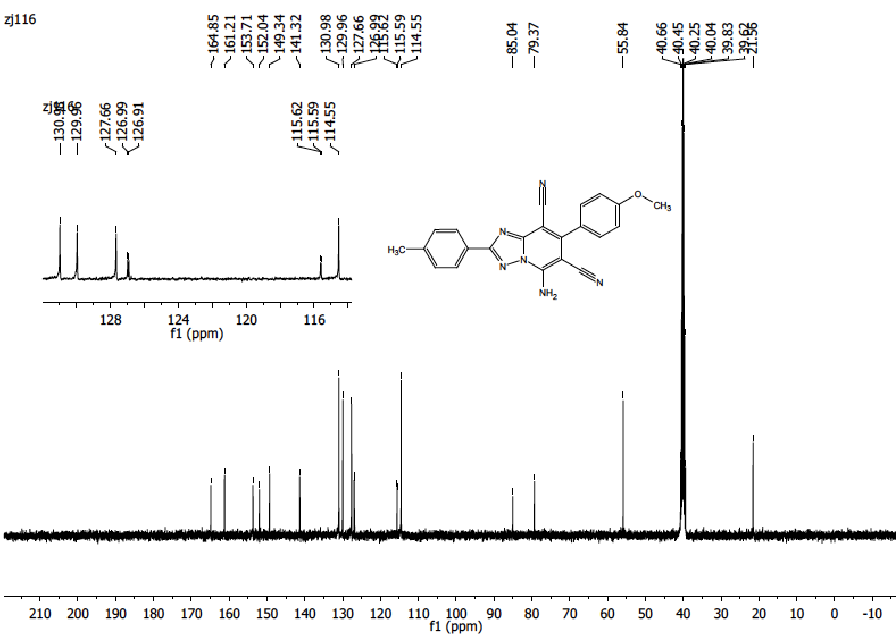

3g

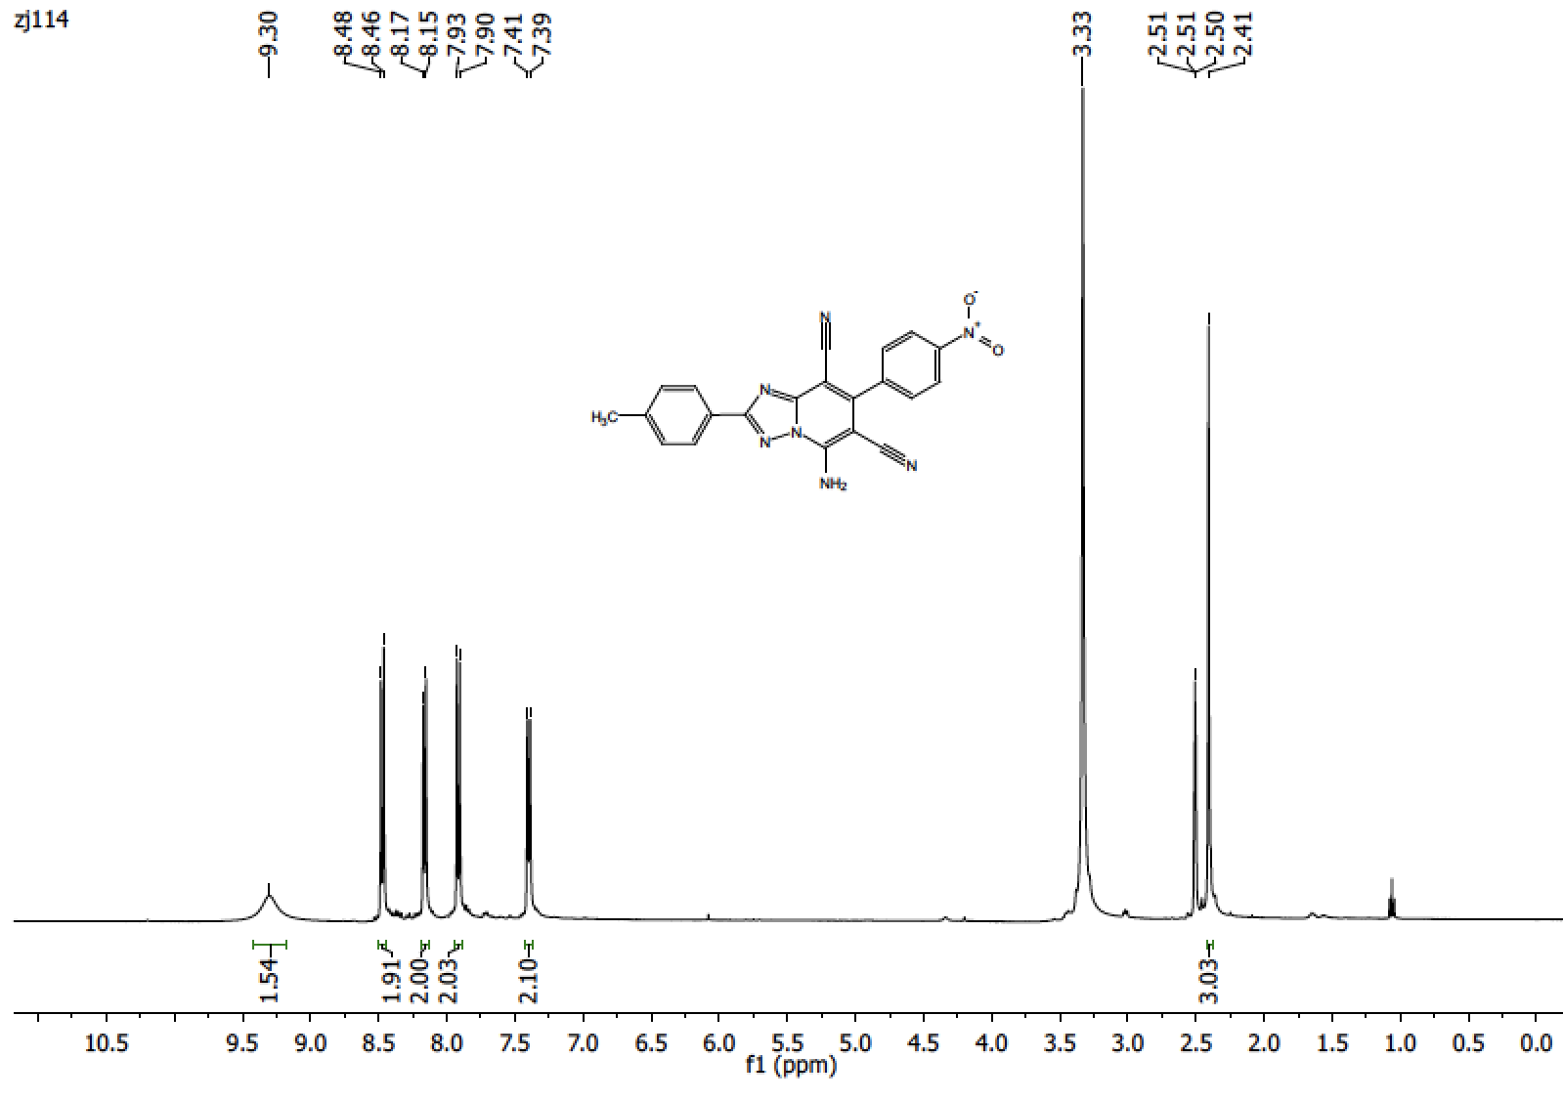

3h

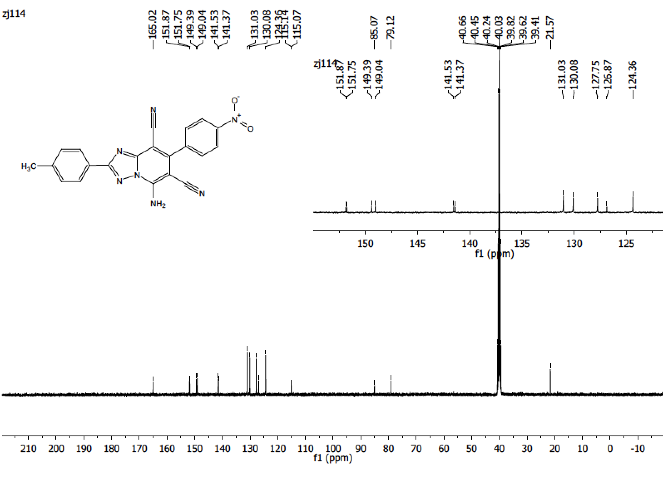

3h

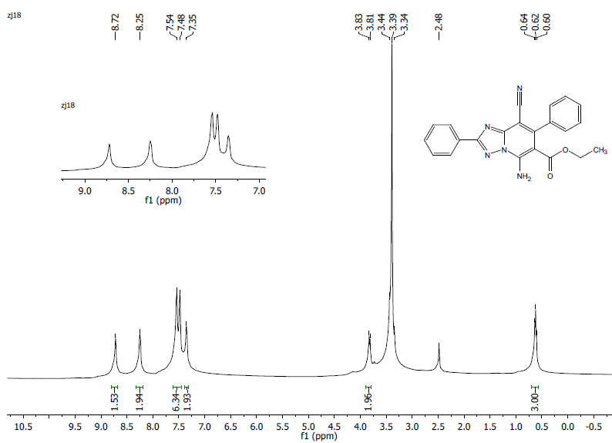

4a

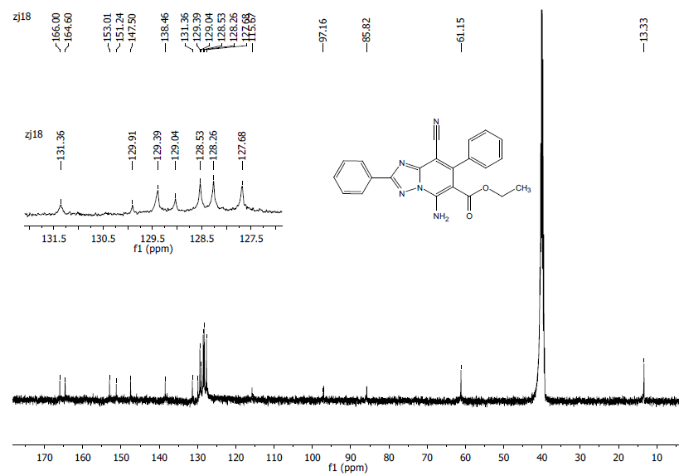
4a

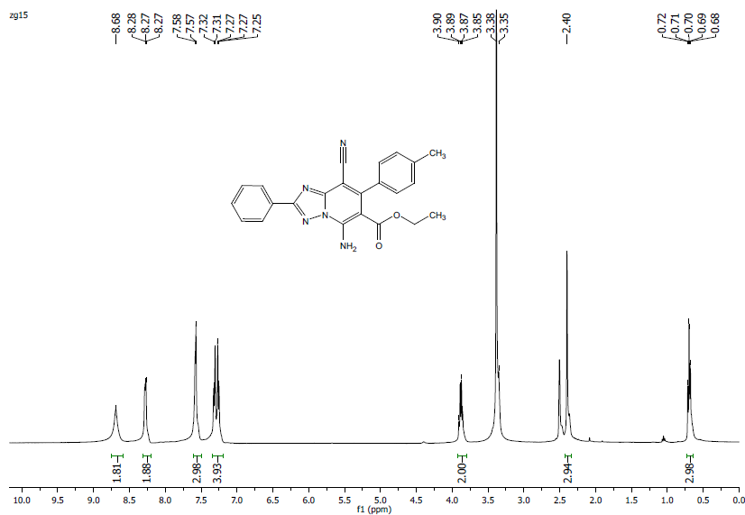
4b

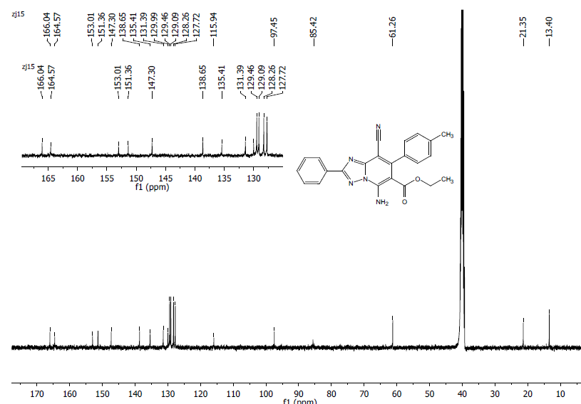
4b

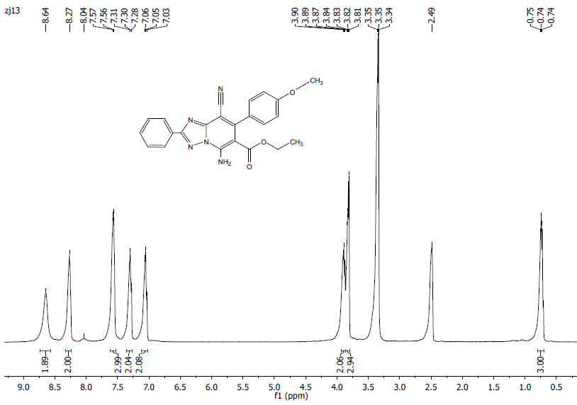
4c
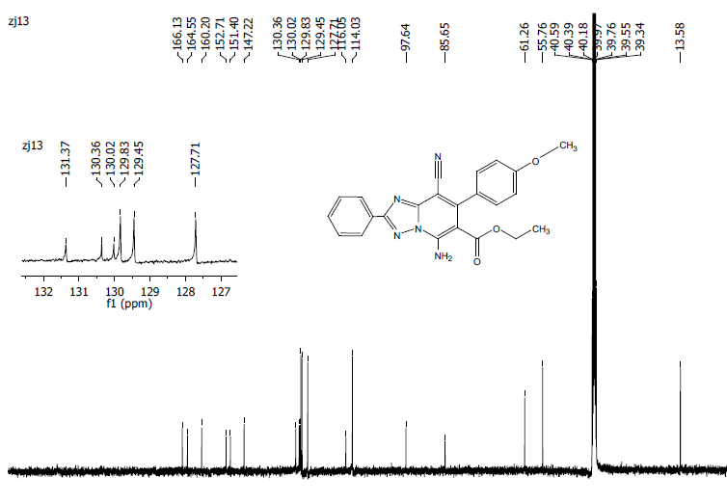
4c

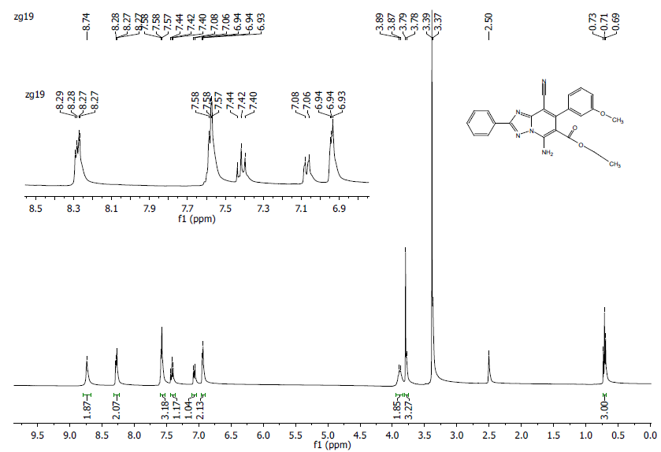
4d
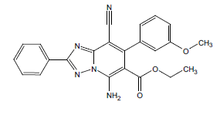
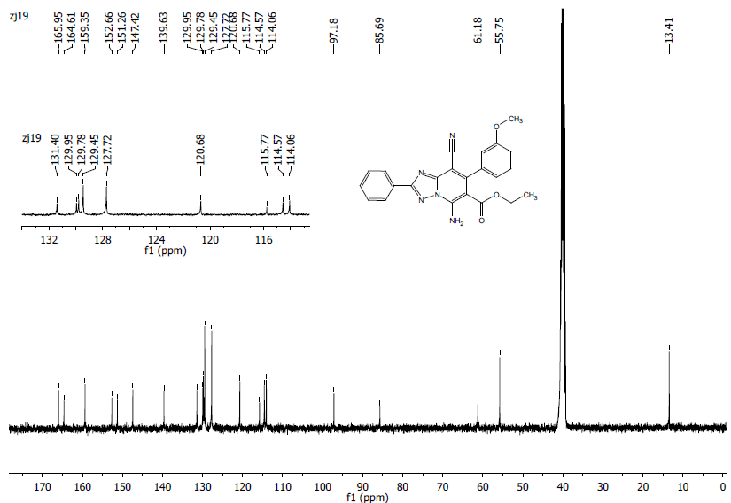
4d
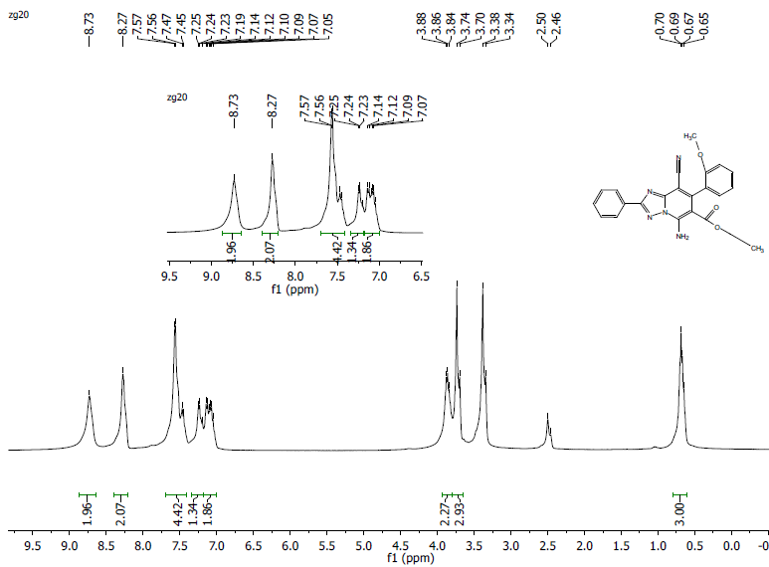
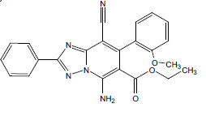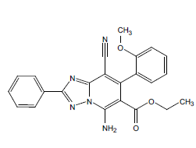
4e

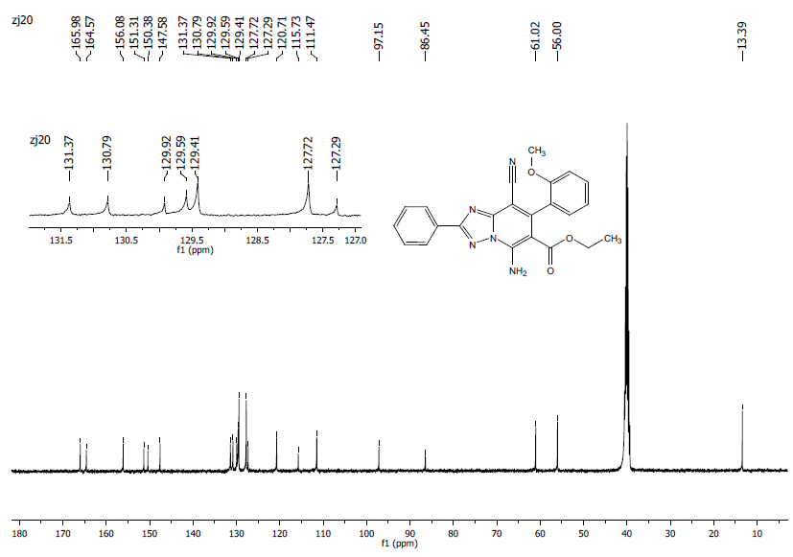
4e
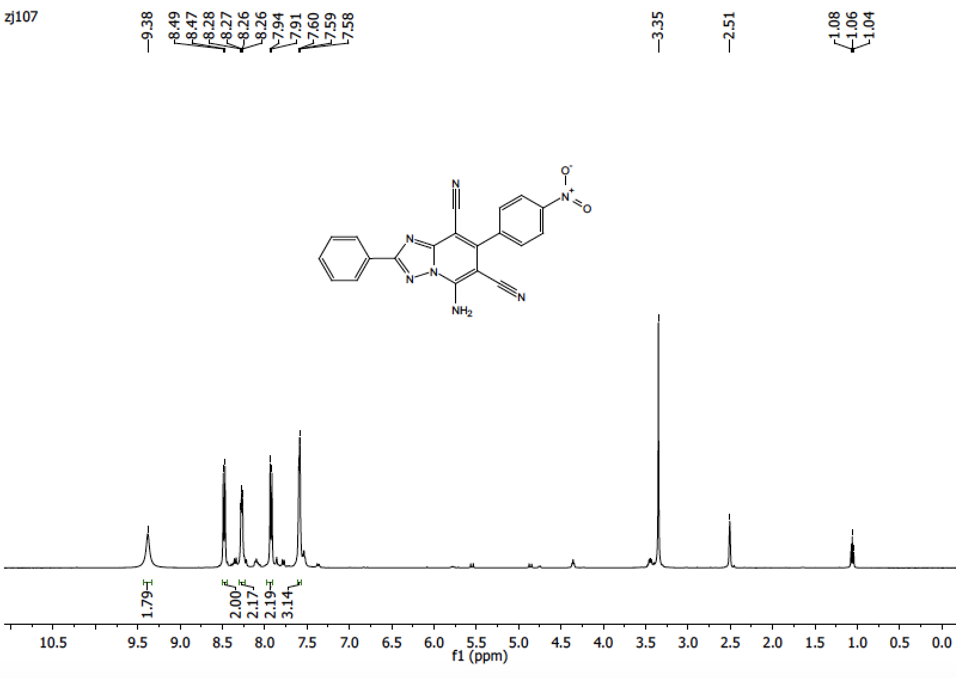

4f

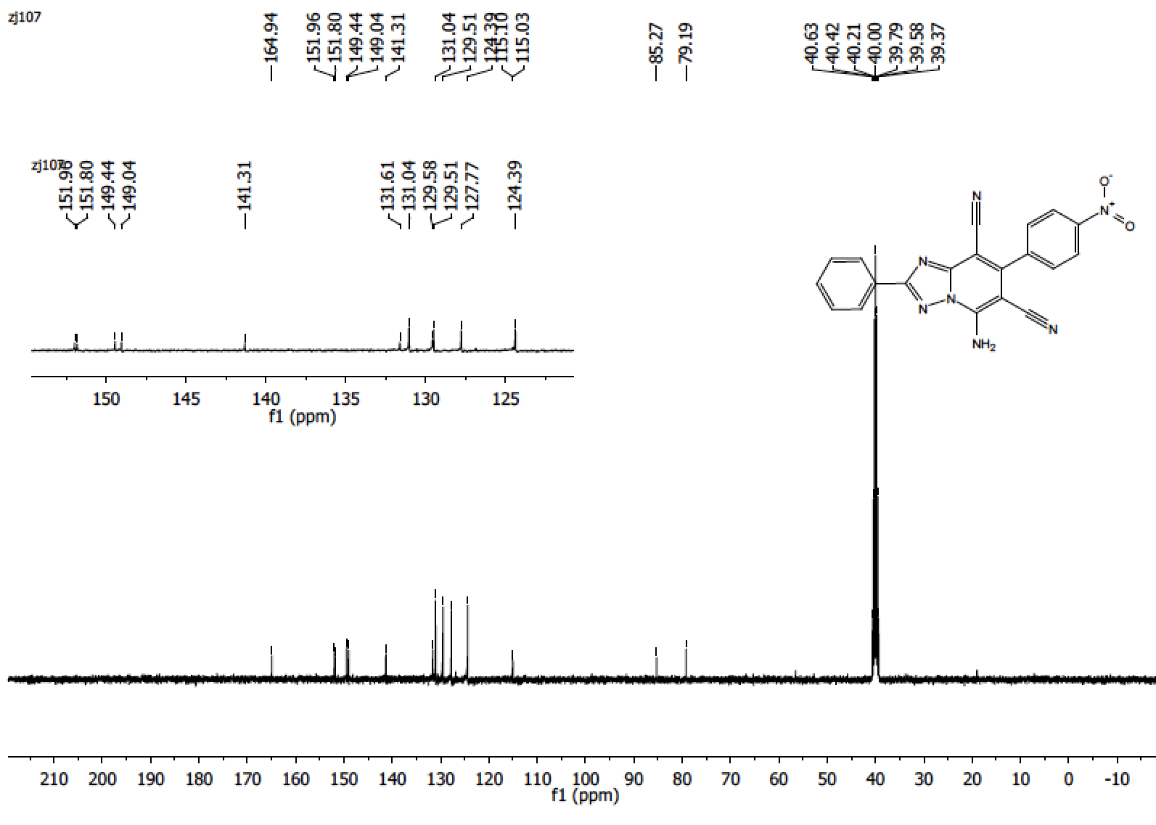

4f

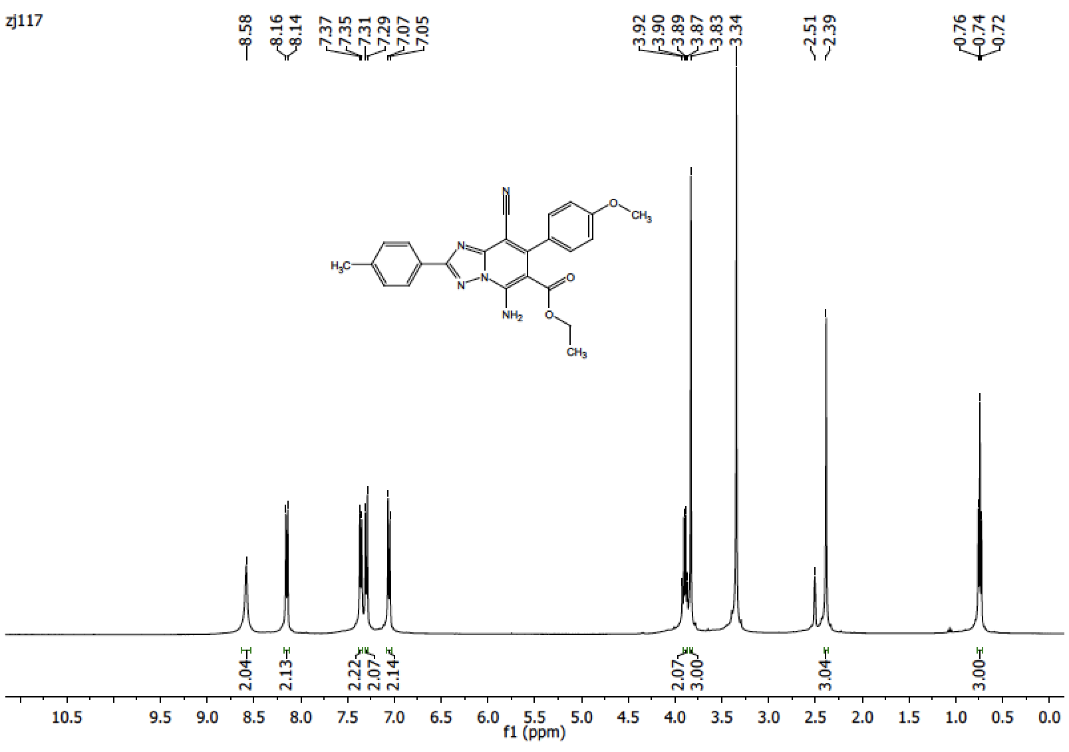
4g

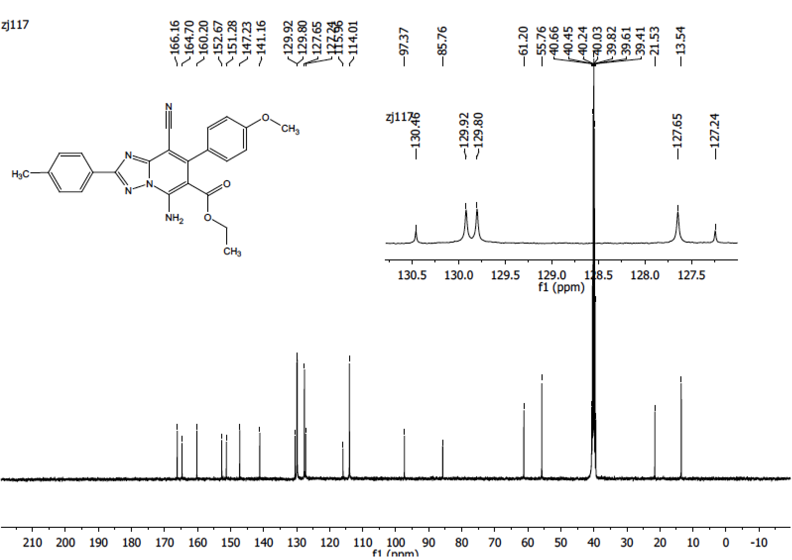
4g

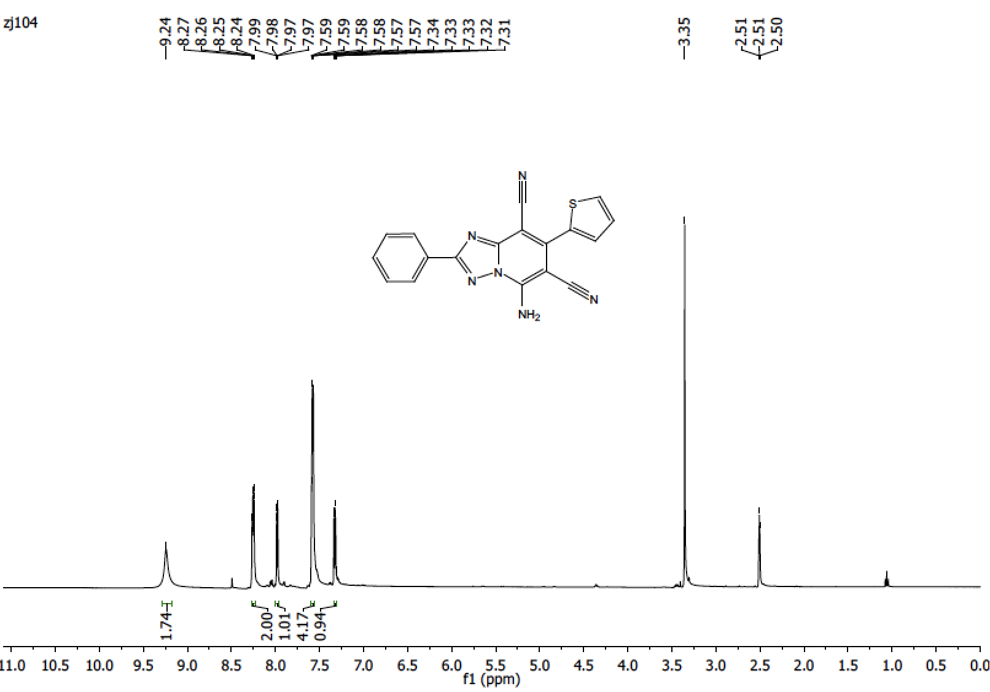

5a

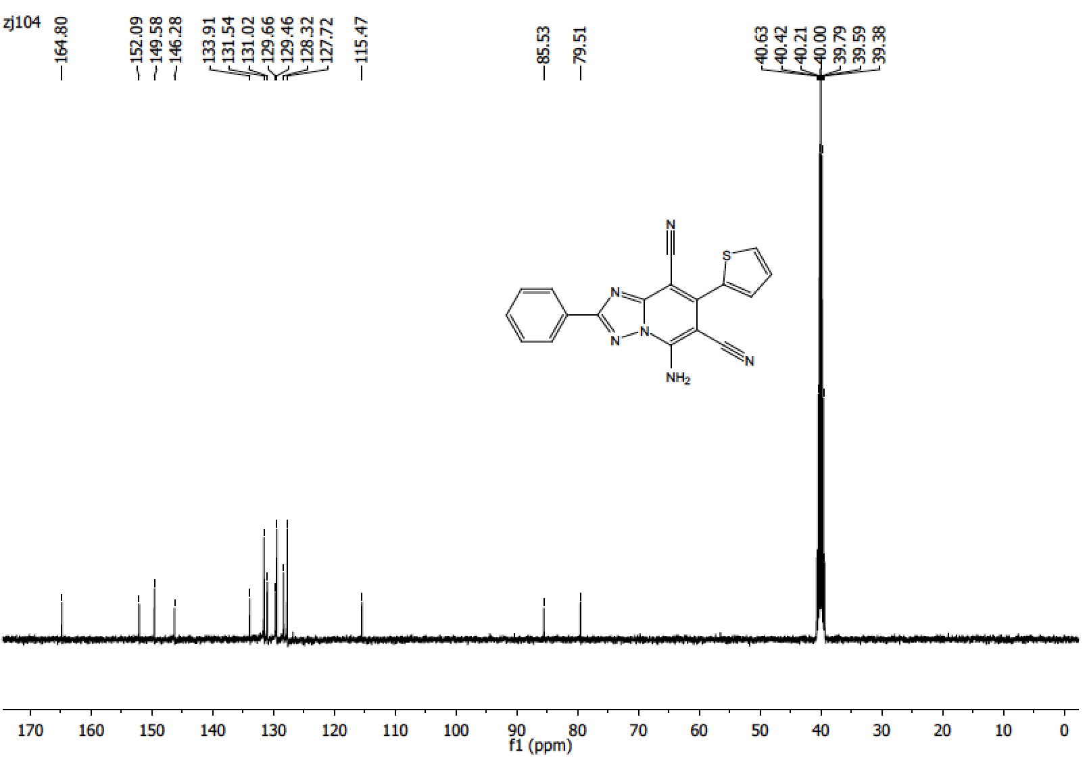

5a

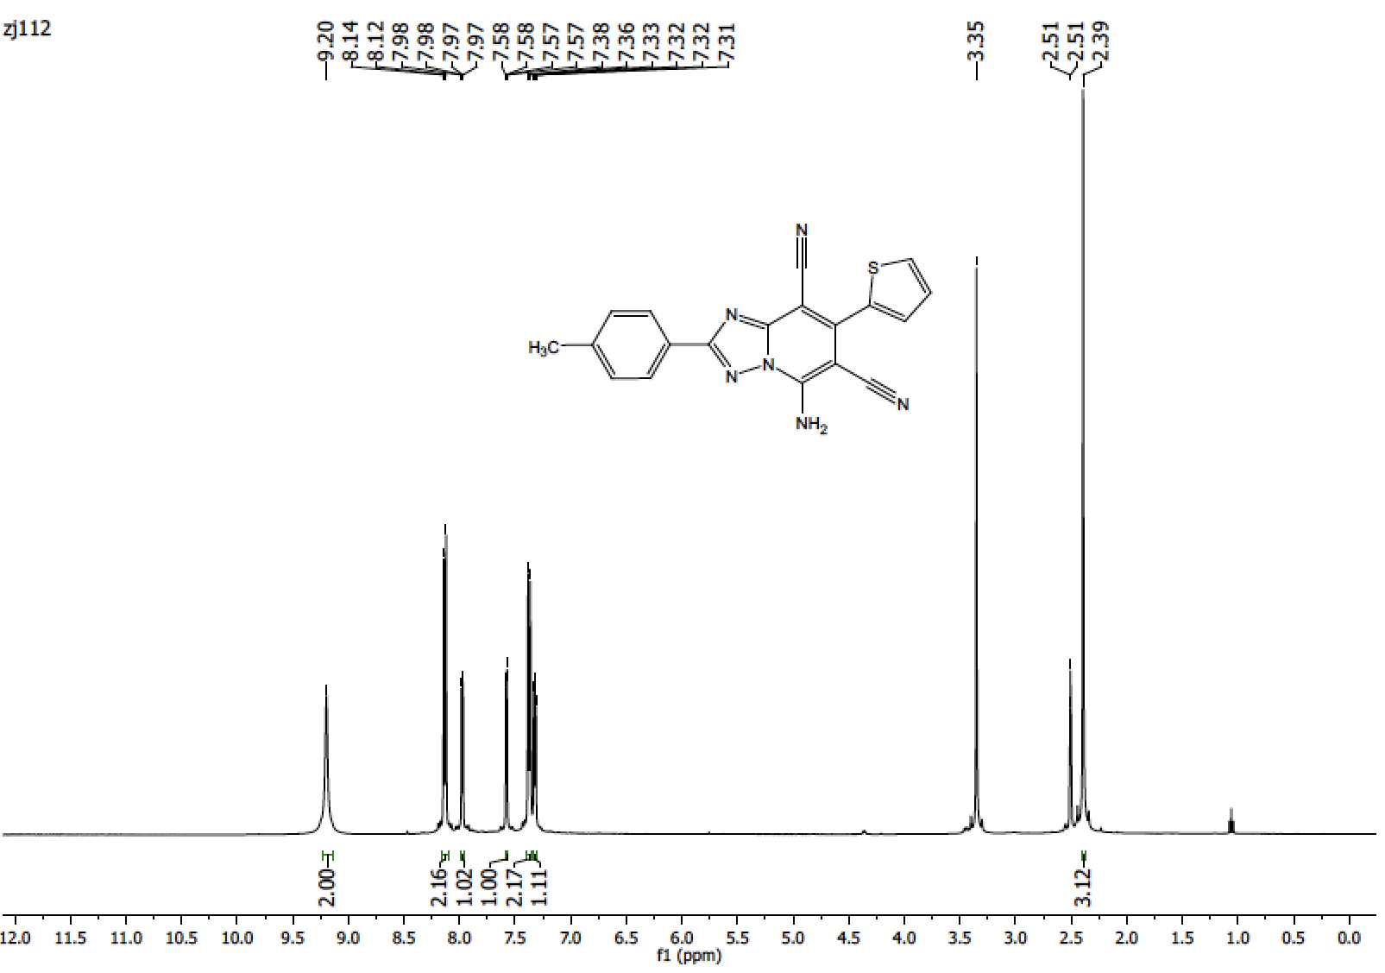

5b

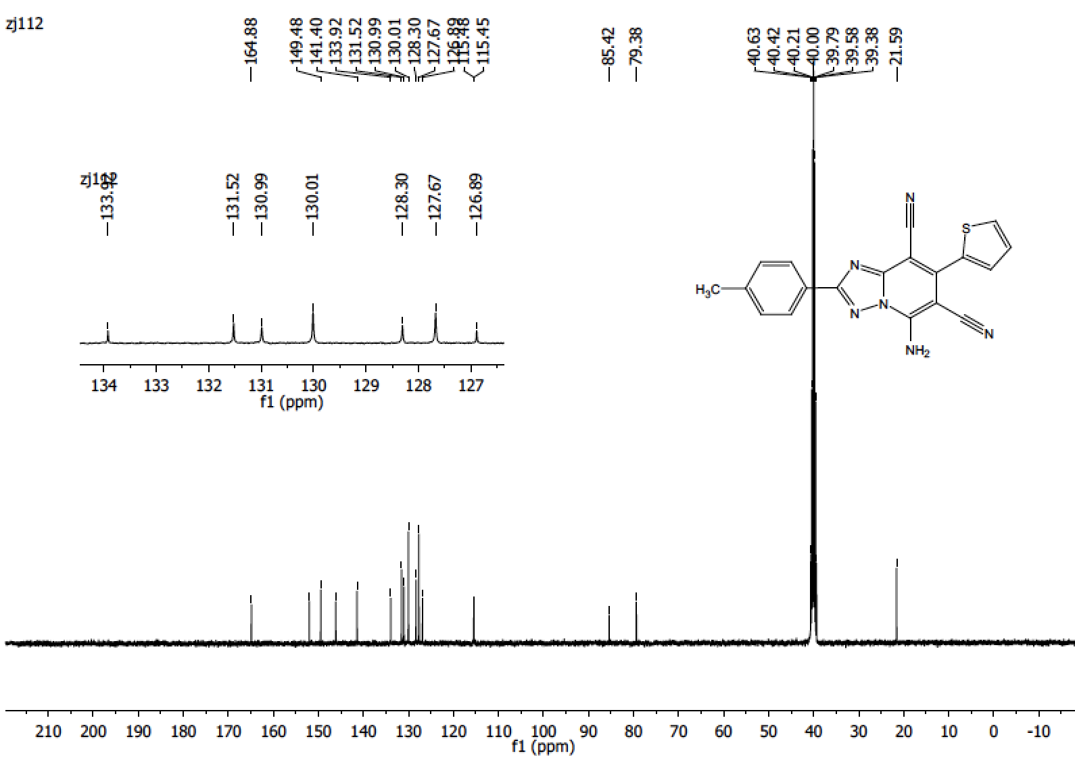
5b

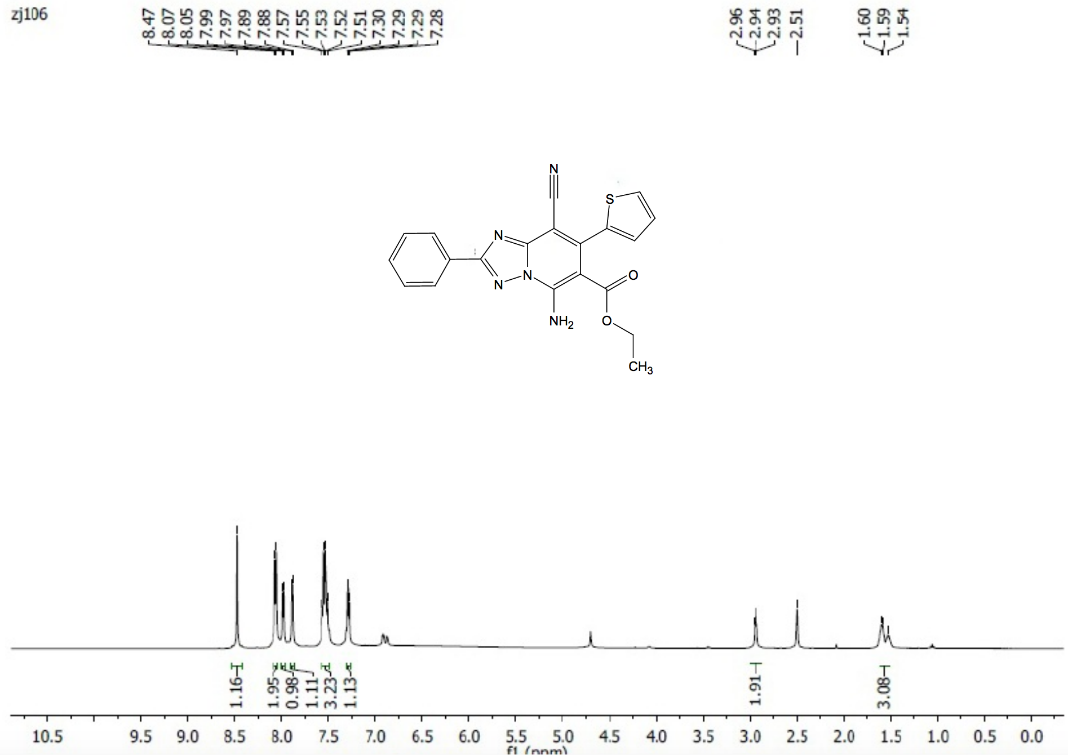

5c

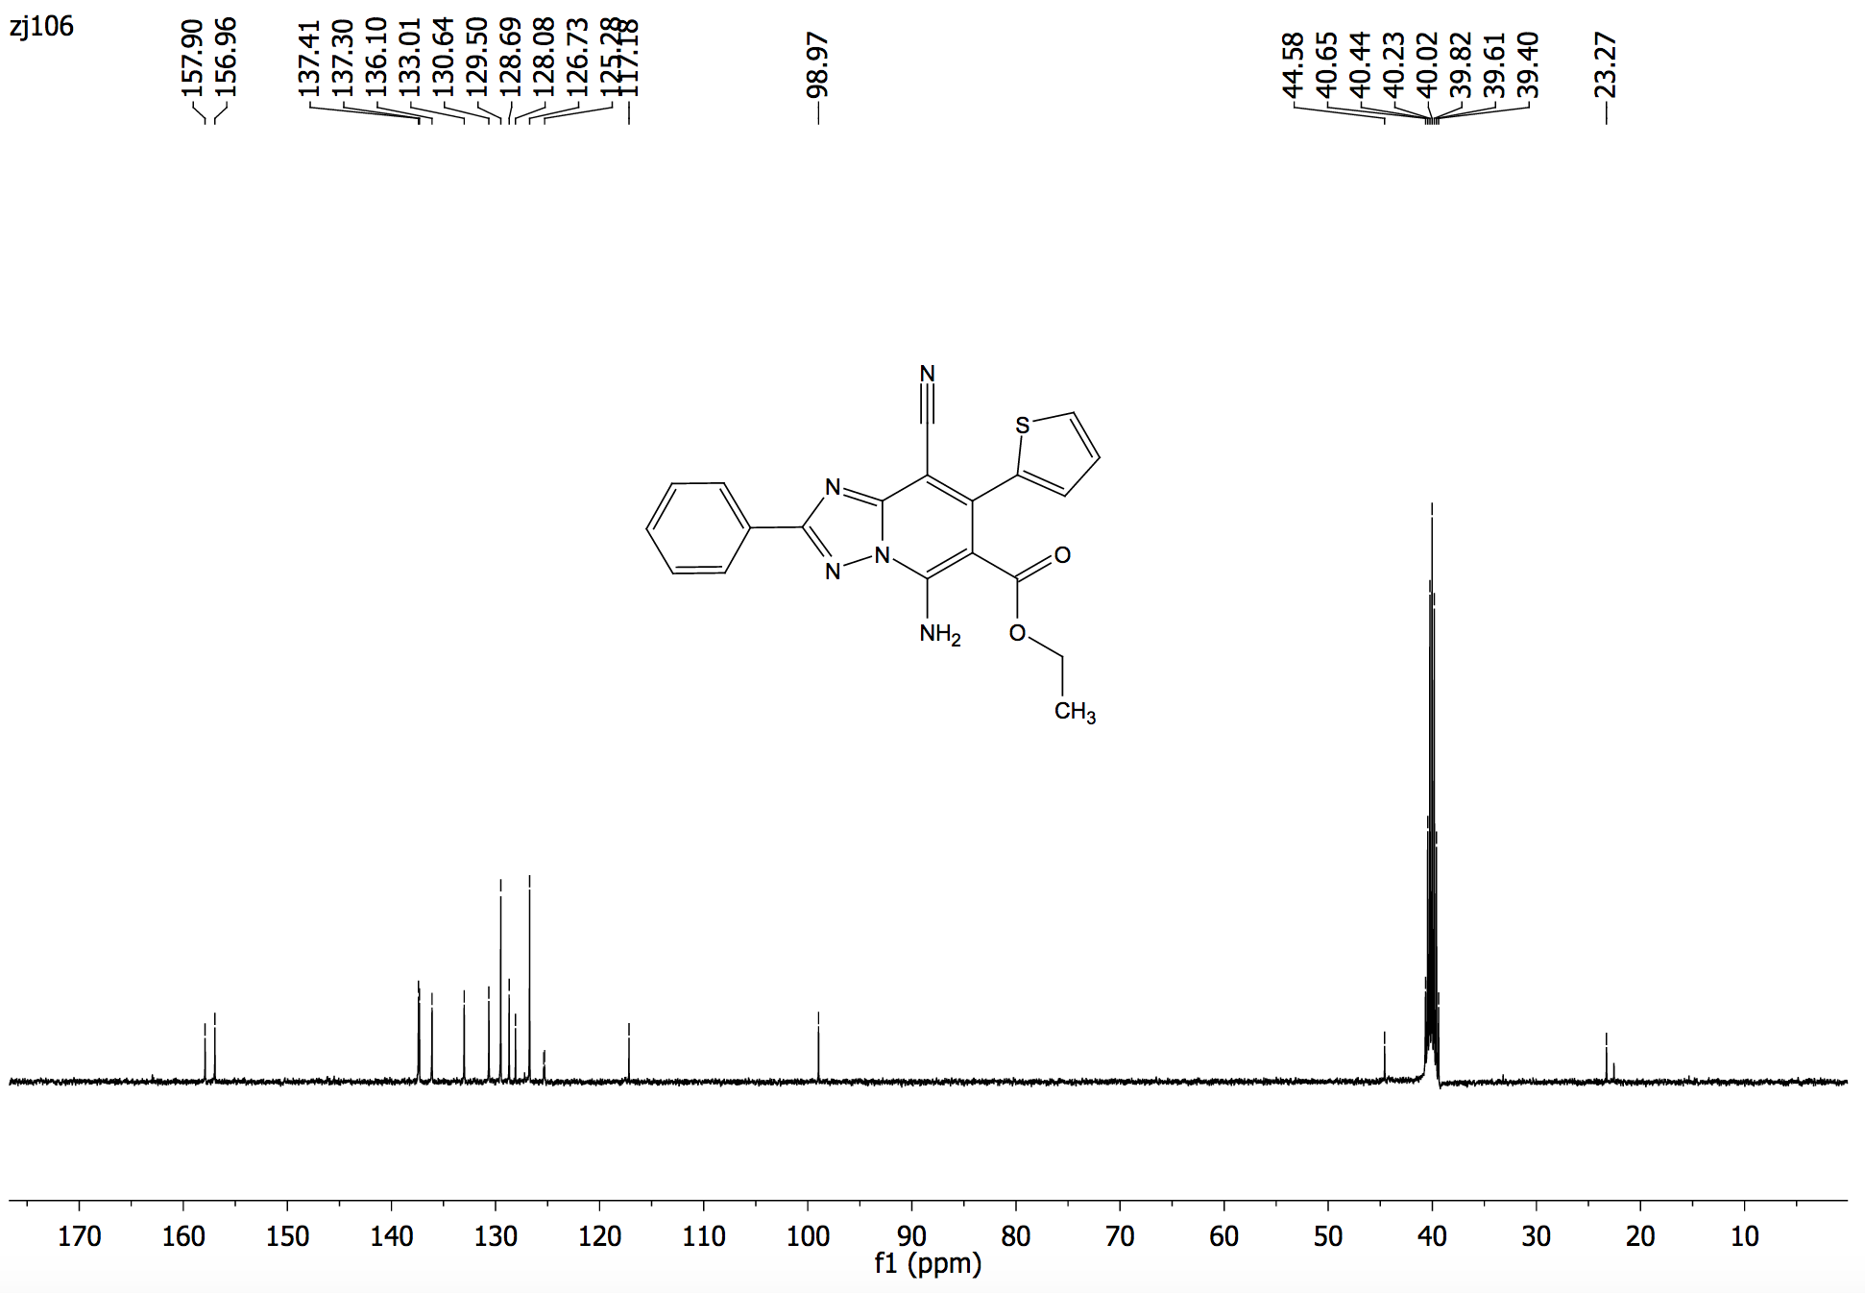

5c

